LAOS – Luang Prabang – Ancient Lao Pottery Making
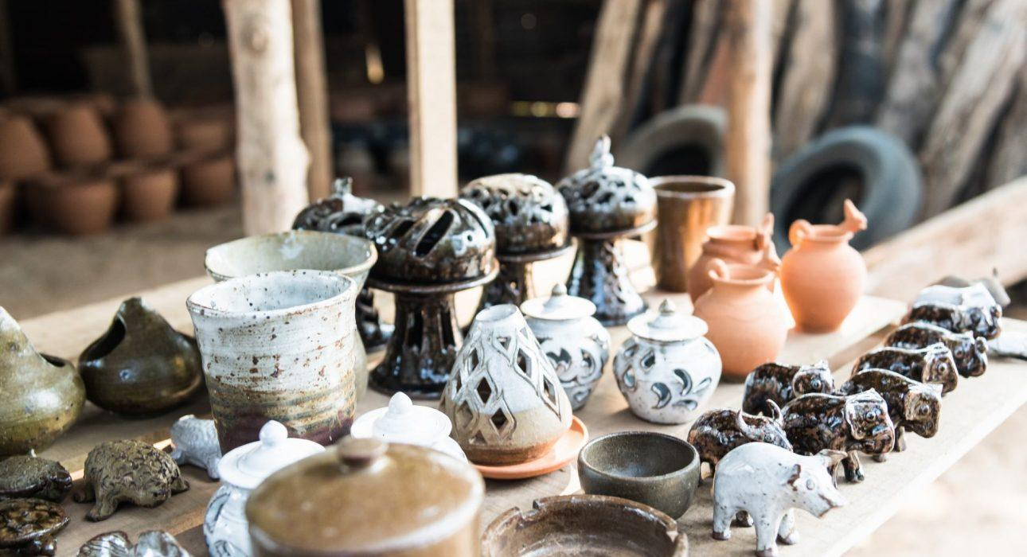

Over View

Theme
Art & Culture, Classic, Family, Honeymoon, Sustainable

Country - City
Laos - Luang Prabang

Market segment
Thematic Leisure

Price Level
$$

Max pax
12

Seasonality
All Year Round

Arrival city
Luang Prabang

Departure city
Luang Prabang

Description

Families in the village of Ban Chan have been specializing in pottery making by hand for over 400 years. Originally, pots were used for fish fermentation and to store water, but today families produce a range of pottery, from beautifully decorated planters to terracotta roof tiles. Upon reaching the village of Ban Chan, located across the Mekong River from Luang Prabang, travelers will have the opportunity to look behind-the-scenes and delve into some of ancient techniques used to make this pottery. Local pottery artisans will help the travelers get their hands wet with the clay and create their own personalized item. This experience ends with a traditional Lao meal made from fresh ingredients, prepared by a local family.

Can be combined with
Thematic Leisure
- LAOS – Luang Prabang – Create Your Own Traditional Lantern in Sa Paper
- LAOS – Luang Prabang – Pak Ou Caves, The Religious Symbol of Luang Prabang

Selling points

- To have an opportunity to get a behind-the-scenes look at the ancient techniques used to make Lao pottery and to get hands-on with the clay.
- To have a chance to experience a rural Lao village located just across the river from Luang Prabang.
- To enjoy delicious local food served on traditional bamboo plates and low rattan tables.
- Easy to combine half-day activity with lunch.

Sustainability

Level Of The Excursion
Medium – This activity offers tangible positive contributions to the local community, culture and/or environment, High – This activity strongly supports local communities and/or helps preserve the culture and environment

The Impact Of This Excursion

Social/cultural Impact
Cultural Conservation, Empowerment and education, Community welfare and health

Economic Impact
Local individual benefits, Community benefits

Time And Transportation

From | To | Km | By | Duration | Road condition
National Museum | Main Boat Pier | 0.3 | Car | 1 minute | Good
Main Boat Pier | Ban Chan Village | 1 | Boat | 15 minutes | Good

Photos

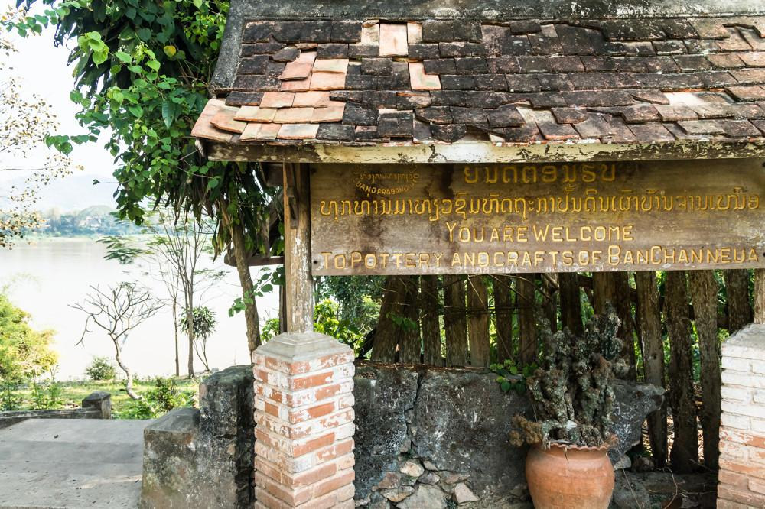
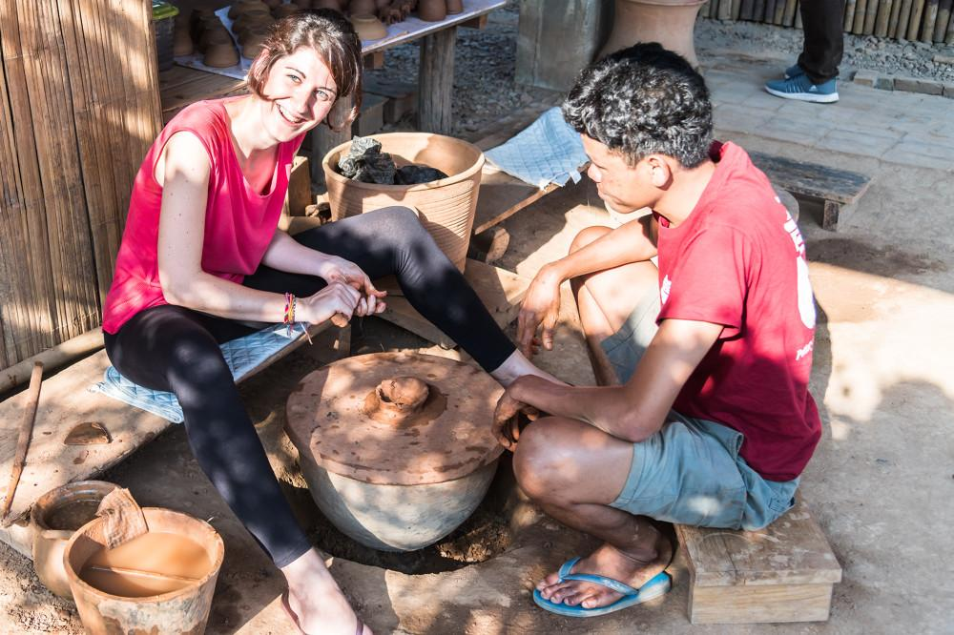
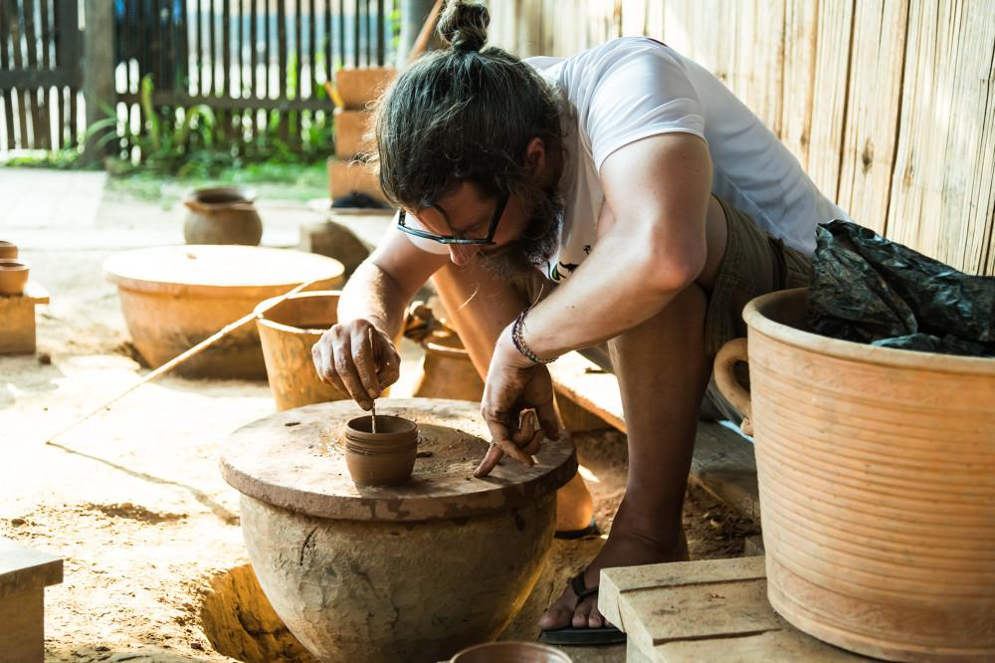
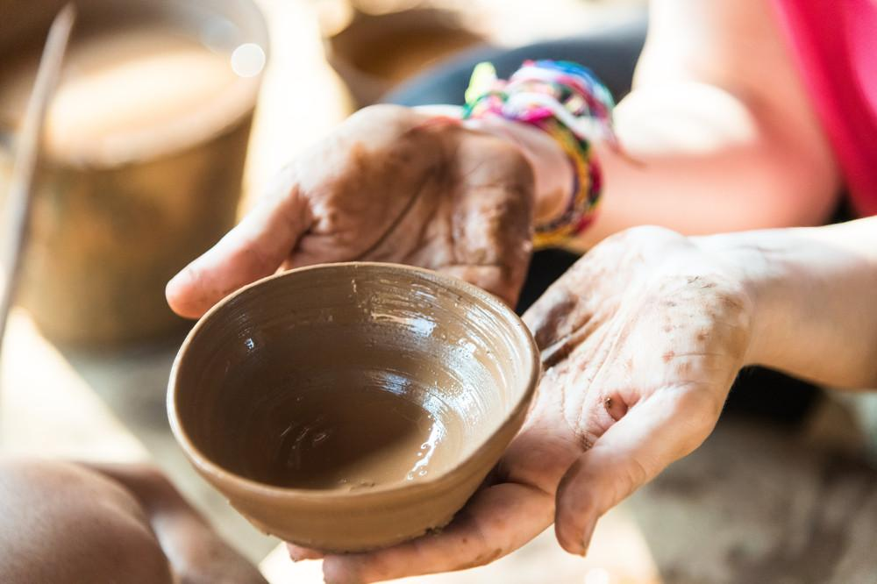
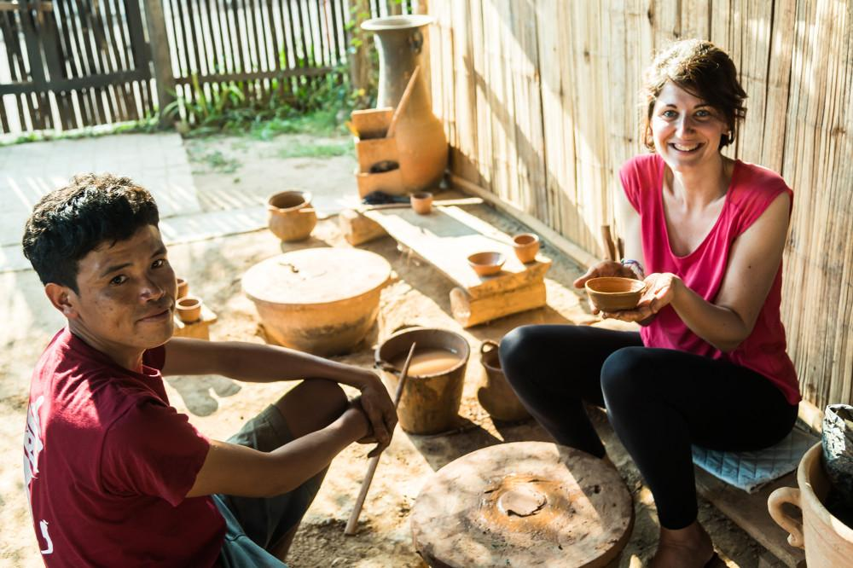
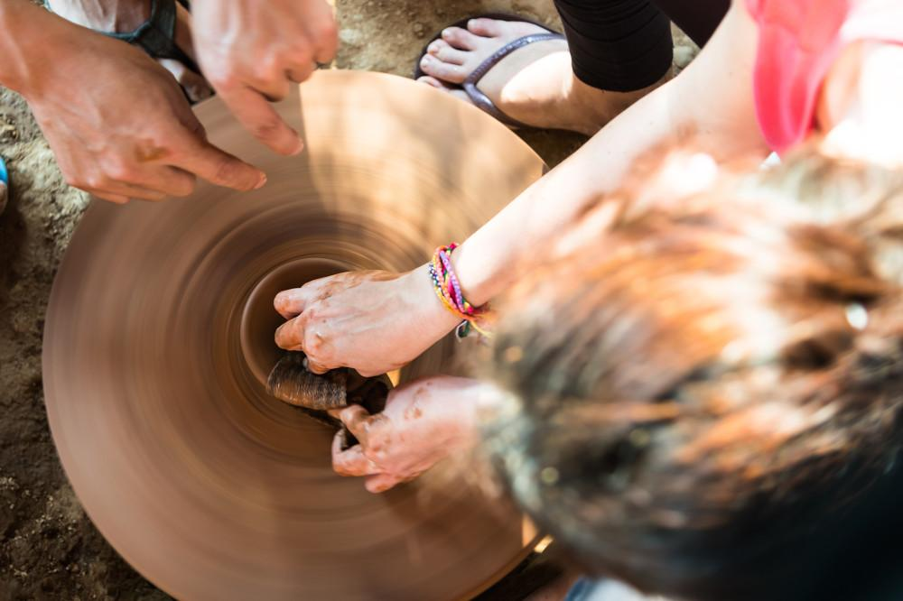

Easia Travel Head Office

Vietnam Head OfficeC/o: ATS Hotel, Suite 326 &327, 33B Pham Ngu Lao Street, Hanoi, VietnamTel: +84 24-39 33 13 62www.easia-travel.com

