LAOS – Luang Prabang – Lunch at Wat Done Khoune Temple
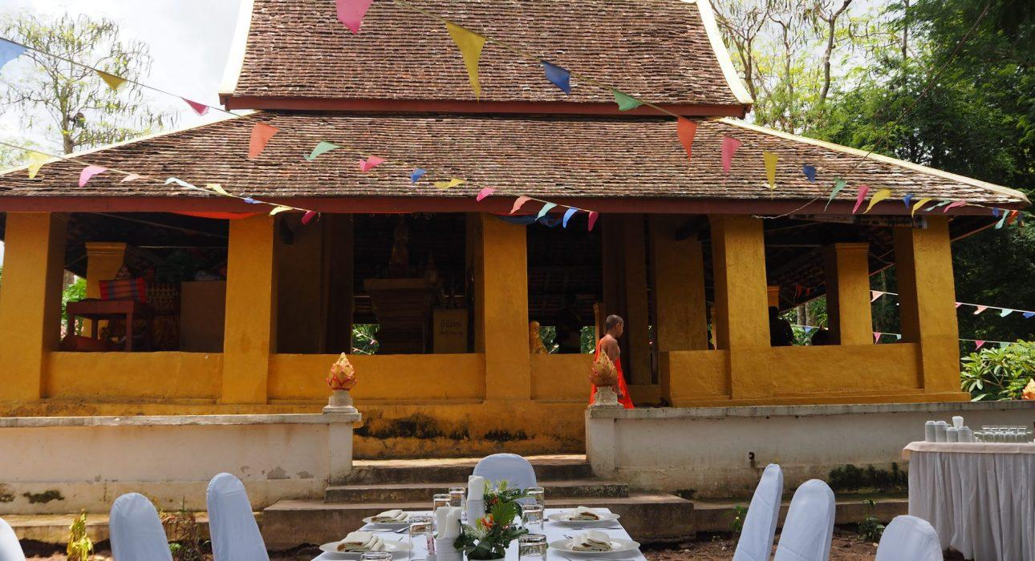

Over View

Theme
Art & Culture, Classic, Gastronomy

Country - City
Laos - Luang Prabang

Market segment
Groups, Thematic Leisure

Price Level
$$$

Max pax
40 (possible to extend for specific requests)

Seasonality
All year round

Arrival city
Luang Prabang

Departure city
Luang Prabang

Description

A northward bound journey along the murky waters of the mighty Mekong to a mysterious temple built on a sandbar island in the middle of the river, an ideal place of retreat for those in search of enlightenment. On this isolated and seldom-visited island there is a cool river breeze, a scattering of monks in saffron-orange robes, and an intriguing island shrine. After wandering around the island and the temple, a luxurious lunch will be served before returning to the riverboat.

Can be combined with
Thematic Leisure
- Luang Prabang – Pak Ou Caves, The Religious Symbol of Luang Prabang

Selling points

- Ideal for those who would like to enjoy a relaxing river cruise with a cool breeze and stunning river and jungle views.
- A chance to visit a little-known island temple and to support the monks and novices who live there.
- To have an opportunity to enjoy a luxurious lunch in magical temple surroundings.
- A half-day activity that can be combined with a visit to Pak Ou Caves.

Time And Transportation

From | To | Km | By | Duration
Wat Done Khoune Temple | Luang Prabang | 17 | Boat | 1h 30min

Photos

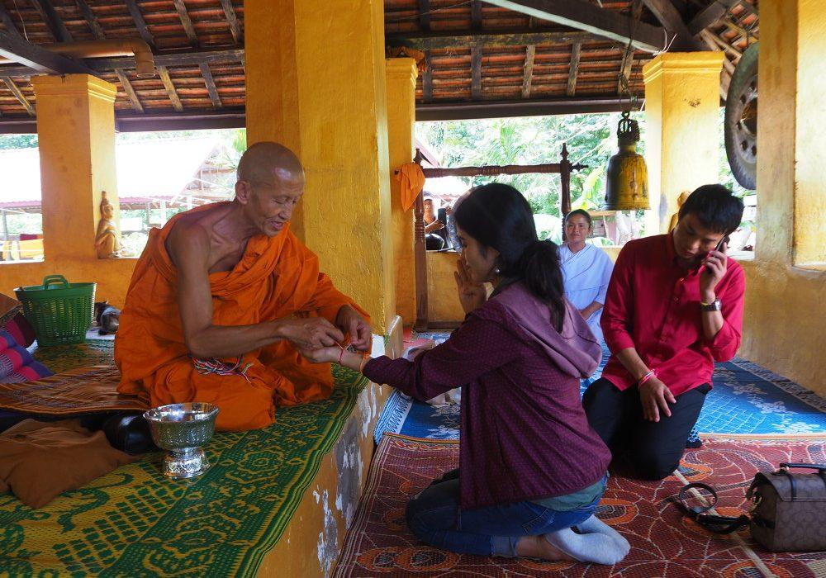
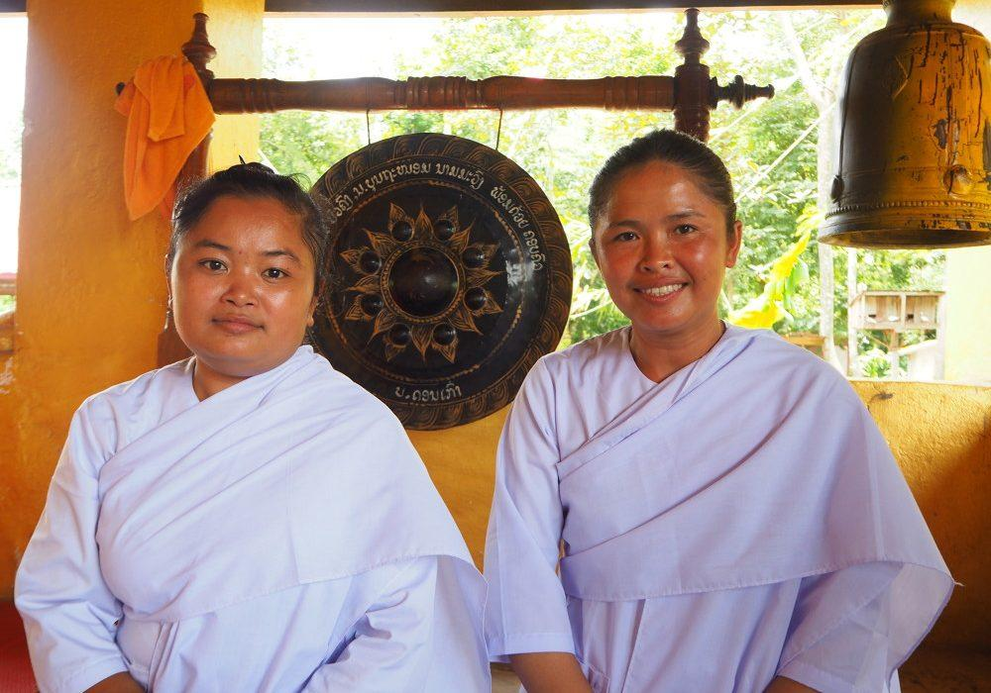
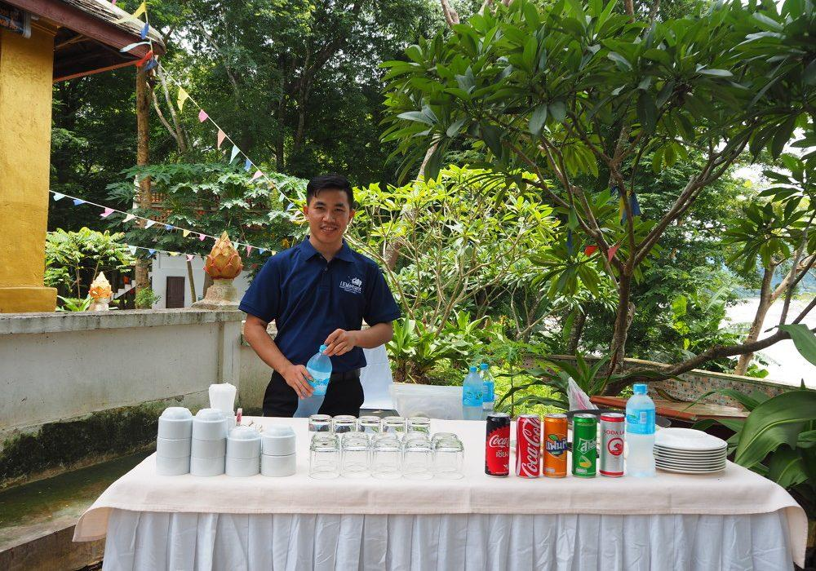
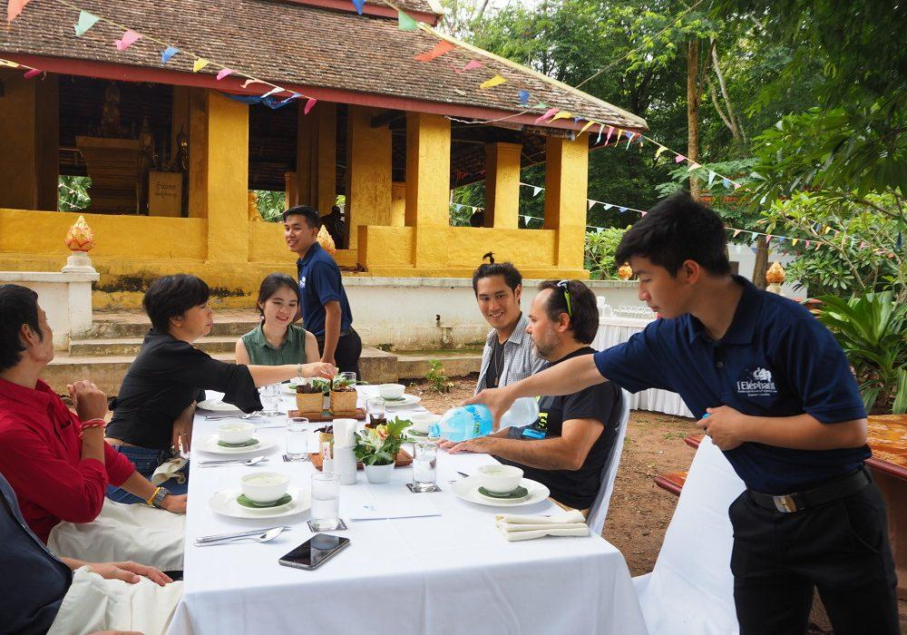
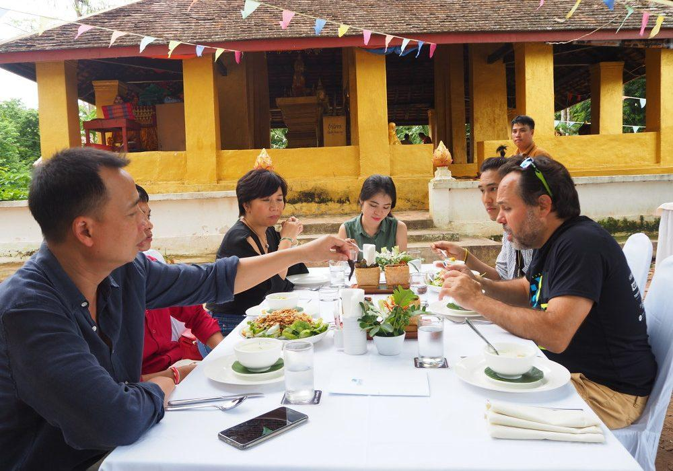
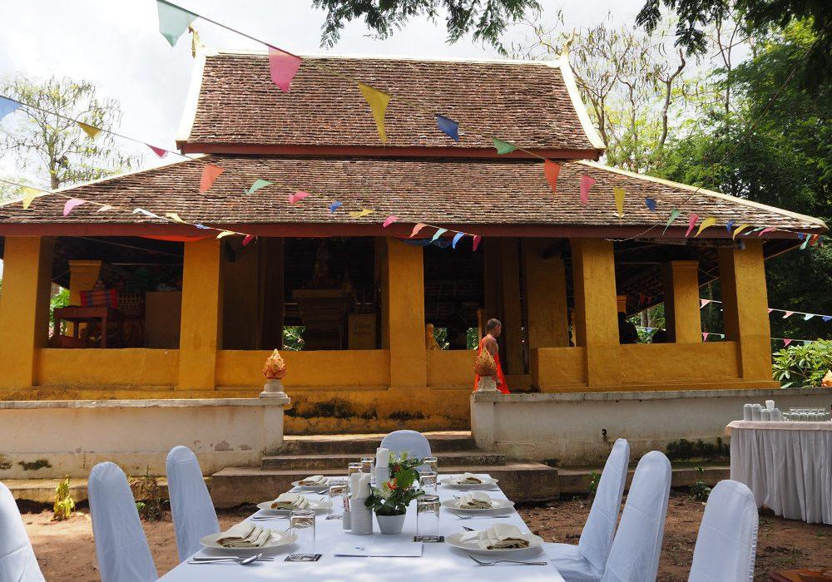

Easia Travel Head Office

Vietnam Head OfficeC/o: ATS Hotel, Suite 326 &327, 33B Pham Ngu Lao Street, Hanoi, VietnamTel: +84 24-39 33 13 62www.easia-travel.com

