MYANMAR – Bagan – Sandbank Cocktail
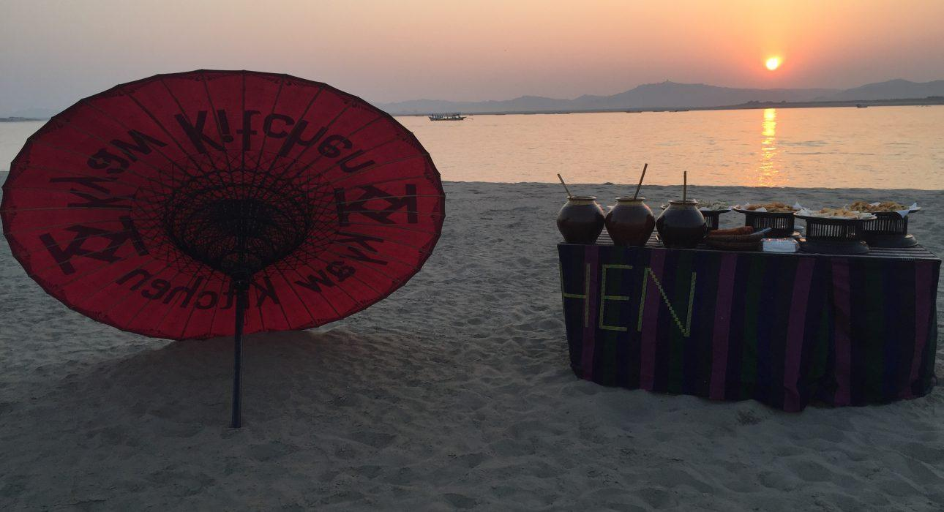

Over View

Theme
Gastronomy, Honeymoon

Country - City
Myanmar - Bagan

Market segment
Groups, Thematic Leisure

Price Level
$$$$

Max pax
2 persons

Seasonality
100 persons

Arrival city
Bagan

Departure city
Bagan

Description

A private cocktail experience on a sandbank, in the middle of the river, with the silhouette of Bagan temples as a backdrop. Whether to celebrate a special occasion or simply to relax after a day of sightseeing, this special cocktail party is set up on an isolated sandbank reached by local boat. A couple of hours of quiet gazing at the sunset from an unusual viewpoint.

Can be combined with
Exclusive
Bagan – Balloon Flight over BaganBagan – Oil Lamp Ceremony at Lawkananda
Incentive
Bagan – Scavenger Hunt Among the Temples

Selling points

- Private cocktail set up on a sandbank in the middle of the river
- A unique way to end the day in Bagan
- A moment of peace away from the usual sunset viewpoints
- A boat ride at sunset leading you to an isolated sandbank in the middle of the river where you will enjoy a private set up

Time And Transportation

From | To | Distance | By | Duration
Ayar Jetty (Old Bagan) | Sandbank | – | Boat | Around 30 min

Photos

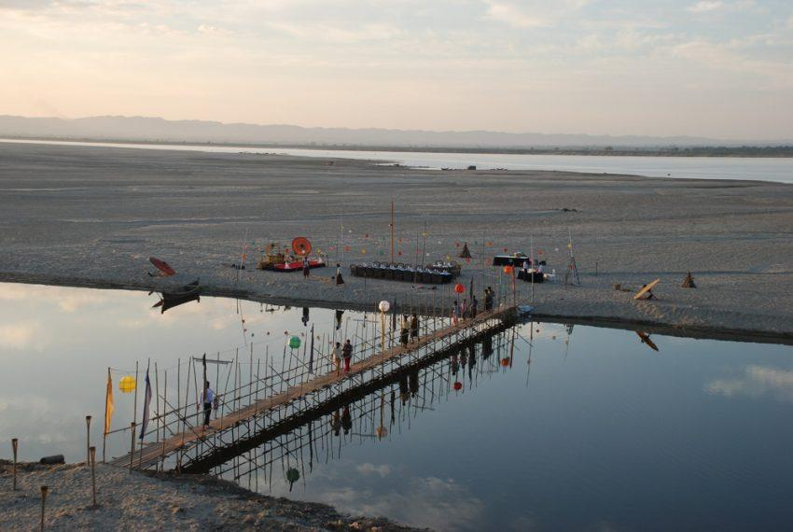
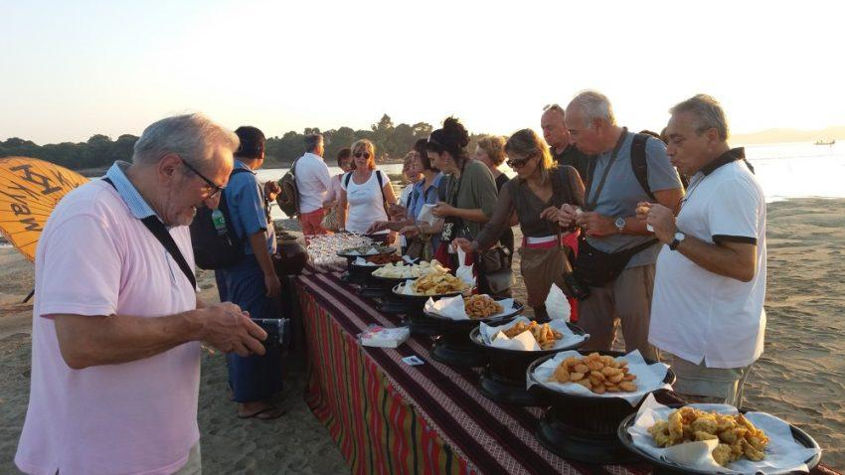
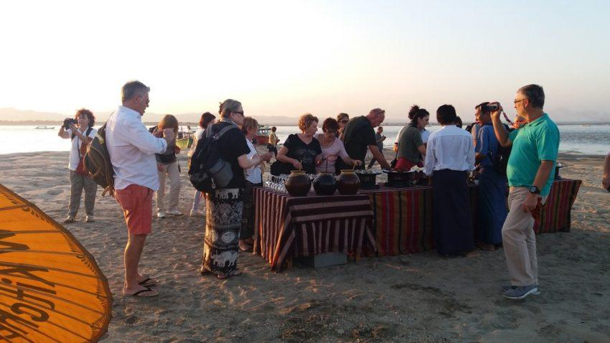
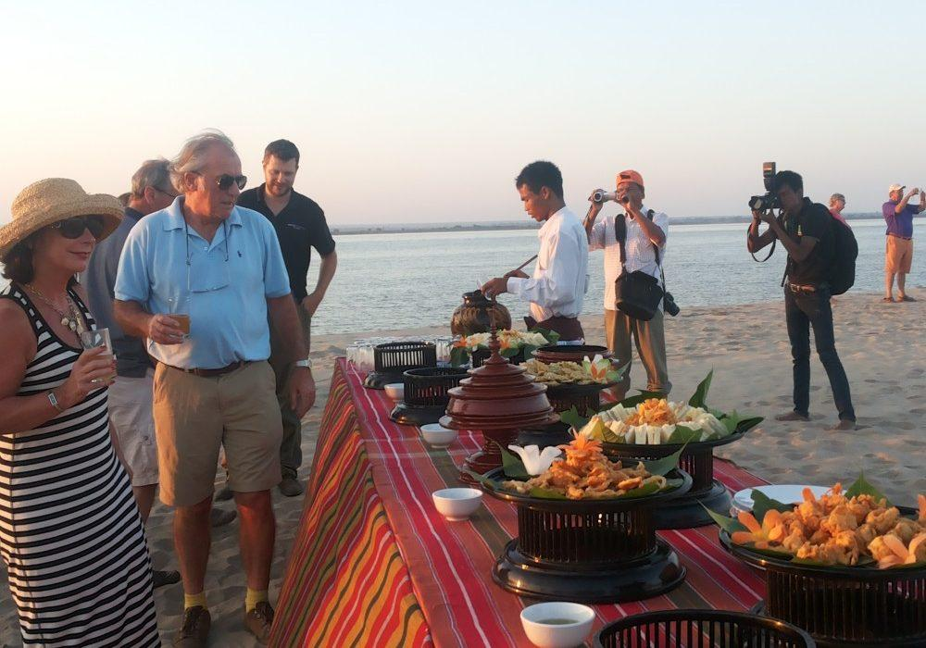
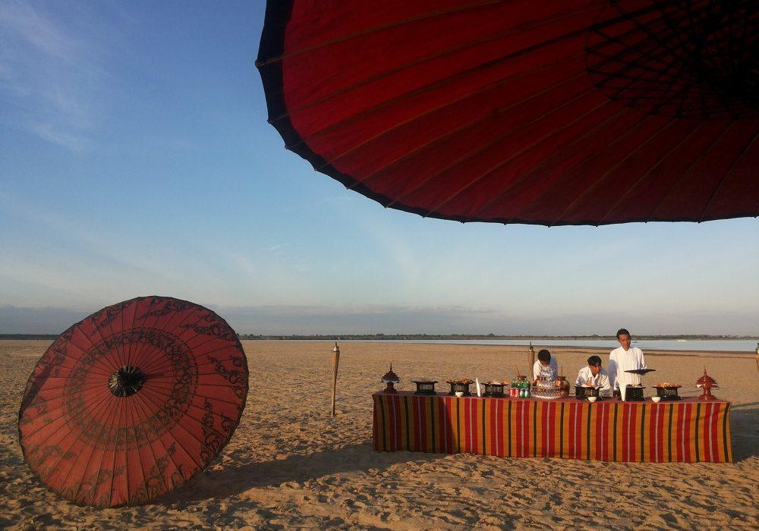
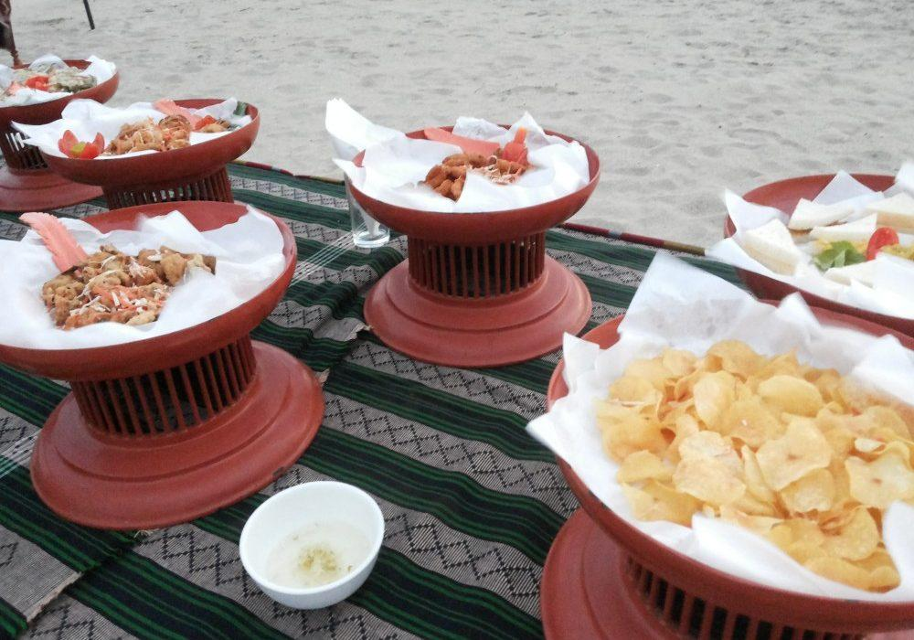
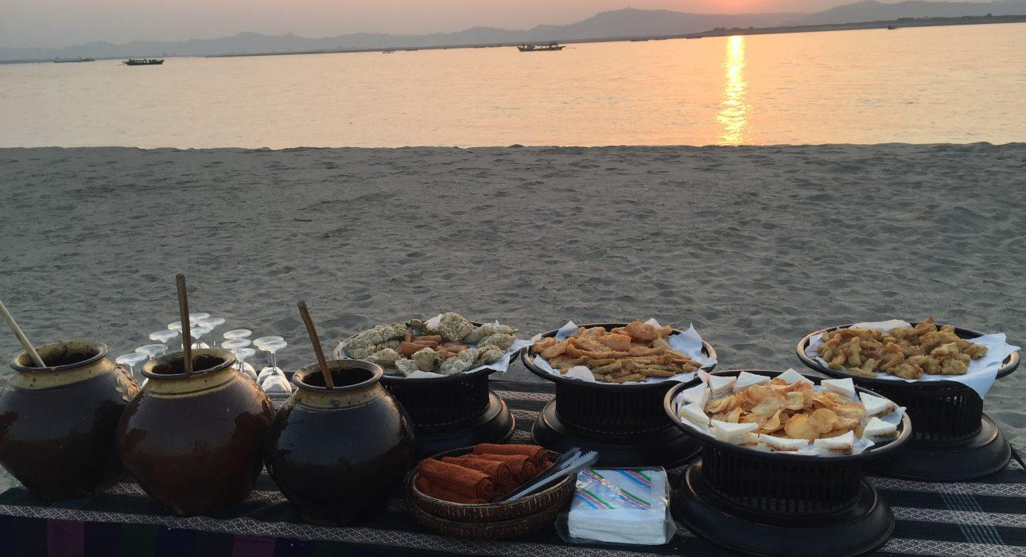

Easia Travel Head Office

Vietnam Head OfficeC/o: ATS Hotel, Suite 326 &327, 33B Pham Ngu Lao Street, Hanoi, VietnamTel: +84 24-39 33 13 62www.easia-travel.com

