LAOS – Luang Prabang – Buffalo Dairy Farm
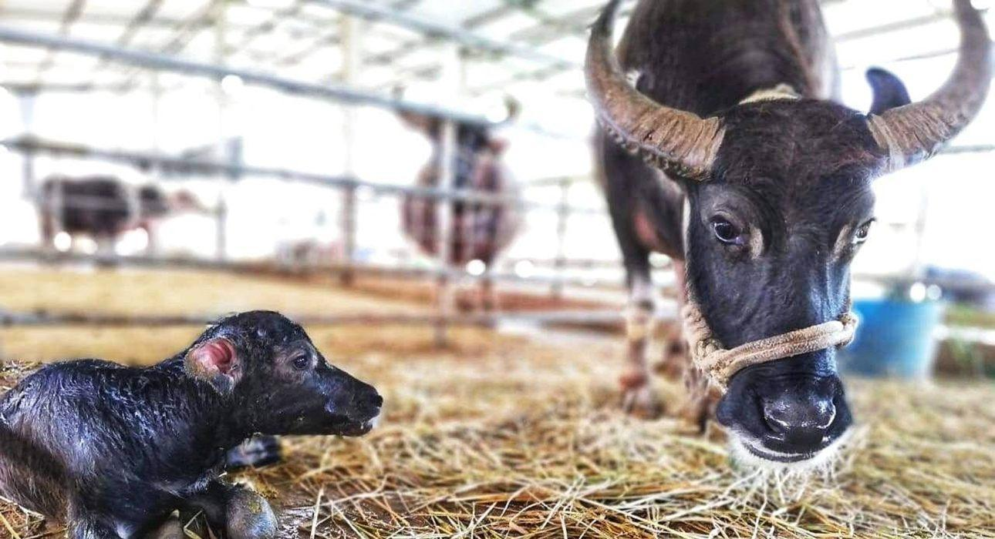

Over View

Theme
Classic, Family, Gastronomy, Honeymoon, Sustainable

Country - City
Laos - Luang Prabang

Market segment
Groups, Thematic Leisure

Price Level
$$

Max pax
54

Seasonality
All year round

Arrival city
Luang Prabang

Departure city
Luang Prabang

Description

A tour around Laos Buffalo Dairy is a unique and tasty experience. The dairy farm showcases sustainable agriculture and social enterprise in action, by leasing buffalos from local farmers in order to provide them with an income. The dairy then uses the milk from the buffalos to create superior quality yoghurt, ricotta, mozzarella, feta, blue cheese, and two types of cheesecake. Situated along a main road not too far from town, the dairy is also renowned for its buffalo milk ice cream hut which features traditional and exotic flavors such as chocolate, vanilla, tamarind, and lemon grass. In addition to an on-site cafe, travelers can take informative tours of the dairy farm, where they will have a chance to milk a buffalo, as well as brush and feed them and their offspring. The farm also houses idealized animal enclosures that it uses as educational tools in their nutrition programs throughout the region. In addition to the unique tour complete with a cheese-tasting plate, there is also the option for travelers to have the dairy farm all to themselves and watch the sunset with a cheese tasting plate and wine, or three-course meal.

Can be combined with
Thematic Leisure
- LAOS – Luang Prabang – Visit Kuang Sy Waterfall
- LAOS – Luang Prabang – Breakfast at Kuang Sy

Selling points

- The only buffalo dairy in Laos.
- The chance to try buffalo milk ice cream.
- A perfect place to buy artisanal cheese and dairy products.
- Learning through interaction with water buffalo.
- Petting rabbits and pigs is also a part of the educational farm tour.
- An excellent stop on the way to or from Kuang Sy Waterfall.
- Supporting a social enterprise that practices sustainable agriculture.
- Private sunset option with wine and a cheese tasting plate, or a three-course dinner.

Sustainability

Level Of The Excursion
High – This activity strongly supports local communities and/or helps preserve the culture and environment

The Impact Of This Excursion

Social/cultural Impact
Empowerment and education, Community welfare and health

Environment Impact
Involving Wildlife

Economic Impact
Local individual benefits, Community benefits

Time And Transportation

From | To | Km | By | Duration | Road condition
Night Market | Buffalo Dairy Farm | 22 | Car | 40 minutes | Good
Kuang Sy waterfalls | Buffalo Dairy Farm | 7 | Car | 15 minutes | Good

Photos

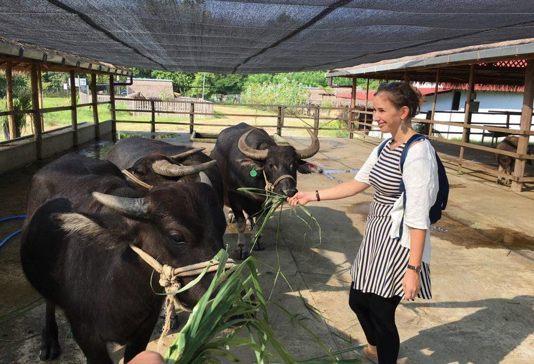
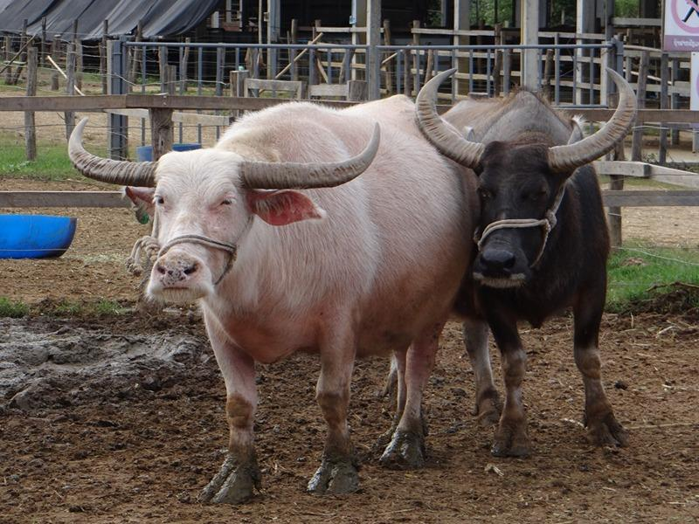
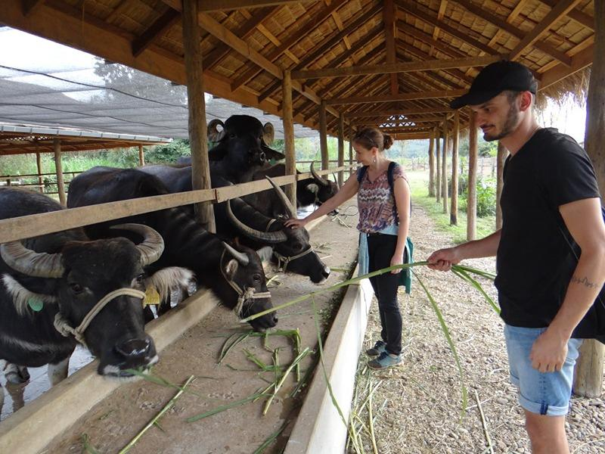
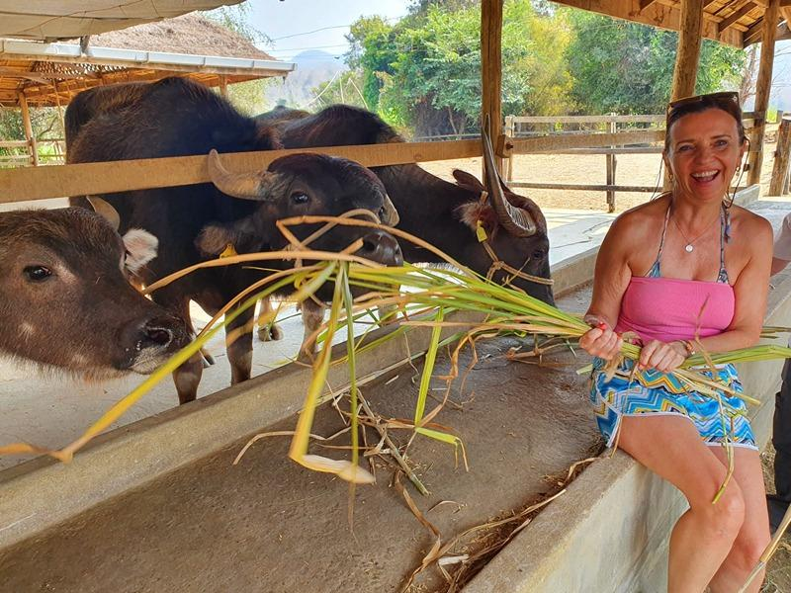
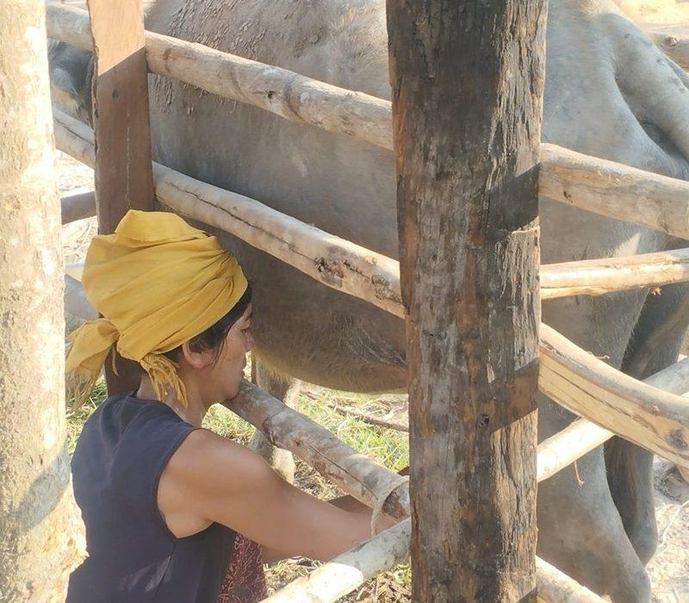
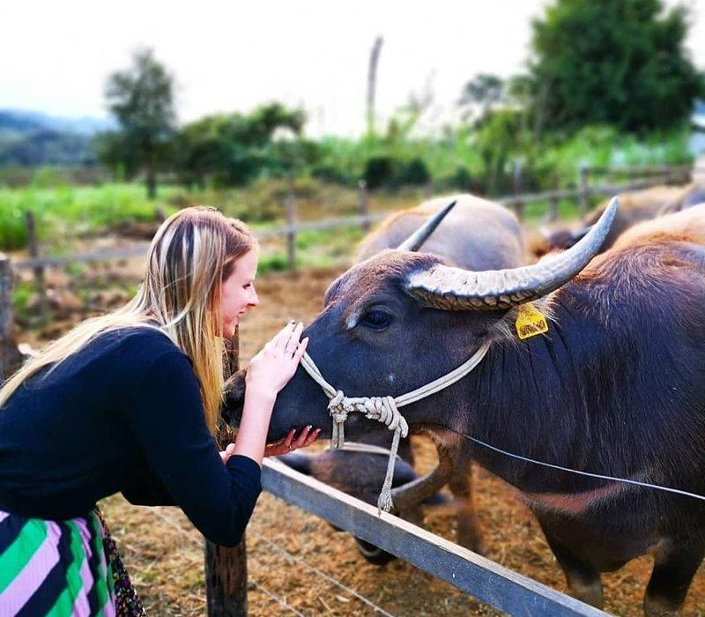
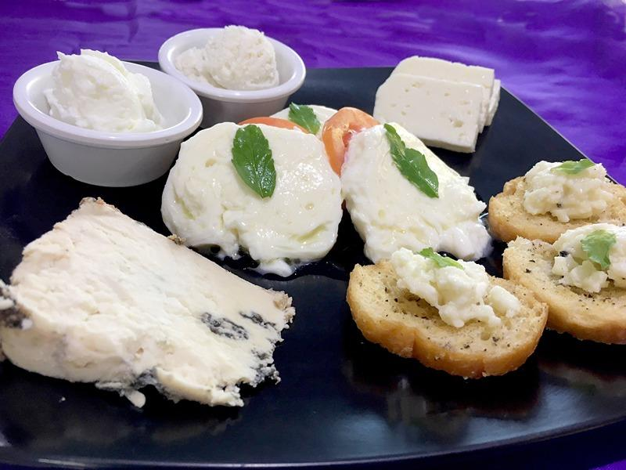
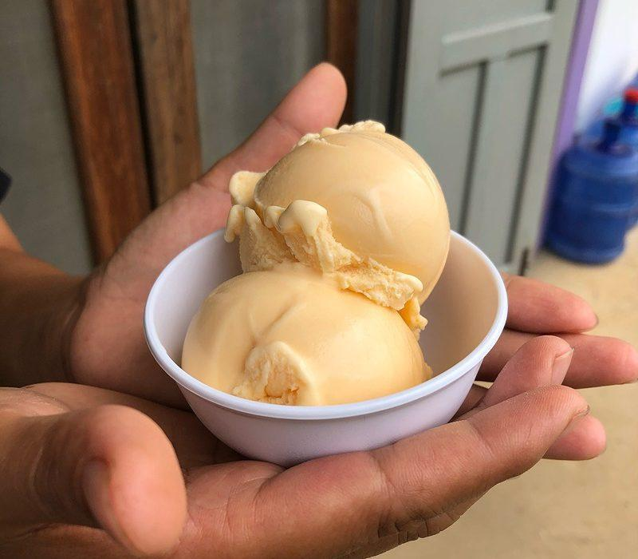
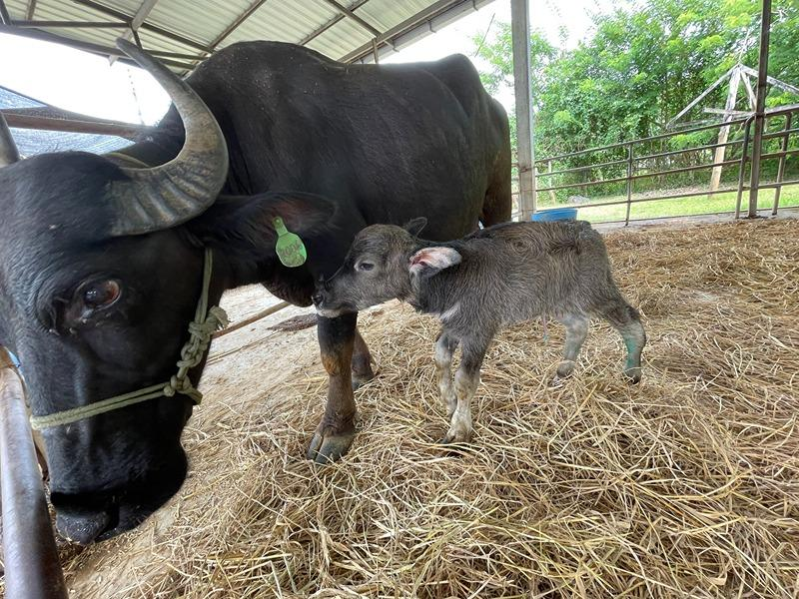
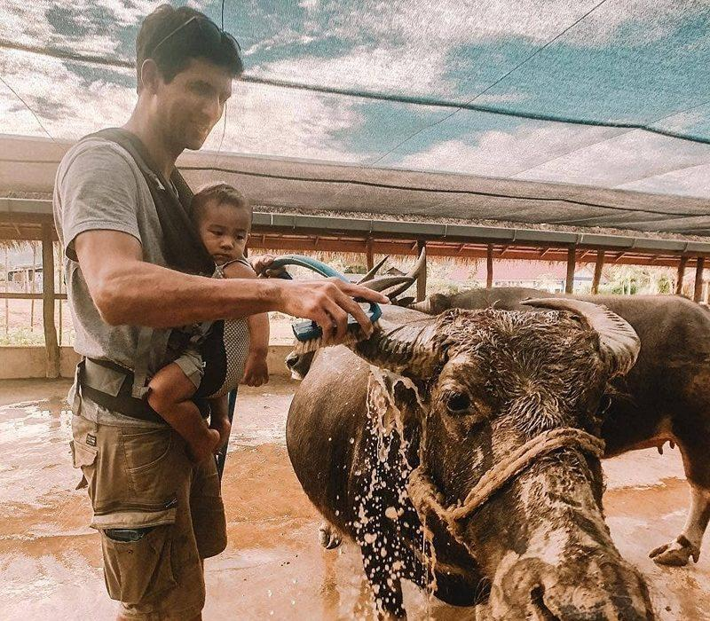
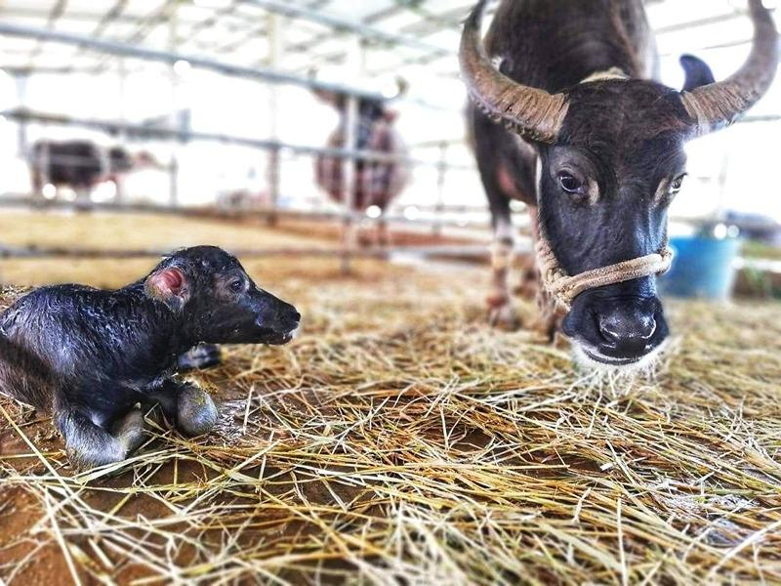
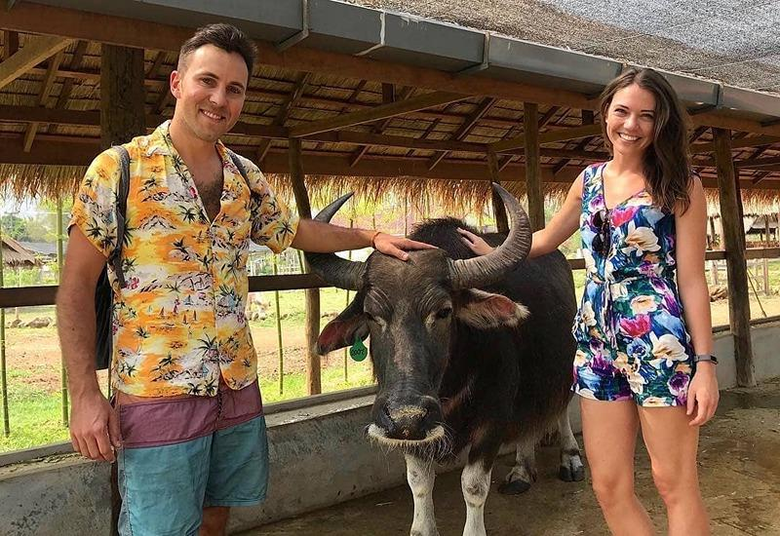

Easia Travel Head Office

Vietnam Head OfficeC/o: ATS Hotel, Suite 326 &327, 33B Pham Ngu Lao Street, Hanoi, VietnamTel: +84 24-39 33 13 62www.easia-travel.com

