MYANMAR – Pindaya – Bike from Heho to Pindaya
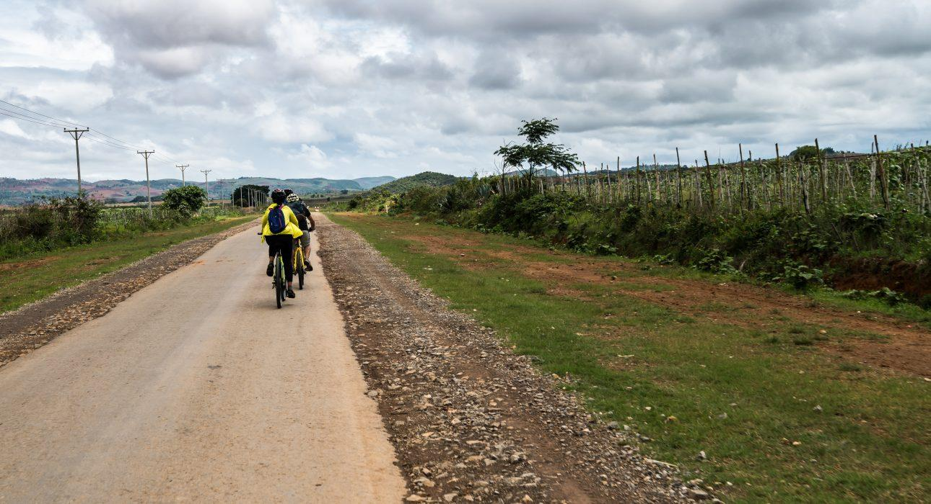

Over View

Theme
Classic

Country - City
Myanmar - Pindaya - Heho

Price Level
$$$$

Level of difficulties
LEVEL 2

Max pax
1 person

Seasonality
20 persons

Arrival city
Pindaya

Departure city
Heho

Description

Guests set out on an invigorating ride along the winding roads of the Southern Shan State. The colourful patchwork of bright green and deep orange, created by the seasonal crops, will be the beautiful backdrop all the way to Pindaya. This is an excellent occasion to take a deep breath and enjoy the cool weather and beautiful relief of this part of the country.

Selling points

- Alternative to the car for active guests
- A 40-kilometer bike ride, partly on the tar road and partly on the dirt roads to link Heho airport to Pindaya
- A first introduction to the colorful landscape of the Shan State
- Occasion to see some back roads not accessible by car
- An unusual way to reach Pindaya from Heho airport

Time And Transportation

From | To | Km | By | Duration | Road condition
Heho | Pindaya | 41 km | bike | 3 h 30min | Good

Photos

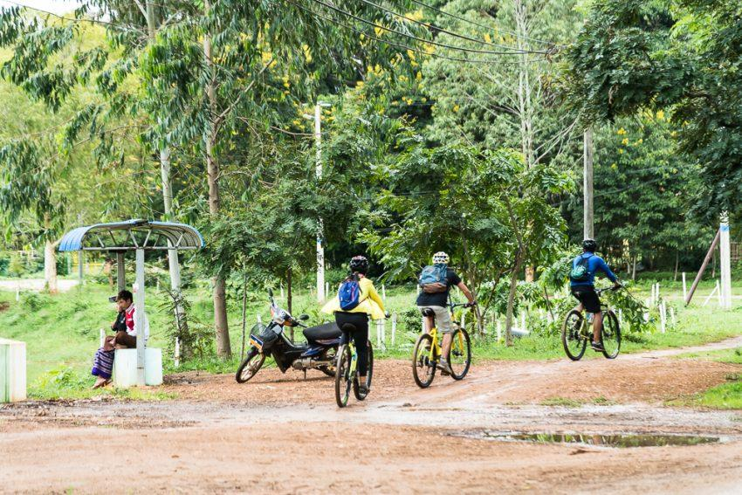
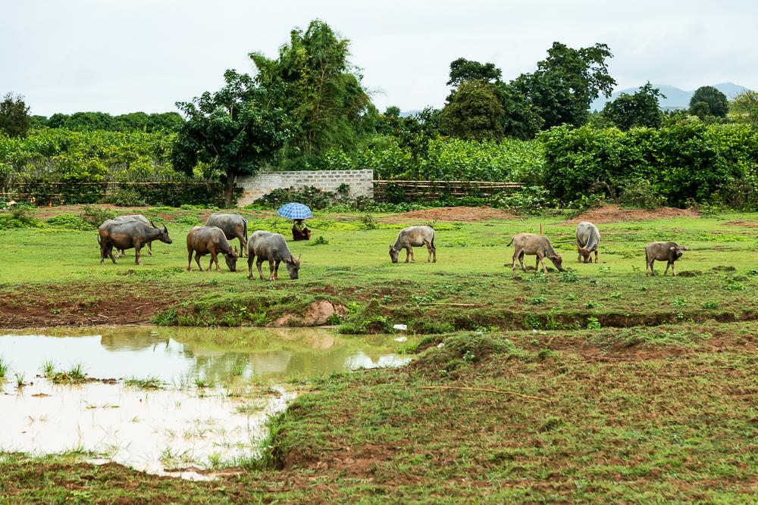
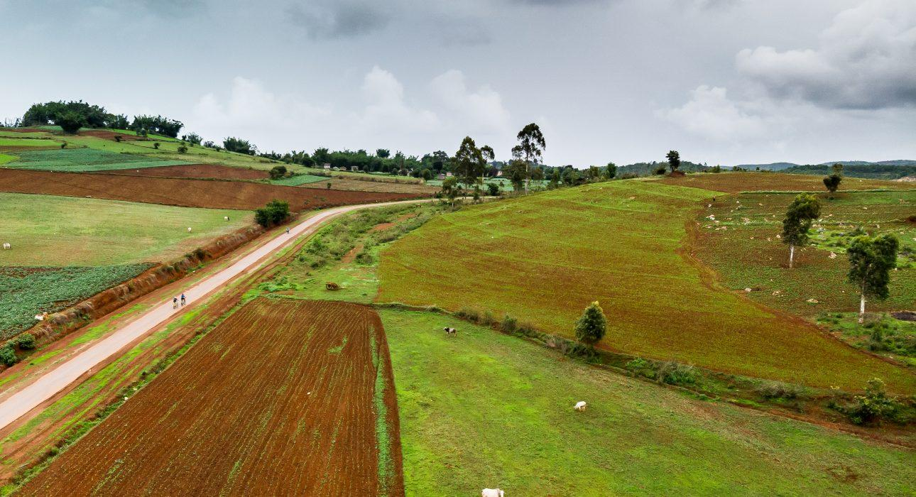
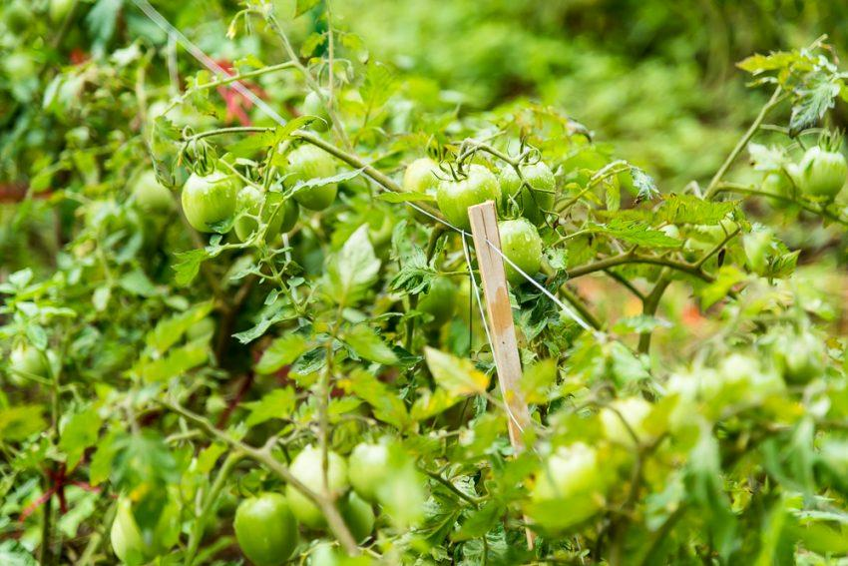
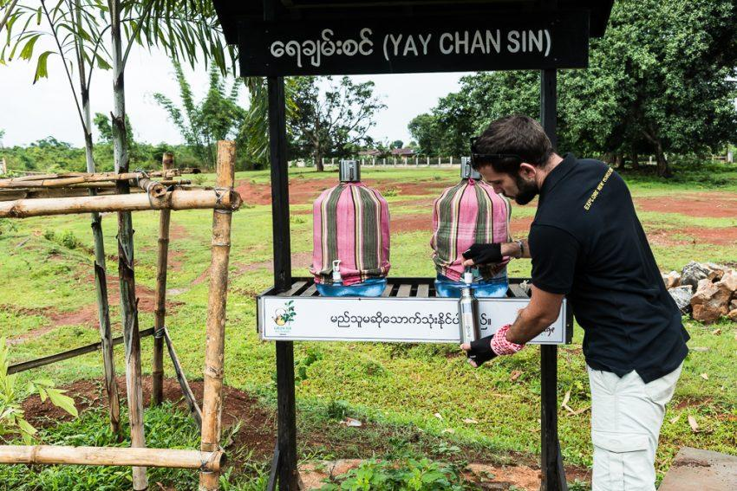
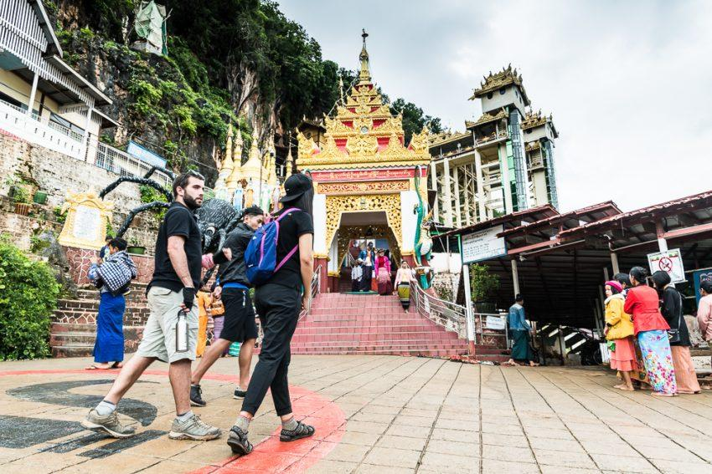
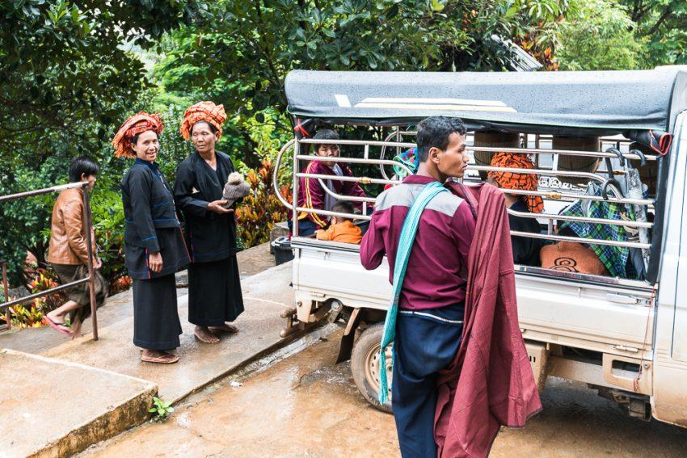
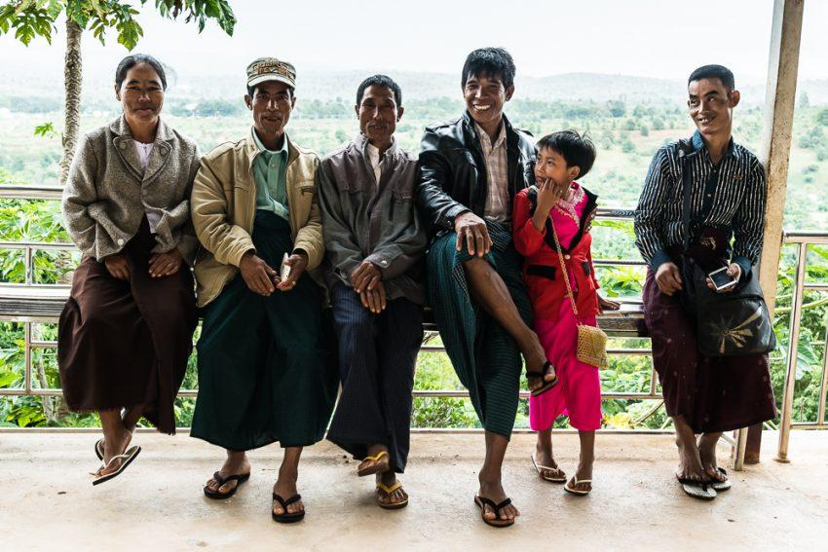
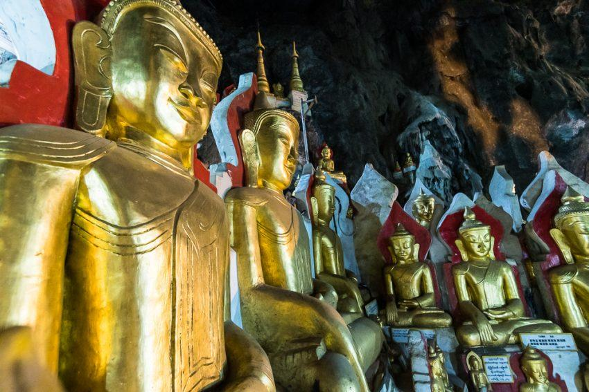
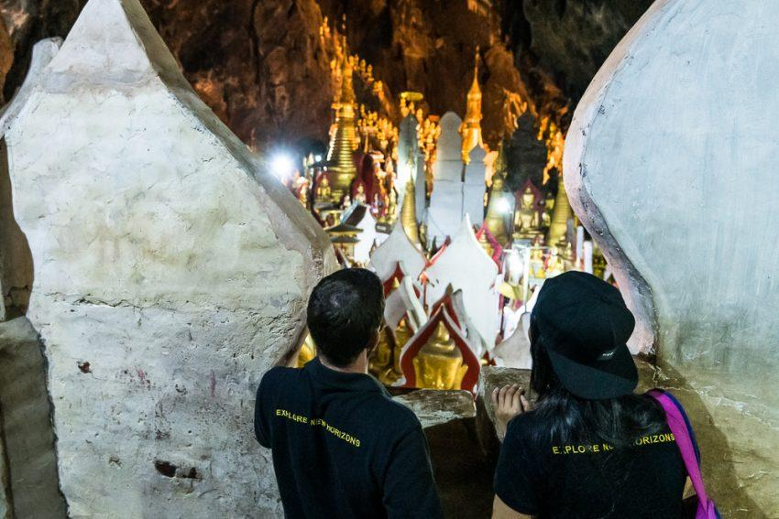
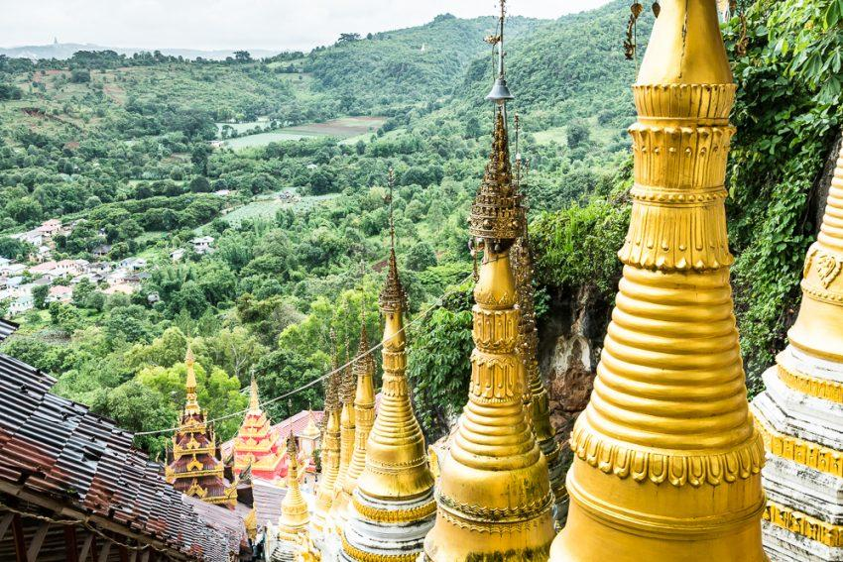
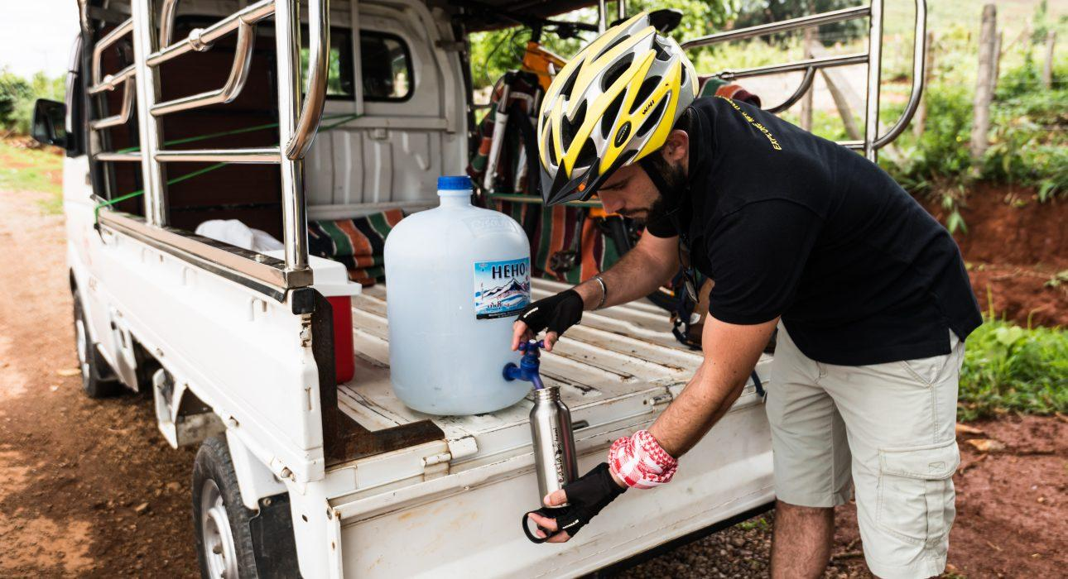
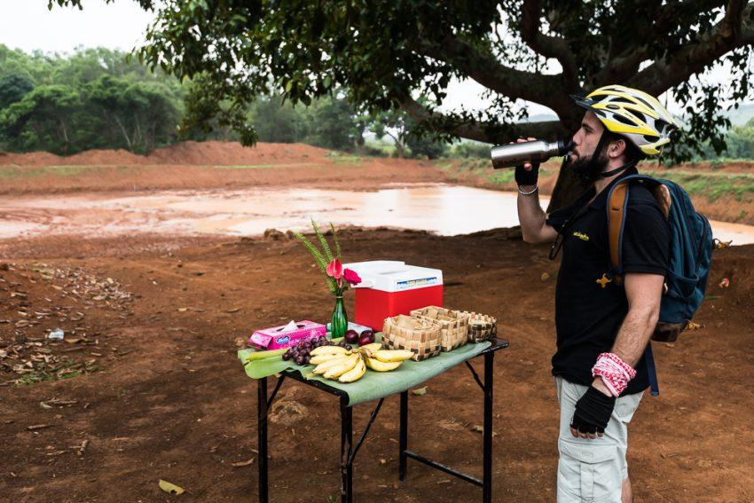
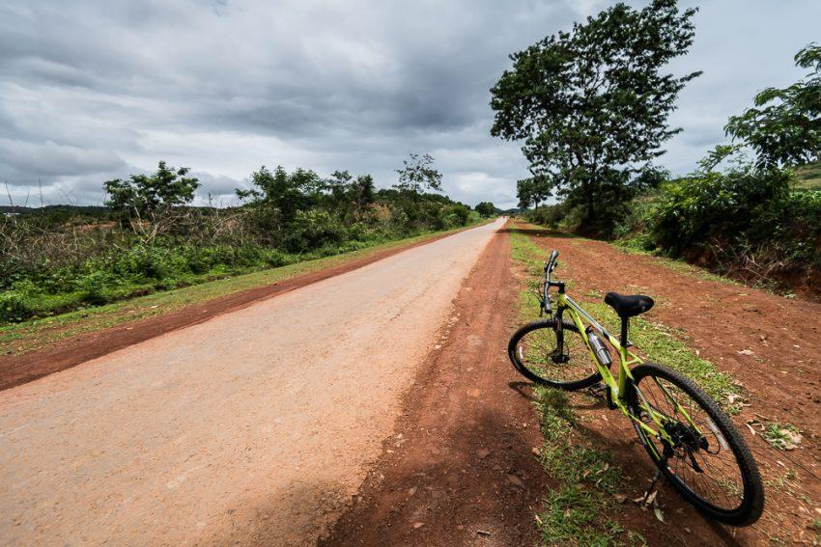
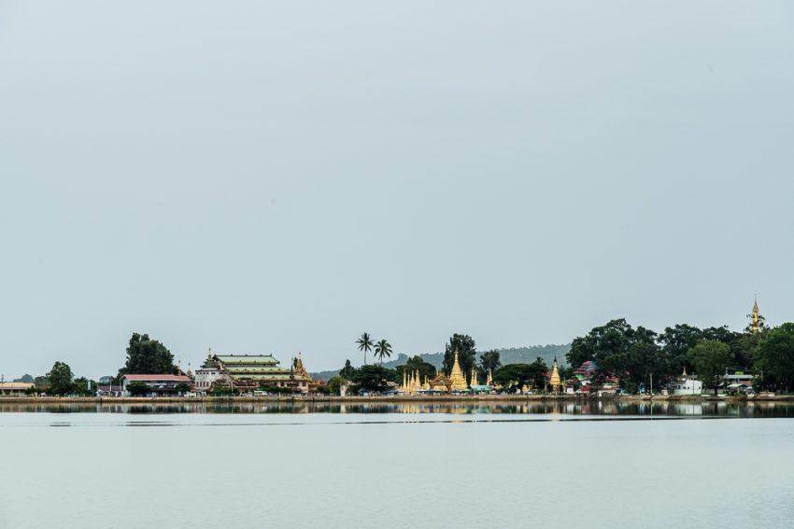
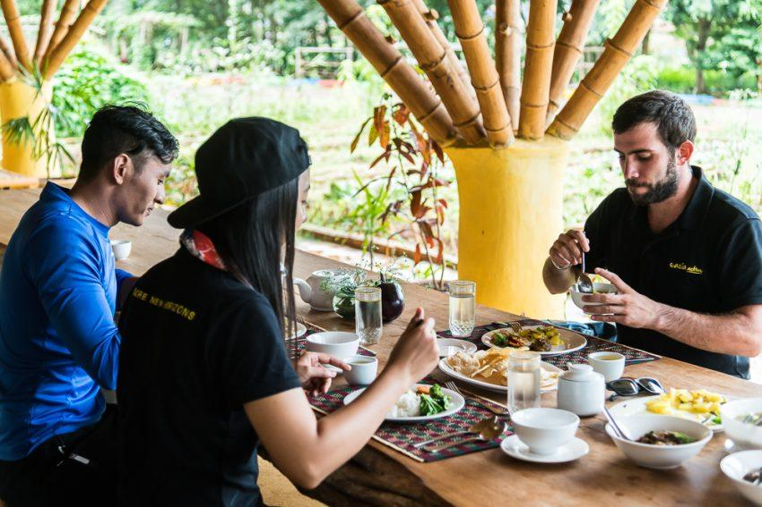

Easia Travel Head Office

Vietnam Head OfficeC/o: ATS Hotel, Suite 326 &327, 33B Pham Ngu Lao Street, Hanoi, VietnamTel: +84 24-39 33 13 62www.easia-travel.com

