LAOS – Muang Ngoi – Hike to Ban Na Village

Over View

Theme
Classic

Country - City
Laos - Muang Ngoi

Market segment
Groups, Thematic Leisure

Price Level
$

Level of difficulties
LEVEL 0

Max pax
10

Seasonality
October to June

Arrival city
Muang Ngoi

Departure city
Muang Ngoi

Description

This easy walk starts directly in Muang Ngoi village. After the first 30 minutes of hiking, a stop at Tam Khang Cave, a former sheltering cave for local villagers during Indochina war (1960-1972), will be the occasion to learn about Lao history or to refresh in the waters nearby. The hike will continue through a lush vegetation and crossing rice paddies to reach the charming village of Ban Na, after around 1 hour walk. The traditional community life revolves around the local handicrafts and the rice cultivation. After enjoying the view of the rice fields and the surrounding hills from a small terrace, the trail heading back to Muang Ngoi will reveal further beautiful natural landscapes.Duration of the walk to Ban Na village: 5 kilometers – around 2 hours one wayLevel: 0

Selling points

- Ideal for nature lovers to discover the landscapes of mountains and rice paddies
- A great insight into a remote village of Laos and the local handicrafts
- An easy active hike in the North Laos suitable for family
- Easia Signature activity

Time And Transportation

Photos

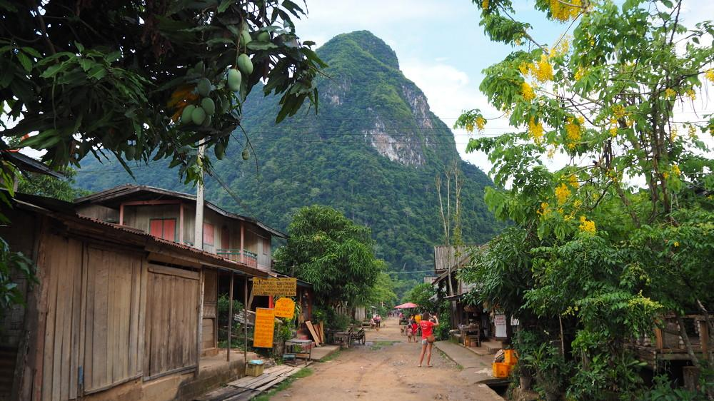
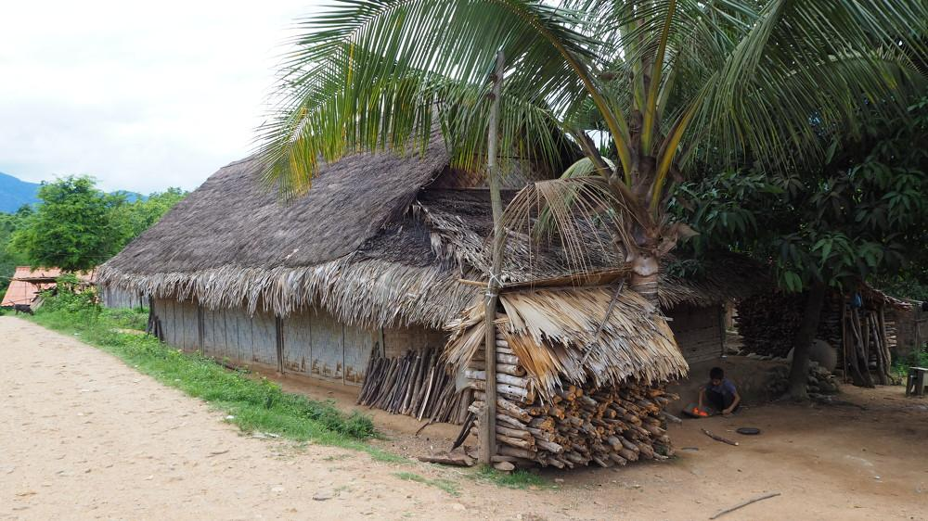
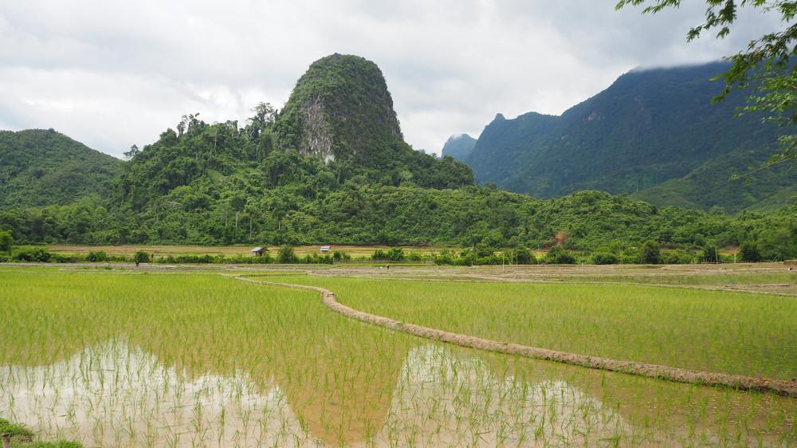

Easia Travel Head Office

Vietnam Head Office4th Floor – ATS hotel, 33B Pham Ngu Lao Street, Hoan Kiem District, Hanoi.T: +84 24-39 33 13 62 (ext. 251)

