CAMBODIA – Siem Reap – Angkor Complex – Angkor Thom to Srah Srang by Bicycle
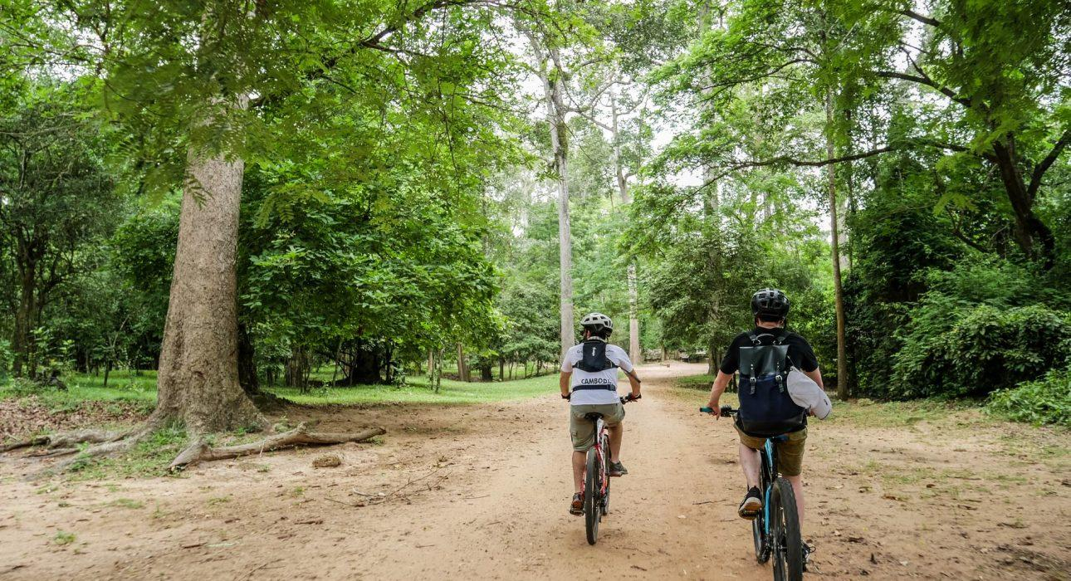

Over View

Theme
Art & Culture, Classic, Family, Sustainable

Country - City
Cambodia - Siem Reap

Market segment
Thematic Leisure

Price Level
$$

Level of difficulties
LEVEL 1

Max pax
20

Seasonality
All year long. Best period from November to March and from July to August.

Arrival city
Siem Reap

Departure city
Siem Reap

Description

The tour gives the opportunity to experience the amazing Angkor Archaeological Park by bicycle, riding along small, hidden jungle trails discovering some of the main temple sites at their own pace. It is designed for all type of travelers, from beginner to experienced cyclists, allowing to visit the park in a much slower way and to enjoy nature, interact with local people, and learn about the Angkor Empire. This half-day tour extends to a pleasant 20-kilometer, off-road trail, starting near the South Gate of Angkor Thom, and ending with a lunch at Srah Srang, an ancient water reservoir. While cycling, travelers will visit some of the main site of the park, such as Angkor Thom, the Ancient Great Khmer Capital, Bayon Temple the most beautifully designed temple, Ta Phrom Temple, so called “Tomb Raider temple,” and finally ending at the Srah Srang reservoir for lunch.Distance and duration of the cycling: 20 kilometers – 2 hours (half-day activity, including temple visits)Level: 1Net elevation gain: less than 150 metersTerrain: mostly narrow jungle off road trails, with some part on the cycling paved roadTransportation: Full day vehicle support : 10 kilometers – 30 minutes (From hotel to Starting Point) – 10 Kilometers -30minutes (Ending point to Hotel)Note: Possible to extend the cycling kilometers, adding a visit to Angkor Wat in the early morning or afternoon.

Can be combined with
Thematic Leisure
- Siem Reap – “Phare, The Cambodian Circus” Show in Siem Reap
- Siem Reap – Exclusive lunch in a private house at Srah Srang

Selling points

- To moderate cycling tour, adaptable to all type of travelers in a reasonable physical condition
- To offer a slow and eco-friendly way to visit the most famous Angkorian sites: Angkor Thom, Bayon Temple, Ta Phrom, Srah Srang
- To cycle though the forest, ancient Angkorian temples ruins
- To get in contact with local communities
- To Enjoy a lunch near by Srah Srang ancient water reservoir

Time And Transportation

From | To | Km | By | Duration | Road Condition
Hotel | Starting point | 10 | Vehicle | 30 minutes | Good
Ending point | Hotel | 10 | Vehicle | 30 minutes | Good

Photos

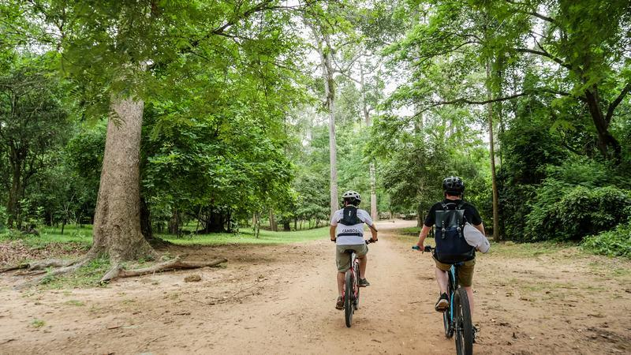
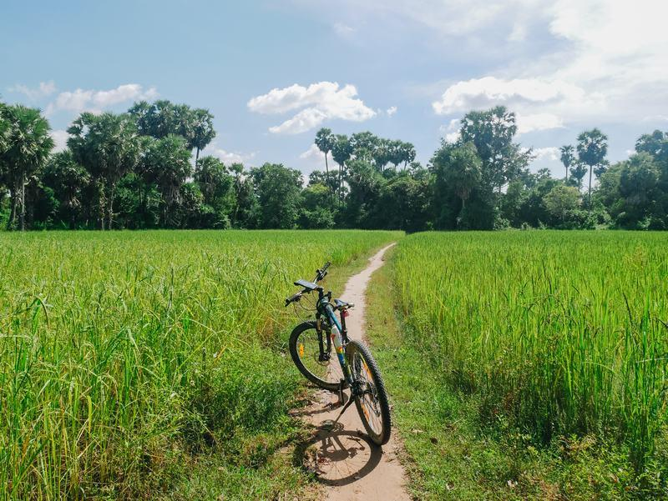
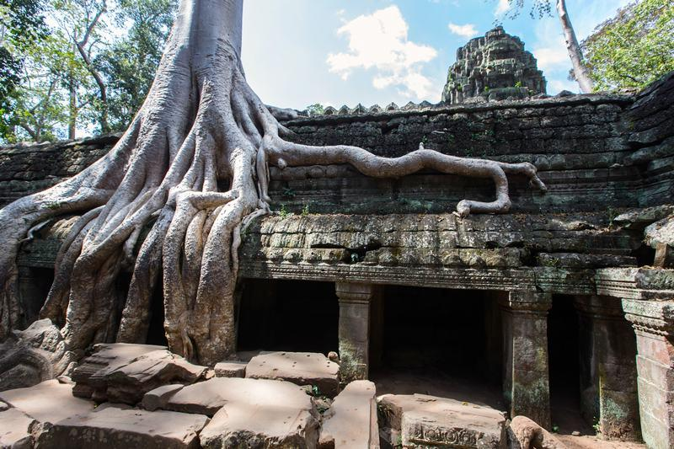
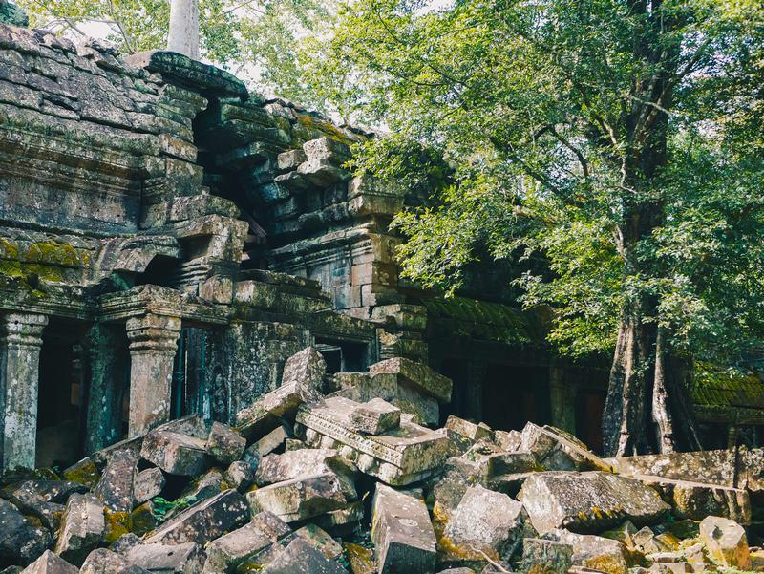
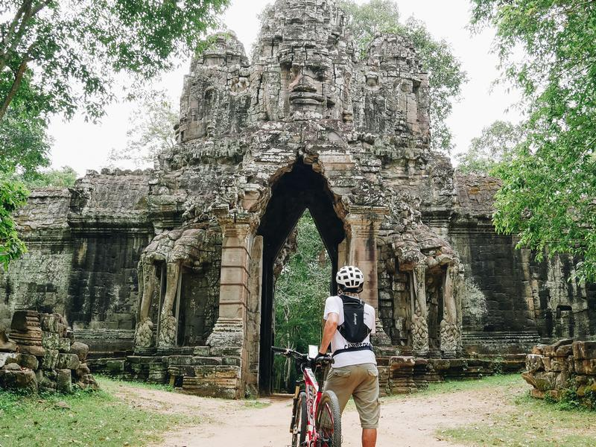
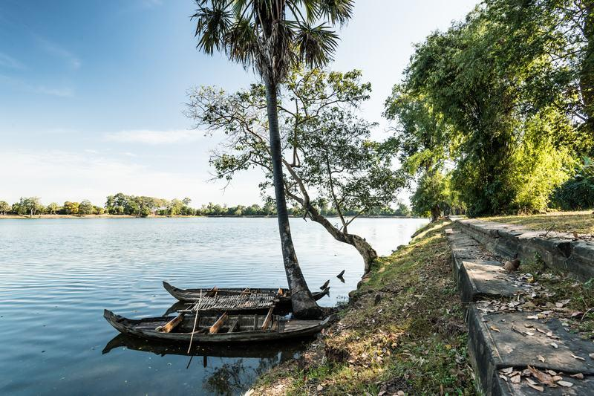
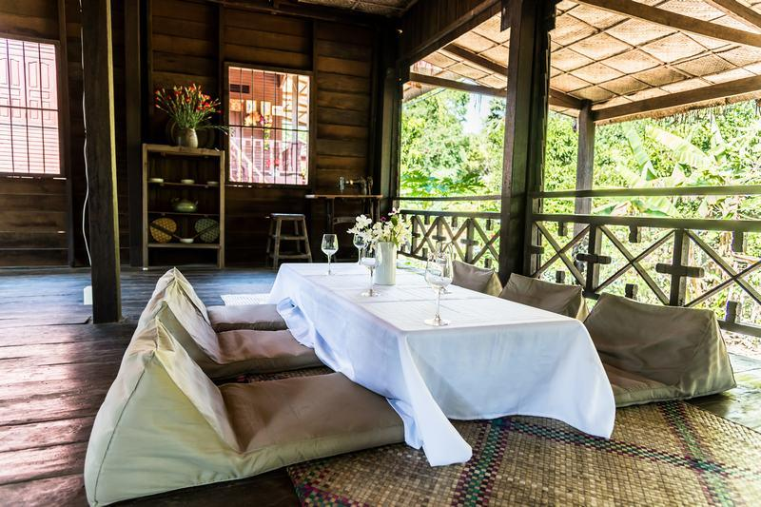

Easia Travel Head Office

Vietnam Head OfficeC/o: ATS Hotel, Suite 326 &327, 33B Pham Ngu Lao Street, Hanoi, VietnamTel: +84 24-39 33 13 62www.easia-travel.com

