LAOS – Luang Prabang – Cycling the Charming Trails of Chompet
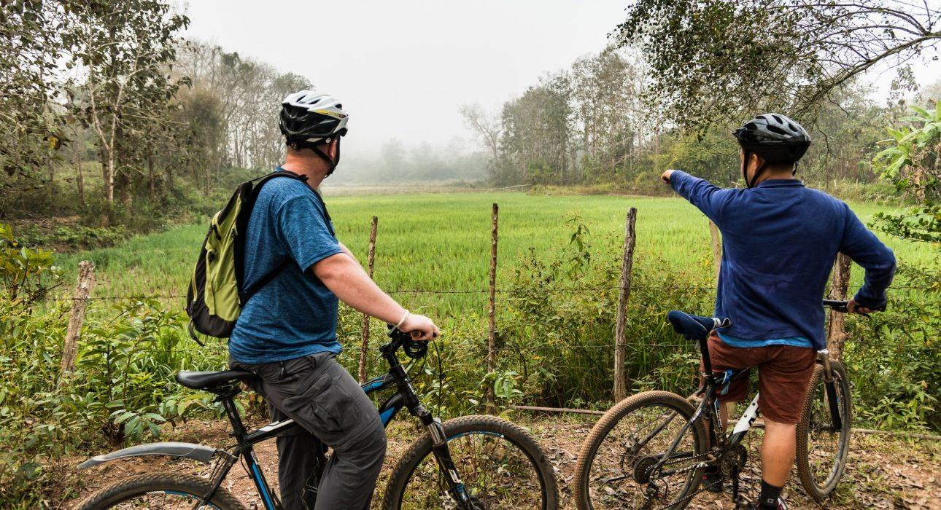

Over View

Theme
Sustainable

Country - City
Laos - Luang Prabang

Price Level
$$$

Level of difficulties
LEVEL 2

Max pax
15

Seasonality
October to June

Arrival city
Luang Prabang

Departure city
Luang Prabang

Description

A unique half-day mountain bike excursion into one of the rarely visited rural areas of Chompet District. The journey begins with a Mekong River crossing before reaching a bustling village. The decent road here is great for warming up before the dirt tracks that wind their way through small settlements and farms. This leg of the journey takes travelers towards Ban Na and Ban Som-idyllic Lao Loum villages nestled amongst rice paddies. After taking a refreshment stop in Ban Som, the journey continues along varied terrain and across a small river before joining a single-track trail used by local residents and children to travel to their farms and school. After leaving the single-track trail, the path continues through several smaller villages before travelers take the bridge back into the UNESCO protected area of the city that hugs the Mekong Riverbank. A visit to Wat Had Siaw, one of the only temples in Luang Prabang to have a Meditation corridor, and to Wat Chompet, a hilltop temple built in 1888 and boasting one of the best views overlooking Luang Prabang, are the final stops of the day.Level:2Distance and duration of cycling: approximately 26 kilometers – 3 hours cyclingTotal elevation gain: 0 meters (+316.5 / -316.5 meters)Terrain: A mix of single-track dirt trails and dirt roads road and jungle trails / undulating with some short but steep uphill sectionsTransportation: 10 minutes to the boat pier

Can be combined with
Thematic Leisure
- LAOS – Luang Prabang – Baci Ceremony at a Local House

Selling points

- For FIT active clients, or leisure travelers that want to see somewhere other tourists rarely go.
- Exploring local life while enjoying beautiful scenery.
- An active off-road cycling excursion.
- Perfect for those who want to get away from the hustle and bustle of the popular tourist areas in the city.
- A route along single-track trails and dirt roads, through scenic farmland, quaint villages, and jungle forest.

Sustainability

Level Of The Excursion
Medium – This activity offers tangible positive contributions to the local community, culture and/or environment

The Impact Of This Excursion

Social/cultural Impact
Community welfare and health

Economic Impact
Local individual benefits, Community benefits

Time And Transportation

From | To | Km | By | Duration | Road condition
Night Market | Boat pier | 1 | Walking | 5 minutes | Good

Photos

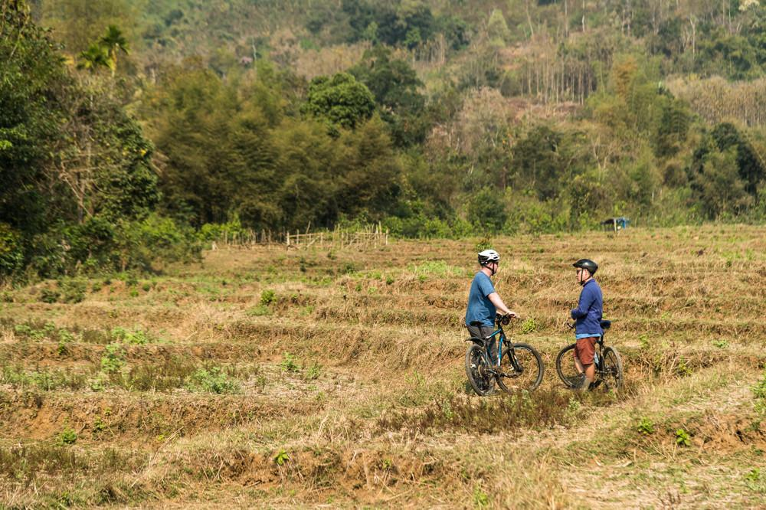
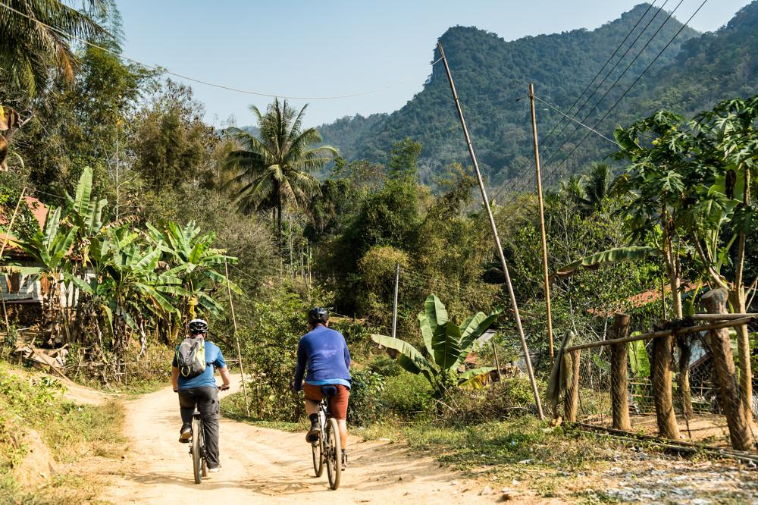
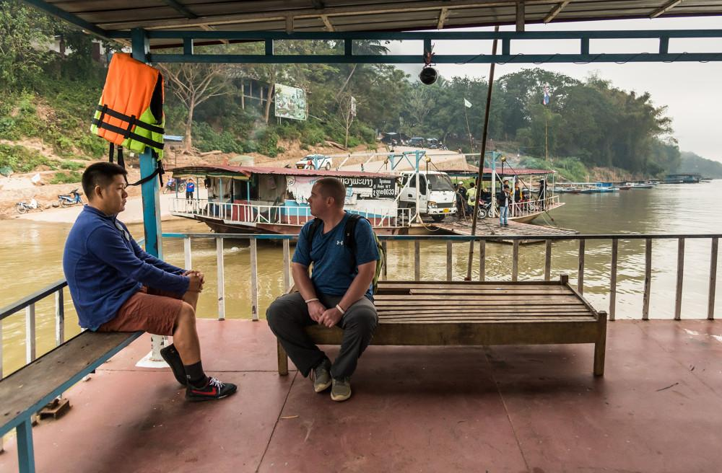
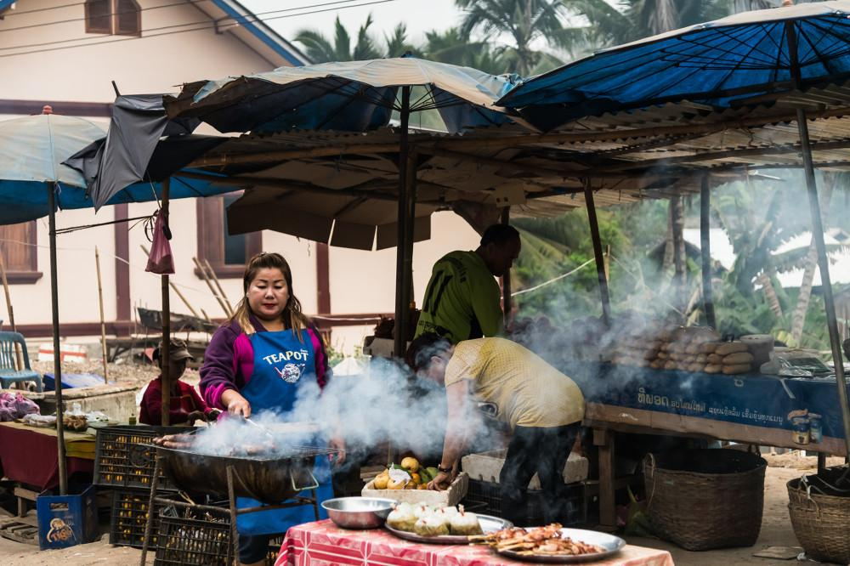
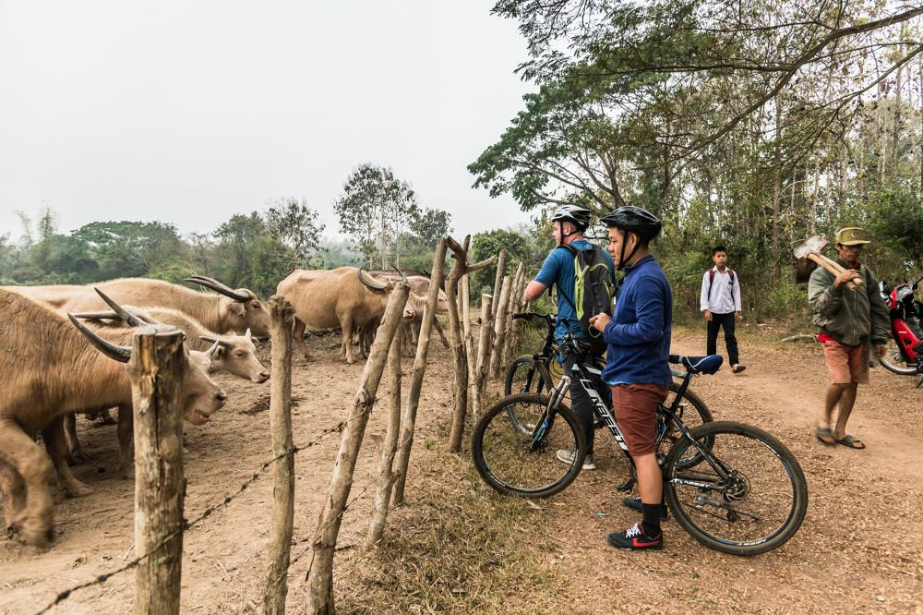
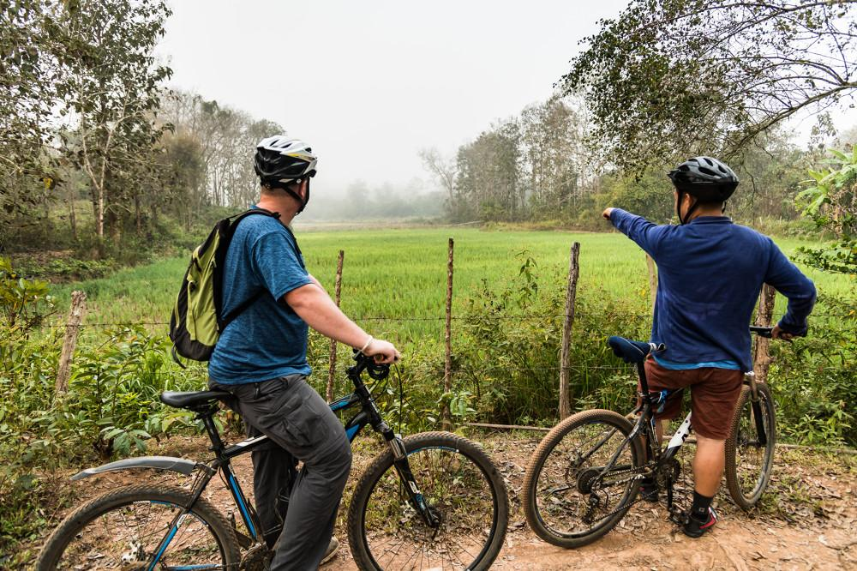
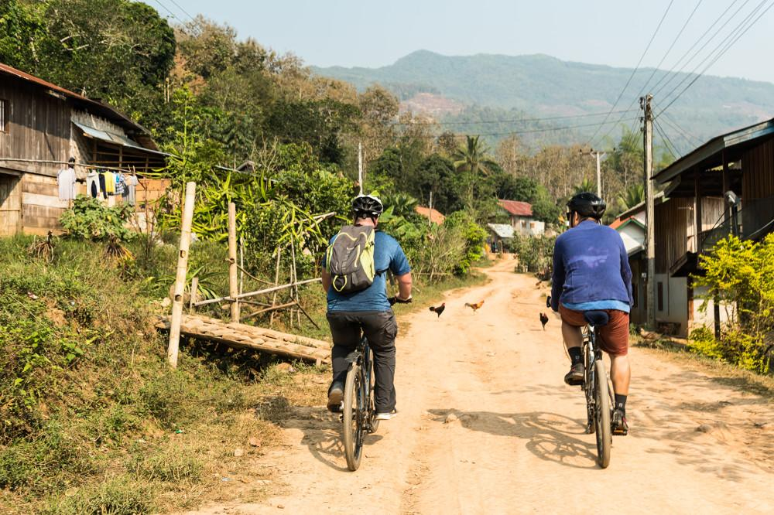

Easia Travel Head Office

Vietnam Head OfficeC/o: ATS Hotel, Suite 326 &327, 33B Pham Ngu Lao Street, Hanoi, VietnamTel: +84 24-39 33 13 62www.easia-travel.com

