CAMBODIA – Mondulkiri – Jungle Hike in Mondulkiri
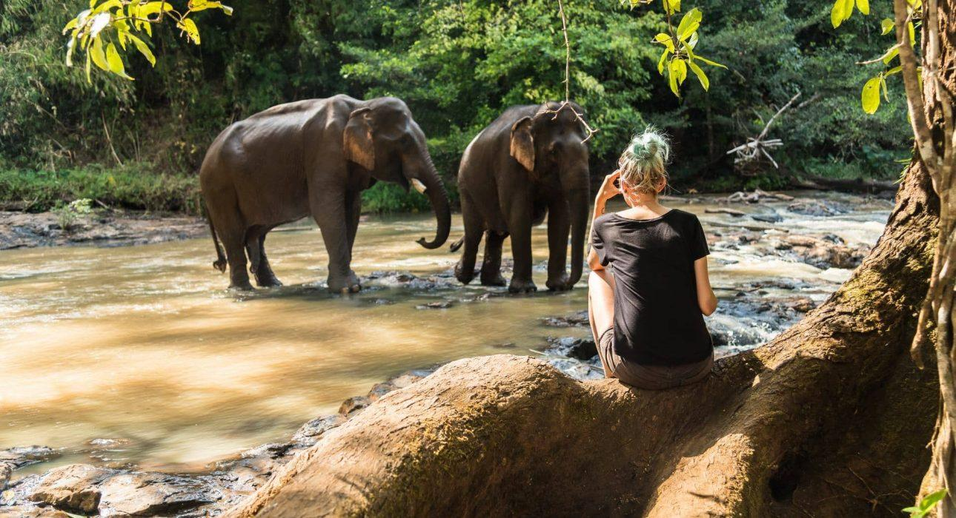

Over View

Theme
Family, Sustainable

Country - City
Cambodia

Price Level
$$

Level of difficulties
LEVEL 2

Max pax
20

Seasonality
Best period from November to March. April & May hottest season, and June, July occasional rainfall

Arrival city
Sen Monorom

Departure city
Sen Monorom

Description

This tour is designed to allow travelers the chance to experience Mondulkiri’s jungle and learn about ethnic Cambodian minorities in an interactive way.Travelers begin their hike from a Bunong village, a well-known ethnic minority in the northeastern region of Cambodia’s highlands. While at the village, travelers can learn about the tribe’s culture and, if available, visit one of the traditional houses. After this introduction, travelers climb a small hill with a view of the surroundings before immersing themselves in the forest. The hike is characterized by different types of trails, with some gentle uphill and downhill parts, crossing a small river and visiting waterfalls surrounded by the nature.Around noon, travelers stop in a quite place in the forest, and the local Bunong villagers cook lunch using traditional cooking techniques. After a relaxing lunch, the hike continues until reaching the village the tour started at before then traveling back to the hotel.Distance & duration of hiking: 16 kilometers – 4 hours (full-day including the visits)Level: 2Net elevation gain: + 300 meters Terrain: mainly jungle trails, through forestTransportation: Full-day vehicle support / 15 kilometers – 30 minutes – (From Hotel to starting point) / 15 kilometers – 30 minutes – (From ending point to hotel)

Selling points

- Visit a Bunong village and learn about ethnic minority in the North-eastern region of Cambodia
- Hike in the Mondulkiri forest on a 16 kilometers trail
- Visit exotic waterfalls and learn about Cambodian flora and fauna
- Enjoy a local lunch cooked in the forest

Time And Transportation

Duration: Full-day TourTotal Kilometers of hiking: 16 kilometersTotal kilometers transfer: 30 kilometers
From | To | Km | By | Duration | Road condition
Hotel | Starting point | 15 kilometers | Car/Van | 30 Minutes | Good
Ending point | Hotel | 15 kilometers | Car/Van | 30 Minutes | Good

Photos

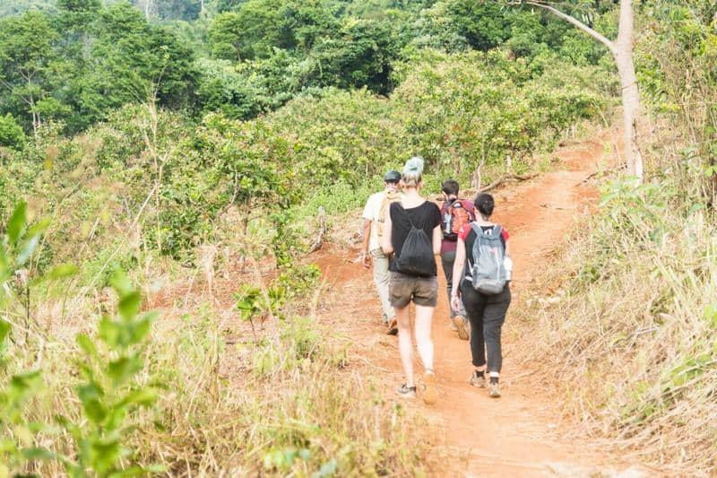
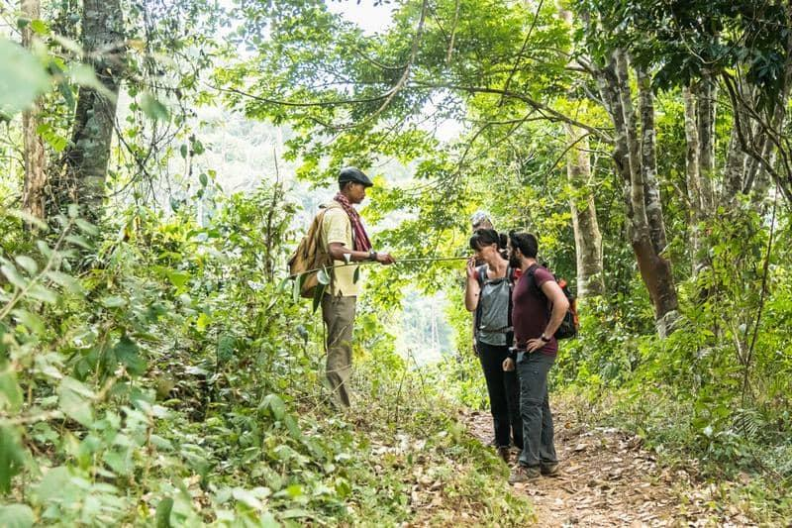
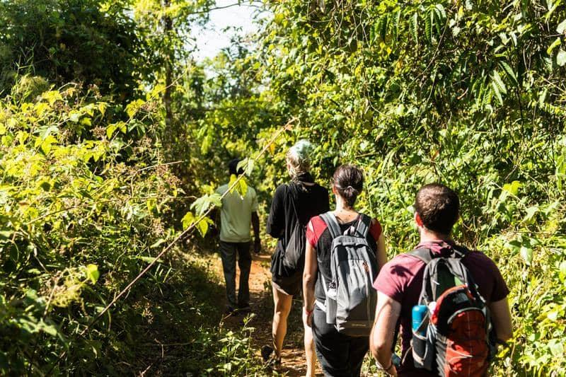
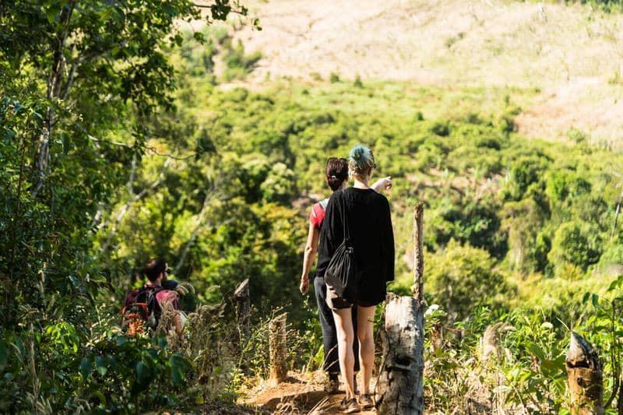
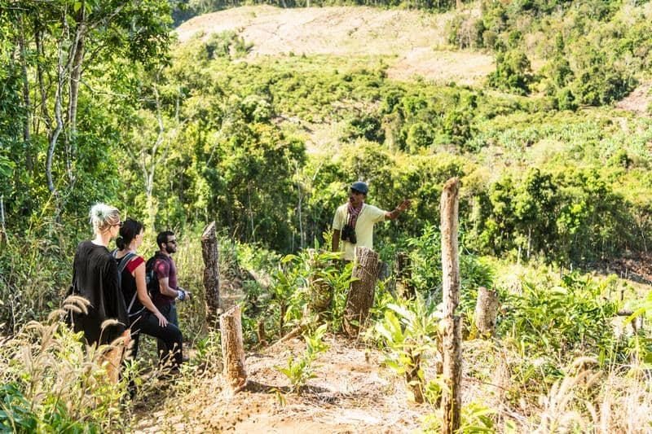
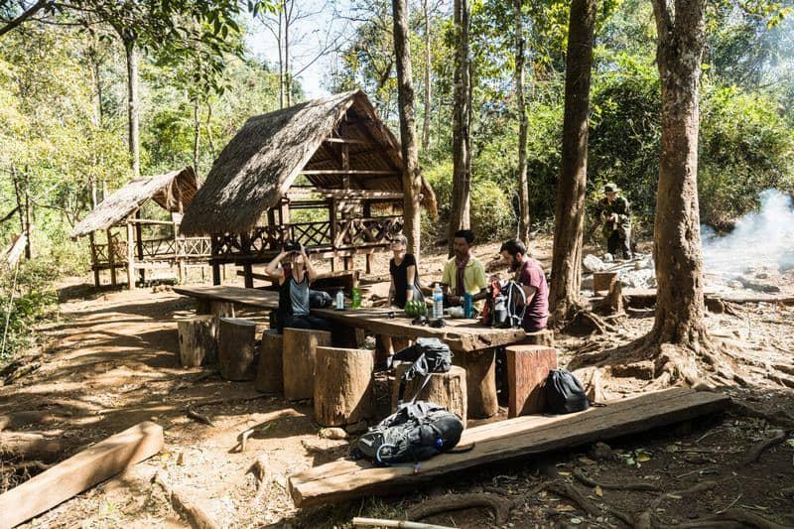
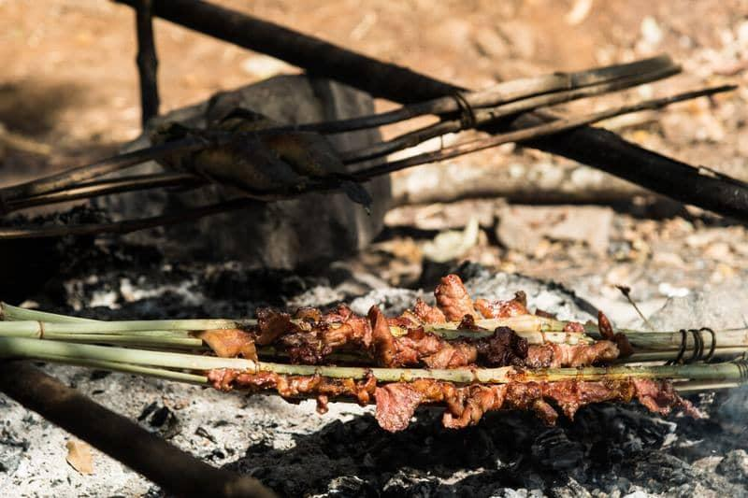
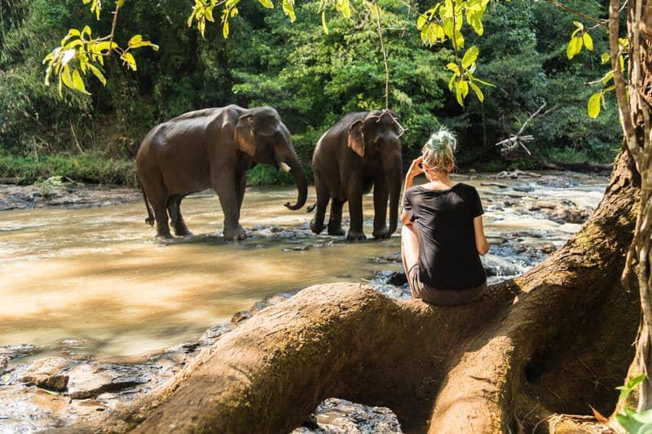

Easia Travel Head Office

