VIETNAM – Hanoi – Meet Vietnamese Contemporary Art
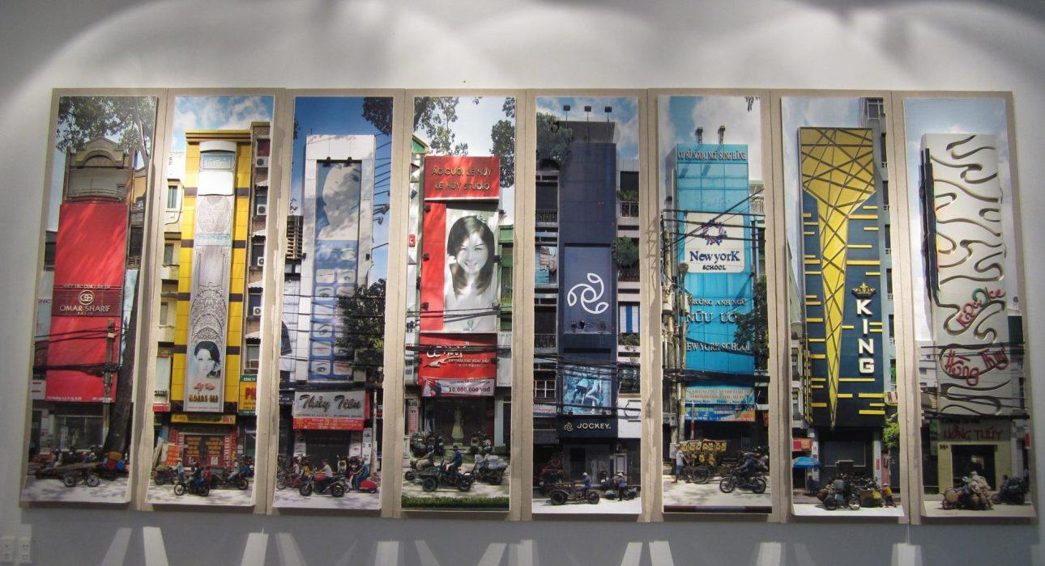

Over View

Theme
Art & Culture, Classic, Family, Honeymoon

Country - City
Vietnam - Hanoi

Market segment
Thematic Leisure

Price Level
$$$

Max pax
15

Seasonality
All year

Arrival city
Hanoi

Departure city
Hanoi

Description

Meet with one of the leading contemporary artists in Hanoi to discover his story about his style & philosophy of art to gain an understanding of the evolving position of contemporary art in Vietnam.

Can be combined with
Thematic Leisure
- Hanoi – Hands-on Vietnamese cooking class in Hanoi
- Hanoi – Visit and meet with a water-puppet craftsman at his house
- Hanoi – Hanoi through the ages with a Polaroid
- Hanoi – A stroll in Hanoi the old quarter of Hanoi
Exclusive
- Hanoi – Hands-on Vietnamese cooking class in Hanoi

Selling points

- A great chance for art lovers to enjoy Vietnamese contemporary art
- A real opportunity to meet a Vietnamese artist who is famous not only in Vietnam but also Internationally
- A serene opportunity to be surrounded by art

Sustainability

Level Of The Excursion
Medium – This activity offers tangible positive contributions to the local community, culture and/or environment

The Impact Of This Excursion

Social/cultural Impact
Cultural Conservation

Economic Impact
Local individual benefits

Additional Information
Positive Impact:This activity provides income directly to local artists.

Time And Transportation

From | To | Km | By | Duration | Road Condition
Metropole | Manzi Art Space | 3.5 | Car | 15 minutes | Good
Metropole | Artist’s place | 5 | Car | 20 minutes | Good

Photos

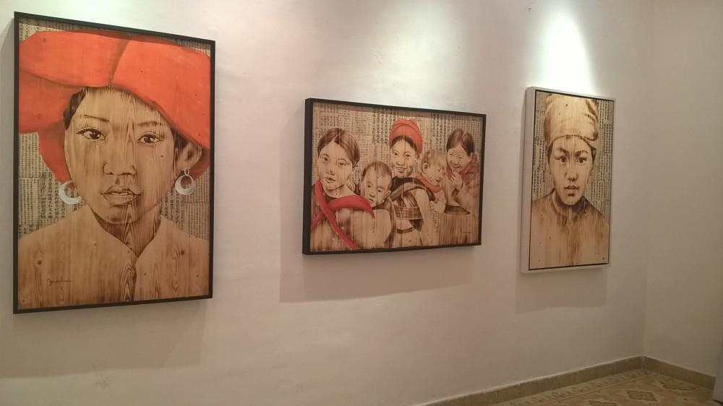
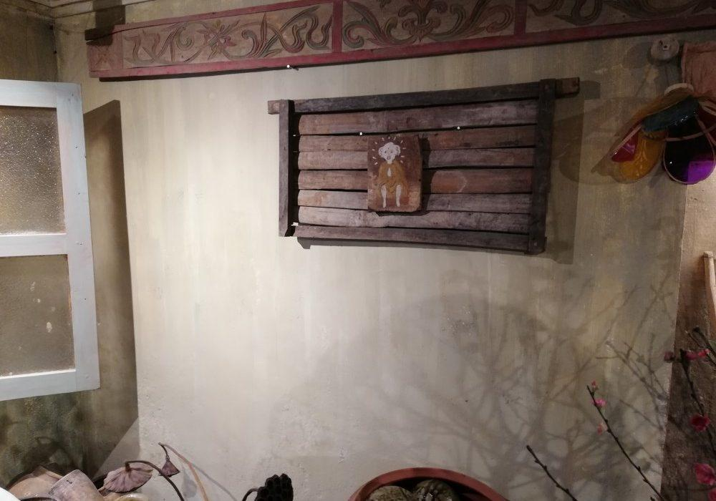
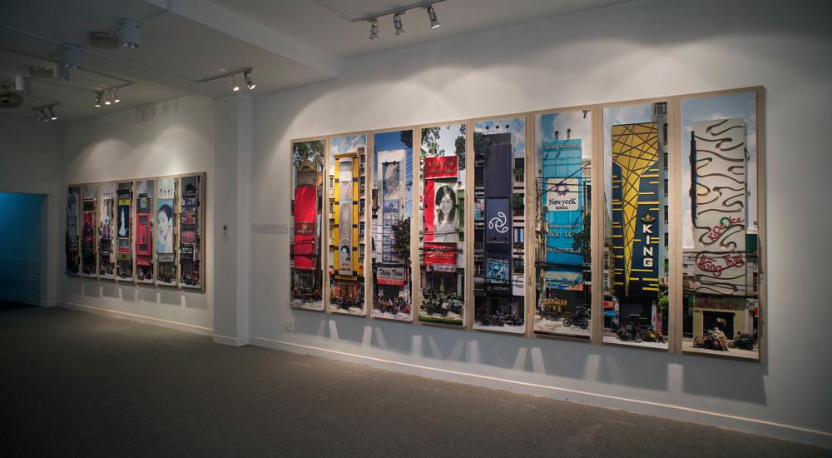
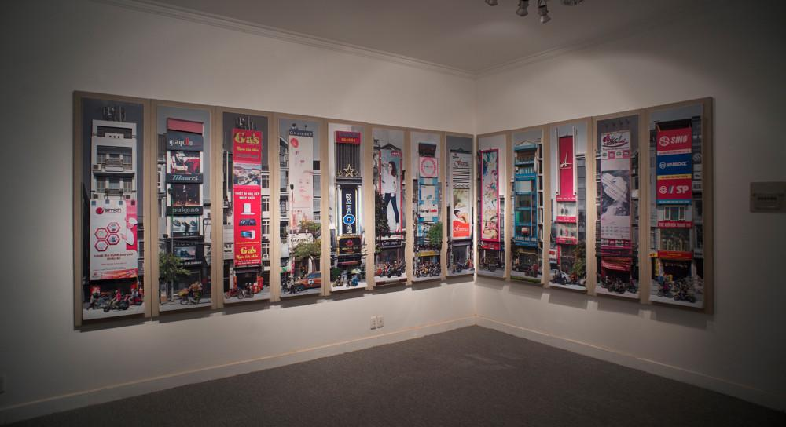
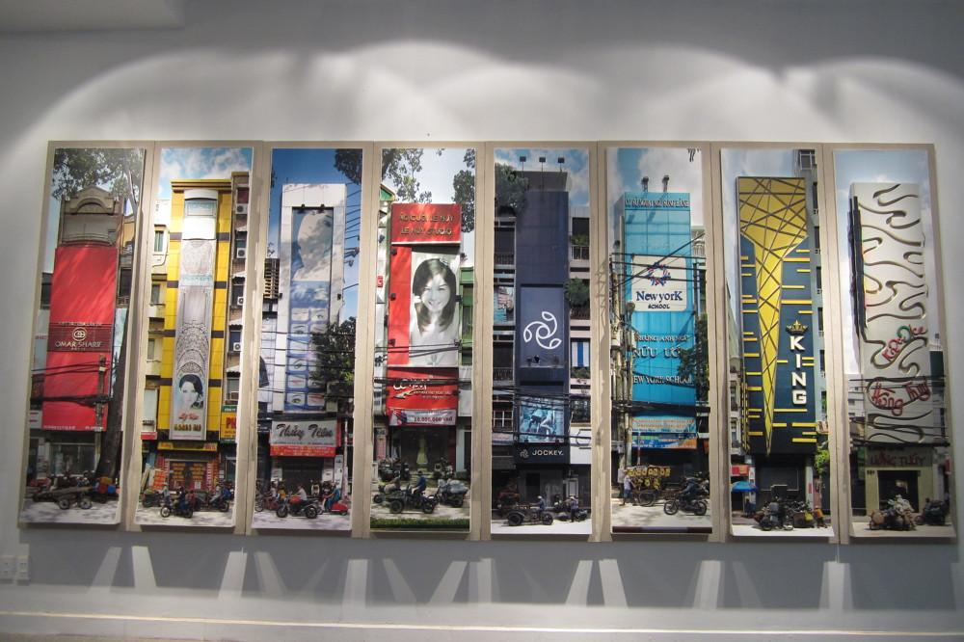
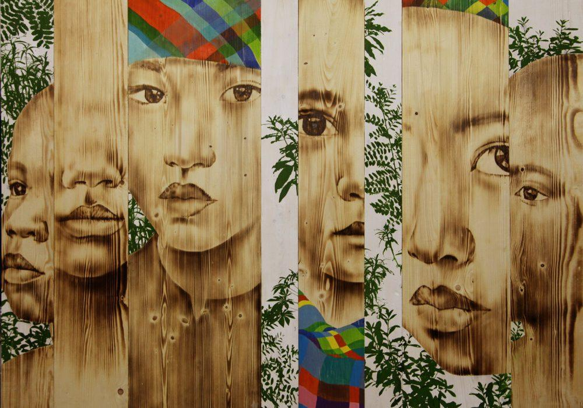

Easia Travel Head Office

Vietnam Head OfficeC/o: ATS Hotel, Suite 326 &327, 33B Pham Ngu Lao Street, Hanoi, VietnamTel: +84 24-39 33 13 62www.easia-travel.com

