LAOS – Luang Prabang – Therapeutic Elephant Trek
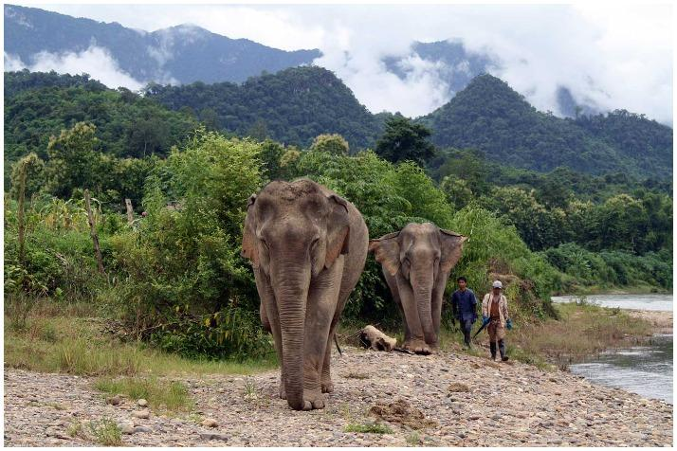

Over View

Theme
Classic, Family, Sustainable

Country - City
Laos - Luang Prabang

Market segment
Thematic Leisure

Price Level
$$$$

Level of difficulties
LEVEL 0

Max pax
8

Seasonality
All Year Round, may be very slippery during rainy season

Arrival city
Luang Prabang

Departure city
Luang Prabang

Description

A visit to MandaLao Elephant Camp on the outskirts of Luang Prabang is guaranteed to make everlasting memories. This amazing place dedicates itself to taking care of these majestic creatures, as well as teaching people about them, in order to further conservation efforts and awareness. The morning begins with an in-depth introduction of elephant behavior and communication, before crossing the river to meet these amazing animals in person. A walk through the lush jungle with the elephants, along a stream, gives travelers the opportunity to spend some quality time with these friendly, curious, and gentle giants. Upon returning back to the camp, a delicious lunch of freshly picked produce will await travelers (with snacks for the elephants too, of course).

Can be combined with
Thematic Leisure
- LAOS – Luang Prabang – Baci Ceremony at a Local House

Selling points

- Suitable for FIT leisure groups looking for a unique wildlife experience around the city.
- No elephant riding-sustainable activity that gives travelers a better understanding of elephants and the challenges they face as a species today.
- Intimate, unique and ethical interactions with free-roaming elephants.
- A half-day morning activity not far from Luang Prabang.
- A chance to enjoy stunning scenery along the Nam Khan River and eat delicious food from the restaurant at the camp.

Sustainability

Level Of The Excursion
Medium – This activity offers tangible positive contributions to the local community, culture and/or environment

The Impact Of This Excursion

Social/cultural Impact
Cultural Conservation, Empowerment and education

Environment Impact
Involving Wildlife

Economic Impact
Local individual benefits, Community benefits

Time And Transportation

From | To | Km | By | Duration | Road condition
Night Market | MandaLao Elephant Camp | 15 kilometers | Car | 25 minutes | Good

Photos

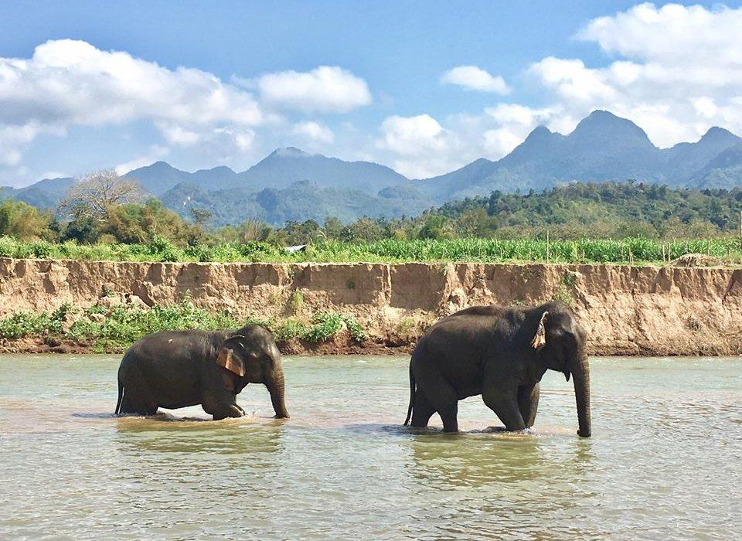
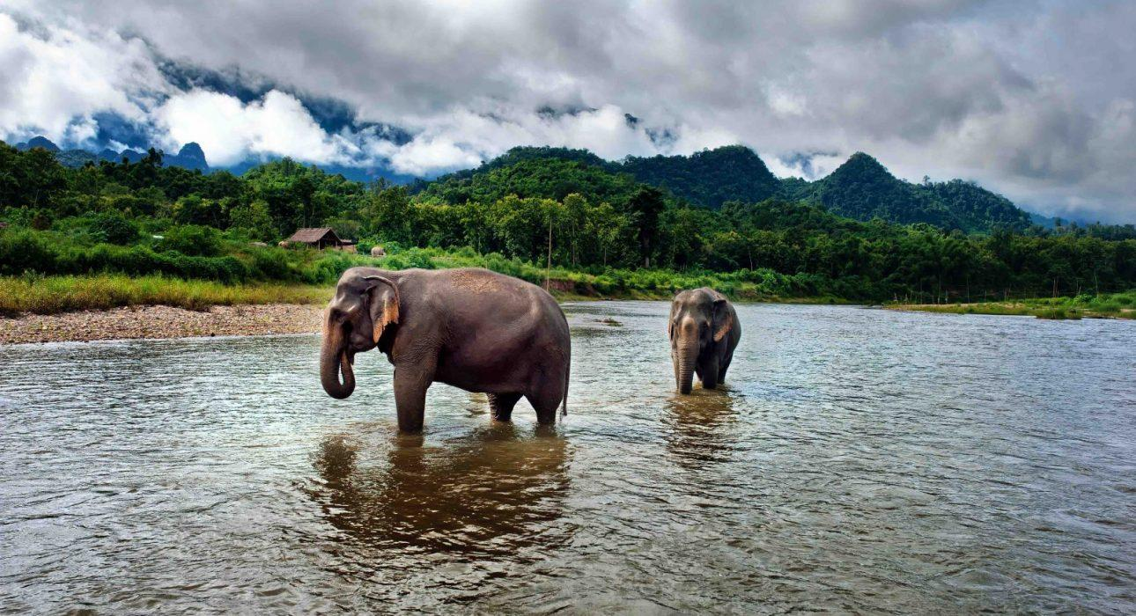
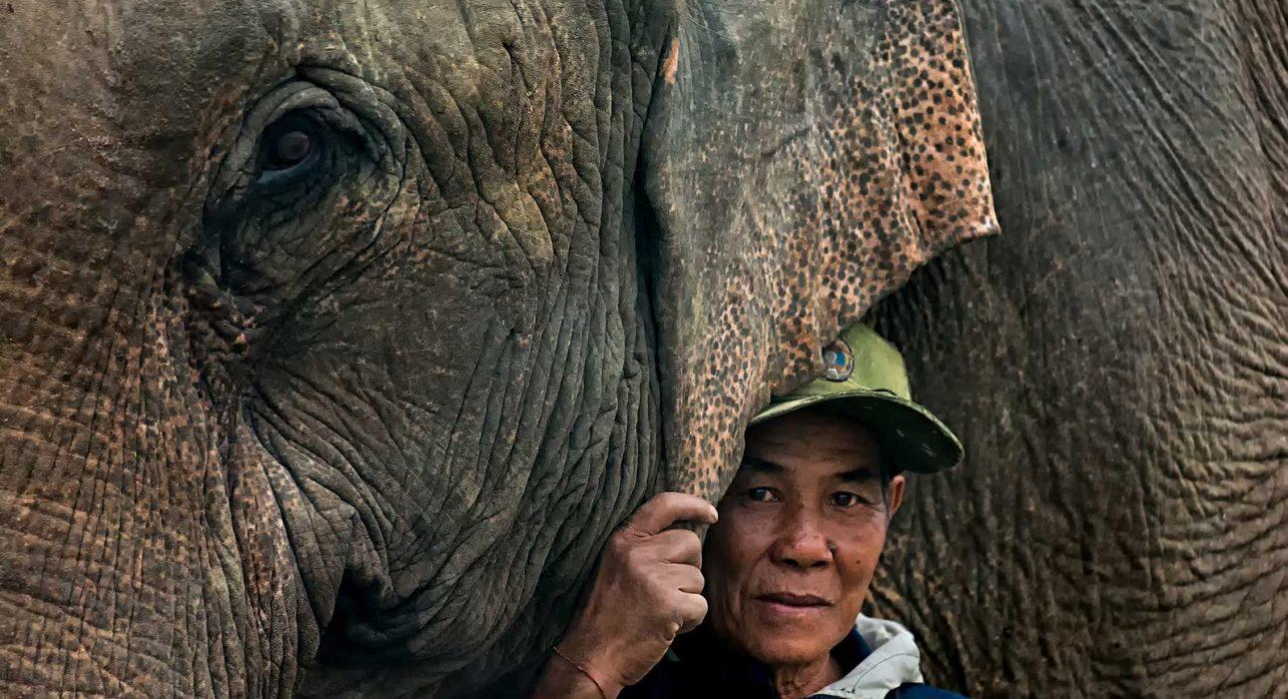
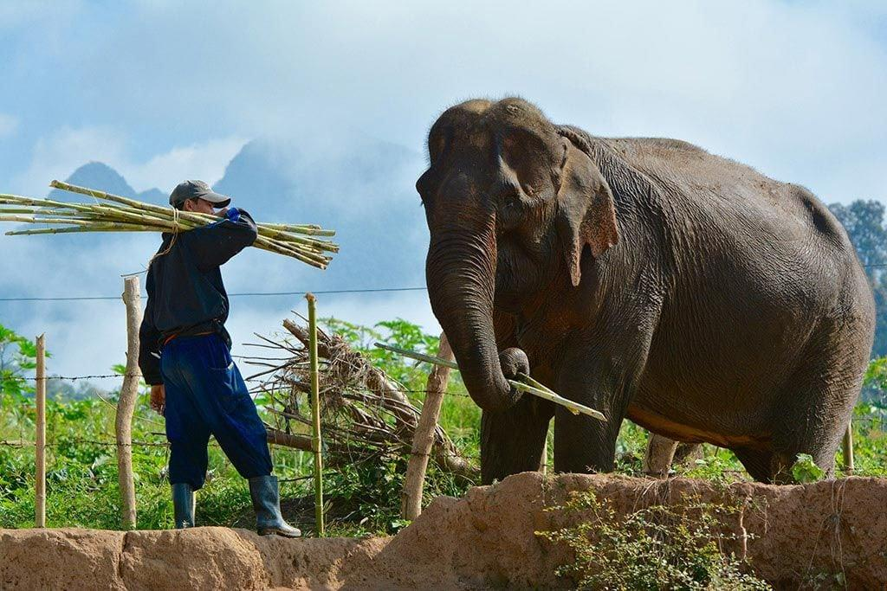
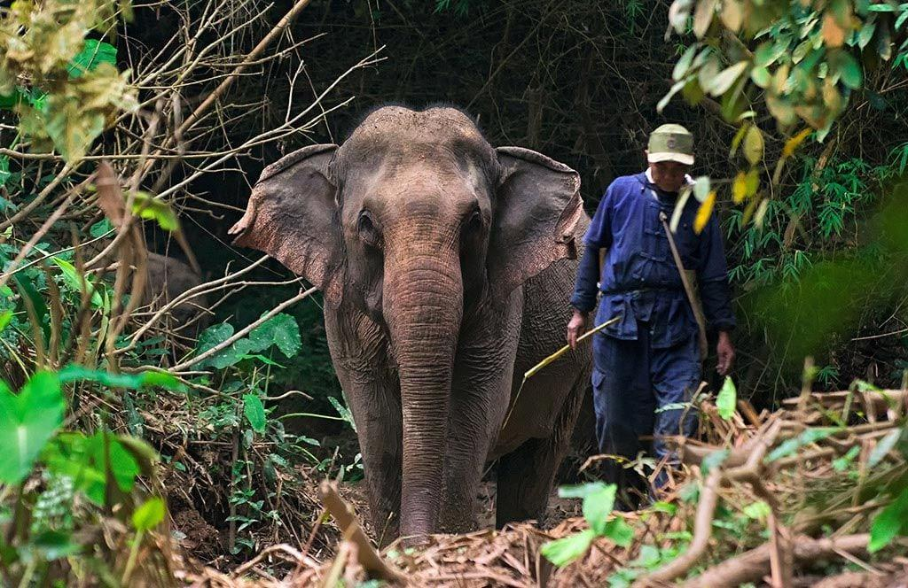
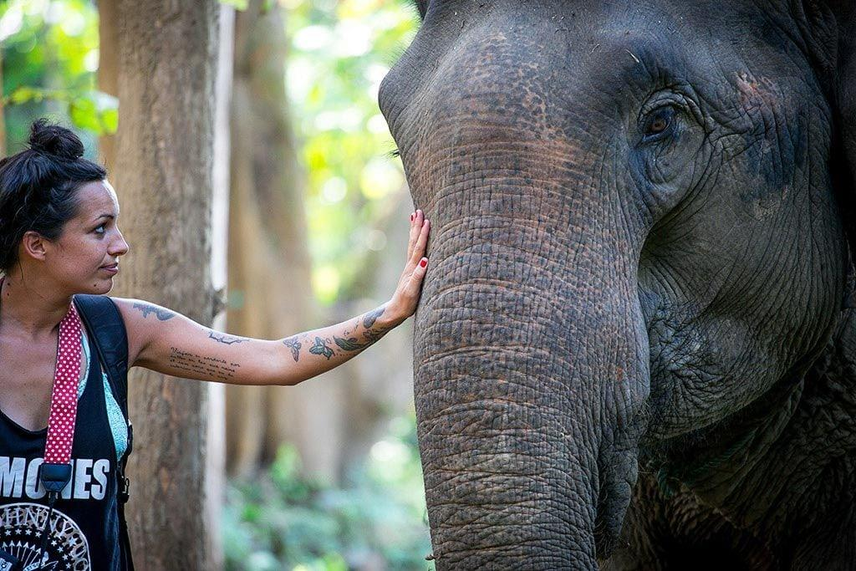
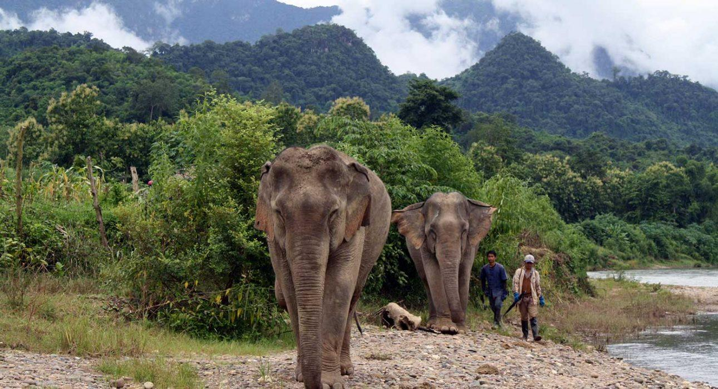

Easia Travel Head Office

Vietnam Head OfficeC/o: ATS Hotel, Suite 326 &327, 33B Pham Ngu Lao Street, Hanoi, VietnamTel: +84 24-39 33 13 62www.easia-travel.com

