CAMBODIA – Siem Reap – A sweet moment with the NGO Bayon Pastry School
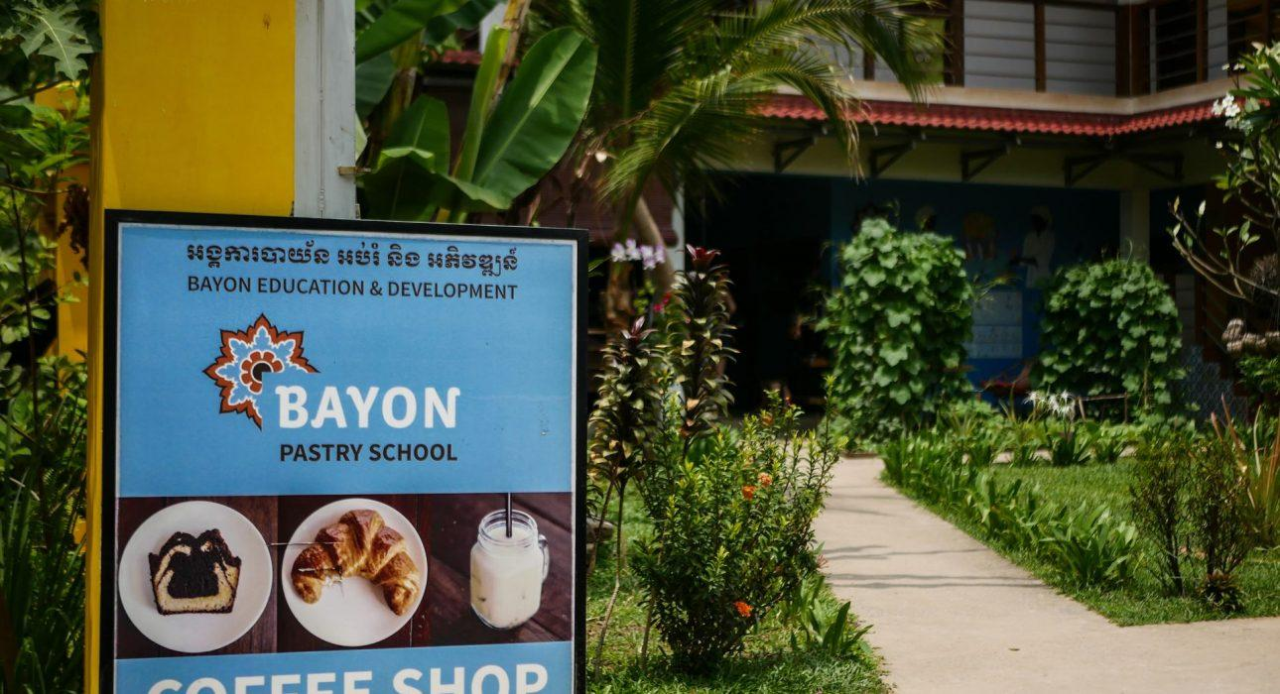

Over View

Theme
Art & Culture, Classic, Family, Gastronomy, Sustainable

Country - City
Cambodia - Siem Reap

Market segment
Groups, Thematic Leisure

Price Level
$$

Level of difficulties
LEVEL 0

Max pax
40

Seasonality
All Year Round

Arrival city
Siem Reap

Departure city
Siem Reap

Description

Located in a peaceful garden in the heart of Siem Reap, Bayon Pastry School NGO, a local, responsible coffee shop, is famous for their cakes and refreshing soft drinks.Those delicacies are concocted by the students of the vocational training school with the aim of providing an education to underprivileged people. Most of the students, after this training, find good jobs and are able to support their families, adding a great sustainable and communal dimension to this simple coffee shop visit.

Can be combined with
Thematic Leisure
- Siem Reap – A moment with the NGO Eco Soap Bank Cambodia
- Siem Reap – Meet Cambodia’s little heroes
Groups
- Siem Reap – A moment with the NGO Eco Soap Bank Cambodia
- Siem Reap – Meet Cambodia’s little heroes

Selling points

- To support the training student of the Pastry School through their NGO
- To learn about the impact of the NGO toward Cambodia
- To offer a way to see things from another perspective and to learn about another side of Cambodia
- To enjoy a delicious pastry break
- To propose an activity which answers the growing demand for sustainable activities.
- To have an activity which follow Childsafe policy, There is no direct interaction with young students

Sustainability

Level Of The Excursion
High – This activity strongly supports local communities and/or helps preserve the culture and environment

The Impact Of This Excursion

Social/cultural Impact
Cultural Conservation, Empowerment and education

Economic Impact
Local individual benefits, Community benefits

Additional Information
Positive impact: Participate to the workshop is a greatly way to support the real impact on the society and to help the disadvantaged youth in a good way.

Time And Transportation

From | To | Km | By | Duration | Road condition
Siem Reap city center | Bayon pastry Shop | 2 | Car | 05 minutes | Normal

Photos

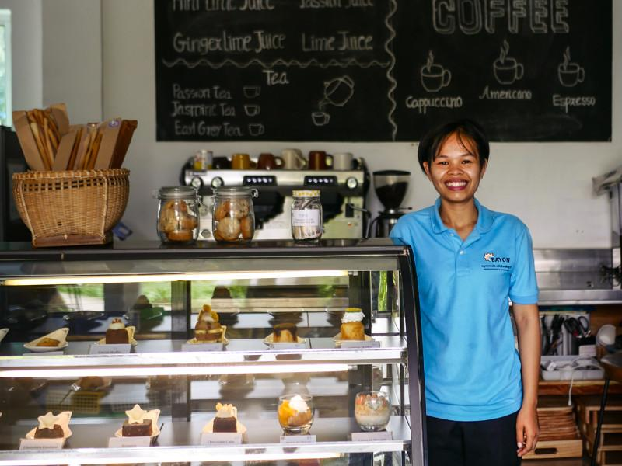
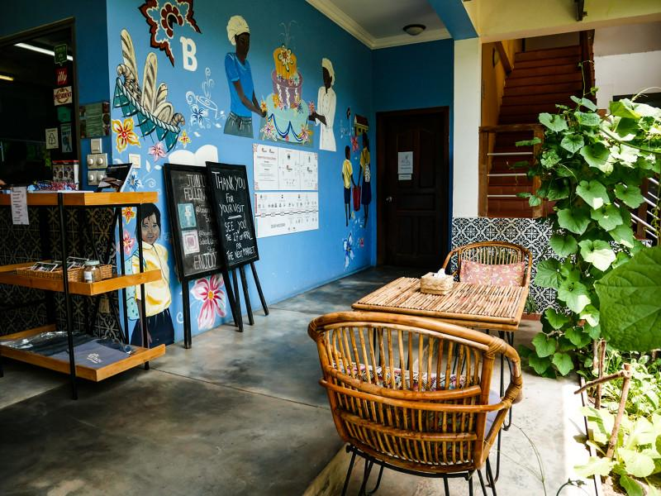
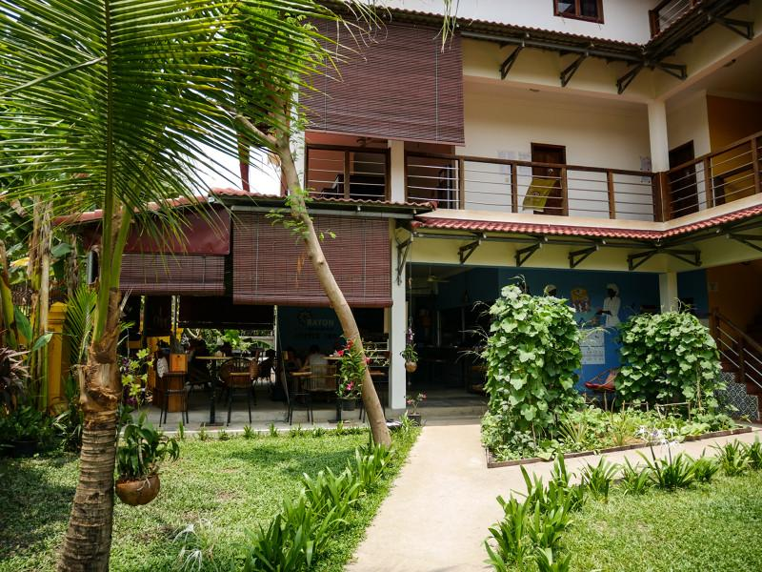
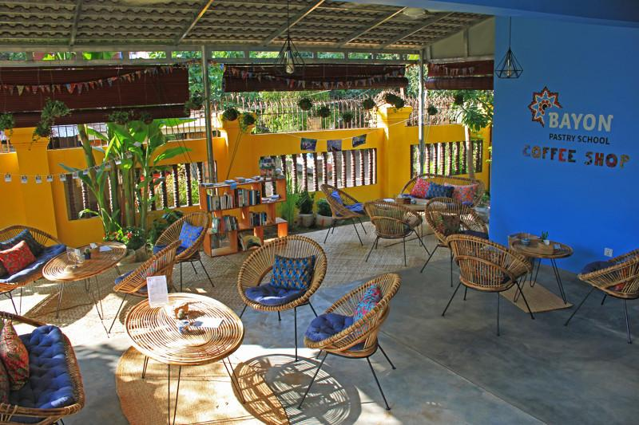
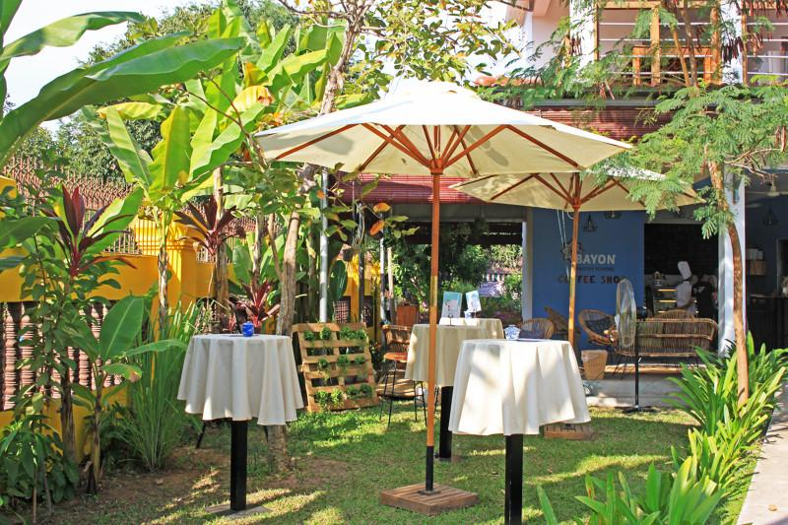
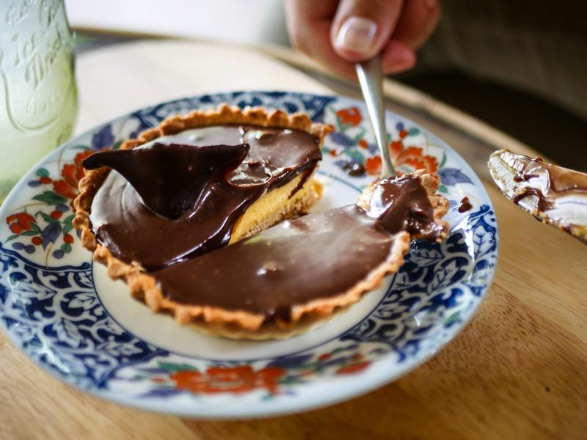

Easia Travel Head Office

Vietnam Head OfficeC/o: ATS Hotel, Suite 326 &327, 33B Pham Ngu Lao Street, Hanoi, VietnamTel: +84 24-39 33 13 62www.easia-travel.com

