CAMBODIA – Ratanakiri – A Venture into Cambodia’s Remote Far East
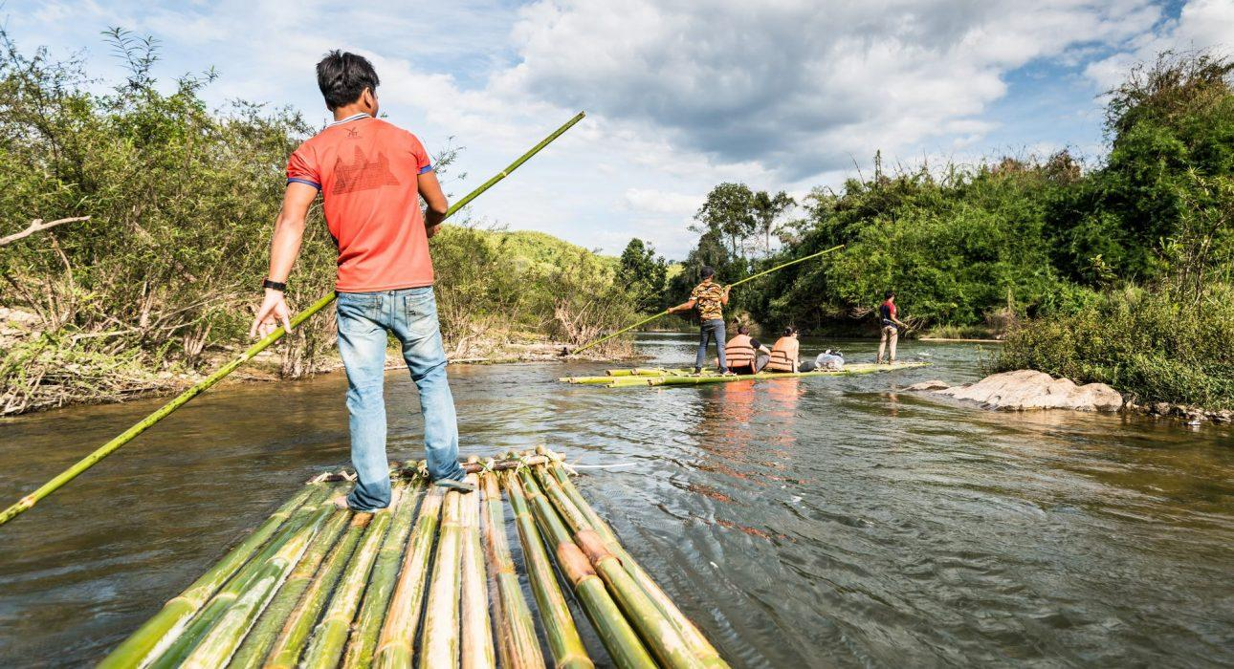

Over View

Theme
Art & Culture, Family, Sustainable

Country - City
Cambodia - Ratanakiri

Price Level
$$$$

Level of difficulties
LEVEL 2

Max pax
20

Seasonality
Best period from November to March. April & May hottest season, and June, July occasional rainfall

Arrival city
Ratanakiri

Departure city
Ratanakiri

Description

The tour offers the opportunity to visit a remote tribal village located in an area outside Ban Lung by using different means of transport, such as a local ferry, a boat, walking, and a motorized tractor known as a Kuyon, traveling through an exciting mix of forest and jungle with opportunity for interaction with the villagers.This full-day private tour is designed for beginner-level and experienced hikers, allowing them the unique experience of being in direct contact with the local tribe while learning about their culture, lifestyle, and cuisine. The day starts with a short transfer aboard a ferry, a ride on a local tractor, a moderate hike for about 3 hours through the jungle, and ends with an experience in a small boat on a river before heading back by tractor again. As part of the day, guests will have the chance to enjoy lunch cooked by the villagers and learn about edible plants and some basic techniques to survive in the jungle. All the while, they will be surrounded by an incredible natural environment.Distance & duration of hiking: 10 kilometers – 3 hours (full-day including the visits)Level: 2Net elevation gain: + 300 meters Terrain: Mainly jungle trails, through forestTransportation: Full-day vehicle support / 30 kilometers – 1 hour – (From Hotel to starting point) / 30 kilometers – 1 hour – (From ending point to Hotel)Note: There is a possibility to reduce the hiking distance by extending the transfer by motorized tractor

Selling points

- This rare opportunity to travel deep into the forest to meet a tribe of Ratanakiri
- Uses the traditional means of transport to reach a local tribe
- Learn about the edible plants of the jungle
- Learn about the culture, lifestyle, and cuisine of the local tribe
- Relaxed and interactive way of exploring Ratanakiri

Time And Transportation

From | To | Km | By | Duration | Road condition
Hotel | Starting point | 30 | Car/Van | 1 hour | Good
Ending point | Hotel | 30 | Car/Van | 1 hour | Good
From November till end of April possible to reach the starting point by big busesFrom end of May to October only wit 25 or 15 seats buses

Photos

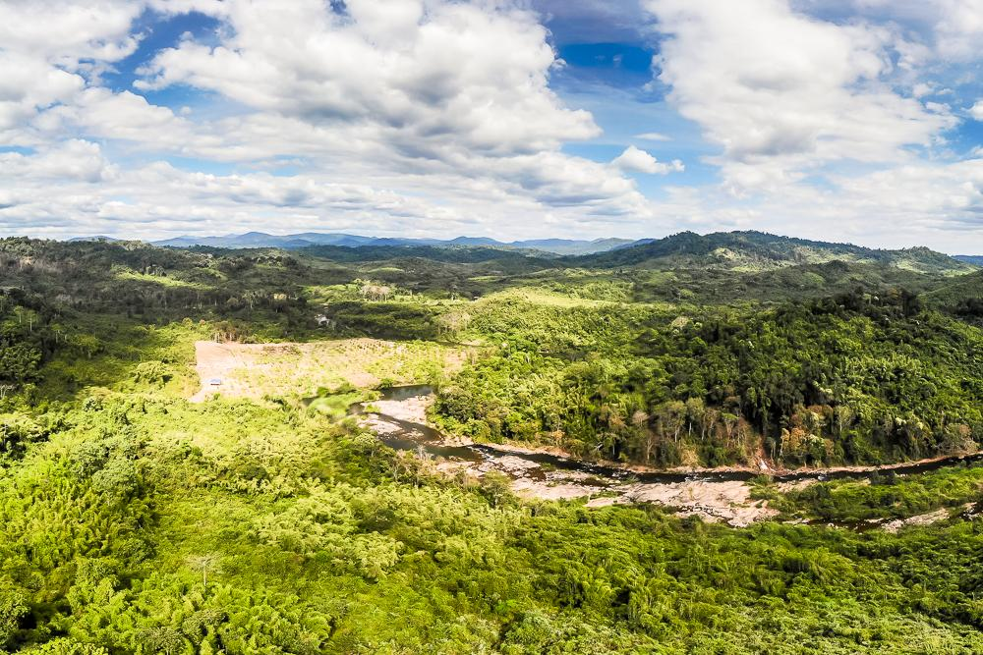
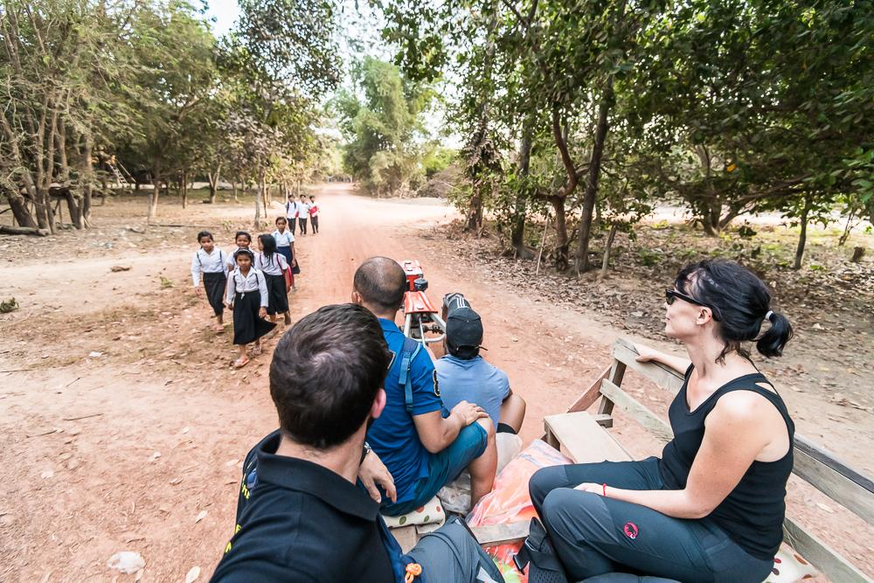
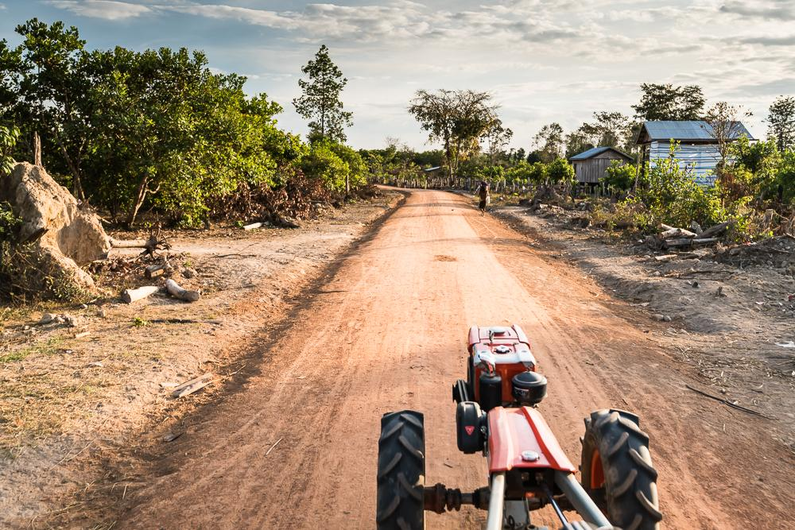
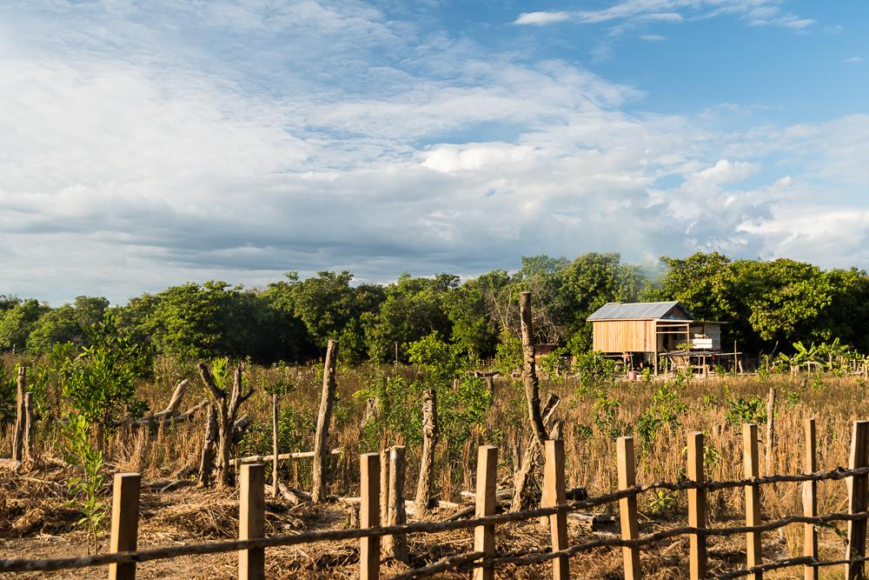
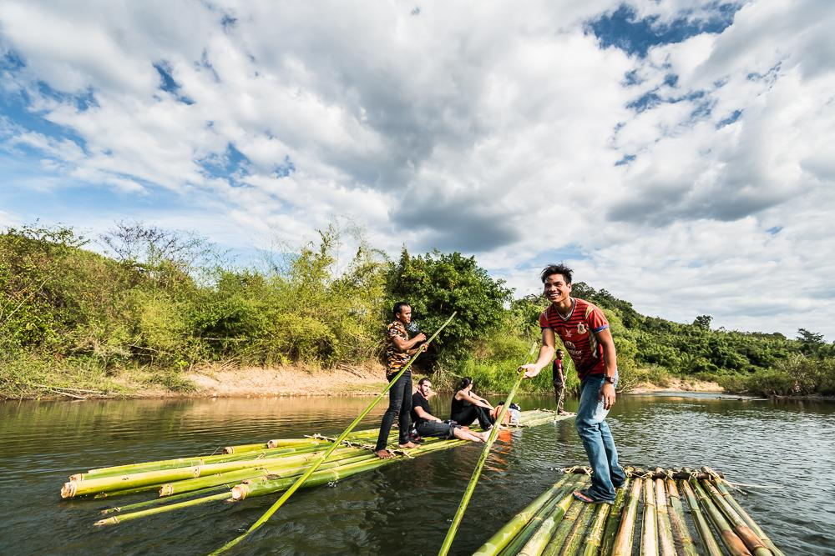
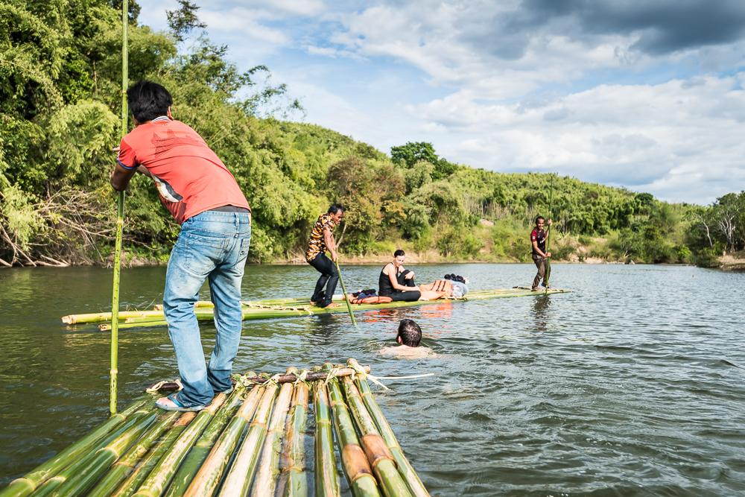
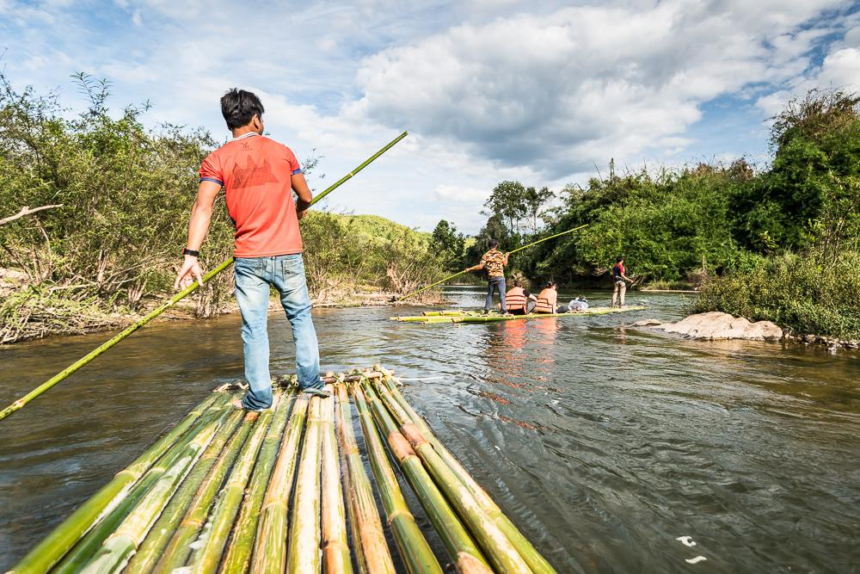
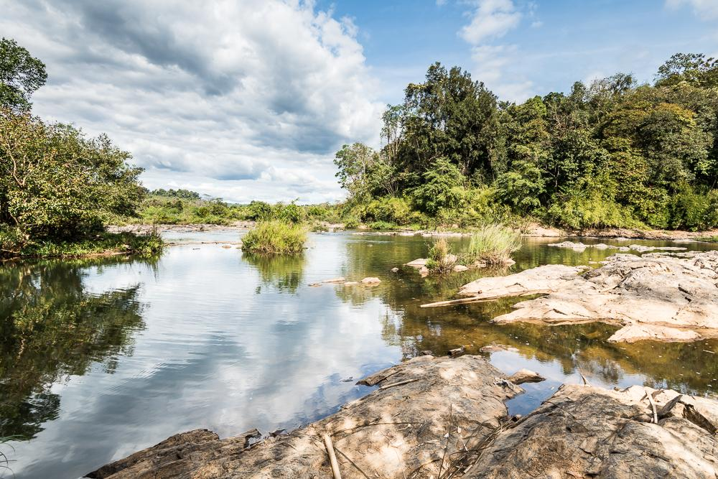
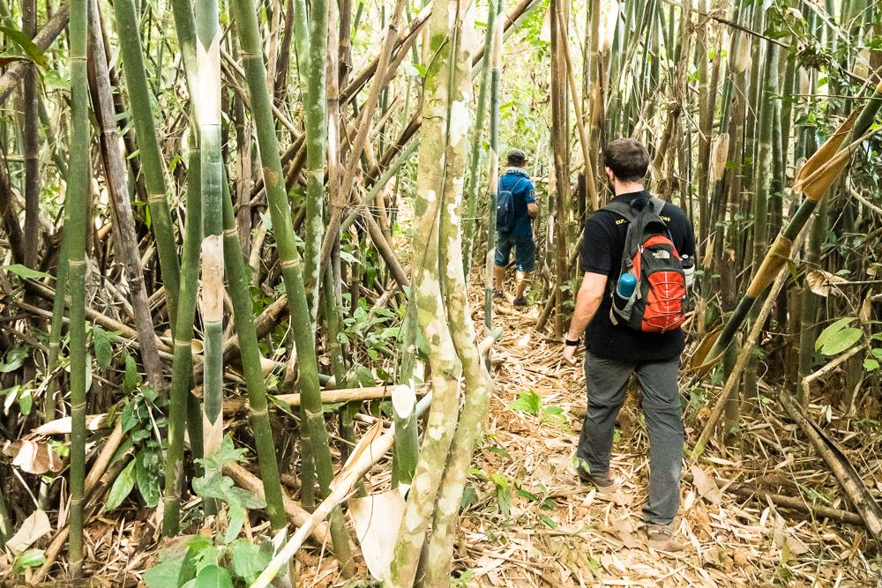
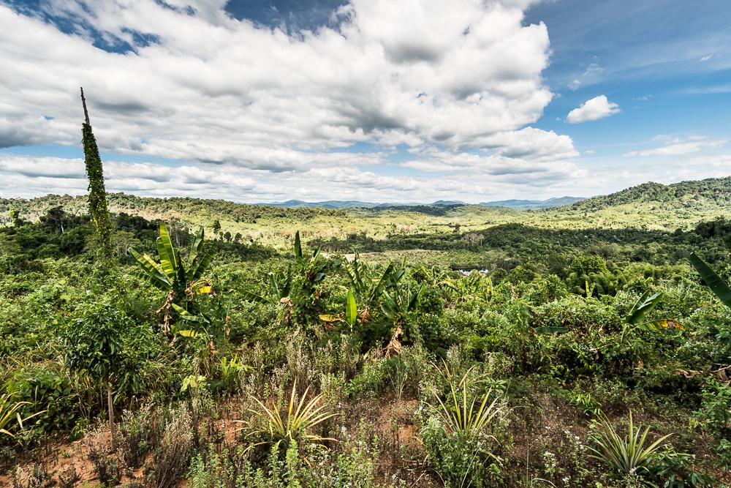
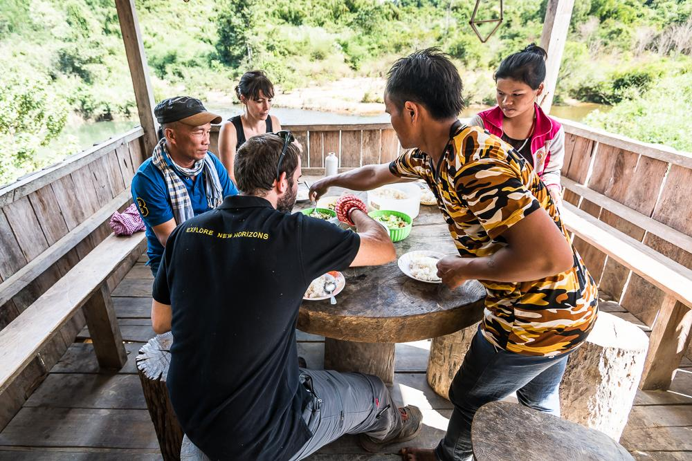
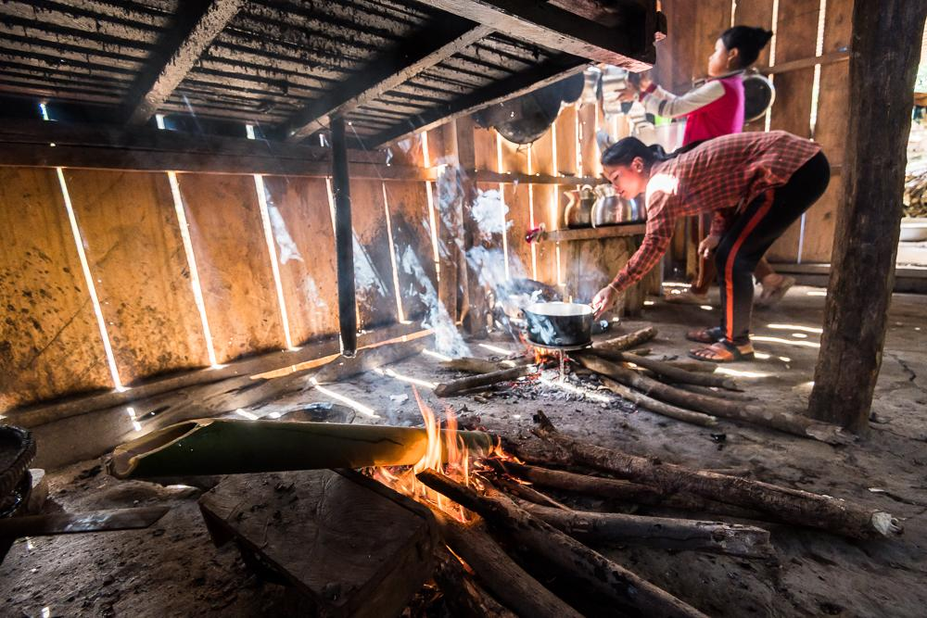
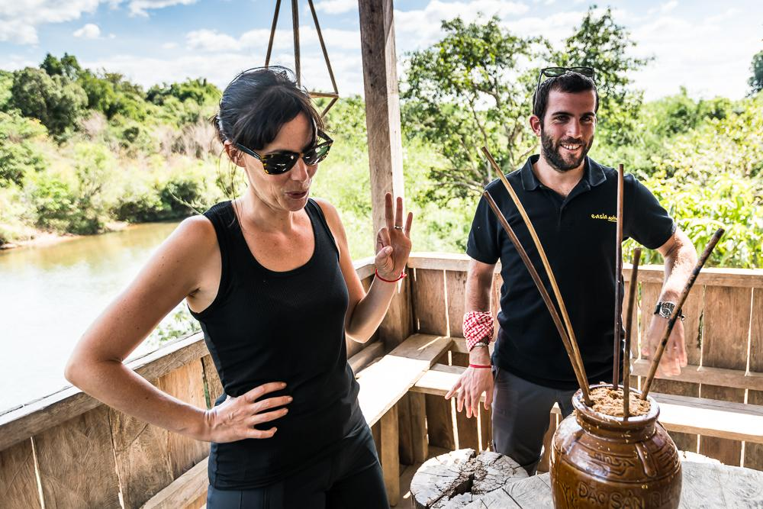
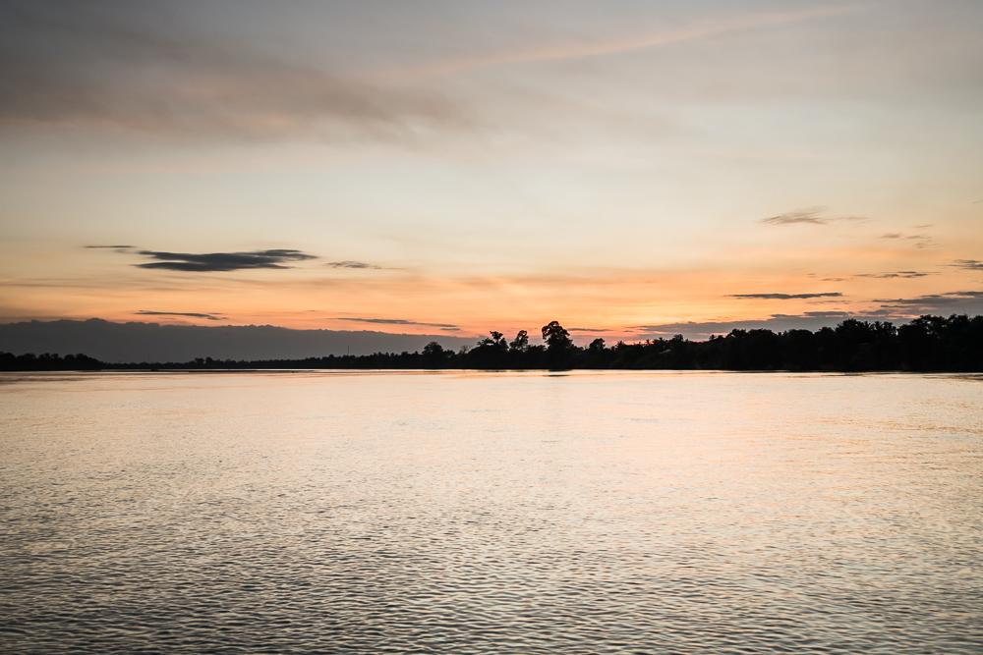
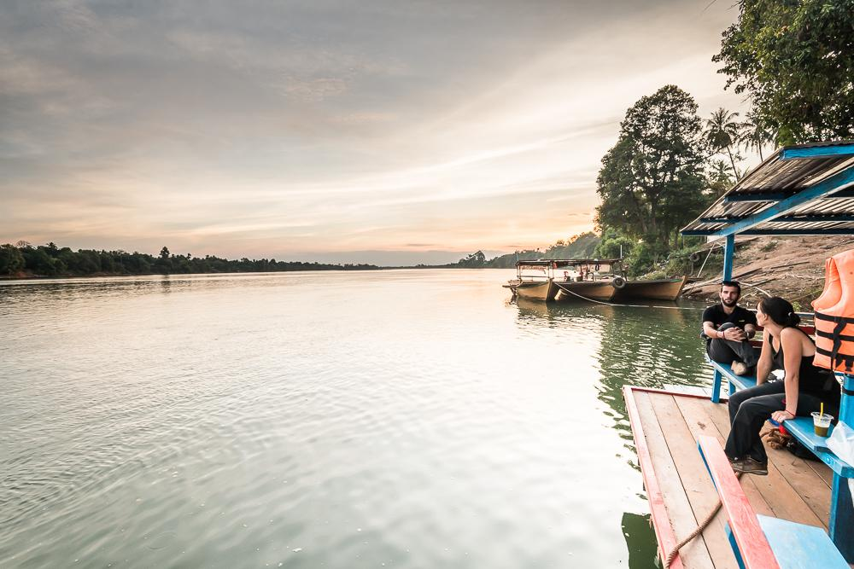
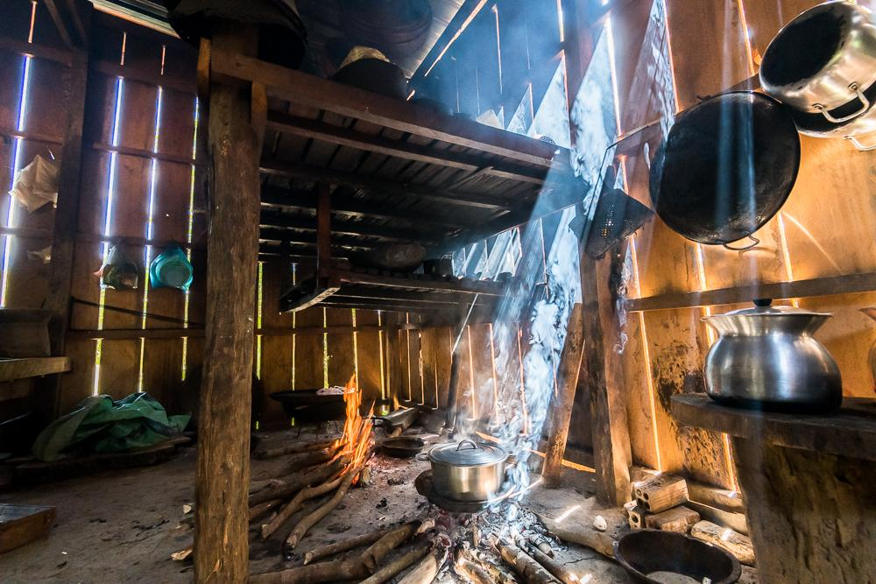
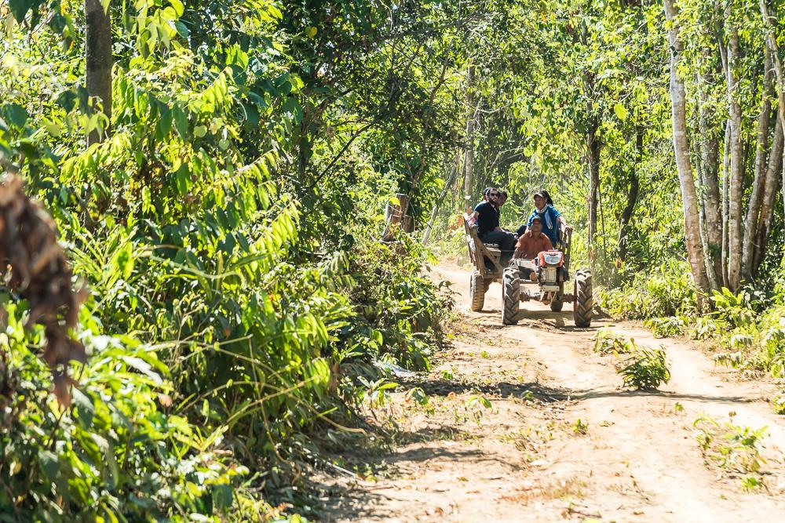
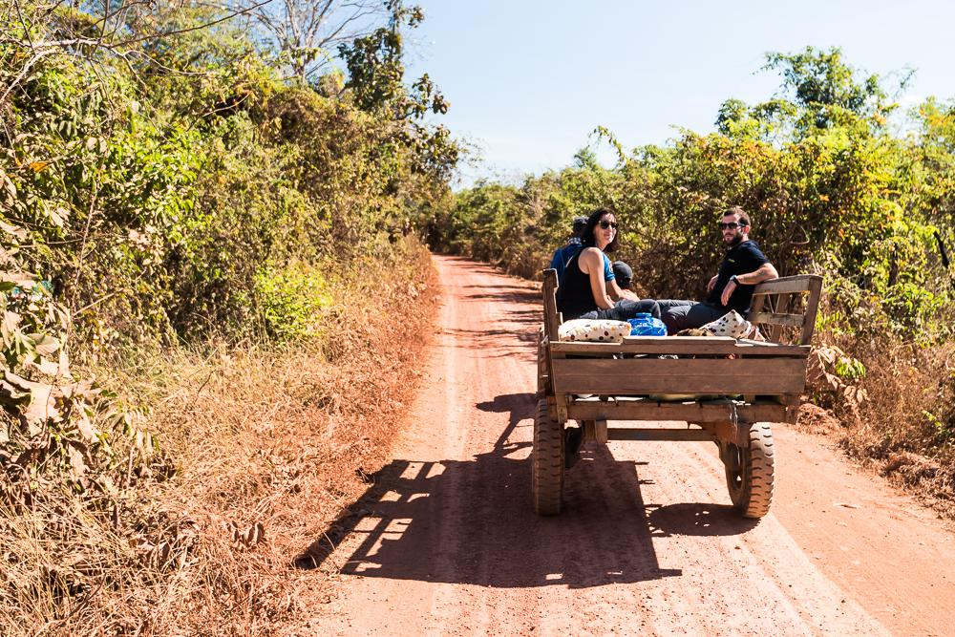
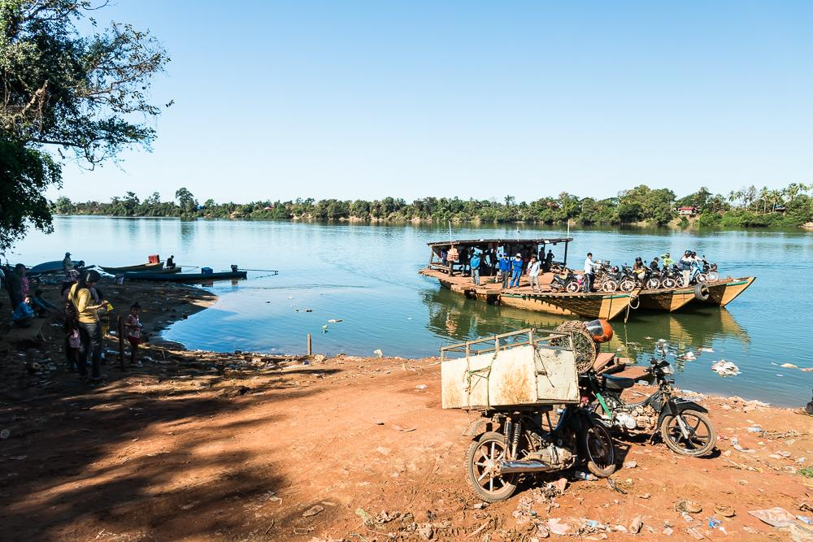

Easia Travel Head Office

