VIETNAM – Hue – Discover Hue Street Food by Cyclo
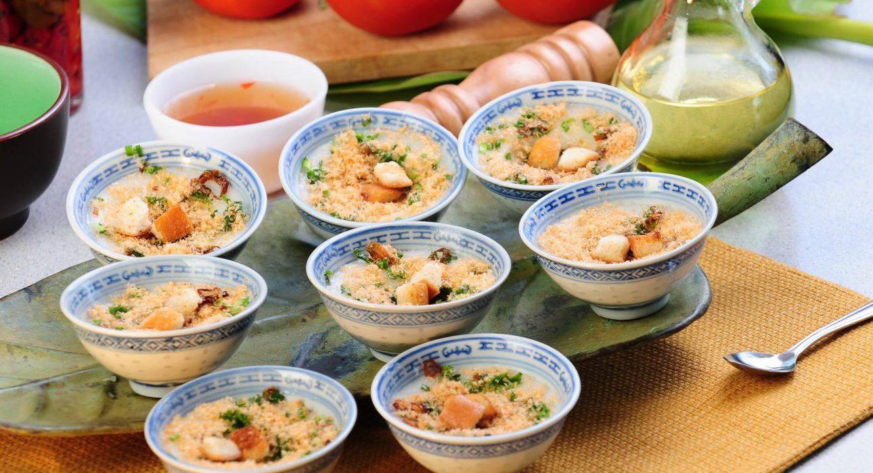

Over View

Theme
Art & Culture, Classic, Family, Gastronomy, Sustainable

Country - City
Vietnam - Hue

Market segment
Groups, Thematic Leisure

Price Level
$$

Max pax
30

Seasonality
All year

Arrival city
Hue

Departure city
Hue

Description

This activity offers the opportunity to enjoy a comfortable cyclo ride around Hue, moving along the Perfume River and around the Imperial Citadel taking in many beautiful sites along the way. Several stops provide the chance to sample local style rice cakes as well as famous noodle and candy unique to the region. Aside from tasting Hue’s signature dishes, this street food by cyclo experience is also a great way to meet and chat with Hue residents in the local restaurants.

Can be combined with
Thematic Leisure
- Hue – Rural life discovery on a Vespa
- Hue – Visit the tomb of Emperor Tu Duc
- Hue – Visit the tomb of Minh Mang
- Hue – Visit the Citadel
Groups
- Hue – Visit the tomb of Emperor Tu Duc
- Hue – Visit the tomb of Minh Mang
- Hue – Visit the Citadel

Selling points

- Taste a variety of Hue’s local dishes in some of the best local restaurants in town
- A fantastic culinary experience mixed with culture in Hue
- Good opportunity to take photos along the walls of the citadels
- Easy to include in a program after the visit of the Imperial Citadel

Sustainability

Level Of The Excursion
Medium – This activity offers tangible positive contributions to the local community, culture and/or environment

The Impact Of This Excursion

Social/cultural Impact
Cultural Conservation

Environment Impact
Transportation

Economic Impact
Local individual benefits, Community benefits

Additional Information
Positive Impact:This activity, made entirely by cyclo, provides income to the driver and all the stops are made at local restaurants and coffee shops.

Time And Transportation

From | To | Km | By | Duration | Road condition
Pilgrimage Village resort | Truong Tien Bridge | 6 | Car | 15 minutes | Good
Thuy Bieu Village | Truong Tien Bridge | 6,5 | car | 18 minutes | Good
Gems Gallery & Coffee | Hotel city | 1 to 1.5 | car | 5 minutes | Good

Photos

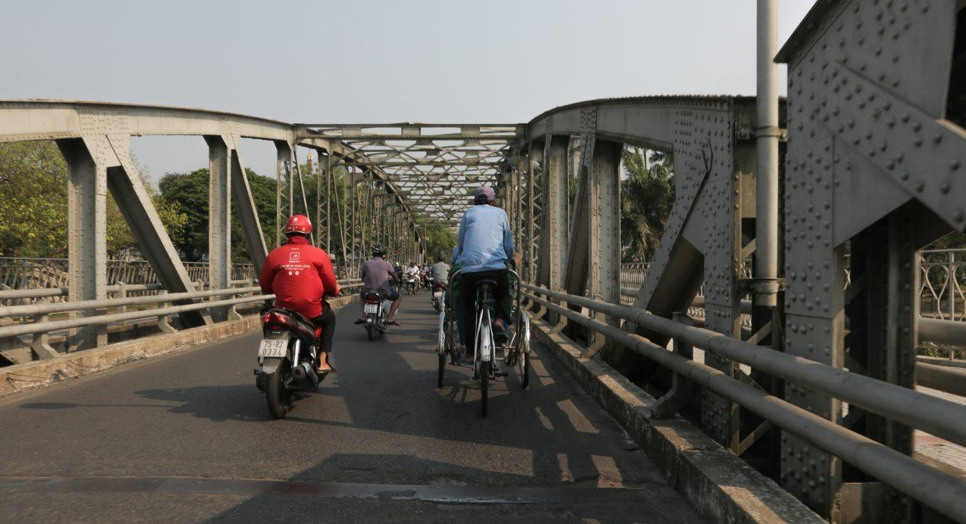
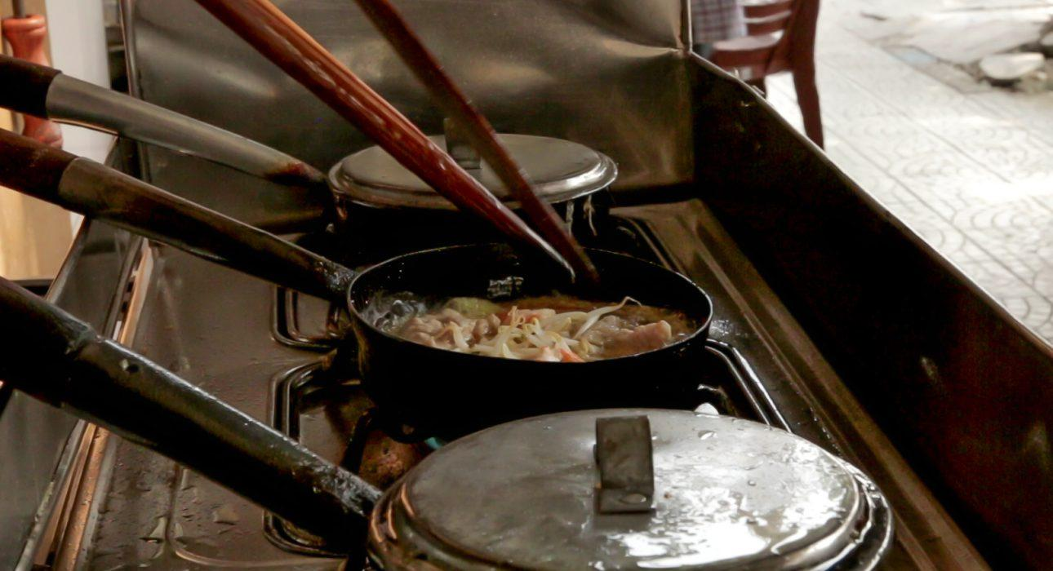
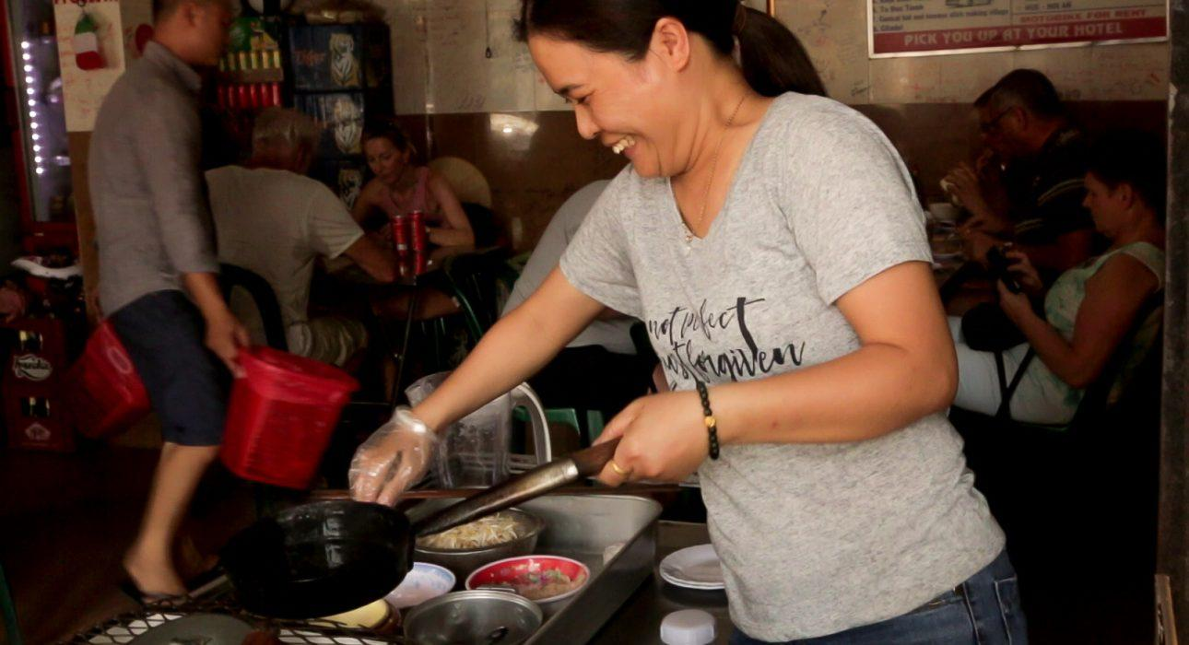
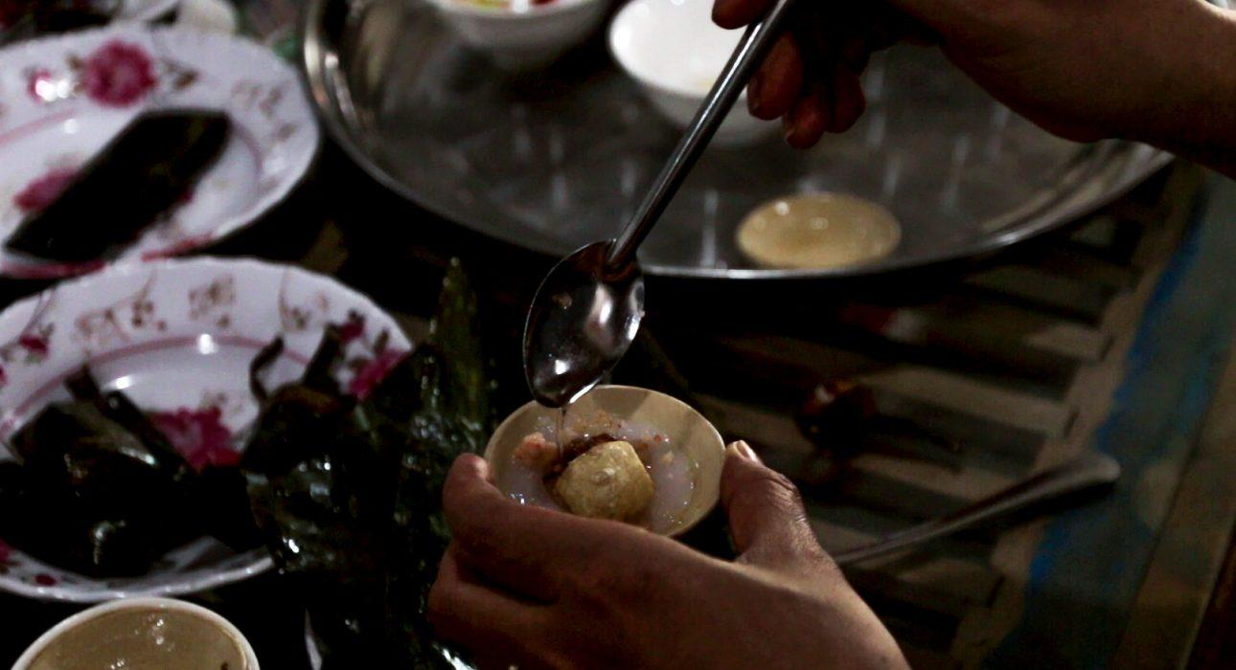
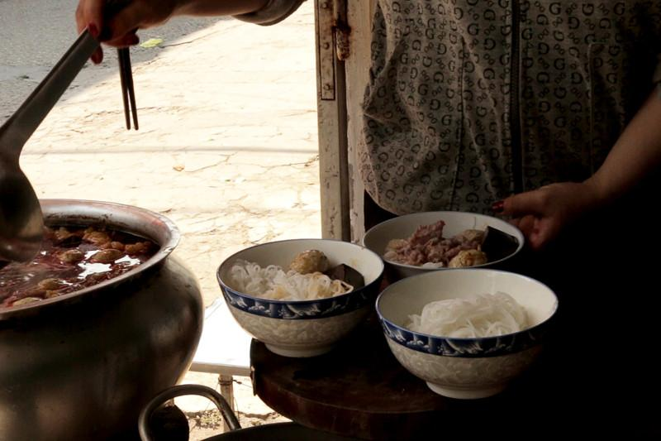
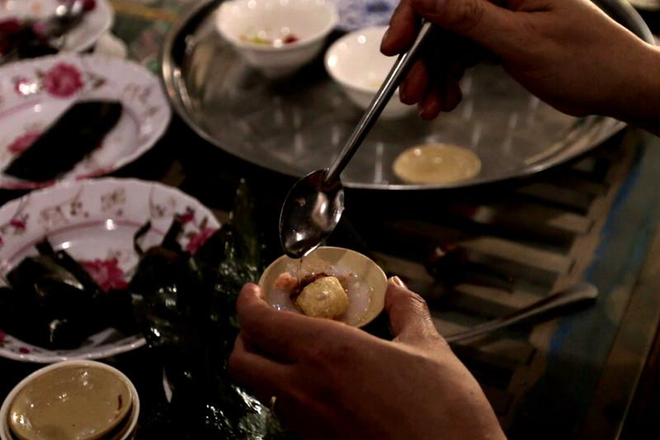
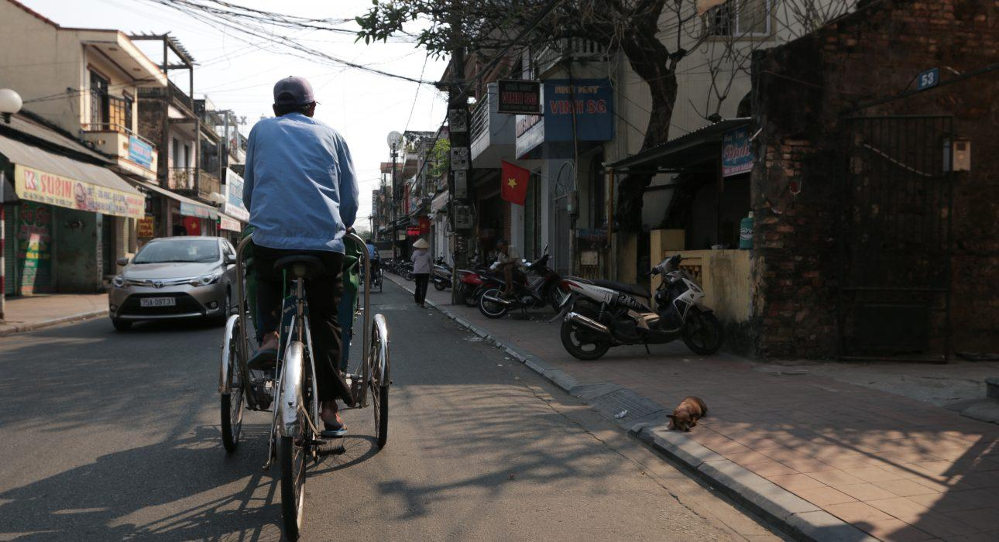

Easia Travel Head Office

Vietnam Head OfficeC/o: ATS Hotel, Suite 326 &327, 33B Pham Ngu Lao Street, Hanoi, VietnamTel: +84 24-39 33 13 62www.easia-travel.com

