VIETNAM – Hanoi – Hands-On Traditional Vietnamese Toy: To He
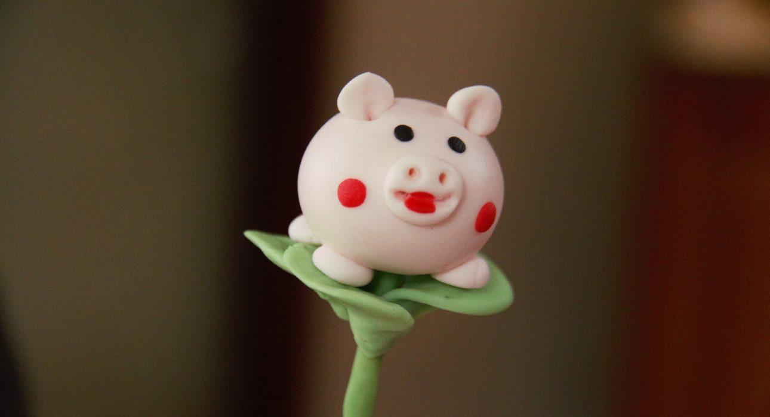

Over View

Theme
Art & Culture, Classic, Family, Sustainable

Country - City
Vietnam - Hanoi

Market segment
Thematic Leisure

Price Level
$$$

Max pax
35

Seasonality
All year

Arrival city
Hanoi

Departure city
Hanoi

Description

To He is one of the most popular toys among Vietnamese children thanks to their colorful designs and creative shapes, from the traditional Vietnamese zodiac signs to Pokemon characters. The quality of the toys depends greatly on the craftsman’s steady hands and his creative vision. In this activity, guests learn the secrets of making To He directly from an expert craftsman.

Can be combined with
Thematic Leisure
- Hanoi – Hanoi experiences
- Hanoi – “My Village” performance
- Hanoi – Hands-on Vietnamese cooking class in Hanoi
- Hanoi – Educational experience in Traditional handicraft village
- Hanoi – Meet with a water-puppet craftsman at his house

Selling points

- A great activity for families with children
- A hands-on experience to create a traditional Vietnamese toy
- An opportunity to learn about Vietnamese culture

Sustainability

Level Of The Excursion
Medium – This activity offers tangible positive contributions to the local community, culture and/or environment

The Impact Of This Excursion

Social/cultural Impact
Cultural Conservation, Empowerment and education

Economic Impact
Local individual benefits

Additional Information
Positive Impact:This activity supports a small company which makes To He, a traditional toy from Northern Vietnam. As well as contributing financially as a new business opportunity, it also helps the employees to have direct contact with foreigners and helps to improve their hospitality skills.

Time And Transportation

From | To | Kilometers | By | Duration | Road condition
Hanoi Opera House | Hanoi Hidden Gem Coffee | 1.1 kilometers | Car | 5 min | Good
West Lake | Hanoi Hidden Gem Coffee | 5.5 kilometers | Car | 25 min | Good

Photos

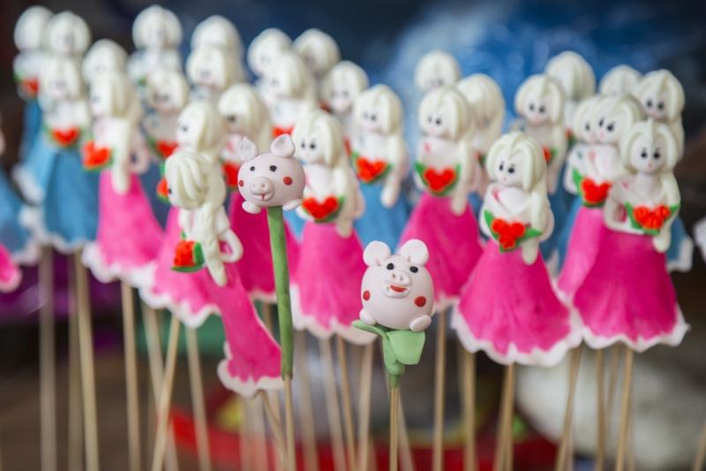
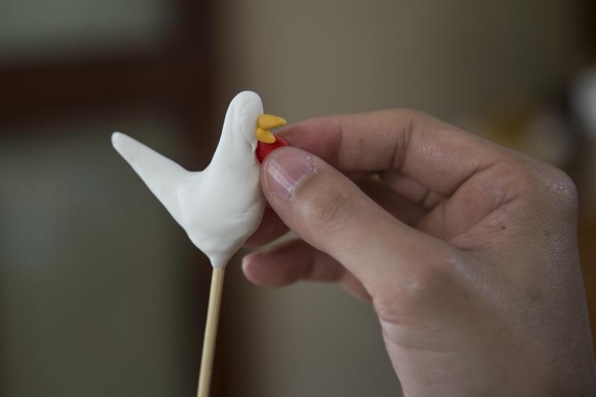
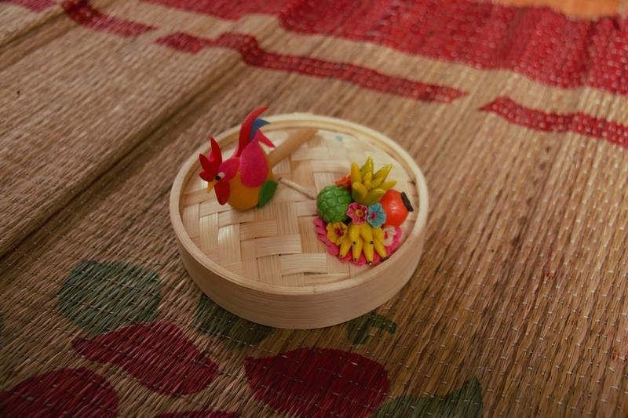
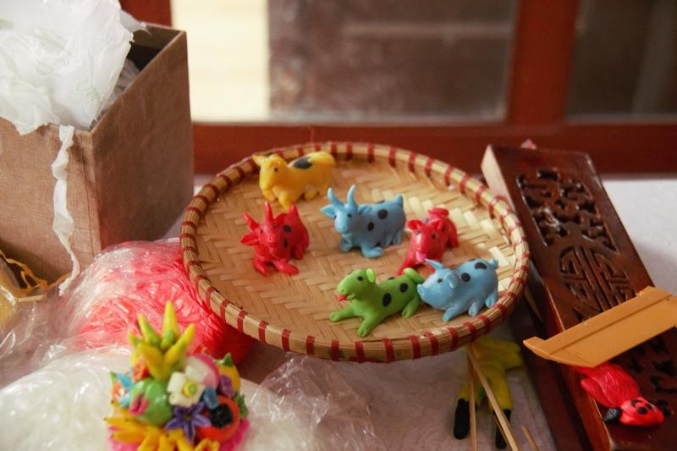
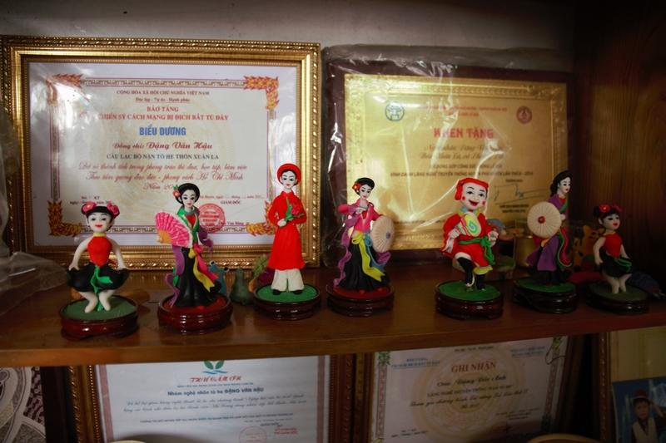
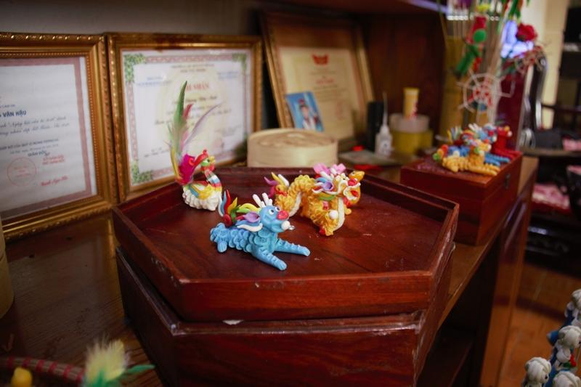
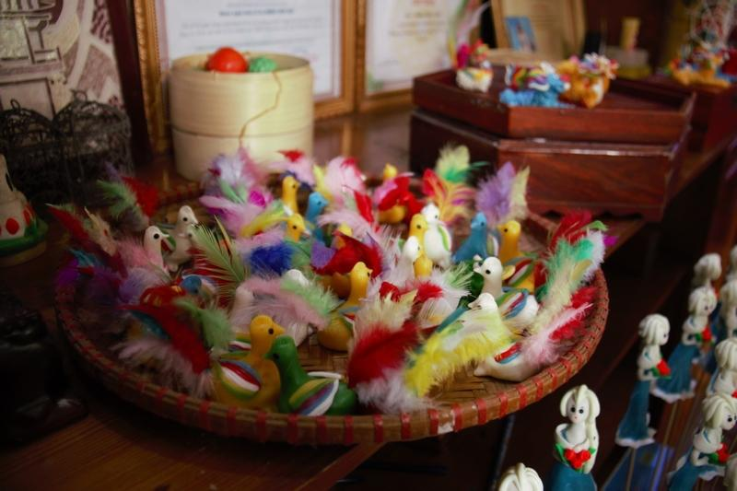
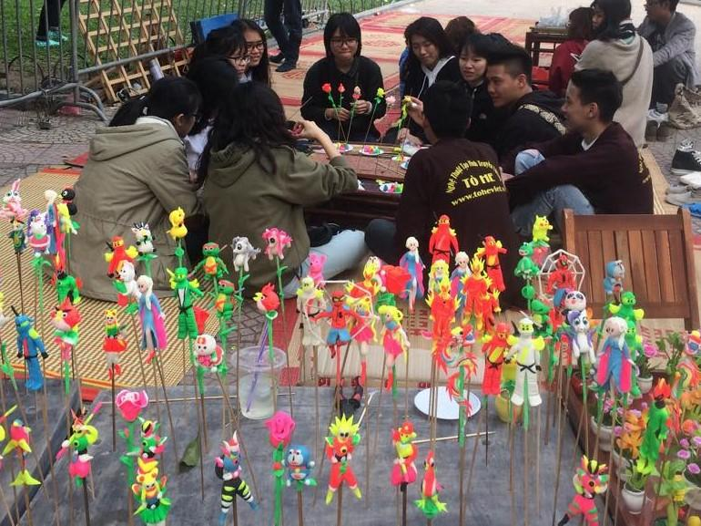
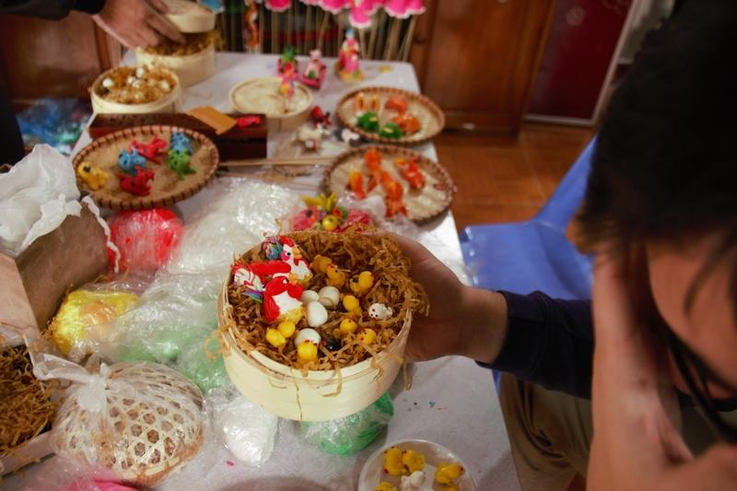

Easia Travel Head Office

Vietnam Head OfficeC/o: ATS Hotel, Suite 326 &327, 33B Pham Ngu Lao Street, Hanoi, VietnamTel: +84 24-39 33 13 62www.easia-travel.com

