CAMBODIA – Siem Reap – Discover the Secret of the Mystical God Hanuman
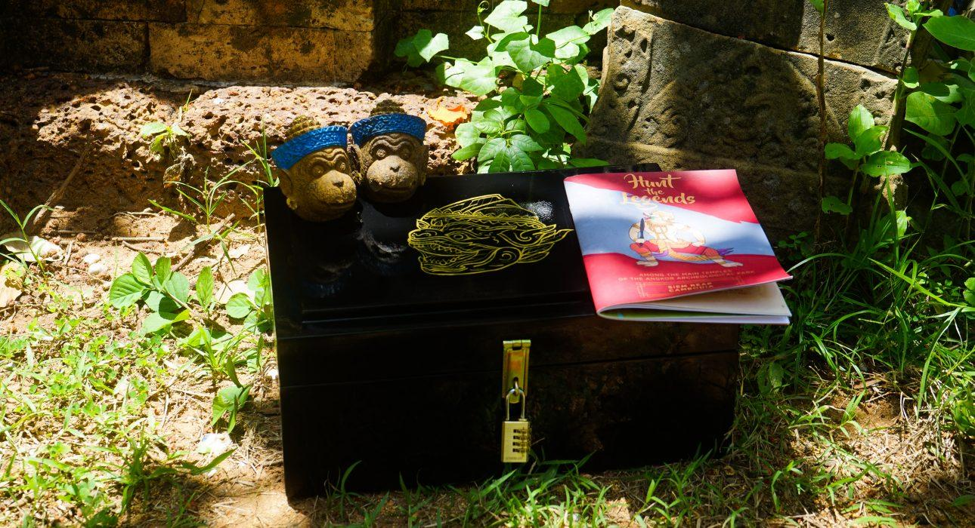

Over View

Theme
Art & Culture, Family

Country - City
Cambodia - Siem Reap

Market segment
Thematic Leisure

Price Level
$$

Level of difficulties
LEVEL 0

Max pax
8

Seasonality
All Year Round

Arrival city
Siem Reap

Departure city
Siem Reap

Description

In the corners of the Cambodian jungle conceal a variety of exotic surprises, suitable only for the bravest of brave souls. Adventure to uncover the lost secret of Hanuman, the god of strength and energy. This temple run allows to conduct a survey in the past of the legendary city of Angkor, in the heart of an incredible playground that only a trip to Cambodia can offer. Angkor Wat, Angkor Thom and Ta Prohm gather all clues to ensure victory!

Can be combined with
Thematic Leisure
During the tour:
- Monk Blessing Ceremony
- Exclusive lunch in a private house at Srah Srang
- Exclusive lunch in a private house at Srah Srang with pastry tasting
- A locally-made lunch at a private house in Srah Srang
After the tour :
- Exclusive aperitif in a private house at Srah Srang
- Exclusive aperitif in a private house at Srah Srang with pastry tasting
- Savor flavors like a local
- Sunset Aperitif at Angkor Balloon
- Phare, the Cambodian circus show
- A unique and tasty food experience at Bugs Café
- Sunset on a gondola boat
- Attend a divine performance of The Sacred Dancers of Angkor
- Private aperitif and/or dinner at the studio of Cambodia’s most famous artist: Mr Theam
- Visit the house of Mr Theam, Cambodia’s most famous artist
Exclusive
During the tour:
- Monk Blessing Ceremony
- Exclusive lunch in a private house at Srah Srang
- Exclusive lunch in a private house at Srah Srang with pastry tasting
- A locally-made lunch at a private house in Srah Srang
After the tour :
- Exclusive aperitif in a private house at Srah Srang
- Exclusive aperitif in a private house at Srah Srang with pastry tasting
- Savor flavors like a local
- Sunset Aperitif at Angkor Balloon
- Phare, the Cambodian circus show
- Attend a divine performance of The Sacred Dancers of Angkor
- Private aperitif and/or dinner at the studio of Cambodia’s most famous artist: Mr Theam
- Visit the house of Mr Theam, Cambodia’s most famous artist

Selling points

- To discover the main temple of Angkor thorough a playful Treasure hunt
- To offer the best way to keep the focus of the small and not-so-small participant on the history/ culture

Sustainability

Level Of The Excursion
Medium – This activity offers tangible positive contributions to the local community, culture and/or environment

The Impact Of This Excursion

Social/cultural Impact
Cultural Conservation, Empowerment and education

Environment Impact
Transportation

Economic Impact
Local individual benefits, Community benefits

Additional Information
Positive impact: this activity bringing income to many different local stores. Moreover, it is an easy game to play, attractive and fun especially for kids.

Time And Transportation

Photos

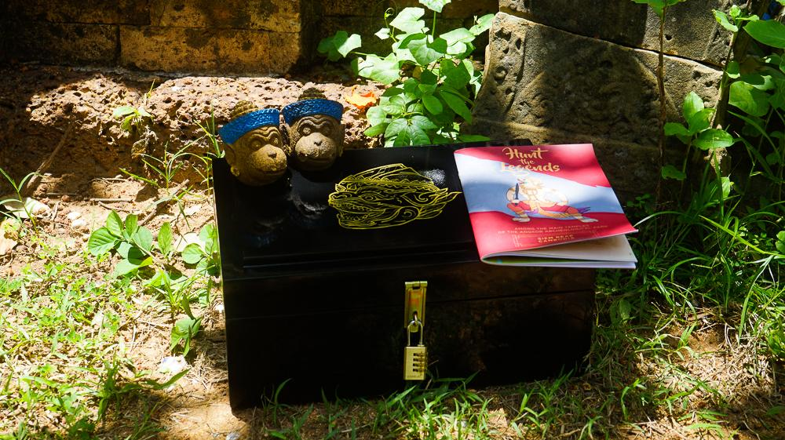
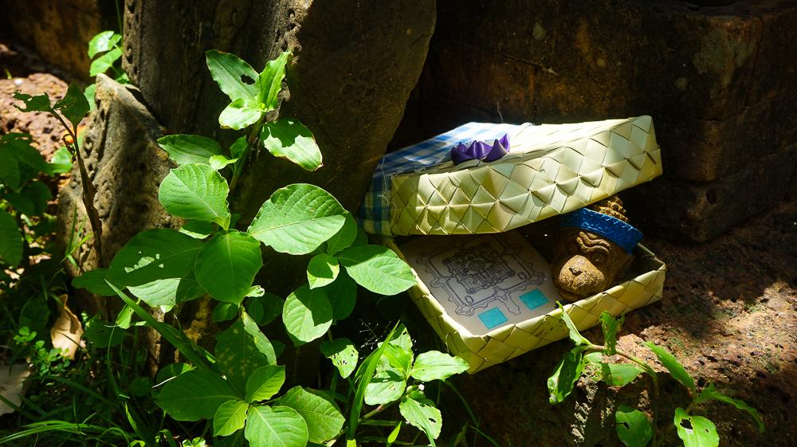
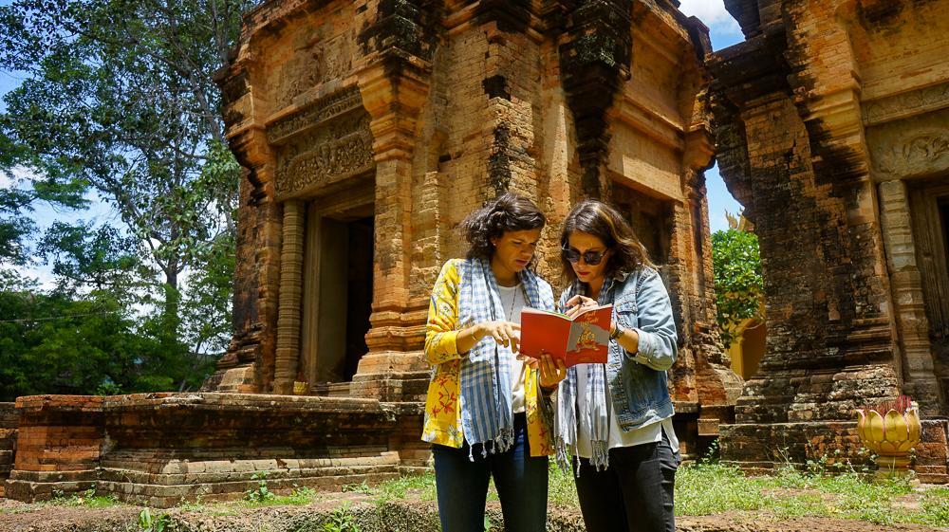
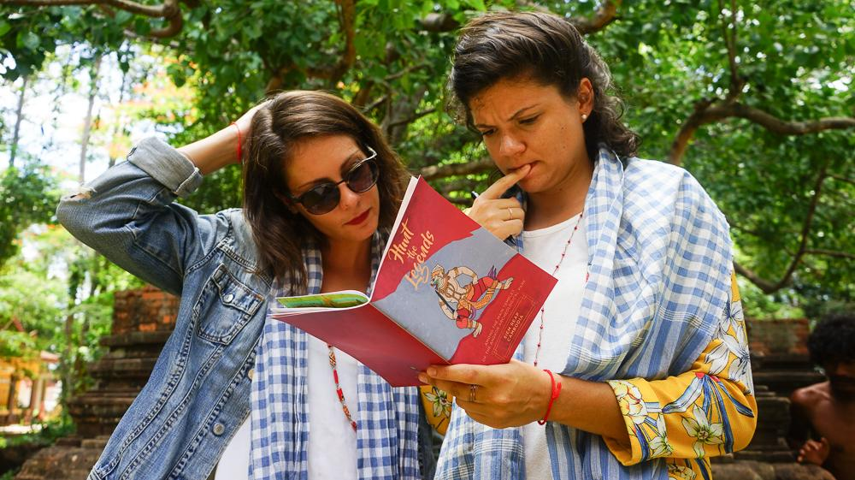
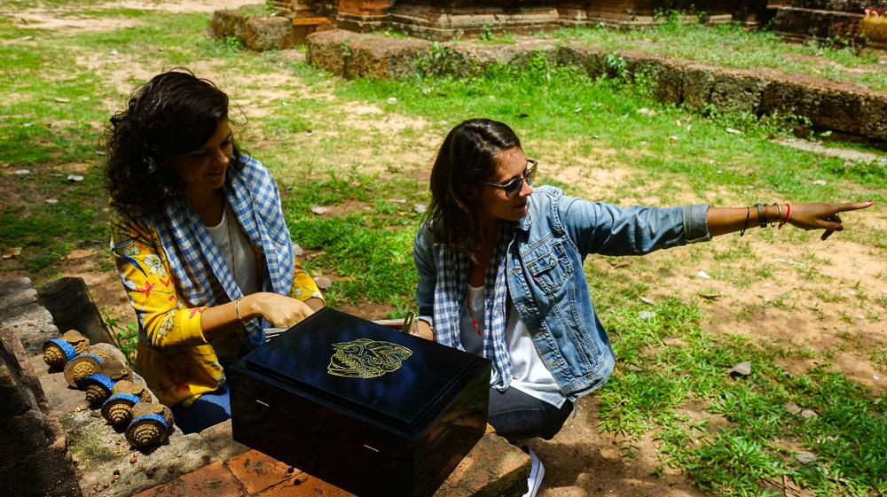
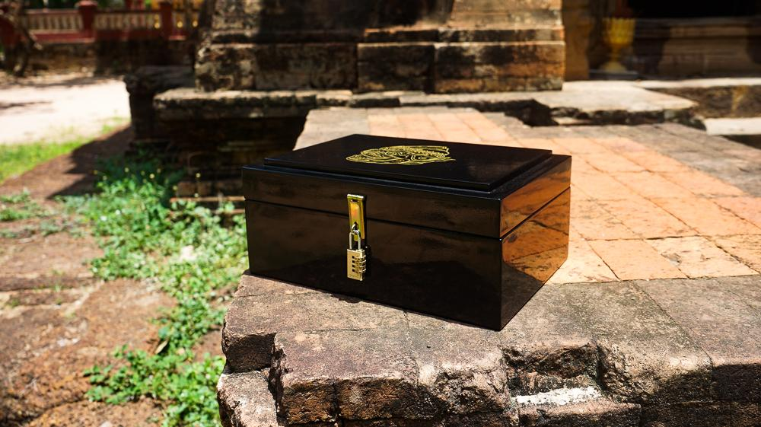

Easia Travel Head Office

Vietnam Head OfficeC/o: ATS Hotel, Suite 326 &327, 33B Pham Ngu Lao Street, Hanoi, VietnamTel: +84 24-39 33 13 62www.easia-travel.com

