MYANMAR – Inle Lake – One Day Walk Around Nampan
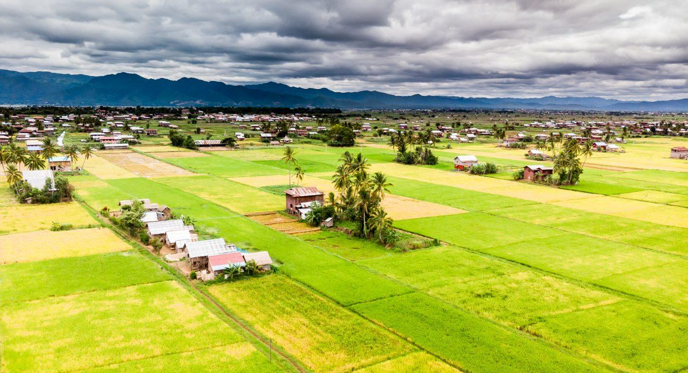

Over View

Theme
Classic

Country - City
Myanmar - Inle Lake

Market segment
Groups, Thematic Leisure

Price Level
$$

Level of difficulties
LEVEL 2

Max pax
20 persons

Seasonality
All year long - Best from September to February

Arrival city
Inle Lake

Departure city
Inle Lake

Description

Away from the usual routes, this hike offers a day break into nature to discover the daily life of farmers and the countryside atmosphere nearby the lake. An itinerary leaving the lake for a day to see more of the beautiful countryside on its shores.

Can be combined with
Thematic Leisure
Inle Lake – Kayak on the LakeInle Lake – Float Across the gardensInle Lake – Serene Morning

Selling points

- Occasion to discover another face of the lake by exploring the villages on its shores
- Enjoy a local lunch in a Pa-Oh Tribe Village
- Flexible itinerary, possible to reduce or extend the hiking distance depending on the guests’ profile
- An ideal alternative for guests willing to experience the local atmosphere of hikes without spending overnight in villages

Time And Transportation

From | To | Km | By | Duration | Road condition
Nyaung Shwe | Starting point (Ma Gyi Gone) | NA | boat | 1 hour | Open Lake
Khaung Daing | Starting point (Ma Gyi Gone) | NA | boat | 45 minutes | Open Lake
Inle Princess/ Inle Resort | Starting point (Ma Gyi Gone) | NA | boat | 45 minutes | Open Lake
Mine Thauk | Starting point(Ma Gyi Gone) | NA | boat | 30 minutes | Open Lake

Photos

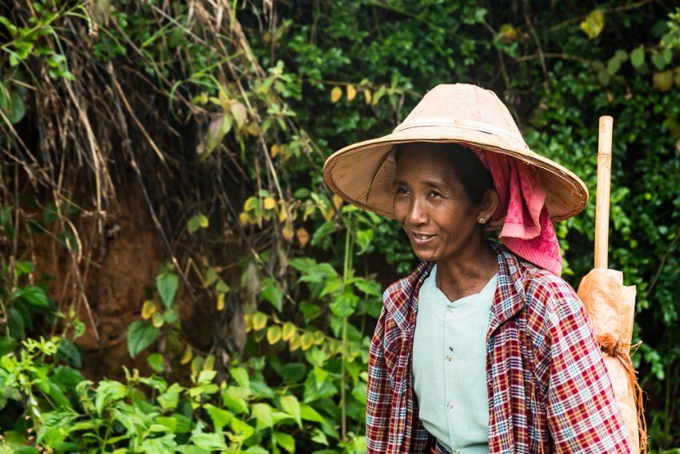
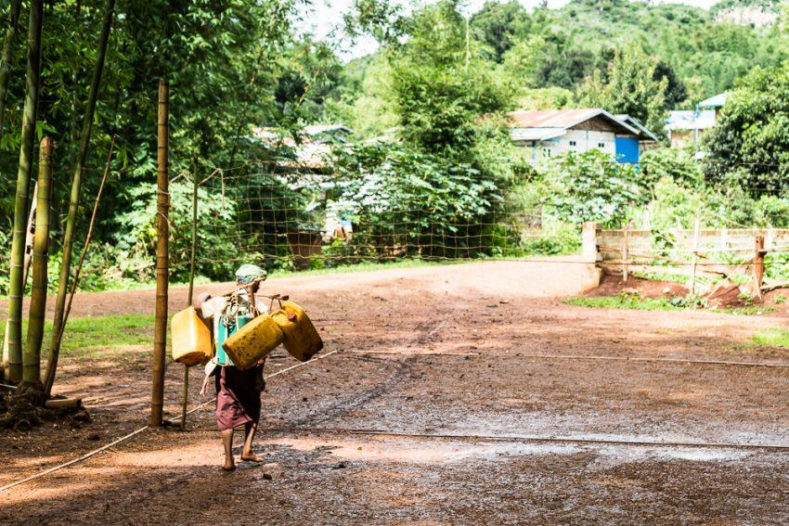
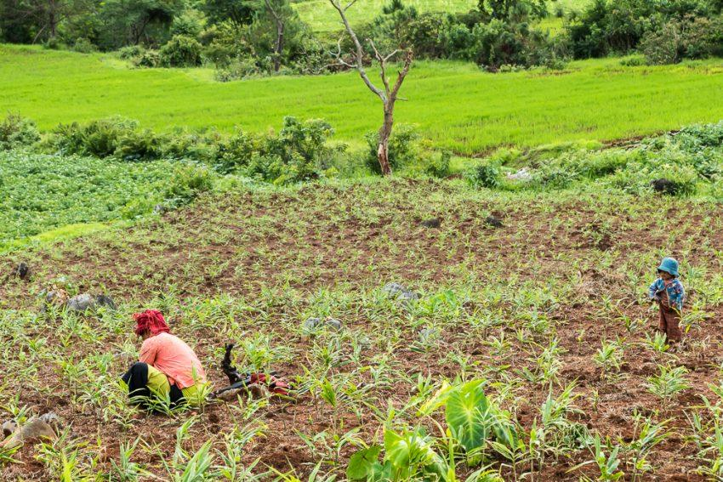
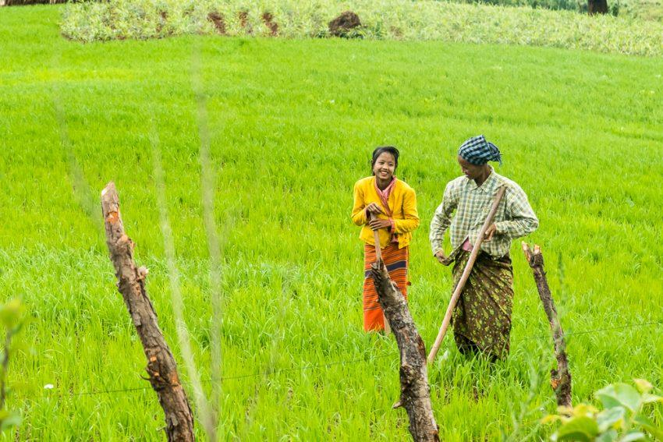
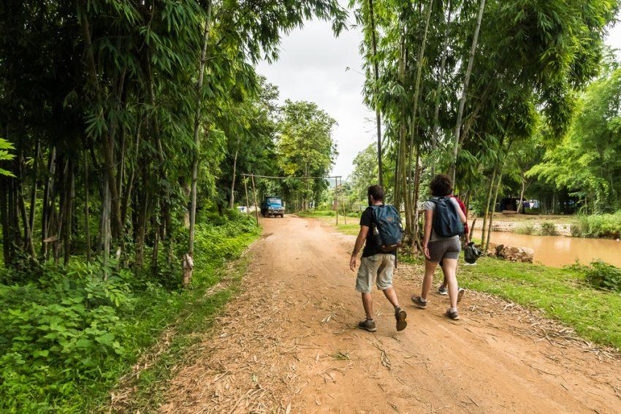

Easia Travel Head Office

Vietnam Head OfficeC/o: ATS Hotel, Suite 326 &327, 33B Pham Ngu Lao Street, Hanoi, VietnamTel: +84 24-39 33 13 62www.easia-travel.com

