VIETNAM – Hanoi – Coffee Tour in Hanoi’s Old Quarter
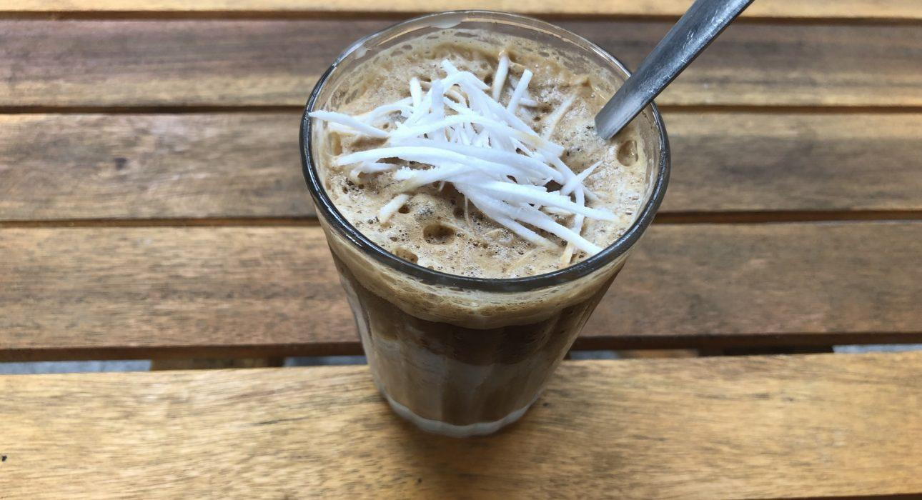

Over View

Theme
Art & Culture, Classic, Gastronomy, Honeymoon, Sustainable

Country - City
Vietnam - Hanoi

Market segment
Thematic Leisure

Price Level
$

Max pax
6

Seasonality
All year round

Arrival city
Hanoi

Departure city
Hanoi

Description

Vietnam is famous for its coffee and is one of the biggest producers in the world. This walking tour introduces travelers to the different ways coffee is served in Hanoi, from the legendary egg coffee to the trendy coconut coffee or the Vietnamese signature ca phe sua da (a dark roast iced coffee with condensed milk). Travelers will go from the very local street-side cafes to a cozy coffee shop with a great view, or a charming gem full of art. Along the way, there is plenty to discover: the busy market, train street, pagodas, art, the famous Hoan Kiem Lake, and much more. It’s a great way to observe daily life in the cultural hub and enjoy the growing contemporary art scene in local coffee shops.

Can be combined with
Thematic Leisure
- Hanoi – Hanoi Experiences
- Hanoi – Brewed in Vietnam Beer Tour
- Hanoi – Evening story of street food

Selling points

- A great opportunity to try Vietnam’s famous coffees: Egg Coffee, Coconut Coffee, Ca Phe Sua Da
- Each way of serving coffee has its own story
- Travelers will discover unique and hidden gems in the famous Hanoi Old Quarter, as well as take the time to enjoy the vibrant atmosphere while drinking a cup of delicious coffee
- Other drinks are available and included in the activity if some travelers do not like coffee

Sustainability

Level Of The Excursion
Medium – This activity offers tangible positive contributions to the local community, culture and/or environment

The Impact Of This Excursion

Environment Impact
Transportation

Economic Impact
Community benefits

Additional Information
Positive Impact:This activity is conducted purely on foot around the Old Quarter of Hanoi. It also provides economic support to several coffee shops in Hanoi.

Time And Transportation

From | To | Km | By | Duration | Road condition
Hanoi Opera House | Giang Cafe Yen Phu | 2,5 | Car | 10 minutes | Good
Dong Xuan Market | Giang Cafe Yen Phu | 0,5 | Walk | 5 minutes | Good

Photos

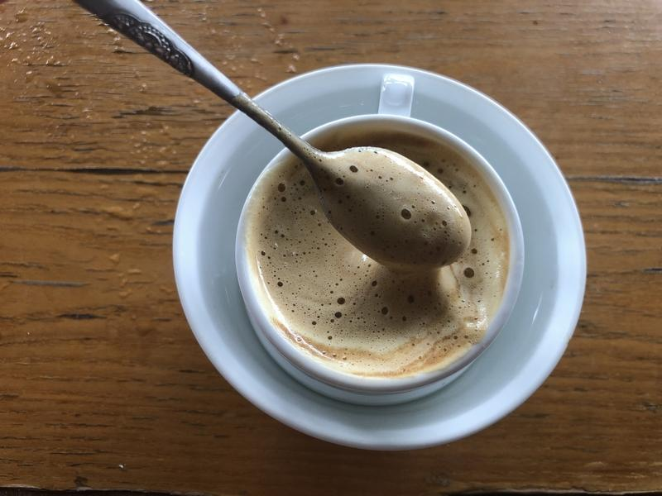
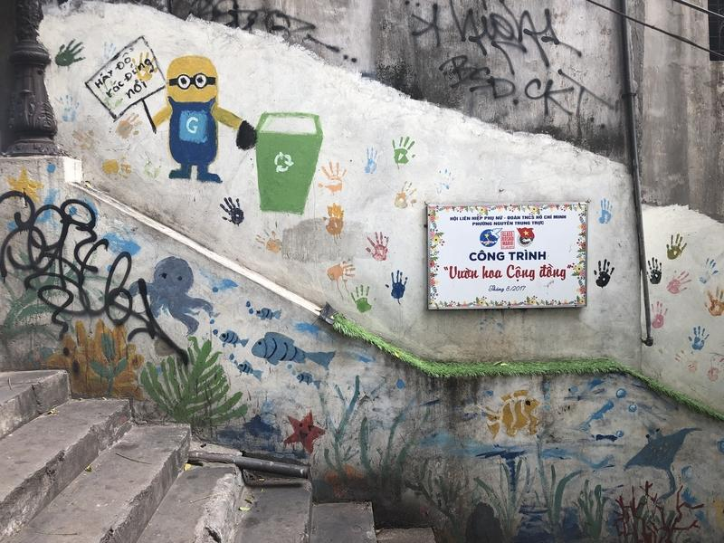
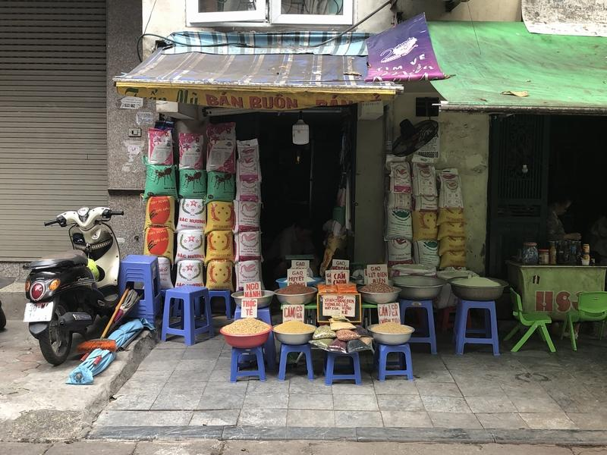
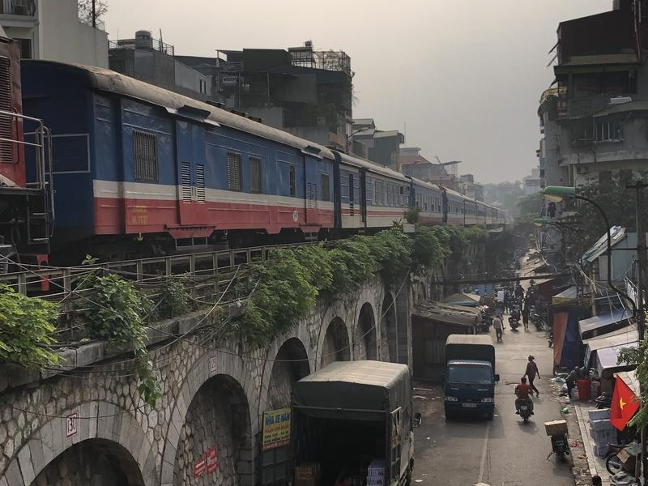
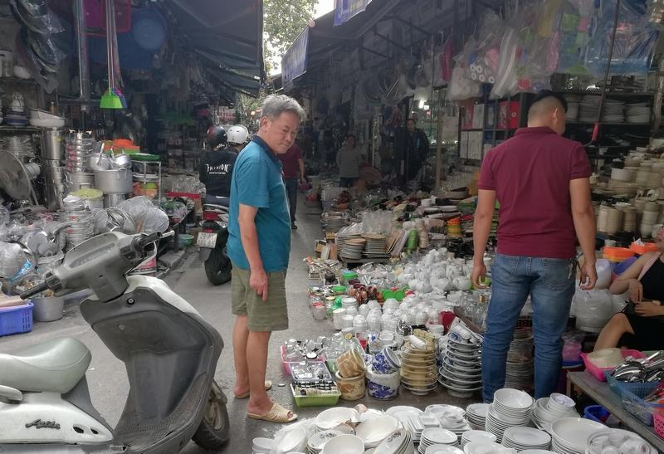
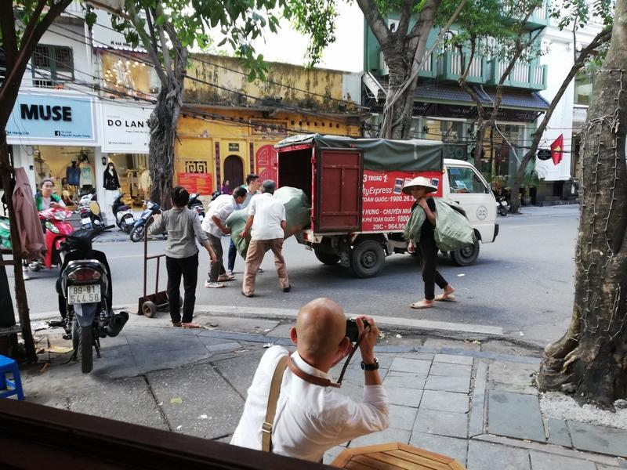
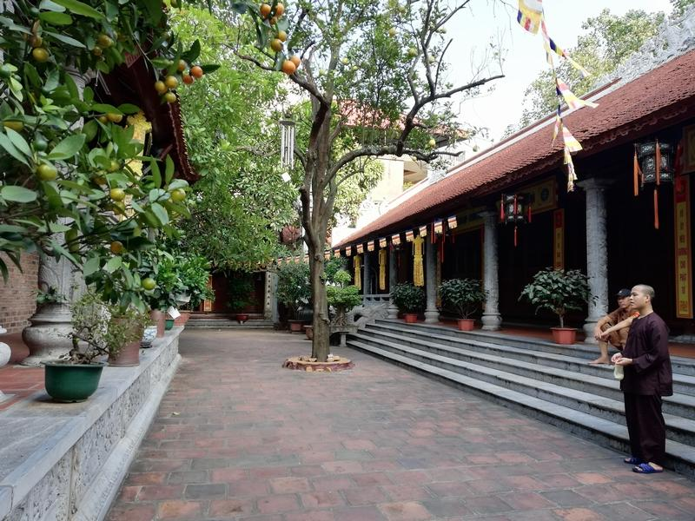
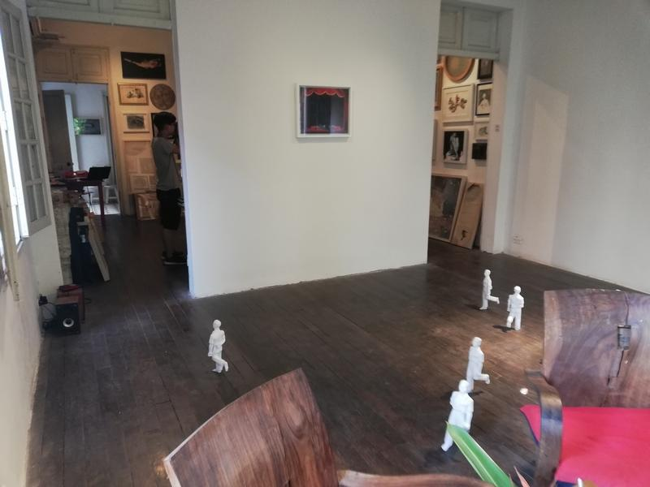

Easia Travel Head Office

Vietnam Head OfficeC/o: ATS Hotel, Suite 326 &327, 33B Pham Ngu Lao Street, Hanoi, VietnamTel: +84 24-39 33 13 62www.easia-travel.com

