THAILAND – Nakhon Pathom – Sunset Cocktail Cruise and Riverbank Dinner
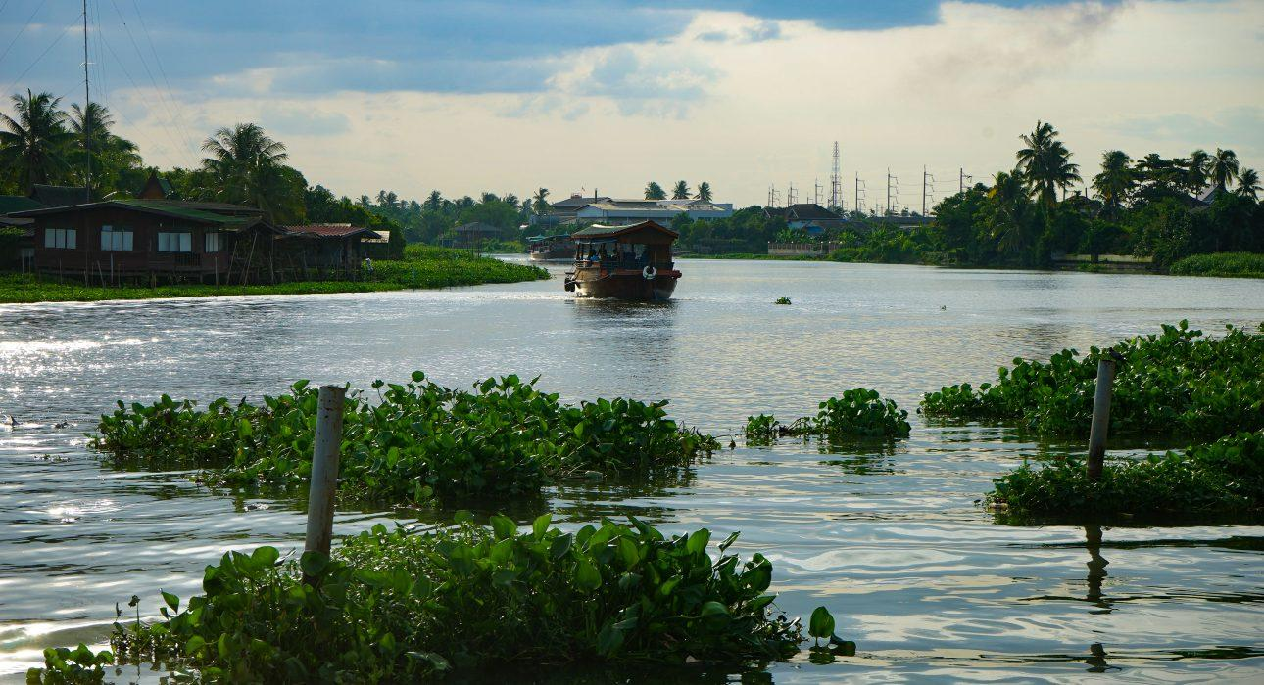

Over View

Theme
Classic, Gastronomy, Honeymoon

Country - City
Thailand - Nakhon Pathom

Market segment
Thematic Leisure

Price Level
$$$$

Max pax
12 pax

Seasonality
All year round

Arrival city
BANGKOK

Departure city
BANGKOK

Description

During a peaceful cruise, guests will enjoy the scenic twilight atmosphere of a river while sipping delicious homemade cocktail before sitting for a delicious chef’s signature dinner in a peaceful garden along the river. An occasion to learn about the host’s history and enjoy real sharing moments.

Selling points

- A gastronomic experience in the countryside far away from the too often seen big cities’ gastronomic experiences.
- A combination between gastronomic experience and encounter
- A sunset signature cocktail in the perfect life to witness the end of the day on the river.
- A hidden tropical garden with a homely touch as setting of the dinner.

Sustainability

Level Of The Excursion
Low - This activity impacts local community, culture and/or environment in a small but meaningful way

The Impact Of This Excursion

Social/cultural Impact
Empowerment and education

Economic Impact
Local individual benefits, Community benefits

Additional Information

Positive impacts
The boat trip is operated by local people, while the dinner is cooked by a local chef who uses locally sourced produce wherever possible.

Negative impacts
The boat used during the activity uses fossil fuel which causes Co² emissions.

Time And Transportation

From | To | Km | Duration | Road condition
Sukhumvit Area | Don Wai | 40 | 40 min – 1h | Car – Often Traffic Jam
Silom/Sathorn Area | Don Wai | 35 | 35 – 1h | Car – Often Traffic Jam
Riverside Area | Don Wai | 30 | 30 – 40 min | Car Often Traffic Jam
BTS Siam(Sukhumvit area) | BTS Bang Wa | 14 – 25 | 45 – 55 min | BTS (Sky Train)
BTS Saphan Taksin (Riverside) BTS | BTS Bang Wa | 10 | 22 min | BTS (Sky Train)
BTS Bang Wa | Don Wai | 28 | 35 – 50 min | Car – Often Traffic Jam
Don Wai | Kanchanaburi | 140 | 1h50 – 2h | Car – Often Traffic Jam
Don Wai | Sai Yoke | 195 | 2h50 – 3h10 | Car
Don Wai | Ayuthaya | 105 | 1h15 – 1h30 | Car

Photos

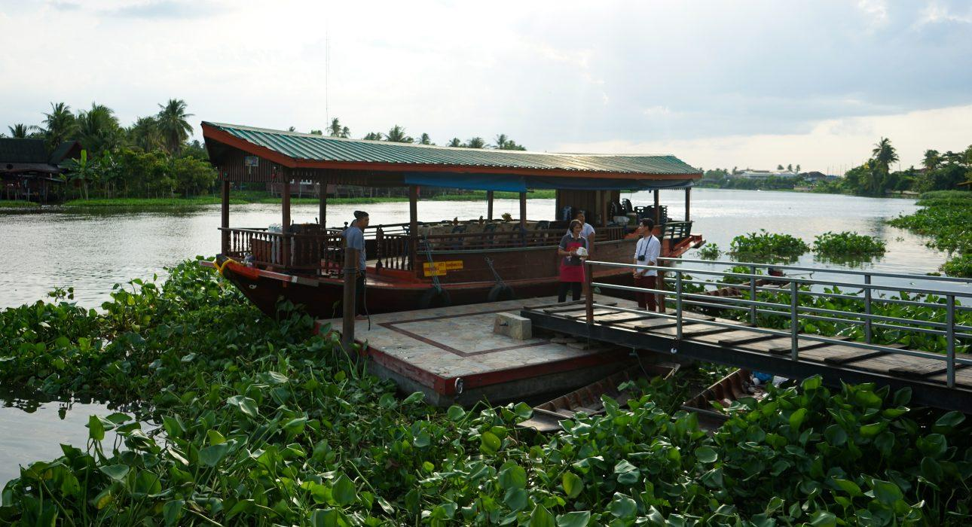
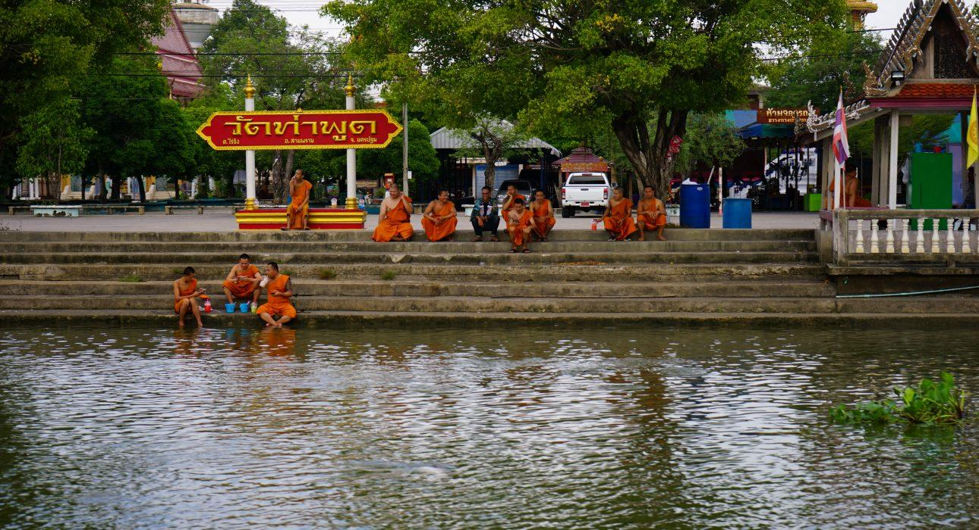
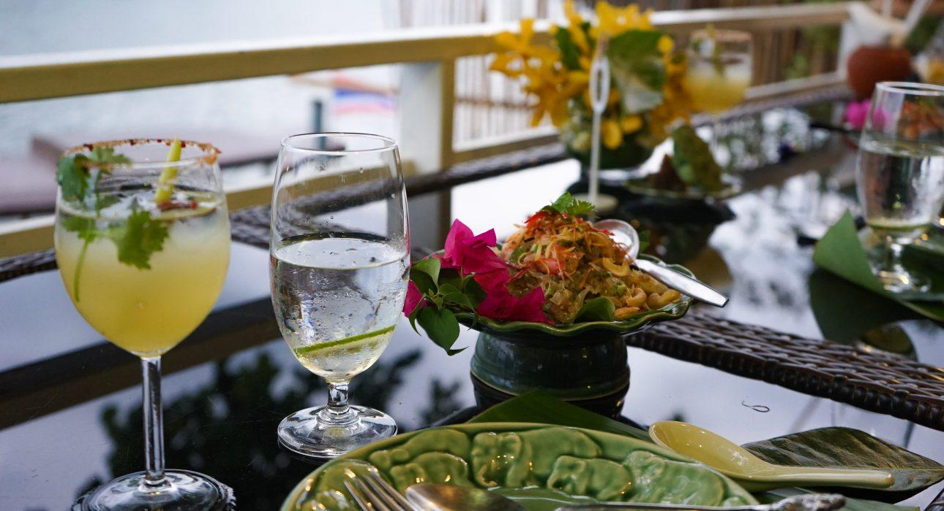
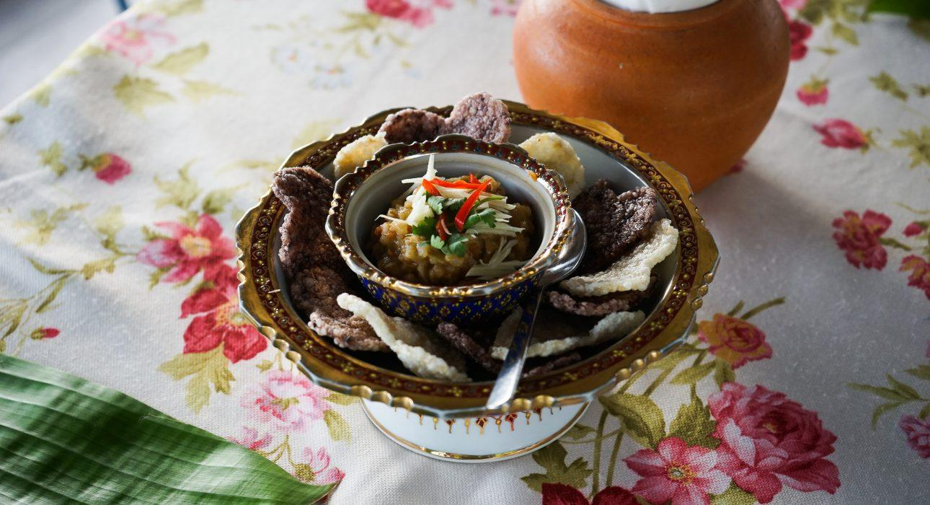
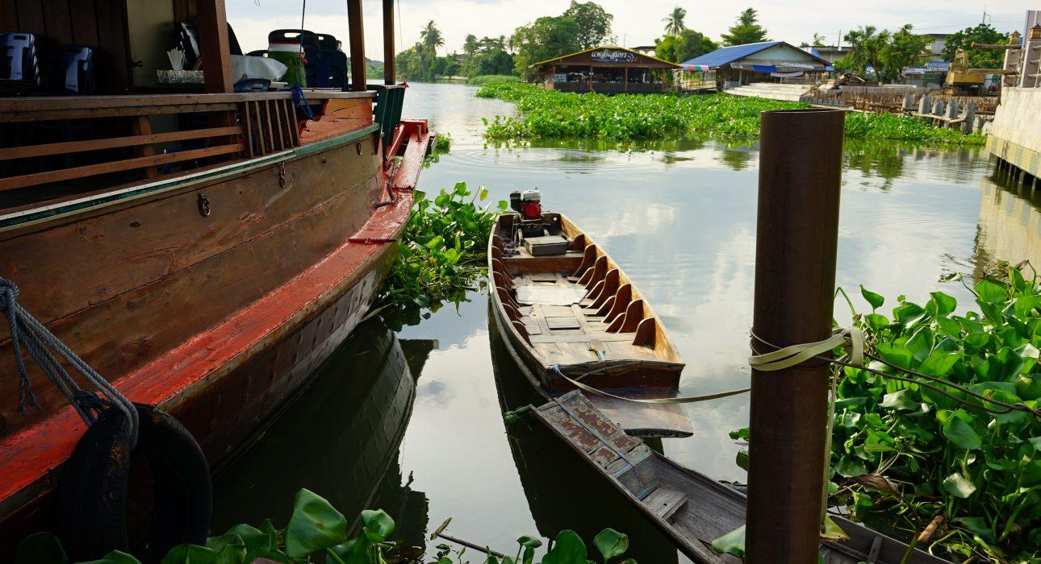
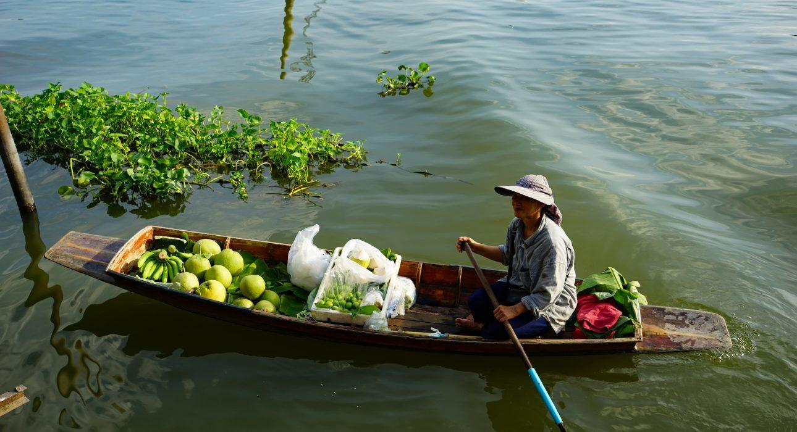
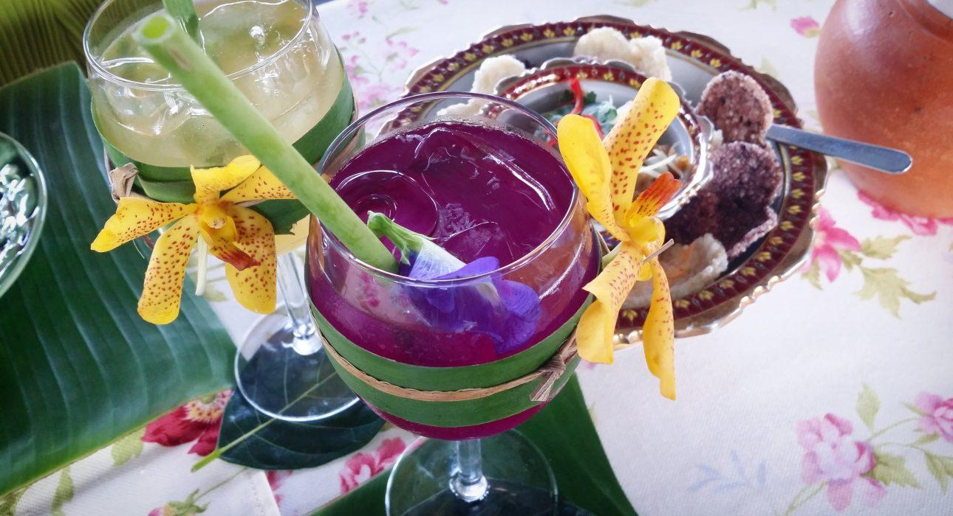
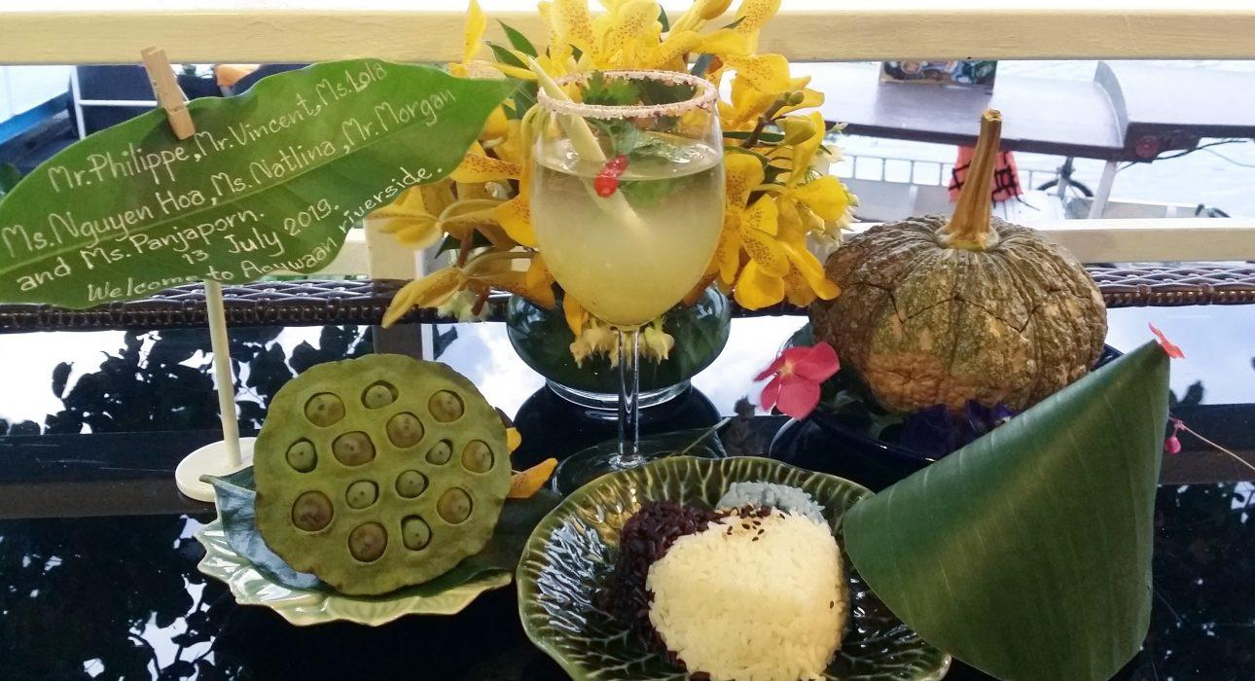

Easia Travel Head Office

