LAOS – Luang Prabang – A Taste of Laos
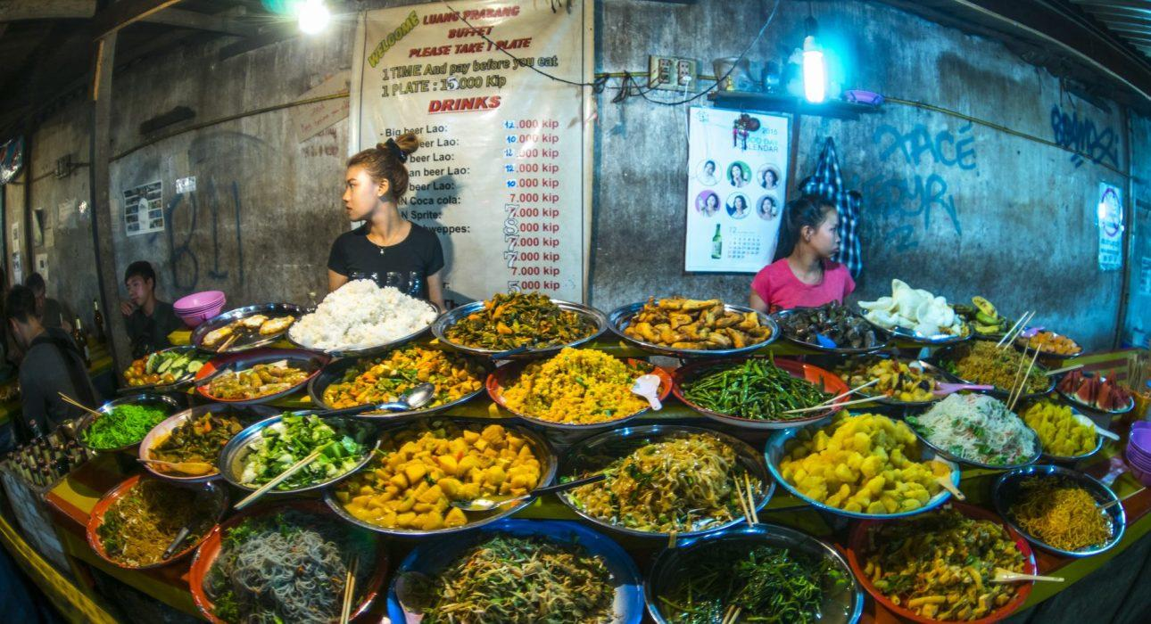

Over View

Theme
Classic, Gastronomy, Sustainable

Country - City
Laos - Luang Prabang

Market segment
Thematic Leisure

Price Level
$

Max pax
12

Seasonality
All year round

Arrival city
Luang Prabang

Departure city
Luang Prabang

Description

Stimulate the senses by taking an evening walking food tour with a local guide while sampling some of the country’s most famous delicacies. The adventure will start with local snacks, Khaojee Lao (bbq skewer of sticky rice mixed with egg), Ping Khai (barbecued egg) and Ping Kwai (barbecued banana). The next stop is directly in the food street of the Night Market. Comfortably seated, it will be time for a delicious bowl of one of the staples of Lao cuisine – Khao Soi or Khao Piak (amongst the most popular dishes in Laos). There will also be Nem Khao (rice crepe stuffed with vegetables), Lao Omelette and Luang Prabang sausage to share and taste. The walk then continues to the sweet stop: fried coconut pancake and Khao Nom Kok (mini coconut cake cooked in a waffle iron). The final leg of the tour will take travelers on the terrace overlooking the night market’s food court, where they will enjoy a refreshing drink, Beerlao or soft drink.

Selling points

- A sustainable local activity that allows travelers to directly support the local community.
- An ideal activity to do in the evening before a visit to the famous night market.
- The walk takes travelers to parts of the city they may not usually get the chance to see.

Sustainability

Level Of The Excursion
High – This activity strongly supports local communities and/or helps preserve the culture and environment

The Impact Of This Excursion

Social/cultural Impact
Cultural Conservation, Empowerment and education

Economic Impact
Local individual benefits, Community benefits

Time And Transportation

The tour starts at the crossing in front of the night market’s food court.

Photos

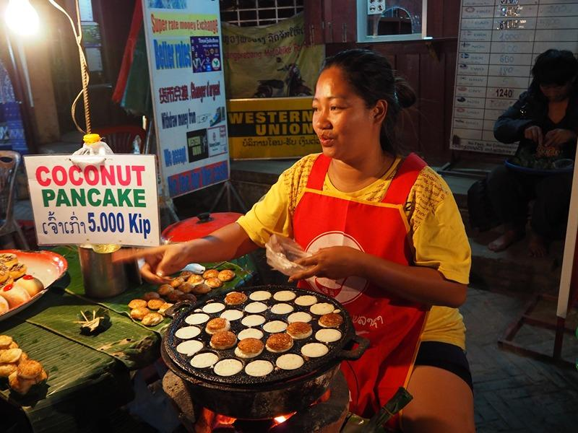
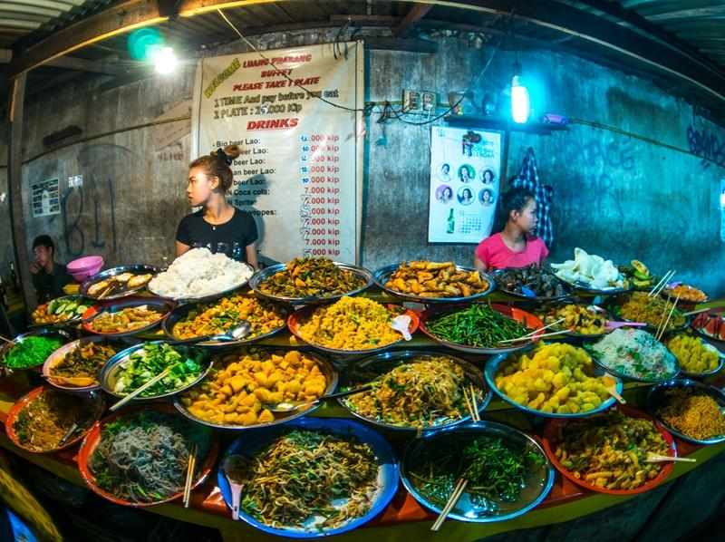
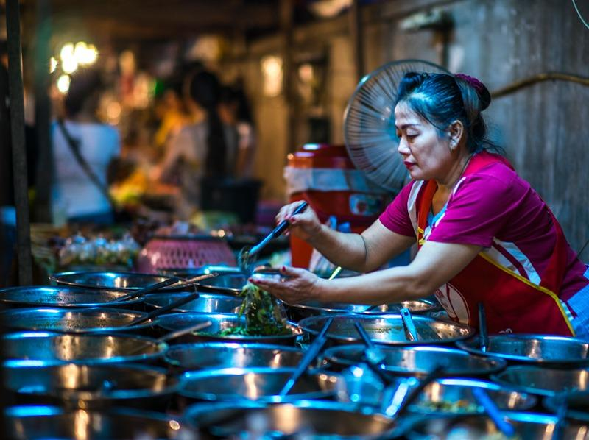
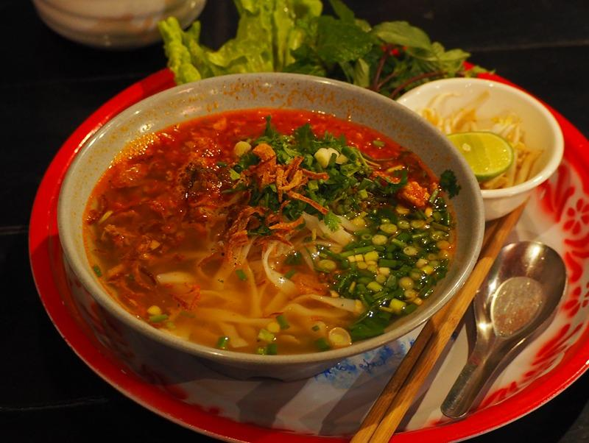
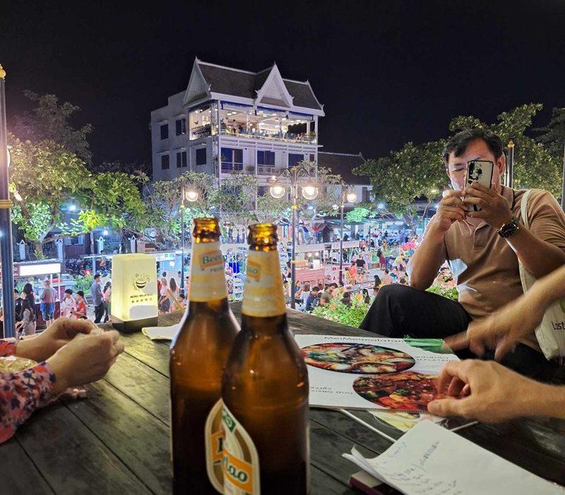
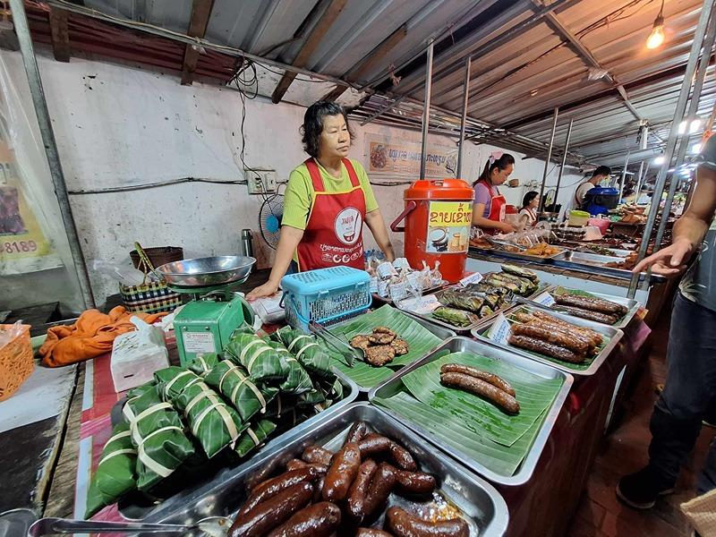
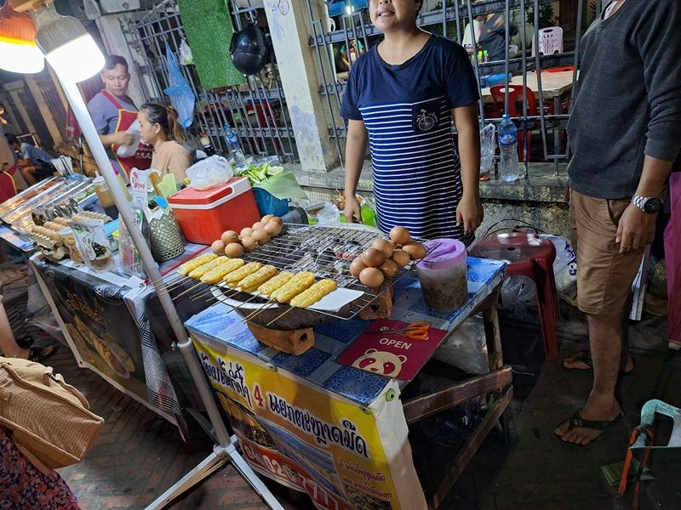
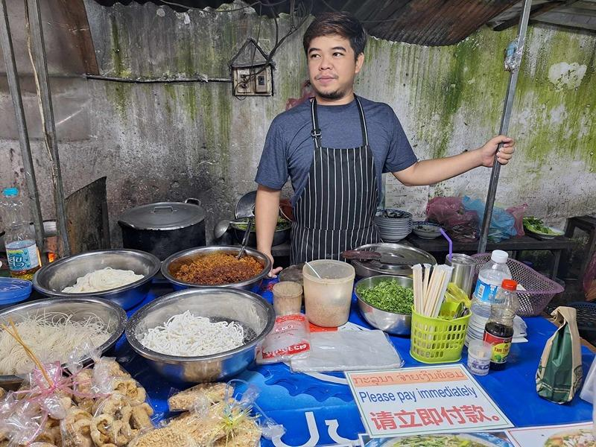
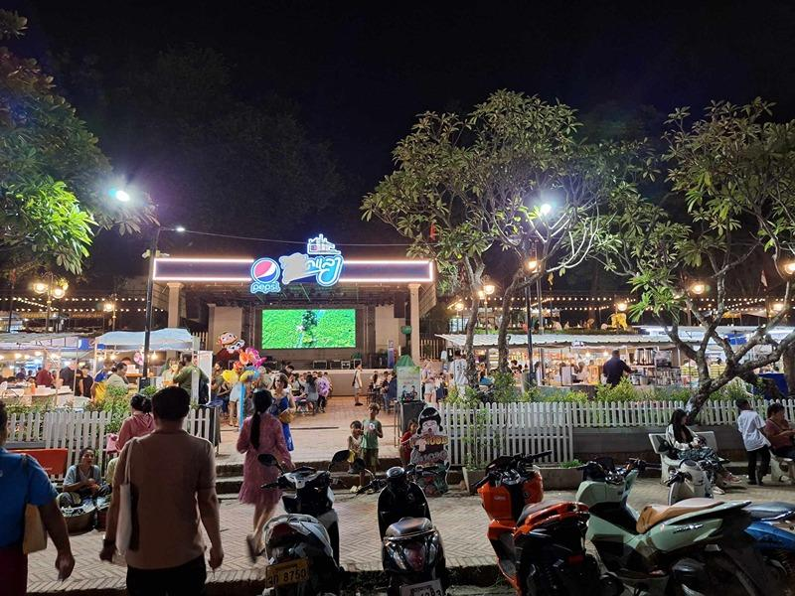

Easia Travel Head Office

Vietnam Head OfficeC/o: ATS Hotel, Suite 326 &327, 33B Pham Ngu Lao Street, Hanoi, VietnamTel: +84 24-39 33 13 62www.easia-travel.com

