MYANMAR – Dawei – Jungle Trail and Forest Spa
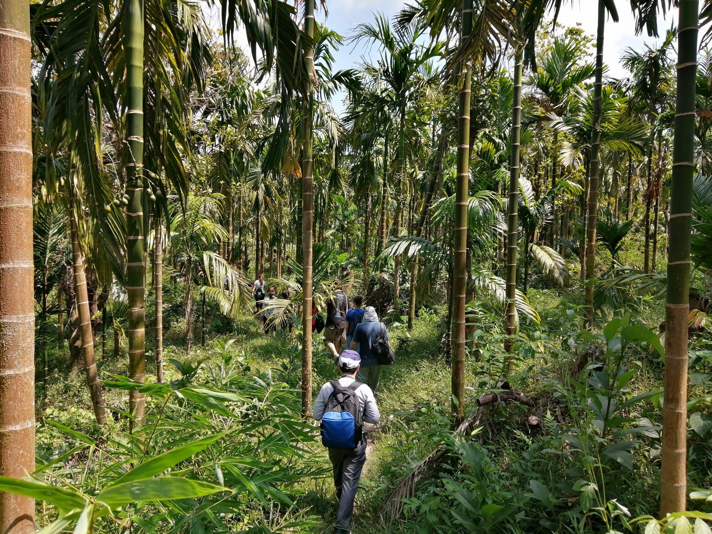

Over View

Theme
Beach Stay, Classic, Family, Sustainable, Wellness

Country - City
Myanmar - Dawei

Market segment
Groups, Thematic Leisure

Price Level
$$

Max pax
1 person

Seasonality
20 persons

Arrival city
Dawei

Departure city
Dawei

Description

Villagers will be leading this excursion inside the jungle surrounding their village. They know the flora by heart and will explain which plant is used for which medicine. The path then crosses the river a few times, allowing for refreshing swimming break. A lunch of local specialties will be served by the rive on a makeshift bamboo picnic table. The last stretch of the walk will be running along the river before reaching the highlight of the day: a low key, natural spa, set up in the jungle!

Can be combined with
Thematic Leisure
Dawei – Fishing experience at Tizit BeachDawei – Moscos Island Snorkeling TripDawei – Dawei Arts and Crafts

Selling points

- The Forest Spa is a real highlight of the program: simple spa completely set up in the middle of nature
- Ka Lone Thar Village is completely off the beaten tracks – offered by no other local operator
- A real connection to nature
- Picnic lunch set up by the river: zero plastic policy and fresh local dishes
- The program is organized from A to Z by the villagers committed to Dawei CBT
- The project is supported by ITC – which already has a good reputation for their project in Loikaw
- The opportunity to discover a rarely explored side of Dawei and to balance a program and not only focus on the beach

Time And Transportation

From | To | Distance | By | Duration | Road Condition
Dawei | Ka Lone Thar Village | 35 kilometers | Car | 1h 30min | Good tar road and small dirt tracks towards the end

Photos

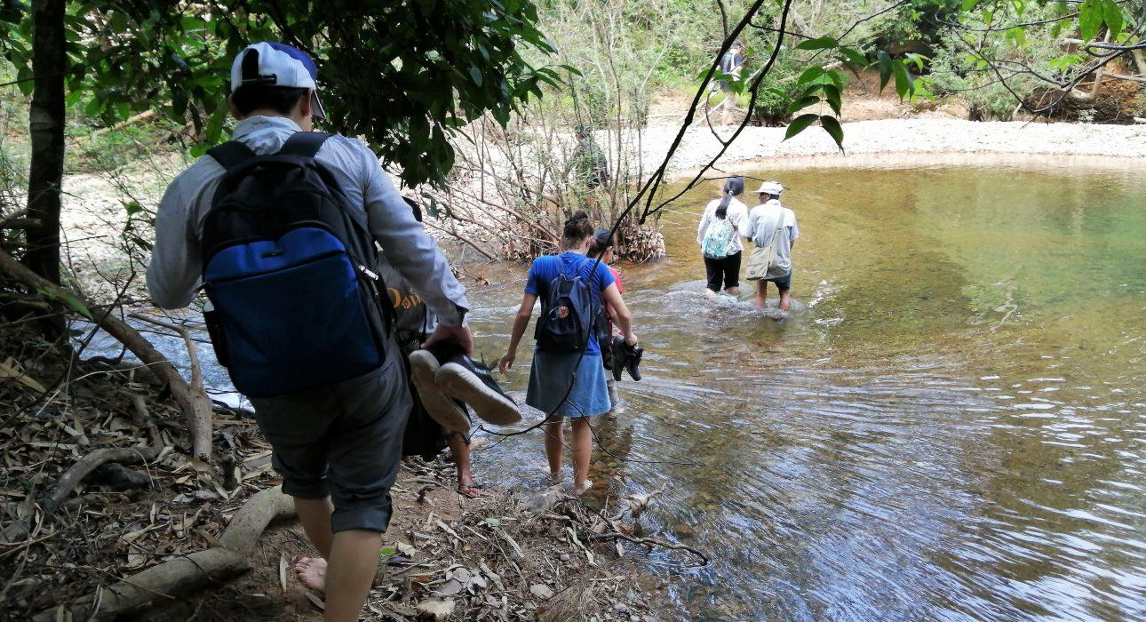
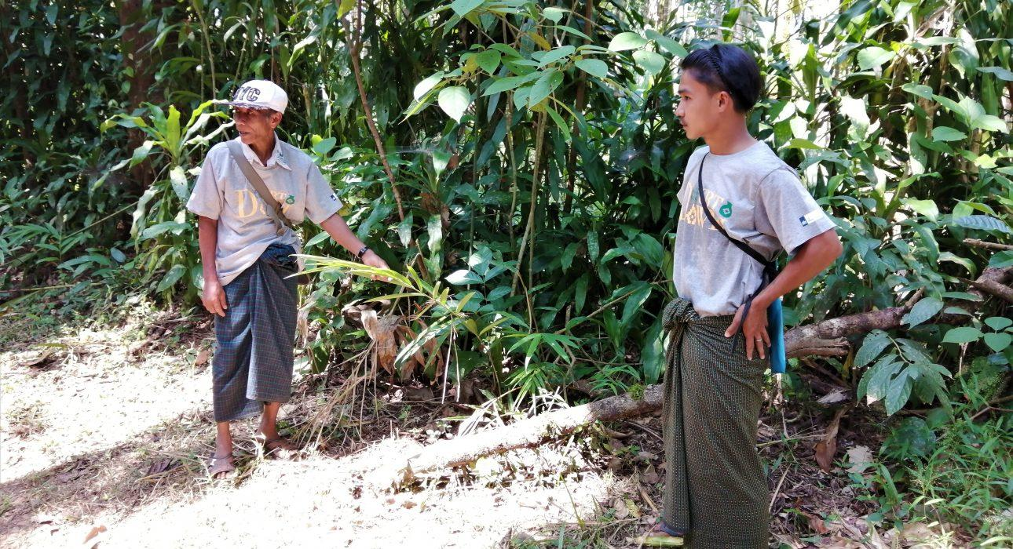
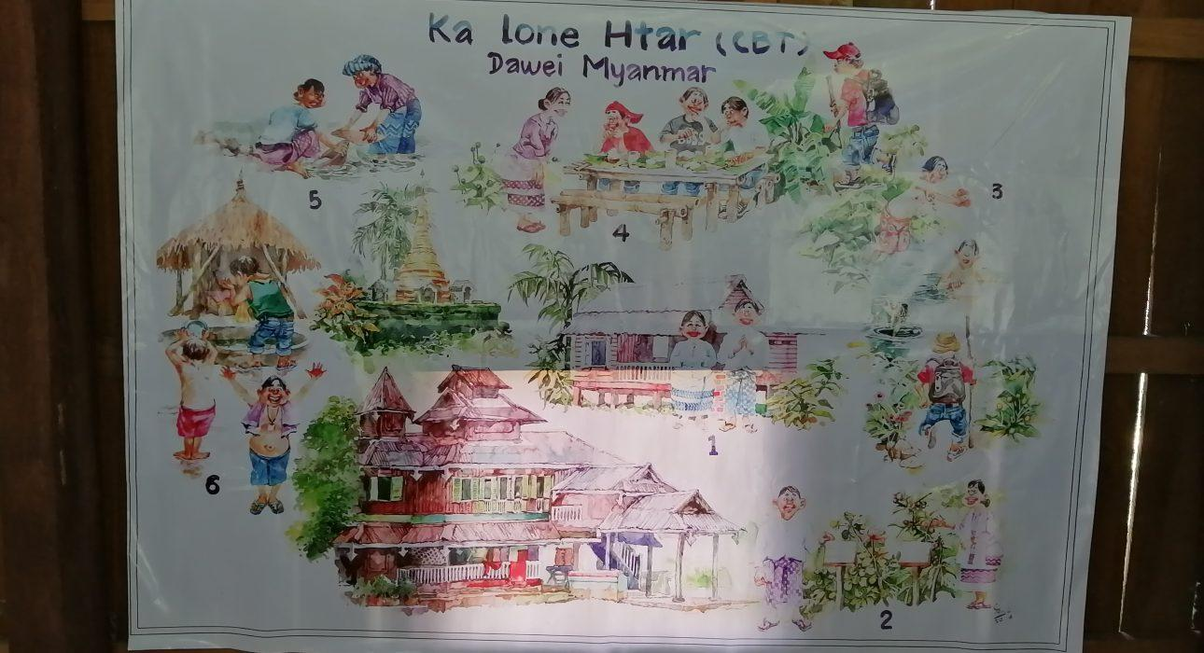
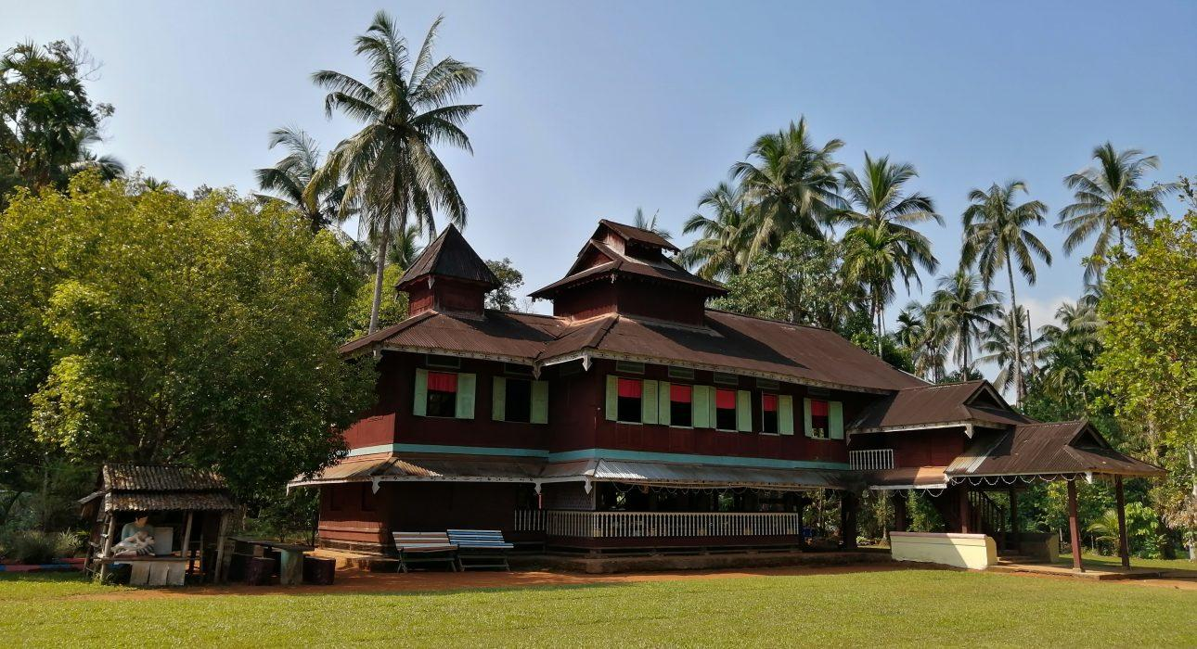
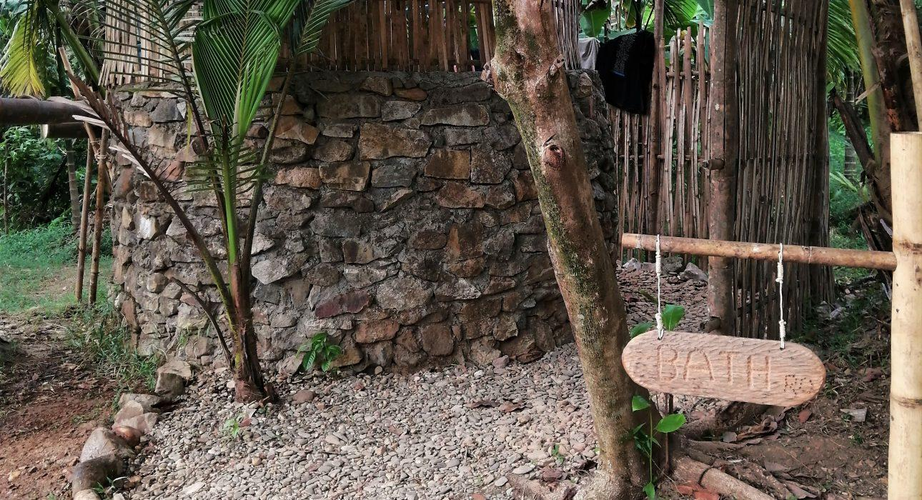
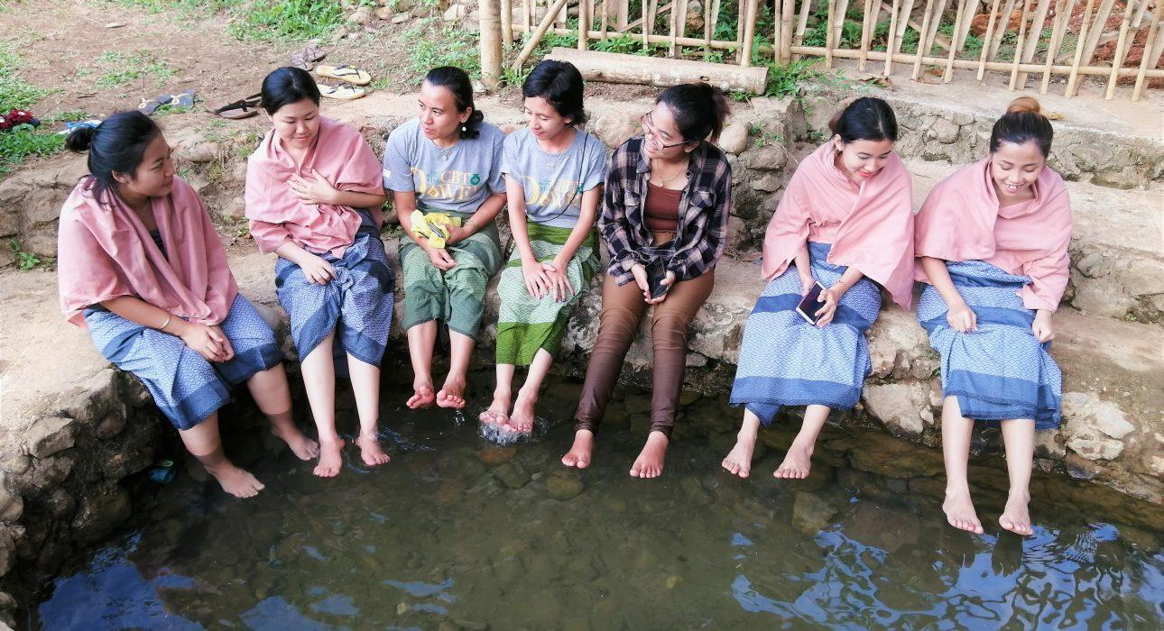
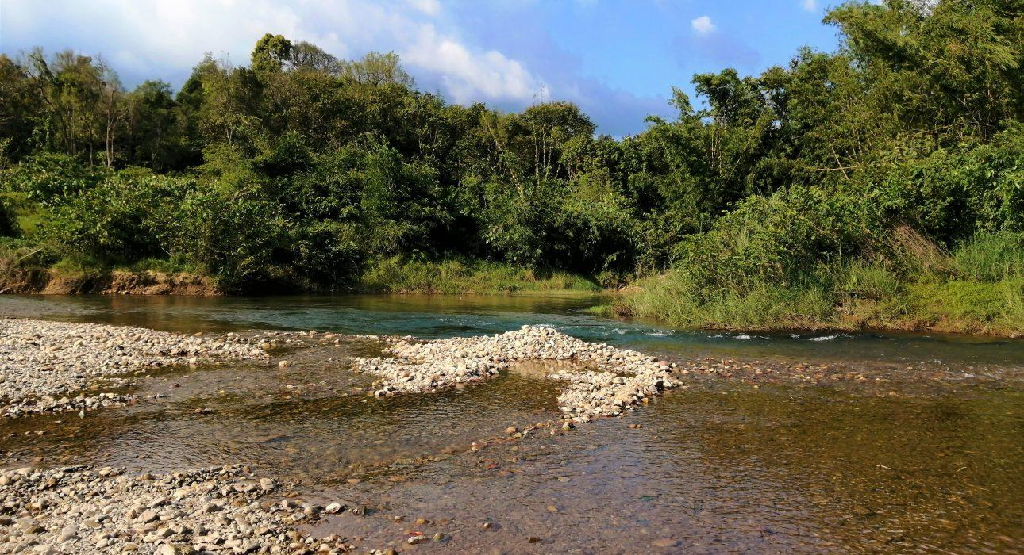
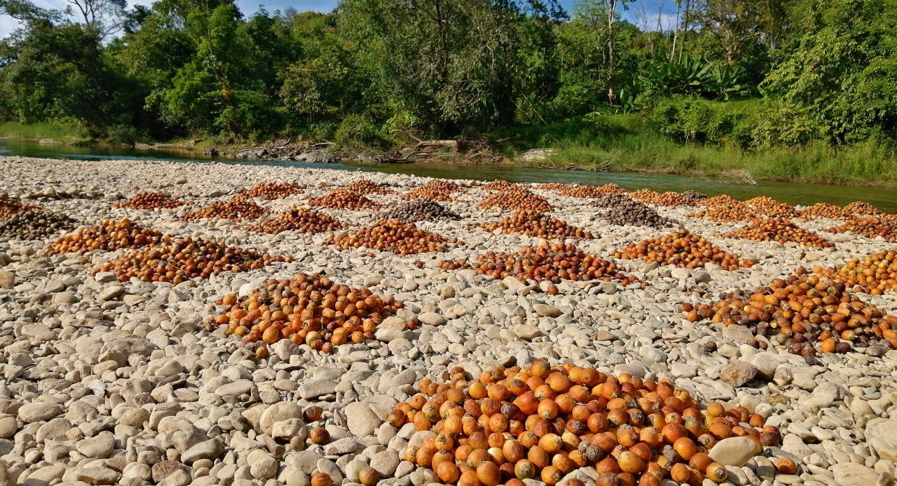
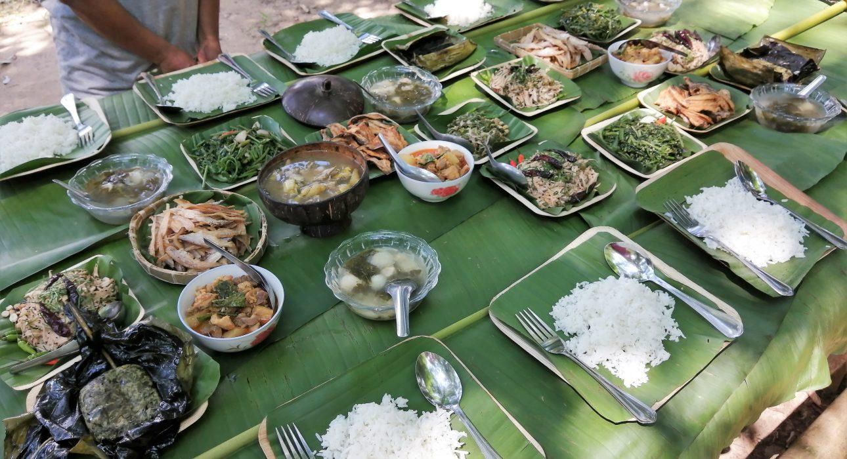

Easia Travel Head Office

Vietnam Head OfficeC/o: ATS Hotel, Suite 326 &327, 33B Pham Ngu Lao Street, Hanoi, VietnamTel: +84 24-39 33 13 62www.easia-travel.com

