MYANMAR – Bagan – Discover Bagan by Bike
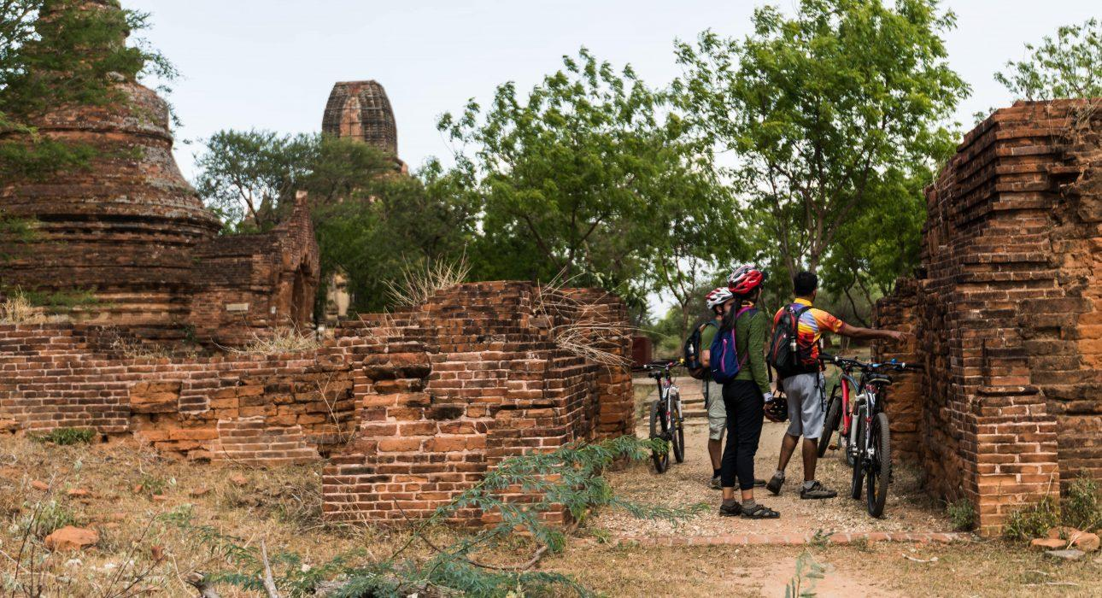

Over View

Theme
Classic, Family, Sustainable

Country - City
Myanmar - Bagan

Market segment
Groups, Thematic Leisure

Price Level
$$

Level of difficulties
LEVEL 1

Max pax
30

Seasonality
All year round

Arrival city
Bagan

Departure city
Bagan

Description

The archaeological plain of Bagan spreads on kilometres of dusty lanes, sandy paths and countryside roads allowing bike enthusiast to get lost for hours in this intricate labyrinth and discover hidden temples at every corner or stopping by a village and sharing a cup of tea with the inhabitants. Whether with one of our expert guide or at leisure, itineraries go from 10 to 40 kilometers around the plain, making this excursion accessible for all fitness profiles.

Can be combined with
Thematic Leisure
Bagan – Cooking class with a local familyBagan – Visit to Taungbi LibraryBagan – Sandbank Cocktail

Selling points

- Flexible itinerary and schedule: several itineraries from 10 to 30-40 kilometers
- Suitable for different profiles of clients: less active and sports lovers
- Slow travel – access to back roads inaccessible by car and immerse deeper in the local life
- Suitable for families: children bike and seat available
- Alternative to electric scooter for clients who don’t feel comfortable driving

Time And Transportation

From | To | Km | By | Duration | Road condition
New Bagan | Old Bagan | 7 | Mountain Bike | 30 minutes | Good tar road
Old Bagan | Nyaung Oo | 10 | Mountain Bike | 60 minutes | Good tar road
Nyaung Oo | New Bagan | 10 | Mountain Bike | 60 minutes | Good tar road

Photos

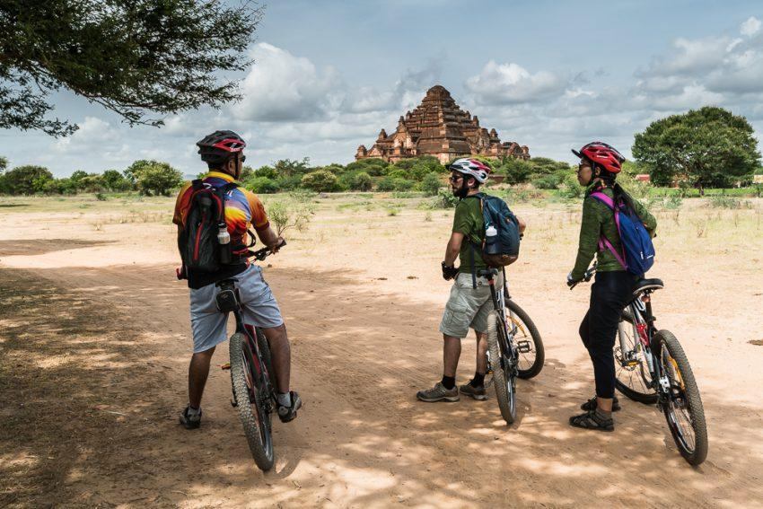
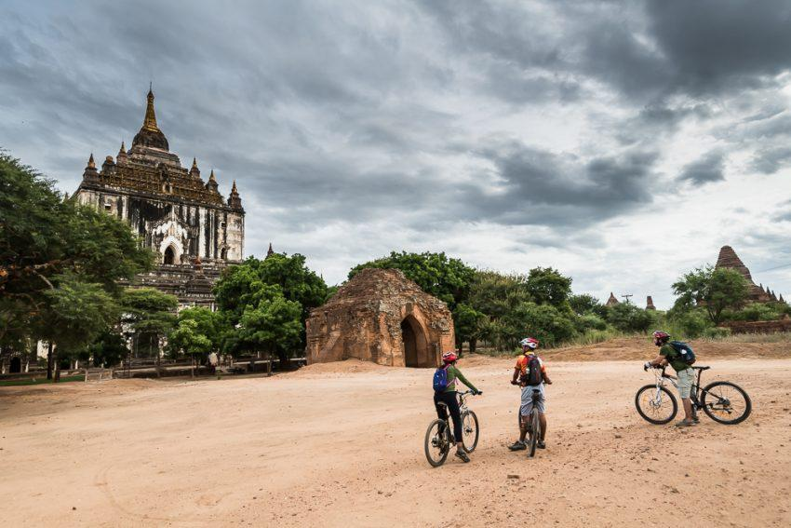
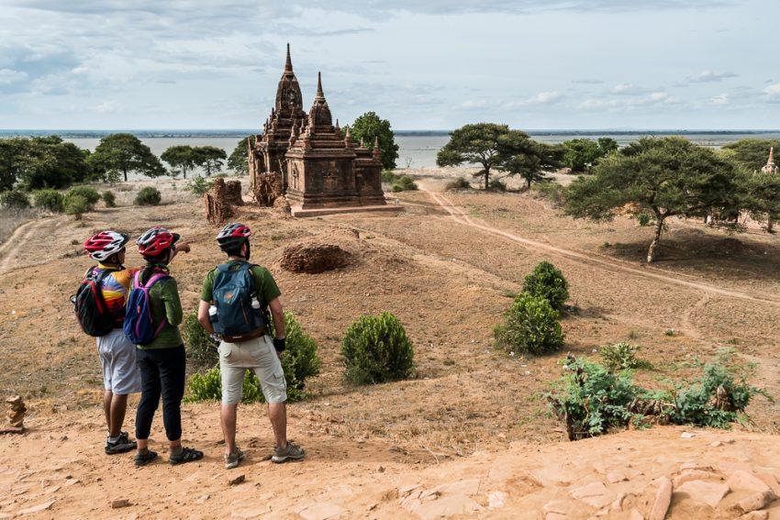
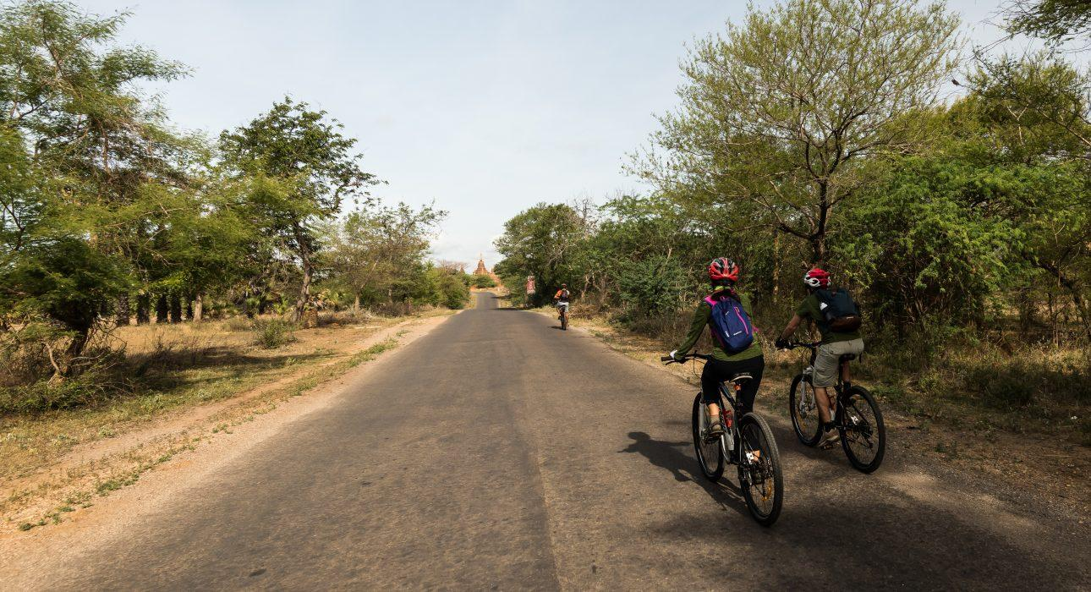
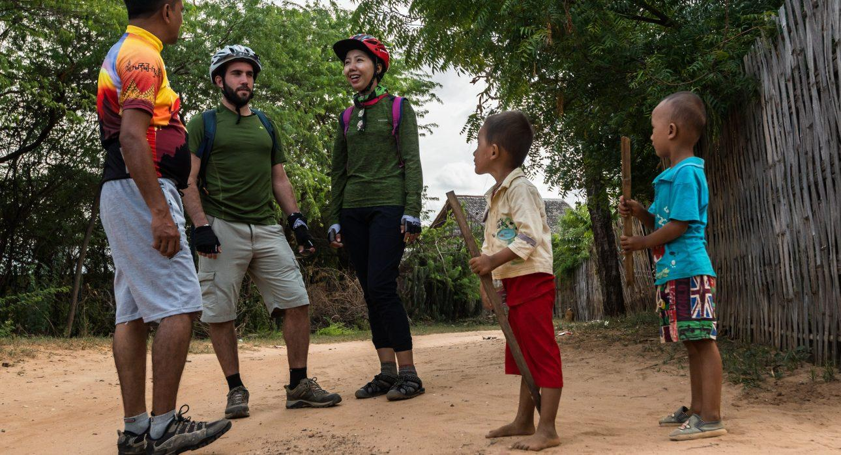

Easia Travel Head Office

Vietnam Head OfficeC/o: ATS Hotel, Suite 326 &327, 33B Pham Ngu Lao Street, Hanoi, VietnamTel: +84 24-39 33 13 62www.easia-travel.com

