MYANMAR – Dawei – Tizit Beach: Sunset Fishing Experience
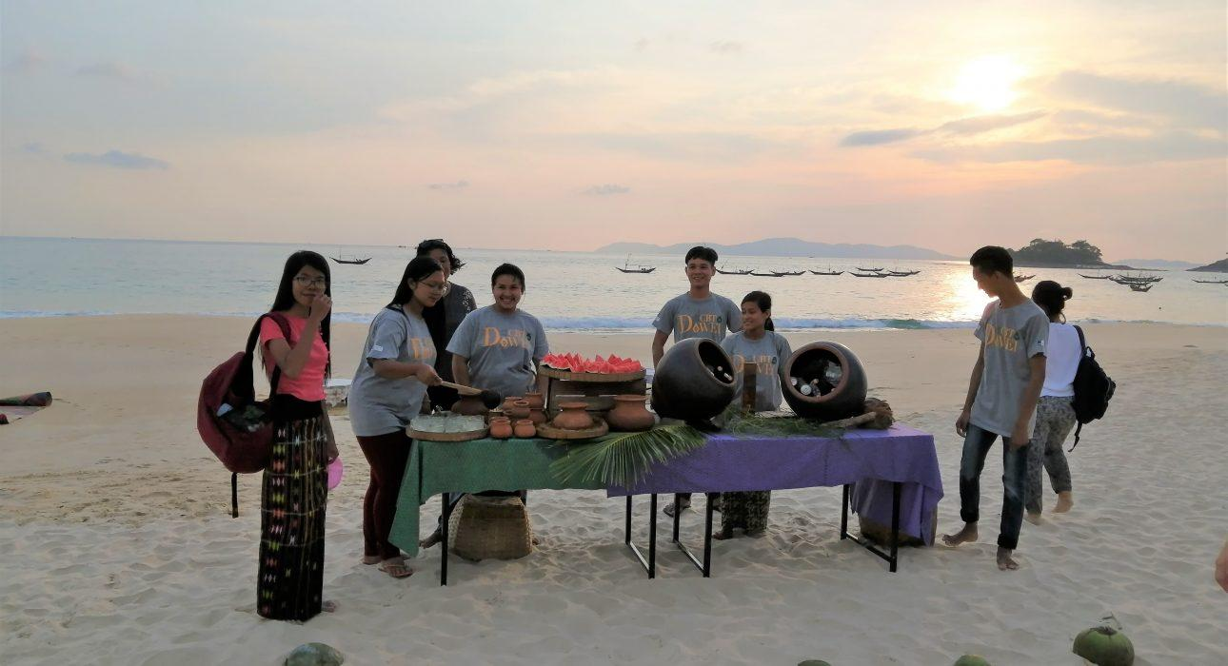

Over View

Theme
Beach Stay, Family, Sustainable

Country - City
Myanmar - Dawei

Market segment
Groups, Thematic Leisure

Price Level
$$$

Max pax
20 persons

Seasonality
October to April

Arrival city
Dawei

Departure city
Dawei

Description

This half-day excursion is the occasion to spend a few hours in company in the fishermen community of Tizit village, testing some traditional techniques to cast a fishing net at high tide or to dig for shellfish at low tide. After a tea break with the villagers, everyone heads to the lagoon for a hands-on fishing experience. The day ends with a refreshing swim on a deserted beach at sunset before enjoying fresh grilled sea food on the beach.

Can be combined with
Thematic Leisure
Dawei – Moscos Island Snorkeling TripDawei – Jungle trail and Forest SpaDawei – Dawei Arts and Crafts

Selling points

- The seafood picnic is flawless: very fresh seafood, big portions and zero plastic policy. On top of it, it is set up on the beach from where you can admire a perfect sunset
- Connect with the fishermen community who will show you their traditional fishing tools and welcome you in their village
- A local experience which has a much more social side than a traditional beach tour
- The program is organised from A to Z by the villagers committed to Dawei CBT
- The project is supported by ITC – which already has good reputation for their project in Loikaw

Time And Transportation

From | To | Distance | By | Duration | Road Condition
Dawei | Tizit Beach | 30 kilometers | Car | 1 hour | Good tar road and dirt tracks towards the end

Photos

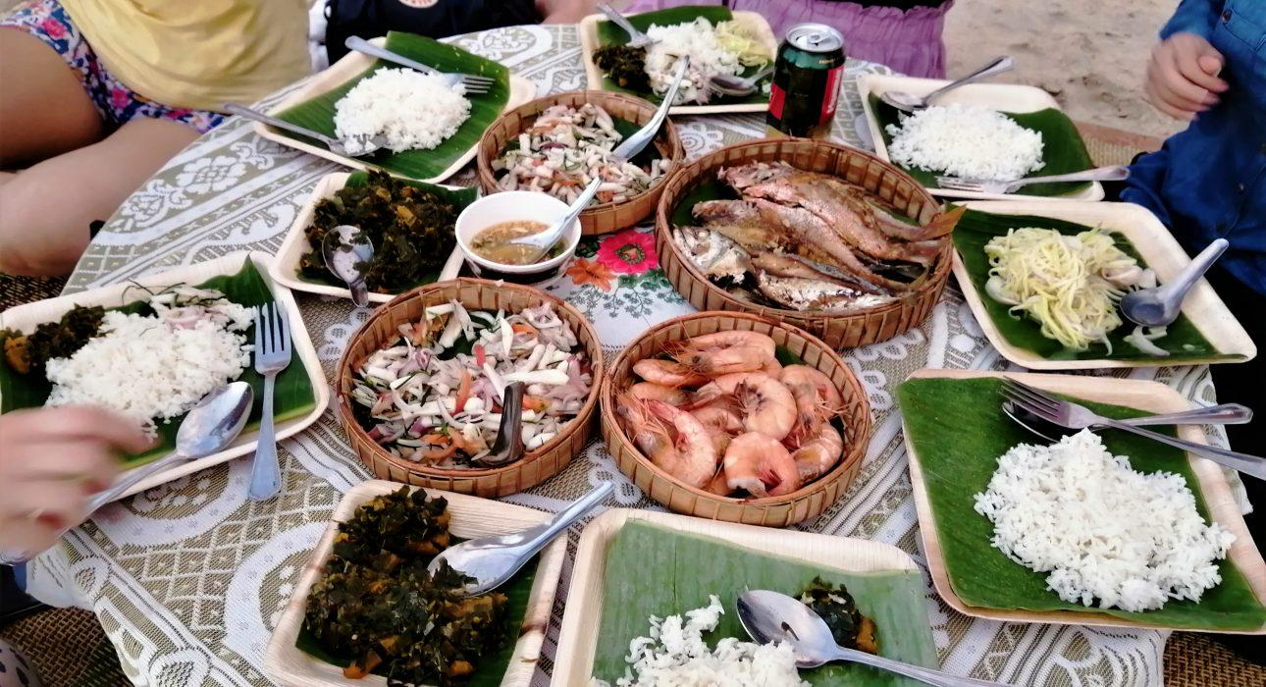
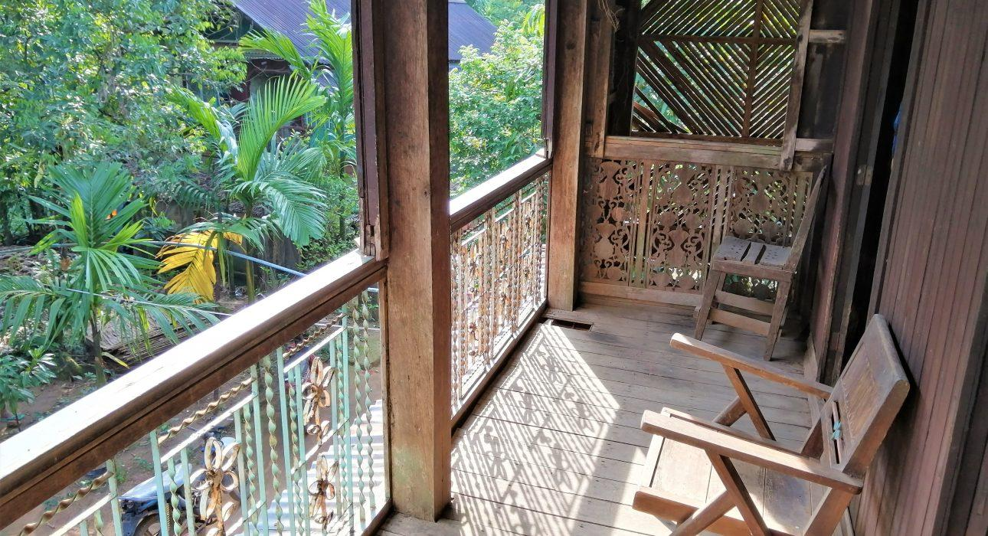
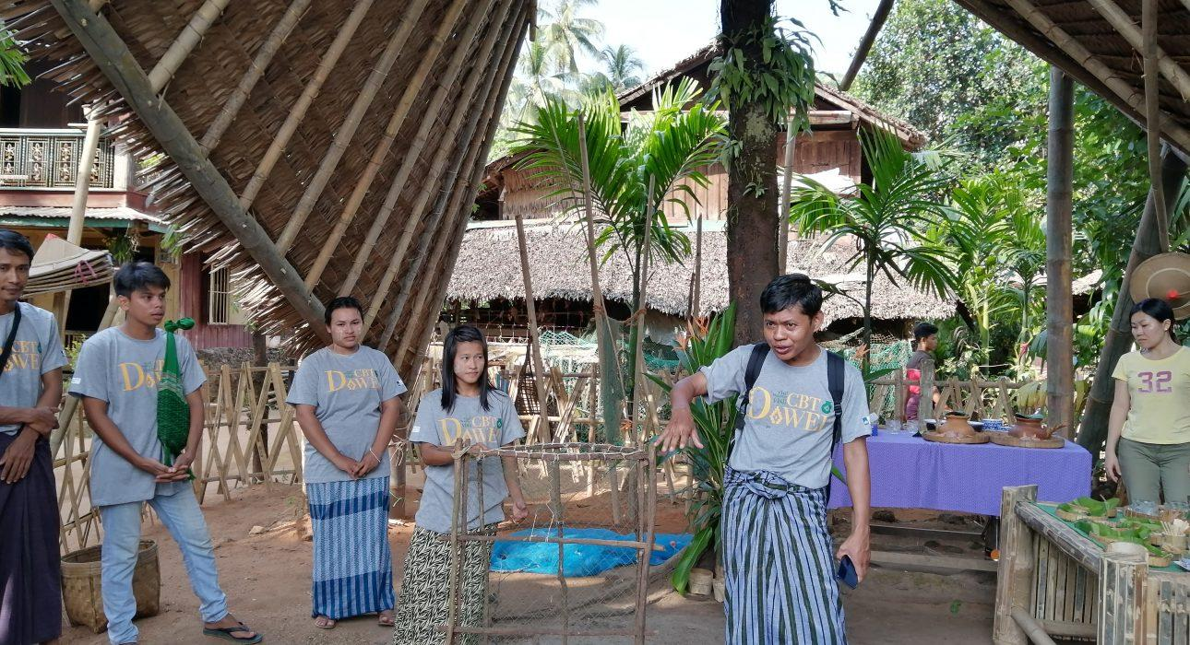
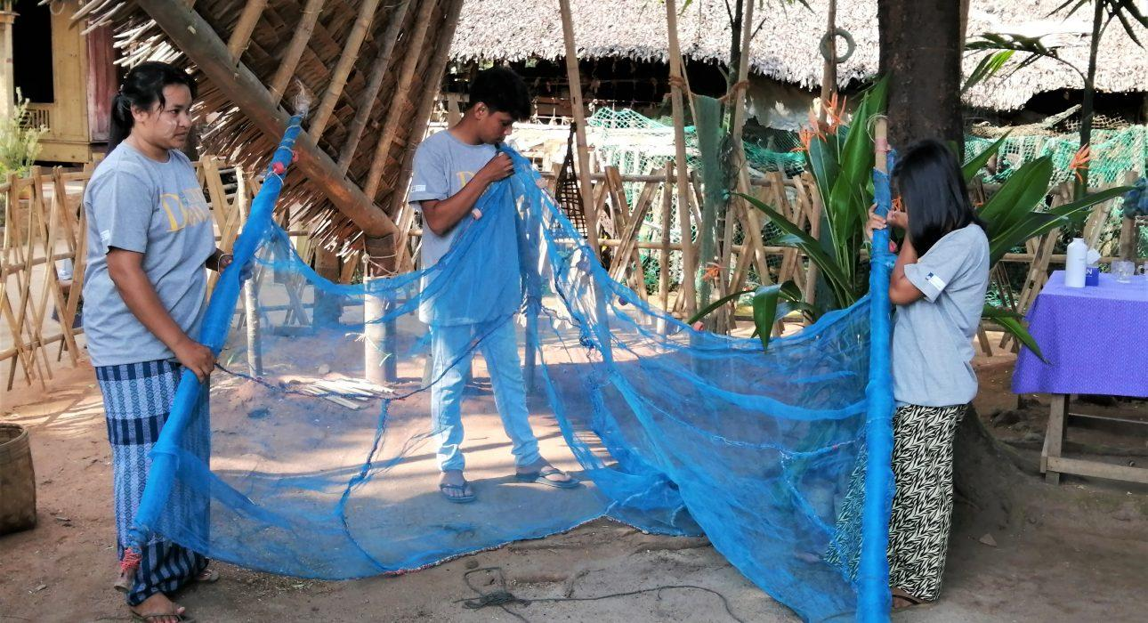
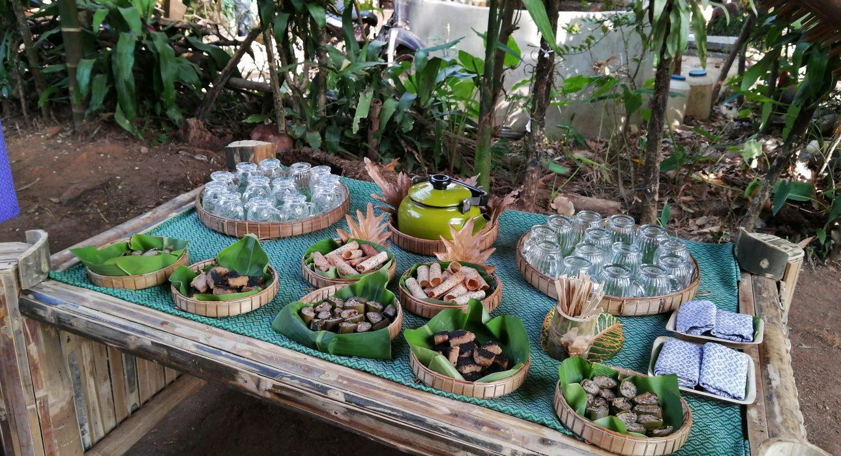
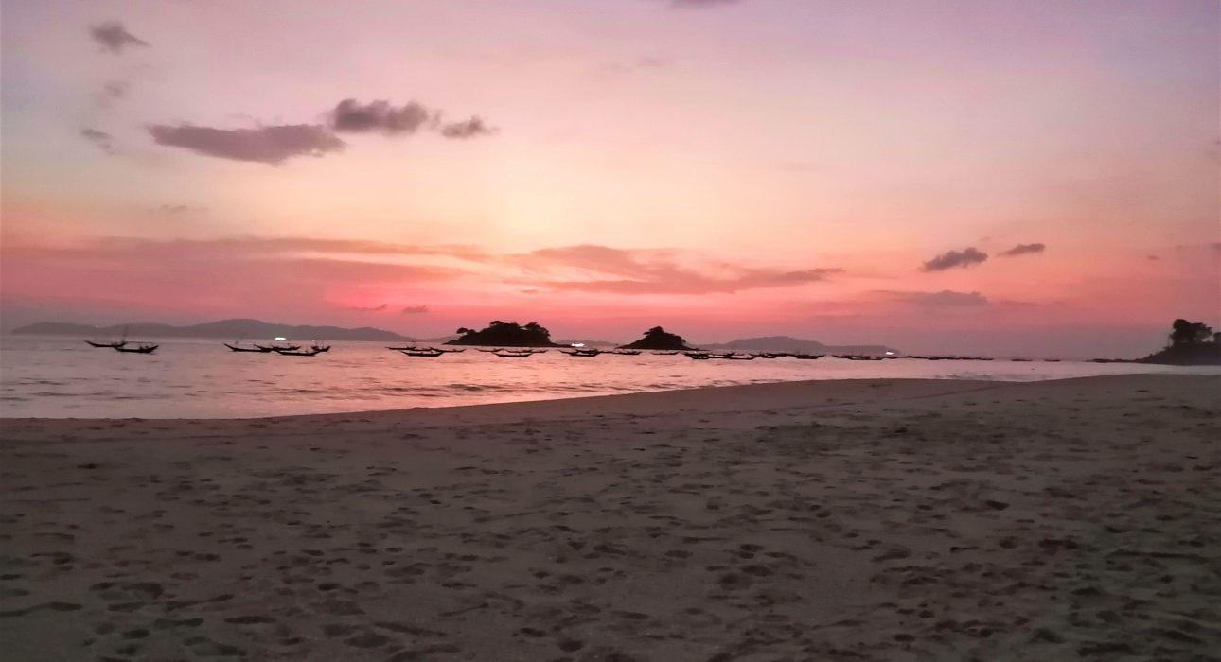
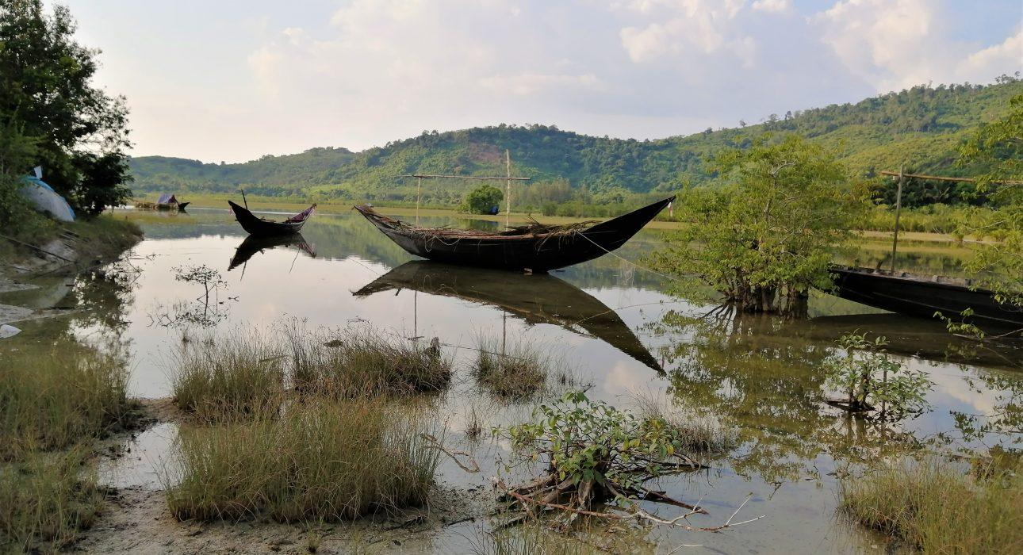
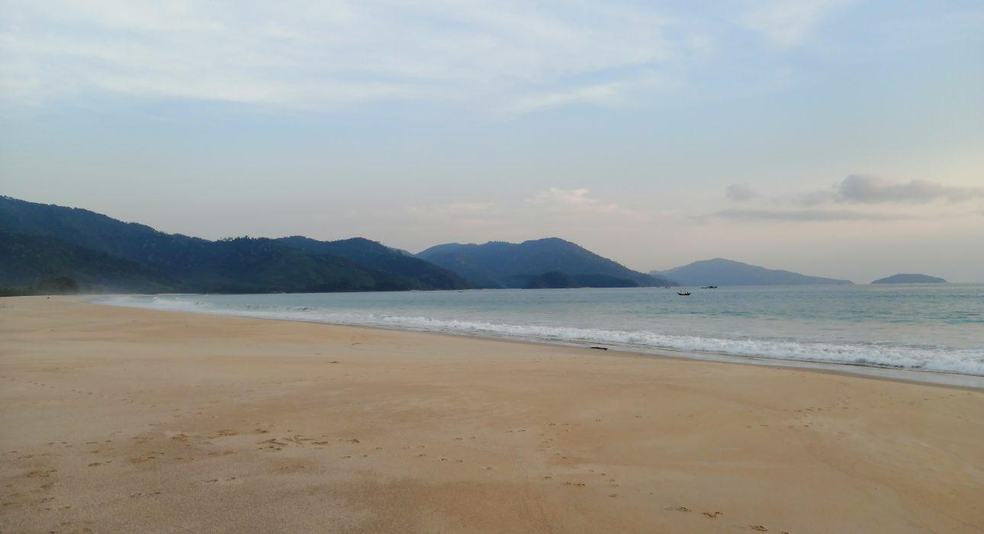
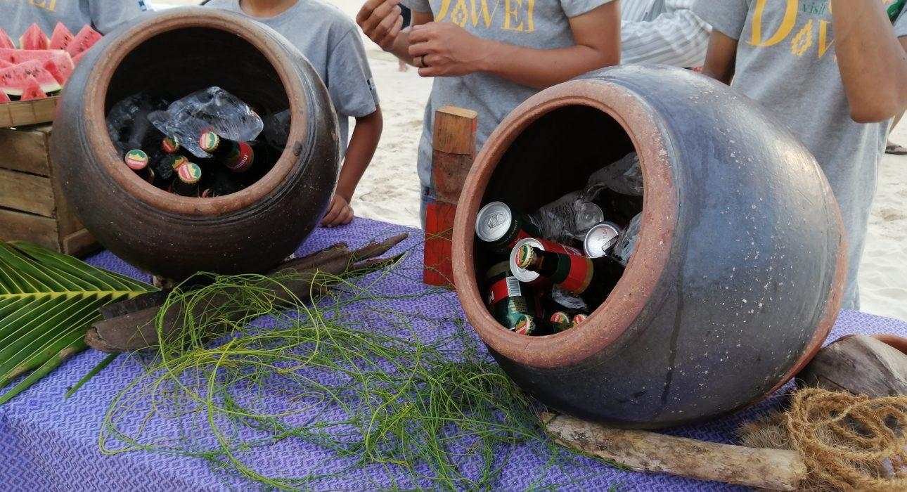
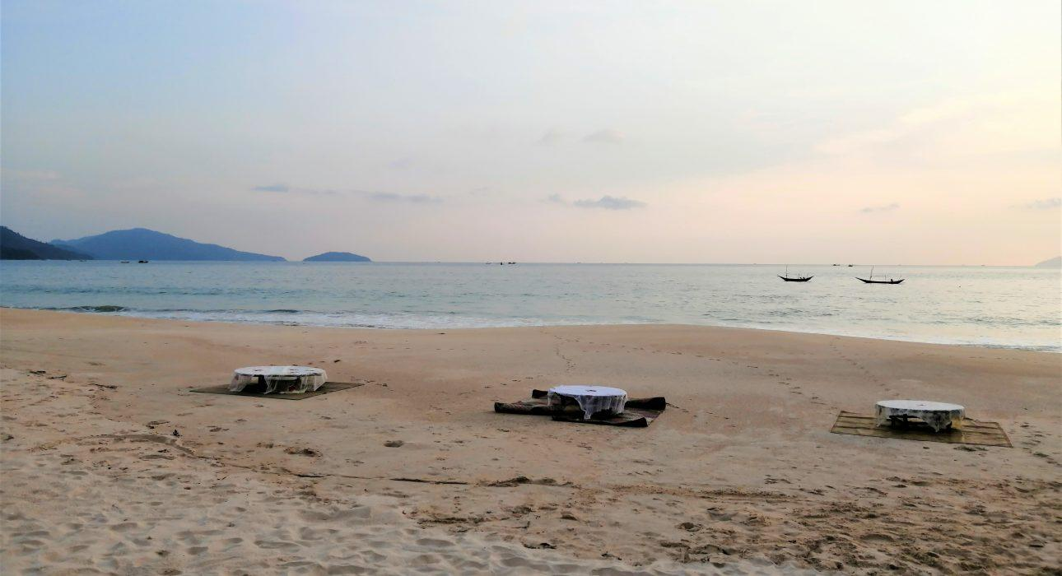

Easia Travel Head Office

Vietnam Head OfficeC/o: ATS Hotel, Suite 326 &327, 33B Pham Ngu Lao Street, Hanoi, VietnamTel: +84 24-39 33 13 62www.easia-travel.com

