MYANMAR – Dawei – Dawei Arts and Crafts
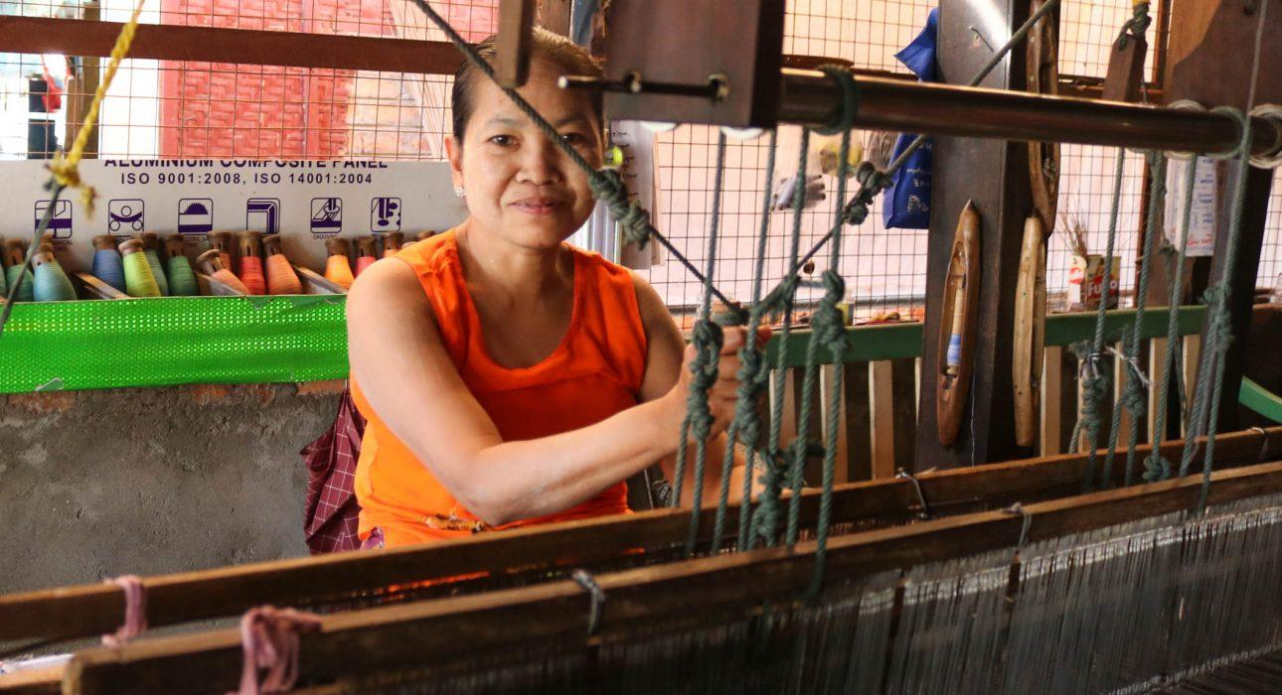

Over View

Theme
Art & Culture, Classic, Family

Country - City
Dawei

Market segment
Thematic Leisure

Price Level
$$

Seasonality
Best advised from September to March // possible all year long

Arrival city
Dawei

Departure city
Dawei

Description

This tuk tuk tour brings the travellers from one corner of Dawei to the other, meeting with local artisan, each expert in their craft, from wood working to weaving, broom making or fish cracker cooking. If some crafts are traditional to Myanmar in general, other more specialised workshop produce very local products. In both cases, this Craft Dawei guarantees genuine encounters in family workshops far away from the idea of the usual “souvenir” workshop.

Can be combined with
Thematic Leisure
Dawei – Fishing experience at Tizit BeachDawei – Moscos Island Snorkeling TripDawei – Jungle trail and Forest Spa

Selling points

- The tuk tuk ride gives travelers the opportunity to take pictures of the beautiful wooden houses typical of Dawei
- Some lesser-known and seasonal crafts are discovered, such as: broom making, cashew nut, fish crackers, etc. (program varies according to the time of the year and the time of day)
- A perfect introduction to the relaxing vibe of Dawei before exploring its empty beaches in the following days
- Family workshops, completely non-touristy: walk inside homes of Daweian and learn about their family stories and art
- A refreshing alternative to workshops in the rest of the country – if you visit other regions of the country, keep the workshop visit for Dawei as some crafts could be similar (cheerots, wood carving)
- Excellent activity for clients who like photography
- Suitable for families with children: the tuk tuk ride is fun and the workshops are interactive!

Time And Transportation

Photos

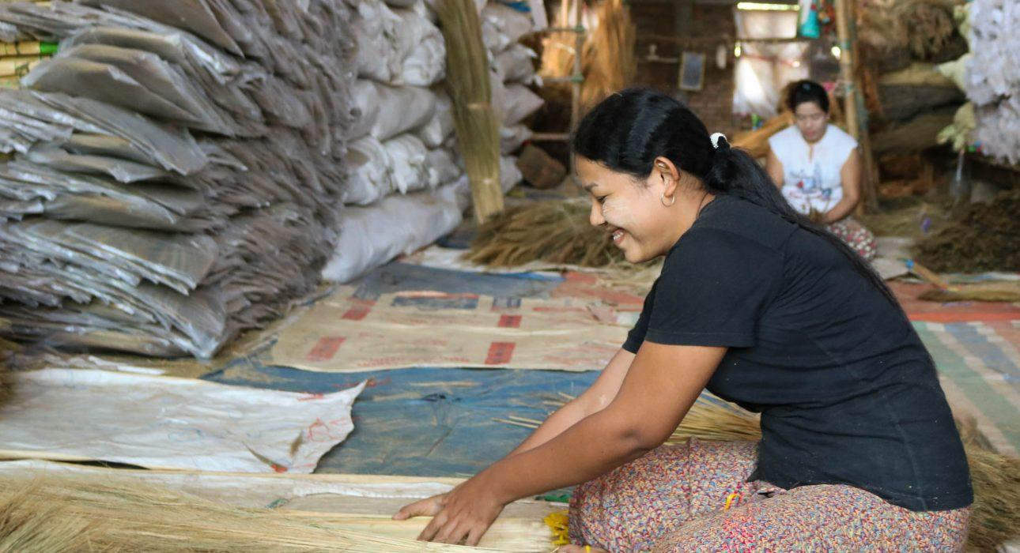
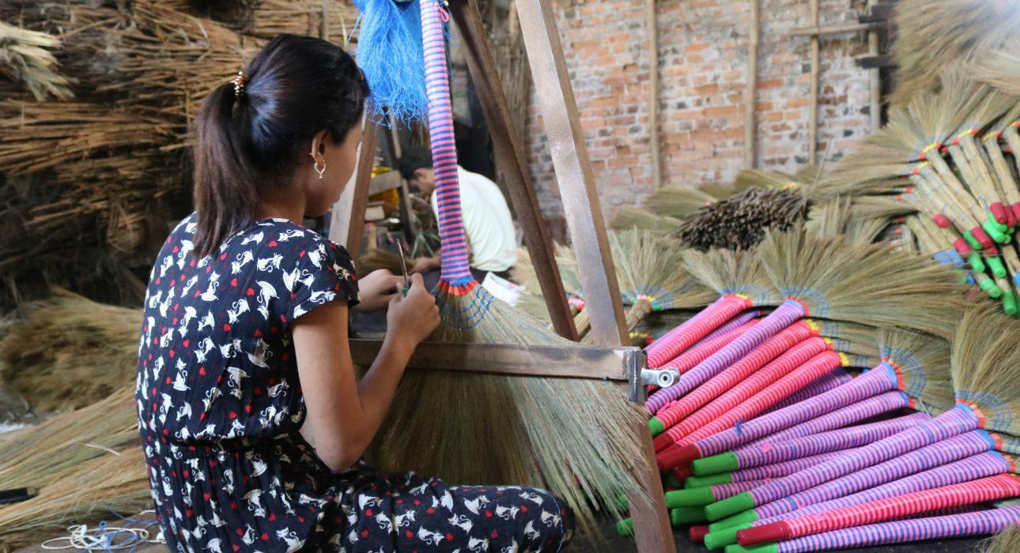
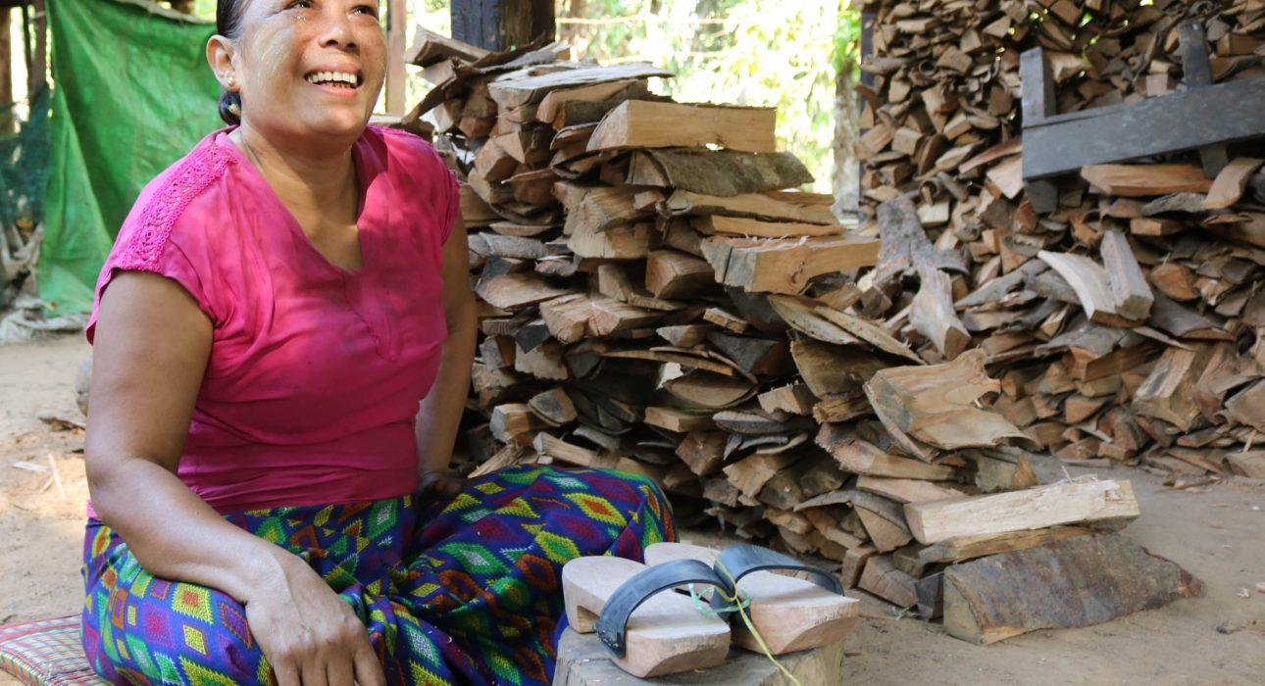
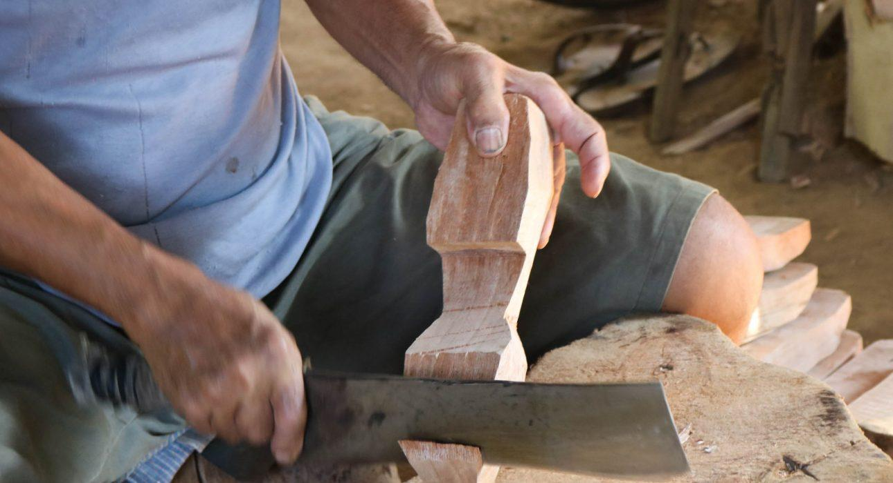
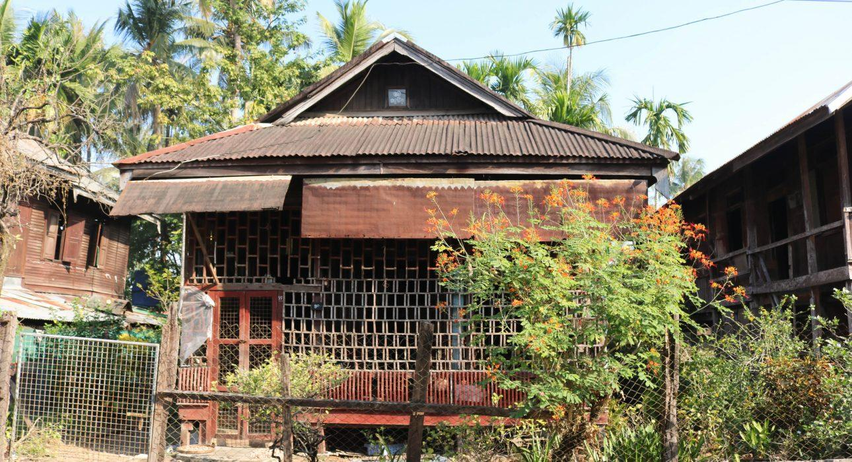
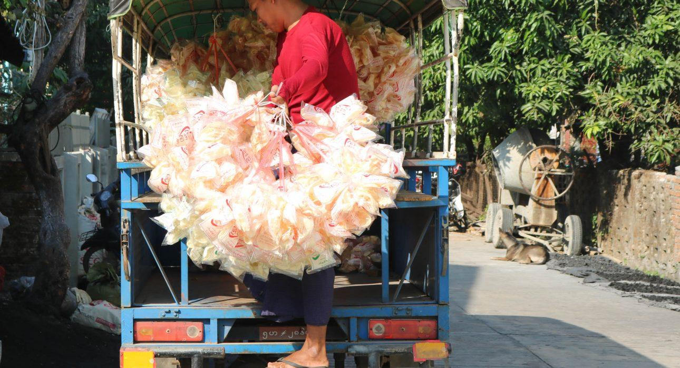
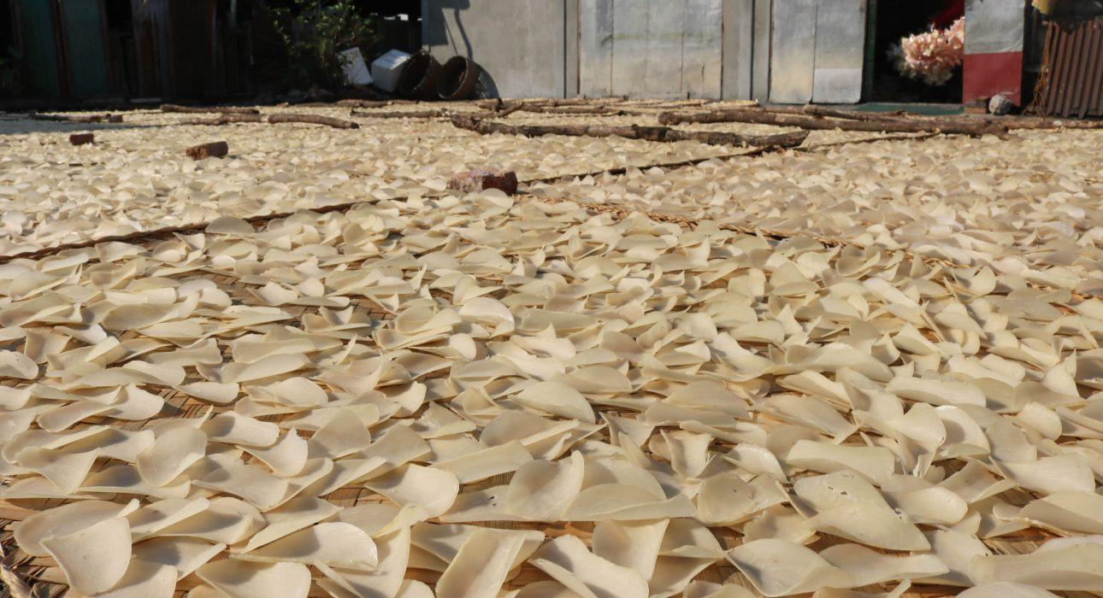
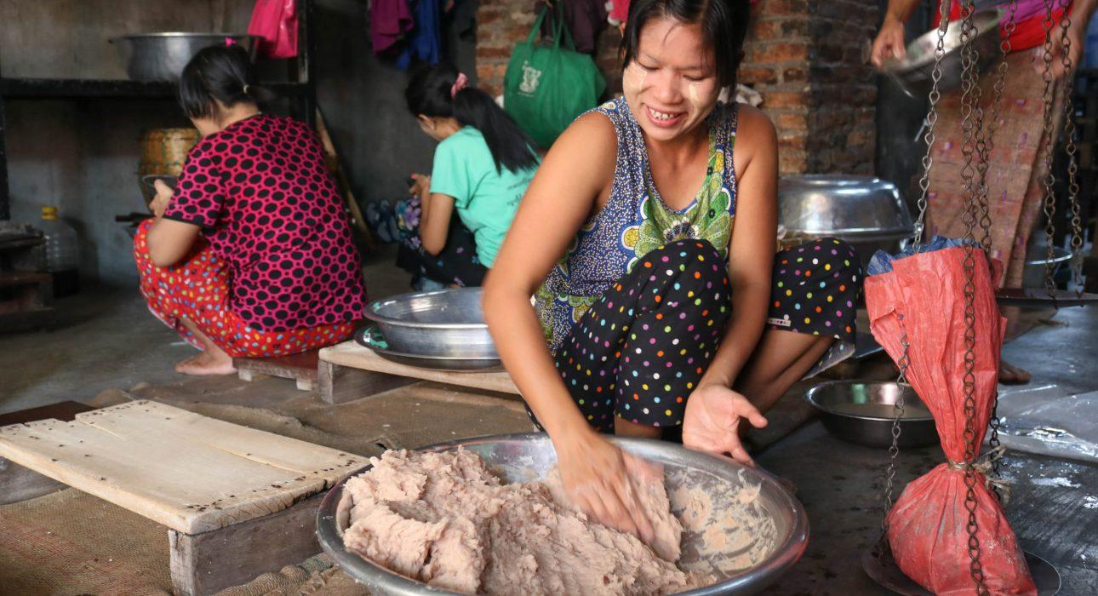
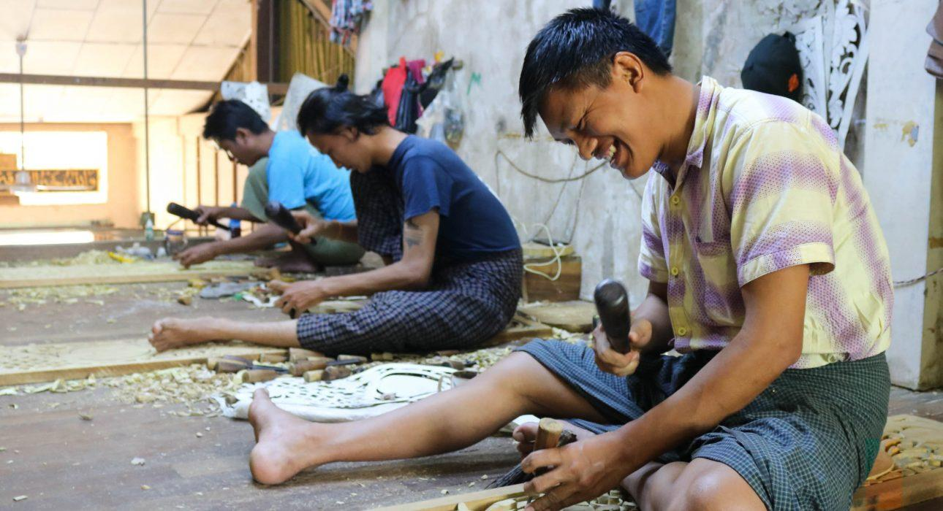
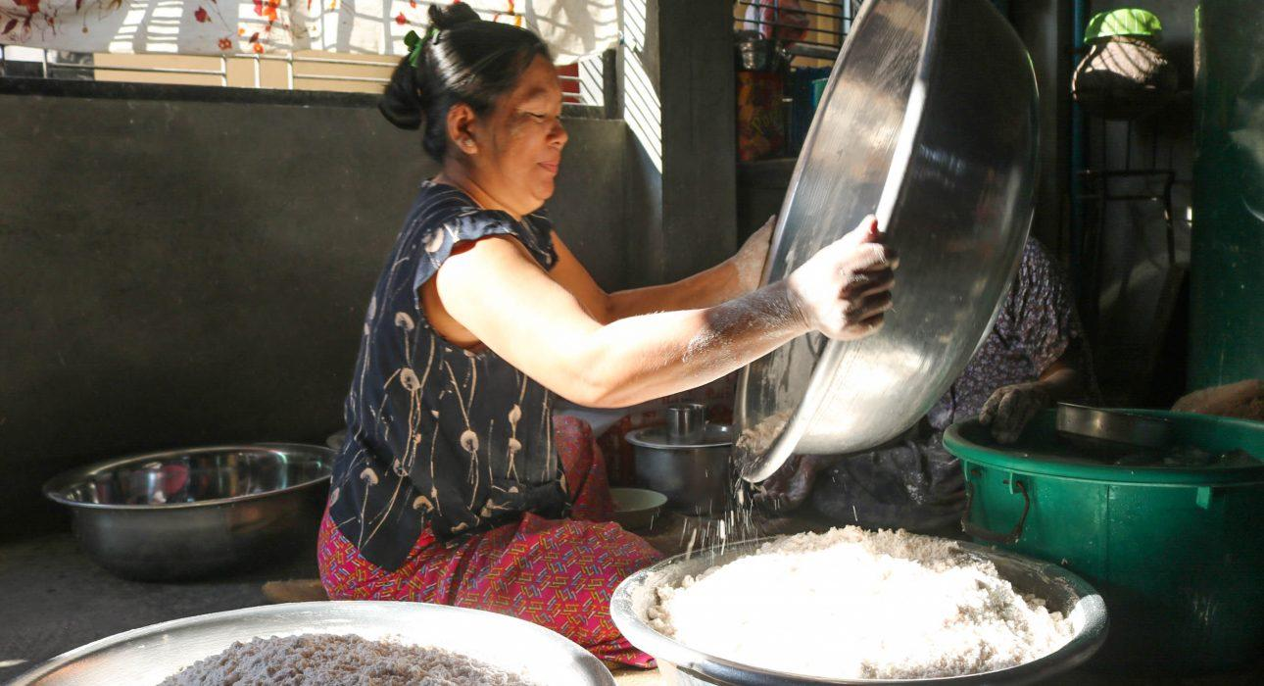

Easia Travel Head Office

Vietnam Head OfficeC/o: ATS Hotel, Suite 326 &327, 33B Pham Ngu Lao Street, Hanoi, VietnamTel: +84 24-39 33 13 62www.easia-travel.com

