THAILAND – Udon Thani – Discover Isaan’s Countryside by E-Tak and Taste Local Specialties
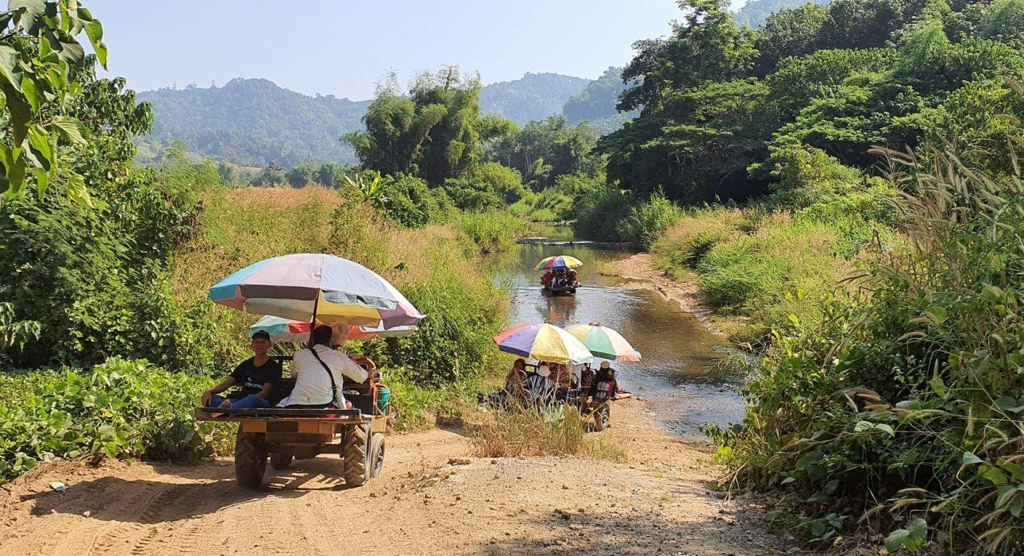

Over View

Theme
Classic, Family, Gastronomy, Sustainable

Country - City
Thailand - Udon Thani

Market segment
Groups, Thematic Leisure

Price Level
$

Max pax
40

Seasonality
Possible year round, but subject to weather conditions

Arrival city
Loei / Udon Thani / Nong Khai

Departure city
Loei / Udon Thani / Nong Khai

Description

Northeastern Thailand, known as Isaan, is a vast region much of which is still unspoiled countryside. During this lunch experience guest get aboard a local tractor, locally called and E-tak, to explore these lush surroundings. Slowly making their way through villages, river beds and plantations they arrive at a scenic spot near a waterfall where they can relax and mingle with locals. While guests are enjoying this moment of peace, the villagers cook up some of the region’s most famous dishes right on the spot. After a simple but delicious meal a short ride by E-tak takes them back to the starting point of the trip.

Selling points

- A truly local experience in the middle of the countryside
- The E-tak is a very fun and unique mode of transport
- A lot of variation throughout the trip, from local villages to river beds and rubber plantations
- The food for lunch is simple but very tasty, some of the dishes are prepared in bamboo which is very interesting to see
- The activity is popular with Thai people too, so there is the opportunity to mingle with locals
- Suitable for both FIT and GIT

Sustainability

Level Of The Excursion
Medium – This activity offers tangible positive contributions to the local community, culture and/or environment

The Impact Of This Excursion

Social/cultural Impact
Empowerment and education

Environment Impact
Waste/plastic packaging, Transportation

Economic Impact
Local individual benefits, Community benefits

Additional Information

Positive impacts
During this activity, guests will venture into the countryside by local transportation. Members of the community will take care of all the services like transportation and lunch, creating income and opportunities for the locals. The meals are prepared with using natural materials like bamboo and banana leaves.

Negative impacts
The local E-tak uses fossil fuel, which causes Co² pollution.

Time And Transportation

From | To | Km | By | Duration | Road Condition
Loei city | Local village for the activity | 125 kilometers | Car | 2 hours 15 minutes | Good most of the time, mountainous roads before arriving at the village
Chiang Khan | Local village for the activity | 75 kilometers | Car | 1 hour 15 minutes | Good most of the time, mountainous roads before arriving at the village
Udon Thani city | Local village for the activity | 140 kilometers | Car | 2 hours 30 minutes | Good most of the time, mountainous roads before arriving at the village
Nong Khai city | Local village for the activity | 125 kilometers | Car | 2 hours 15 minutes | Good most of the time, mountainous roads before arriving at the village

Photos

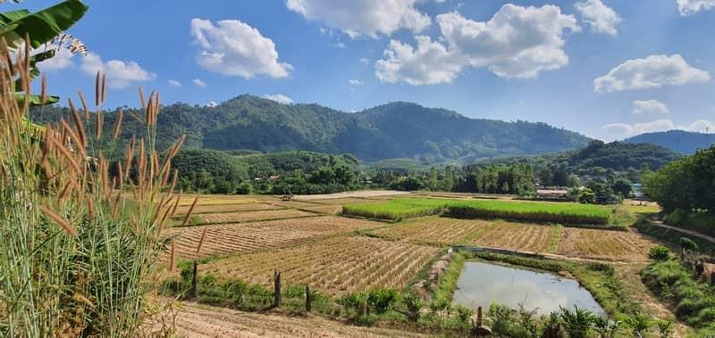
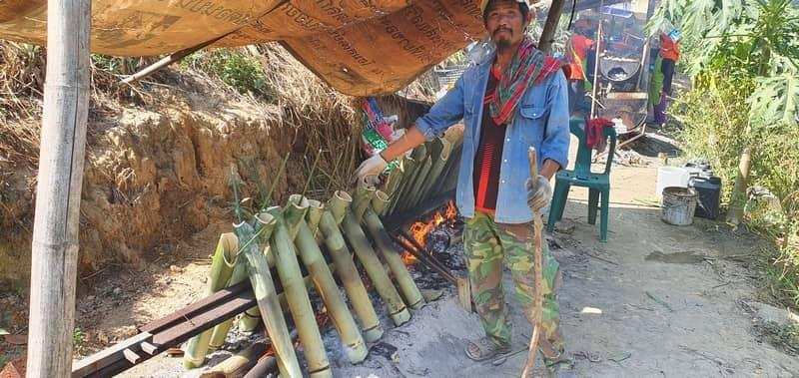
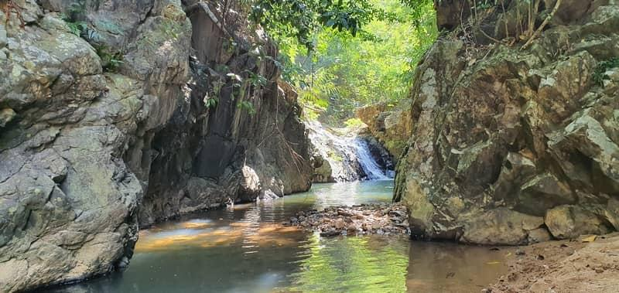
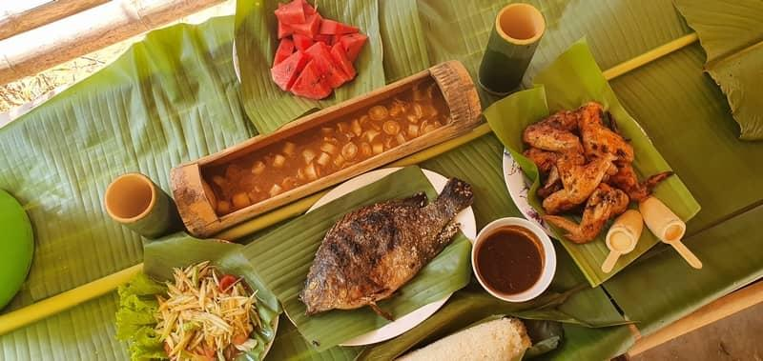

Easia Travel Head Office

Vietnam Head OfficeC/o: ATS Hotel, Suite 326 &327, 33B Pham Ngu Lao Street, Hanoi, VietnamTel: +84 24-39 33 13 62www.easia-travel.com

