THAILAND – Nakhon Pathom – Don Wai Market and Private Cooking Class Along the River
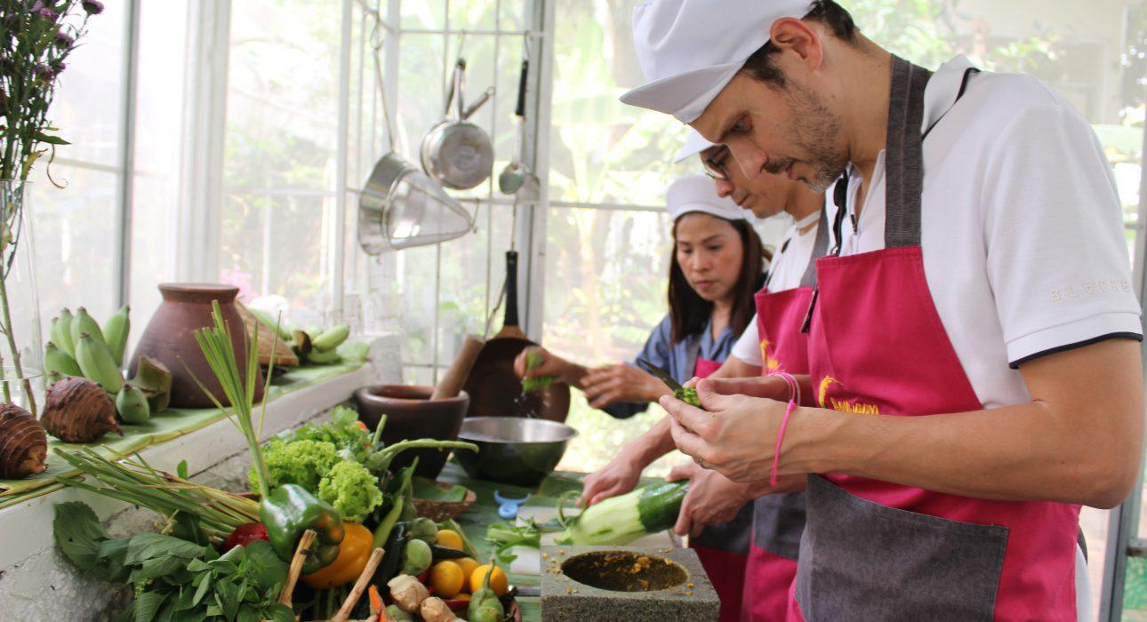

Over View

Theme
Art & Culture, Classic, Family, Gastronomy, Honeymoon, Sustainable

Country - City
Nakhon Pathom

Market segment
Thematic Leisure

Price Level
$$$$

Max pax
30 pax

Seasonality
All year Round

Arrival city
BANGKOK

Departure city
BANGKOK

Description

After being welcomed by their host, guests will enter Don Wai Market, years ago used to be floating market but nowadays almost entirely brought back to the land but still keeping the authentic and local atmosphere far from the usual touristic markets.
The host, native of the area, will first guide the guest entrance the market through the temple. An opportunity for them to learn about buddhism and thai culture, before entering the colorful market where guests will taste, learn and all about foods, fruits, locals ingredients while the host a renowned chef will buy some ingredients for the day.
After a little hour of visit, it will be time to go to the jetty to embark a little boat onboard which, the host will drive the guests along a peaceful fifteen minutes cruise through scenic scenery with floating gardens, water hyacinths until reaching a peaceful house along the river where the approximate cooking class will take place. After (1h30 – 2h) (depending guests’ ability) getting the hand dirty and listening to the advice of the chef between laughs and lesson, it will be time to take place to the table (on the terrace overlooking the river or in the air conditioned dining room) to taste the work of the day !

Selling points

- To experience one of the oldest market of Thailand, combined private cooking class by a renowned chef 2 iconic aspects of thai culture in one day.
- To offer a combination between culture, gastronomic experience and encounter with a passionate character
- To have a gastronomic experience in the countryside far away from the too often seen big cities’ gastronomic experiences
- An hidden tropical garden for a relaxing lunch overlooking a river.

Sustainability

Level Of The Excursion
Low - This activity impacts local community, culture and/or environment in a small but meaningful way

The Impact Of This Excursion

Social/cultural Impact
Empowerment and education

Economic Impact
Local individual benefits

Additional Information

Positive impacts
During the activities guests will visit a local market where they buy some ingredients. The ingredients for the cooking class are also locally sourced, which supports the local economy, and creates income and opportunities for the farmers.

Negative impacts
No negative.

Time And Transportation

From | To | Km | Duration | Road condition
Sukhumvit Area | Don Wai | 40 | 40 minutes – 1 hour | Car – Often Traffic Jam
Silom/Sathorn Area | Don Wai | 35 | 35 minutes – 1 hour | Car – Often Traffic Jam
Riverside Area | Don Wai | 30 | 40 minutes | Car Often Traffic Jam
BTS Siam(Sukhumvit area) | BTS Bang Wa | 15 – 25 | 50 minutes | BTS (Sky Train)
BTS Saphan Taksin (Riverside) BTS | BTS Bang Wa | 10 | 20 minutes | BTS (Sky Train)
BTS Bang Wa | Don Wai | 30 | 35 minutes – 50 minutes | Car – Often Traffic Jam
Don Wai | Kanchanaburi | 140 | 1h 50min – 2 hours | Car – Often Traffic Jam
Don Wai | Sai Yoke | 195 | 2h 50min – 3h 10min | Car
Don Wai | Ayuthaya | 105 | 1h15 – 1h30 | Car

Photos

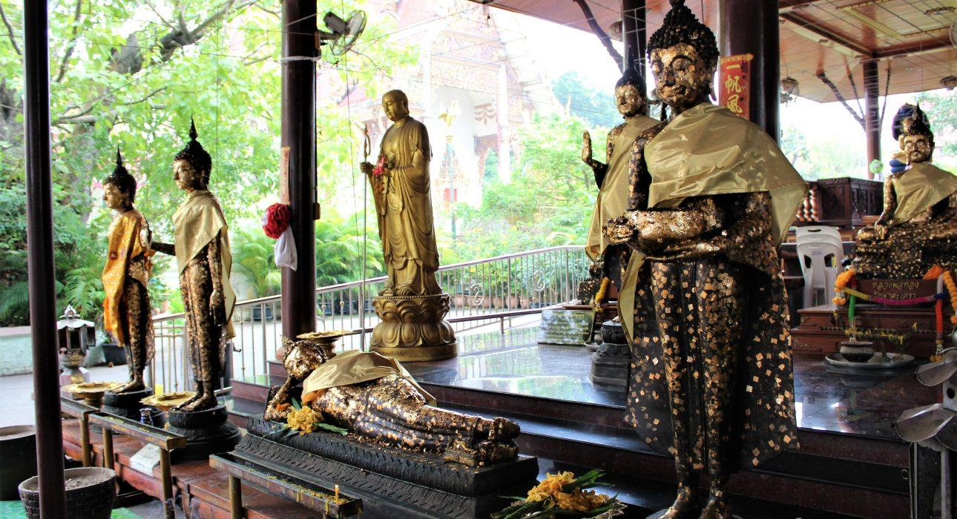
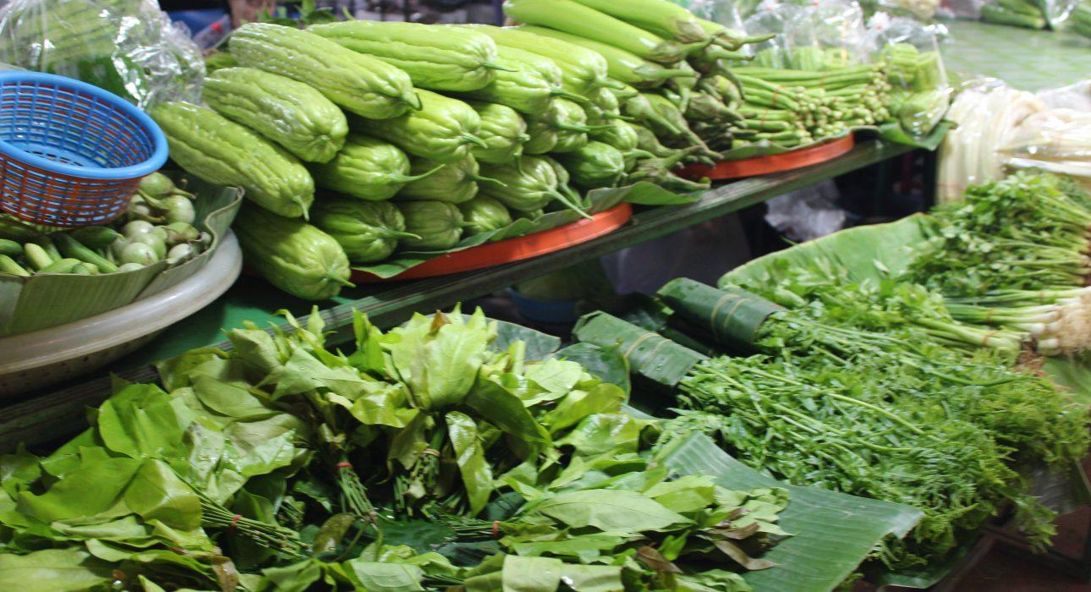
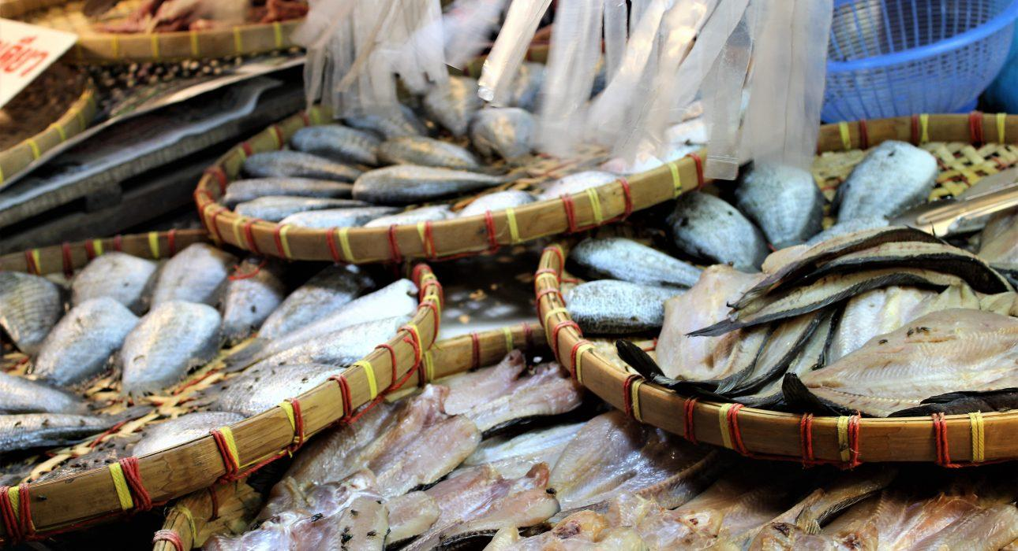
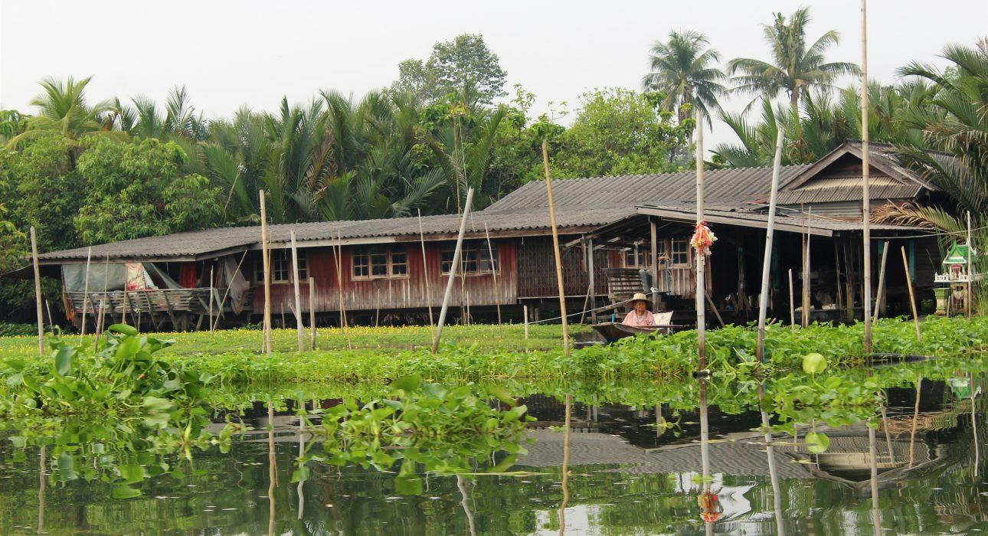
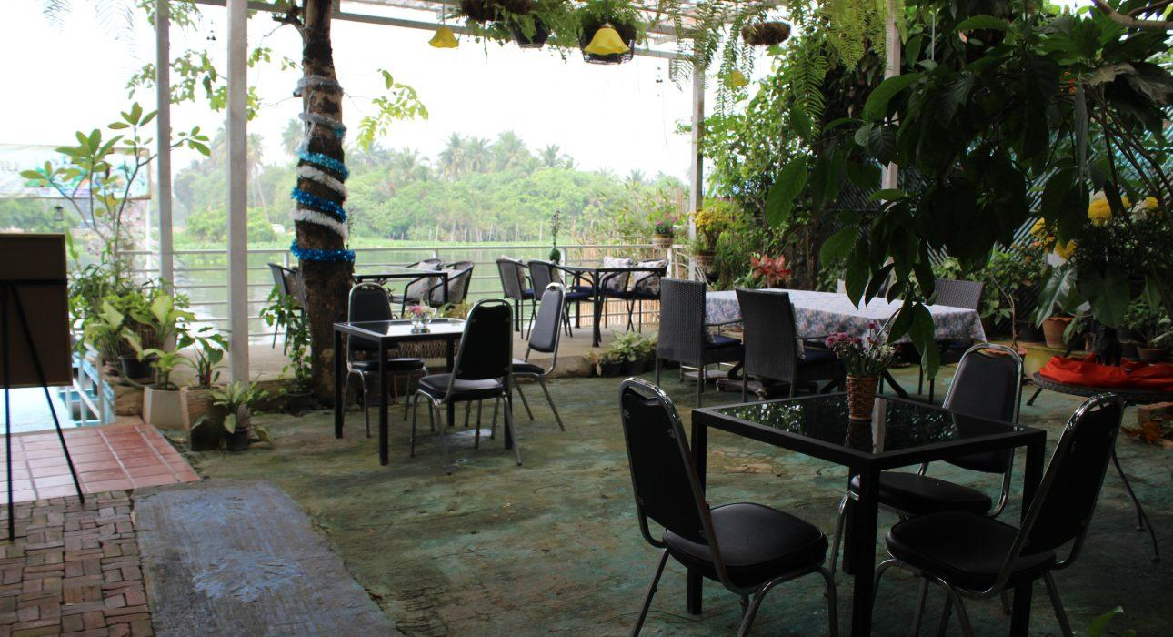
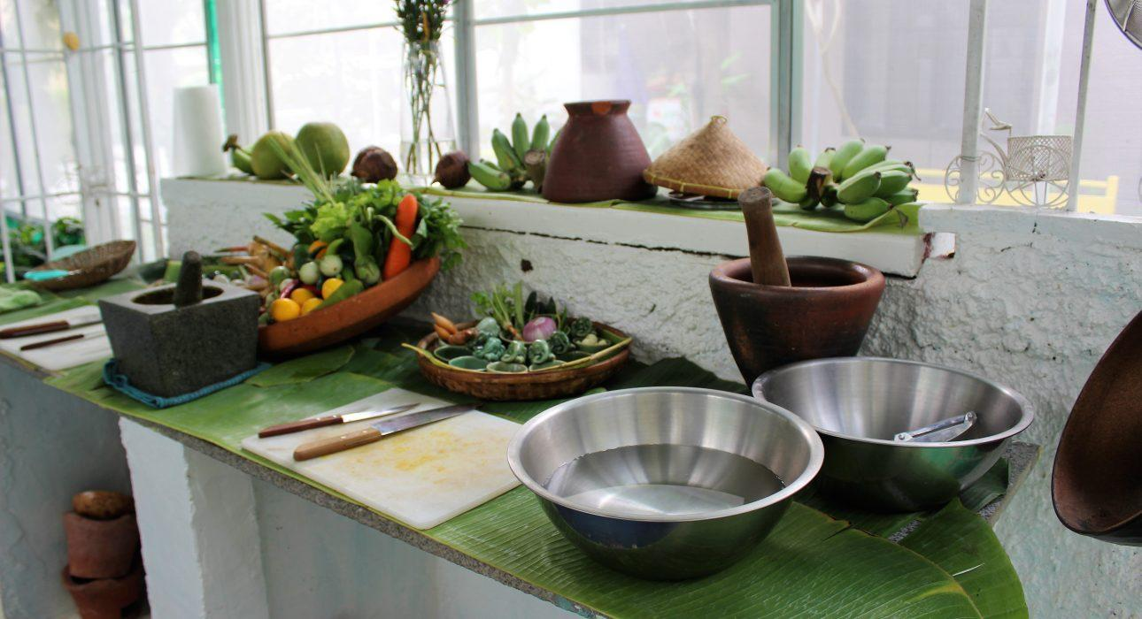
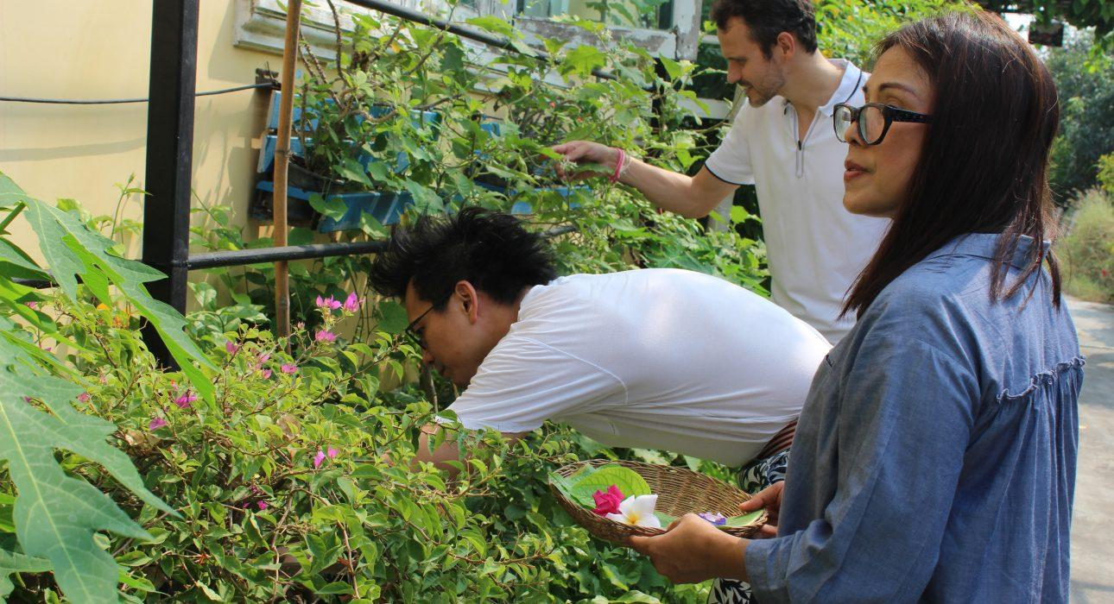
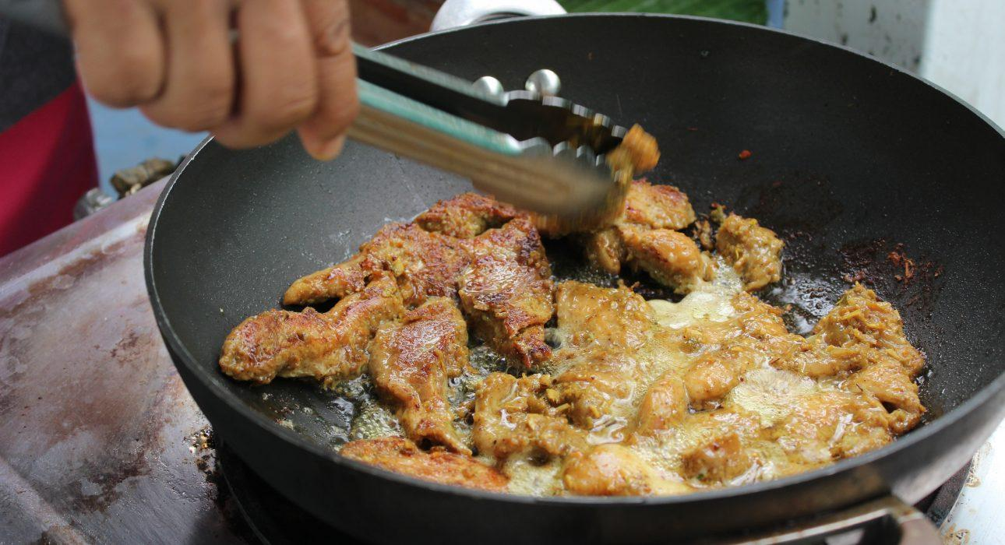
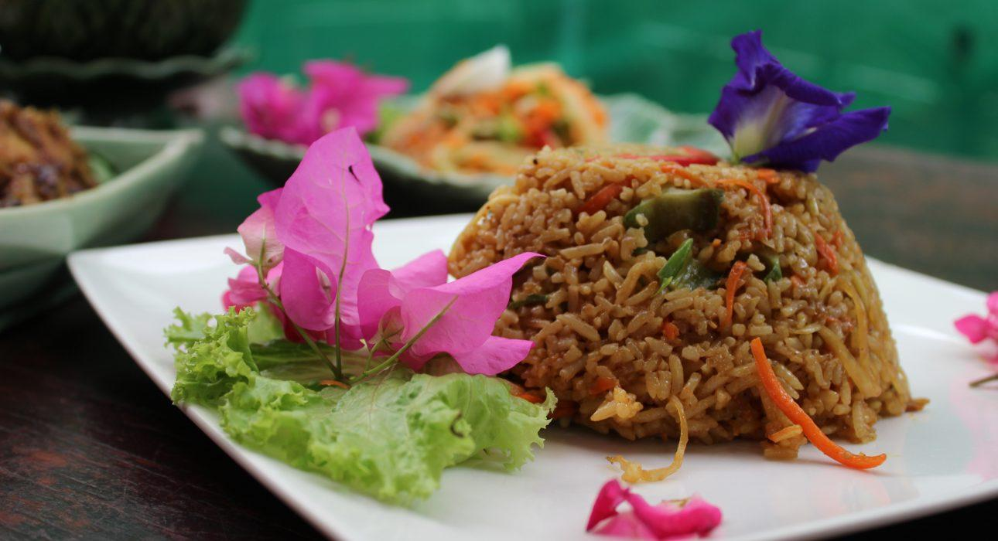
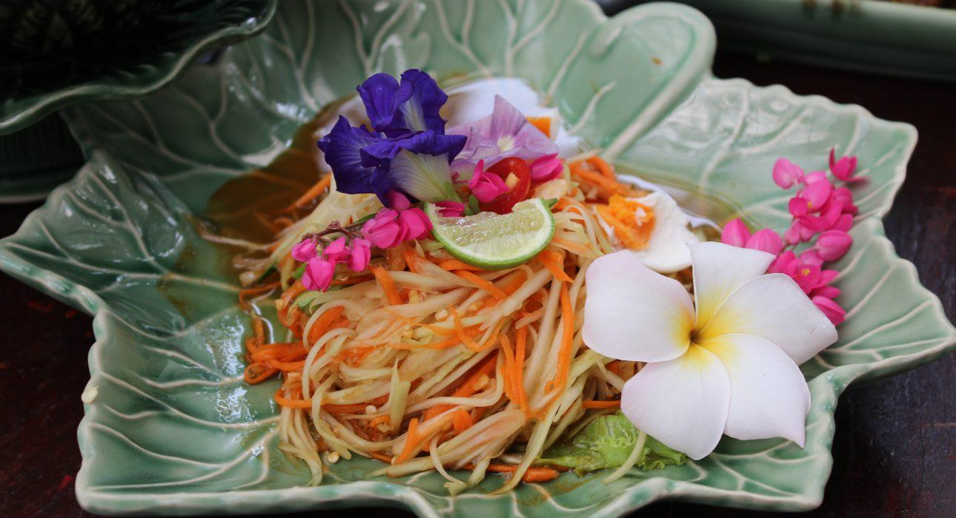

Easia Travel Head Office

Vietnam Head OfficeC/o: ATS Hotel, Suite 326 &327, 33B Pham Ngu Lao Street, Hanoi, VietnamTel: +84 24-39 33 13 62www.easia-travel.com

