VIETNAM – Chau Doc – Cycling Tour in the Countryside
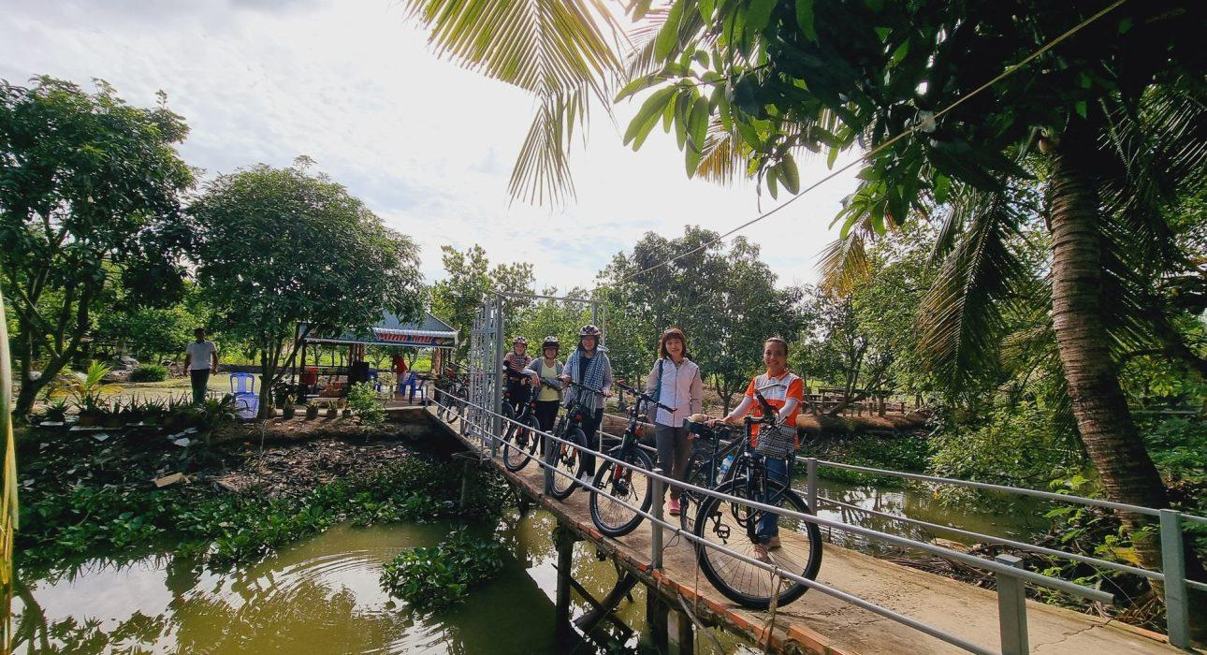

Over View

Theme
Classic, Family, Sustainable

Country - City
Vietnam - Chau Doc

Market segment
Groups, Thematic Leisure

Price Level
$$

Level of difficulties
LEVEL 1

Max pax
30

Seasonality
All Year Round (except raining season in the South May-Sep)

Arrival city
Chau Doc

Departure city
Chau Doc

Description

This activity offers travelers the rewarding experience of cycling in the Mekong Delta through peaceful rice fields. Chau Doc’s beautiful rice fields are easy to discover by cycling along small roads with light-traffic, occasionally seeing lotus fields, water buffaloes and hundreds of ducks!

Selling points

- Cycle in the beautiful rice fields of Chau Doc
- Explore the countryside following small paths with little or no traffic
- Flexible itinerary and easy to include during the morning or afternoon in Chau Doc

Sustainability

Level Of The Excursion
Medium – This activity offers tangible positive contributions to the local community, culture and/or environment

The Impact Of This Excursion

Environment Impact
Transportation

Economic Impact
Local individual benefits

Additional Information
Positive Impact:This activity does not include any motorized transportation since the travelers move on bicycles. It also provides financial support to a bicycle supplier in Chau Doc.

Time And Transportation

- Pick-up time from the hotel is from 08:00 or 14:30

Photos

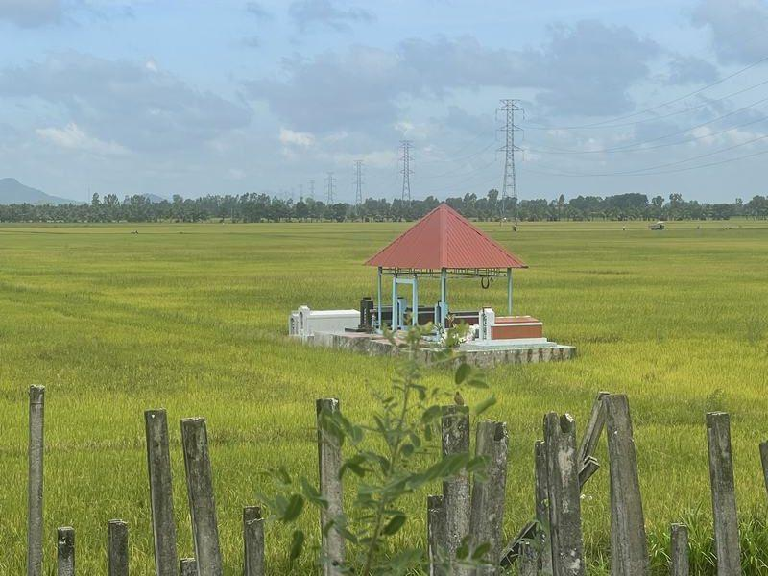
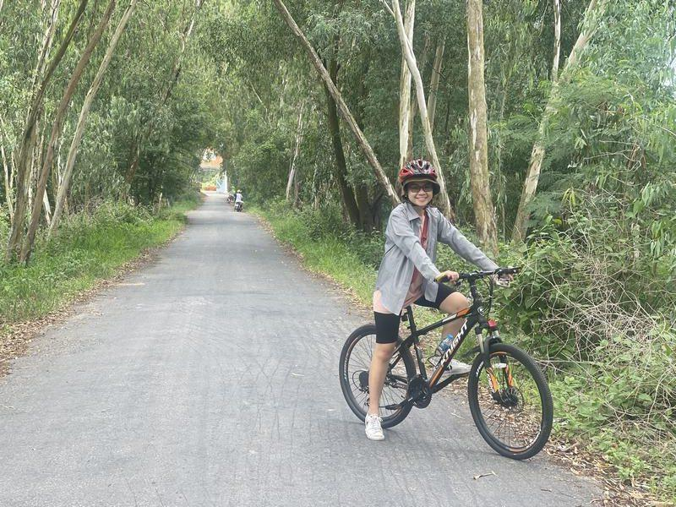
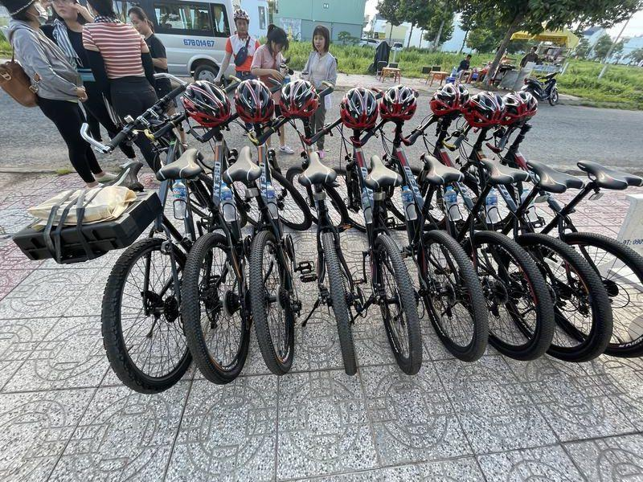
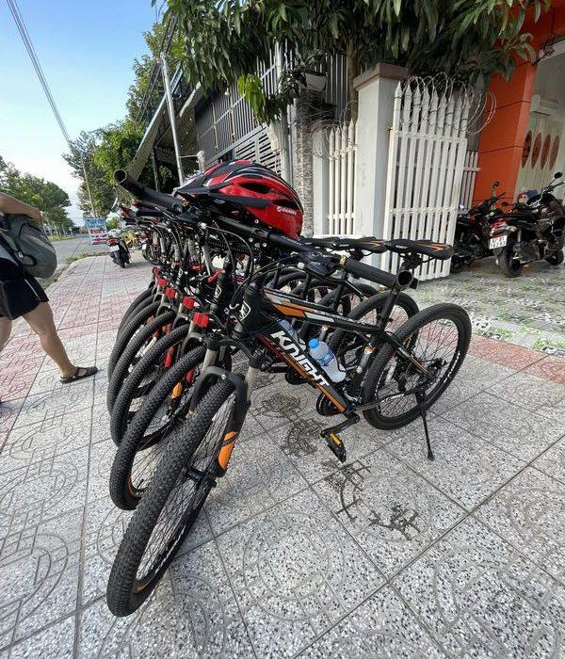
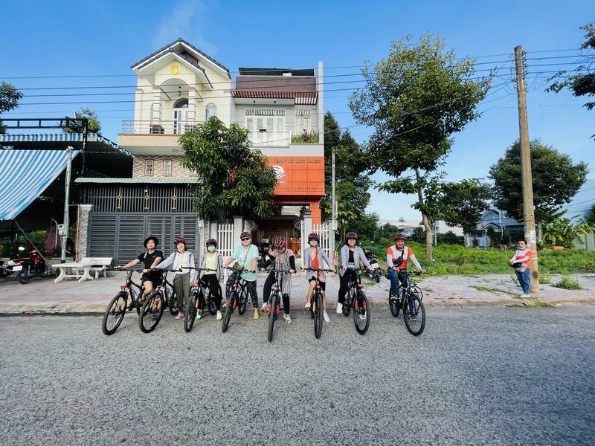
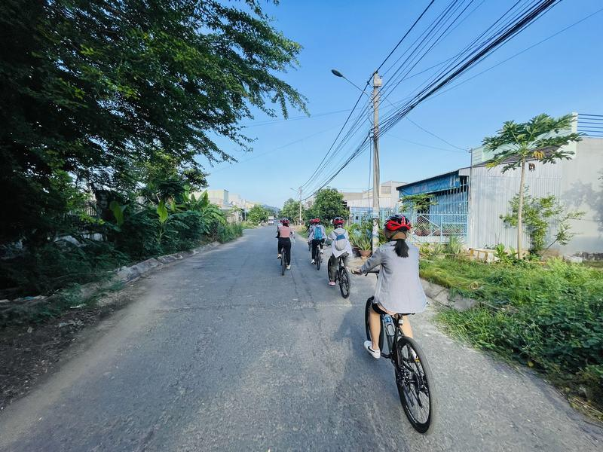
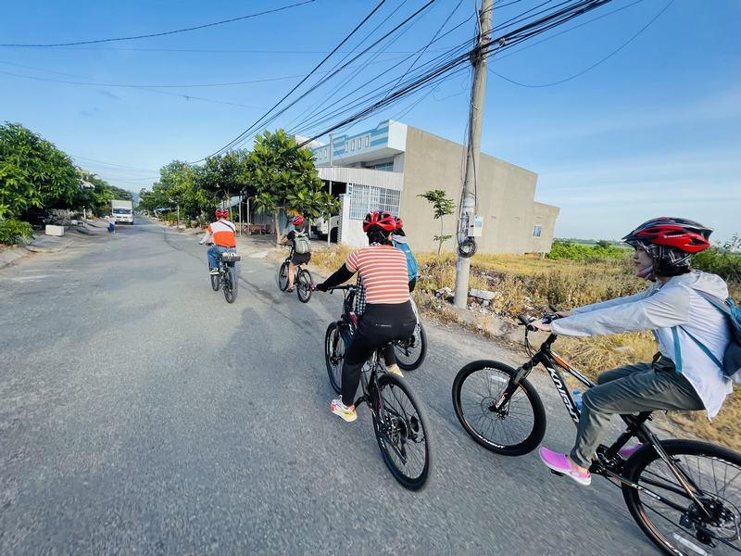
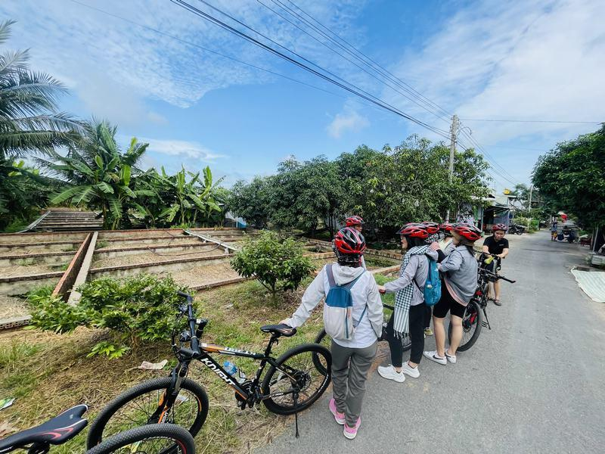
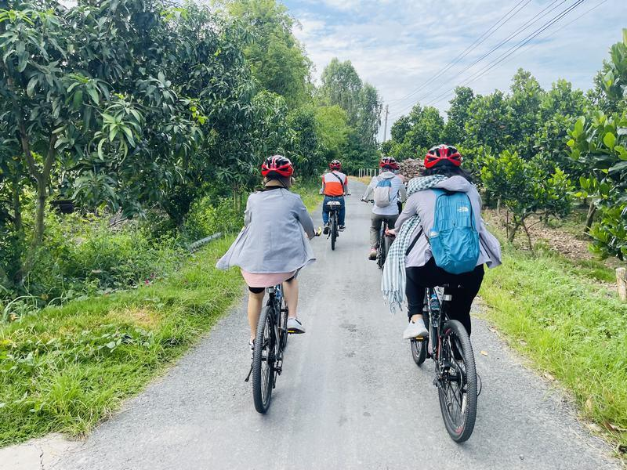
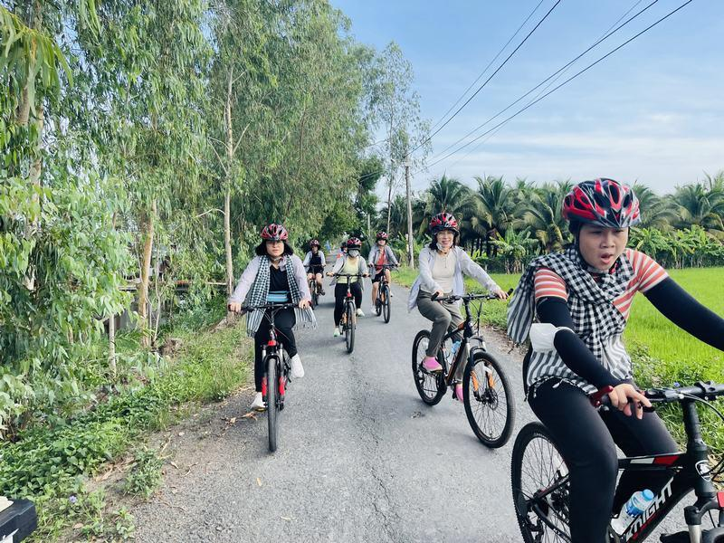
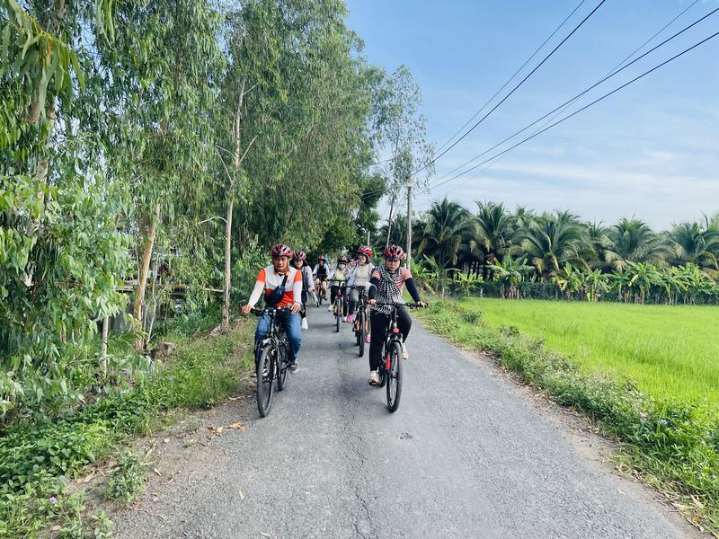
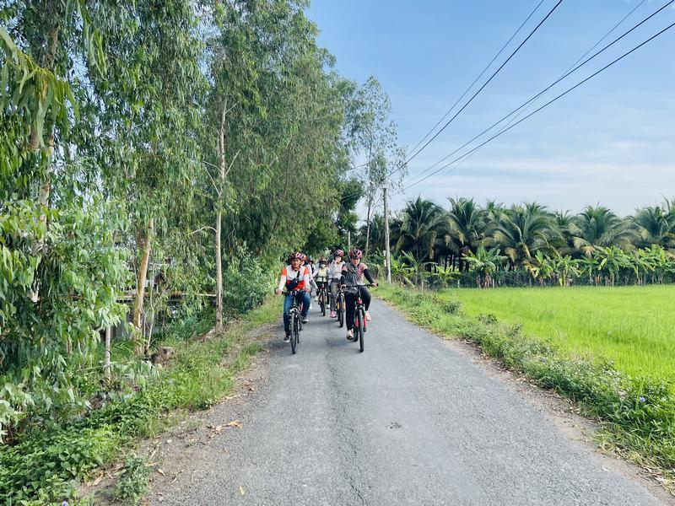
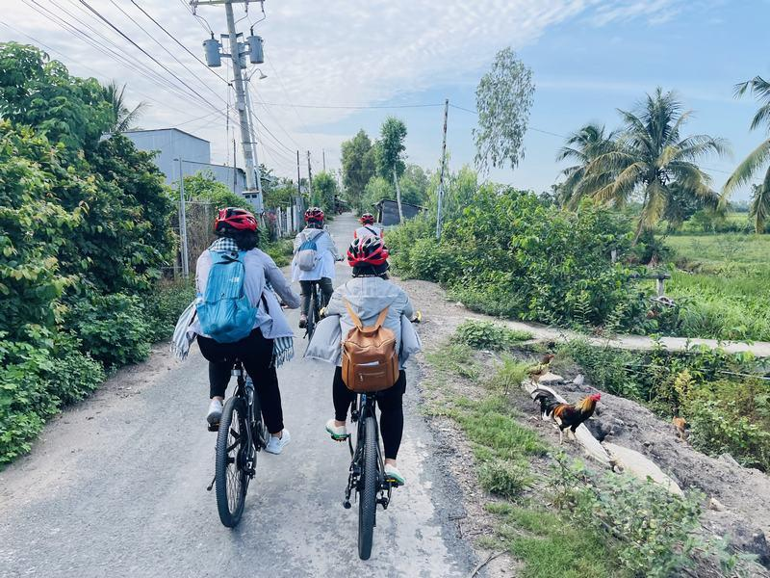
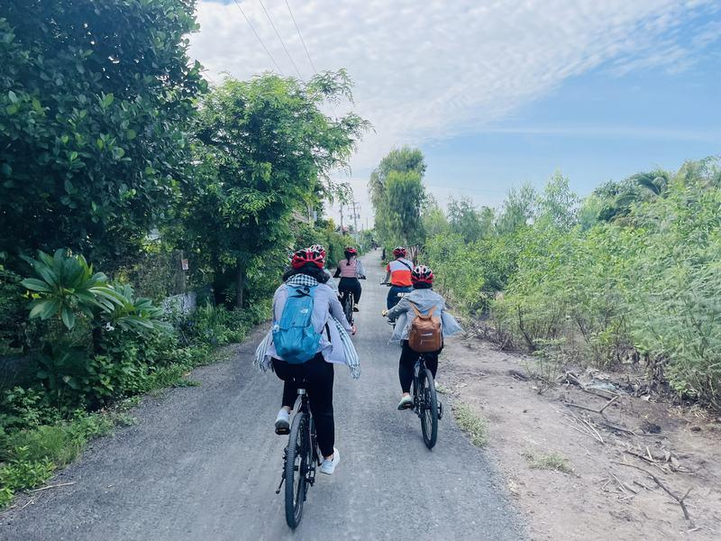
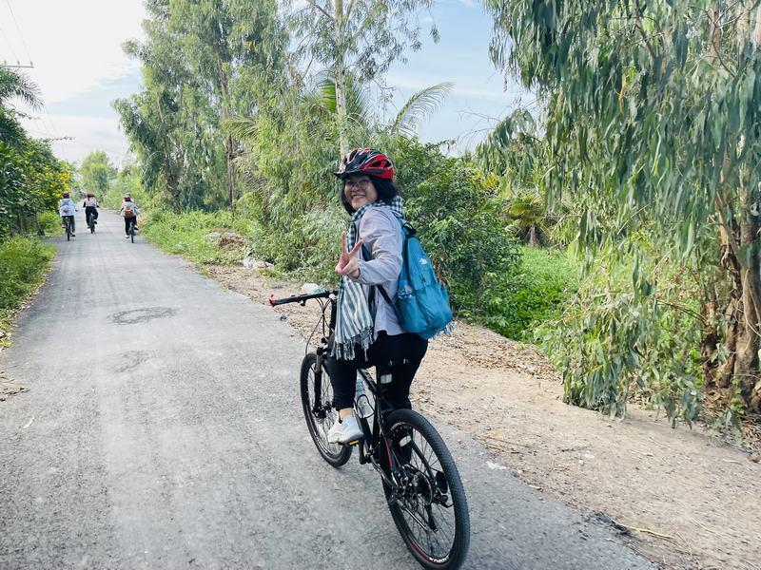
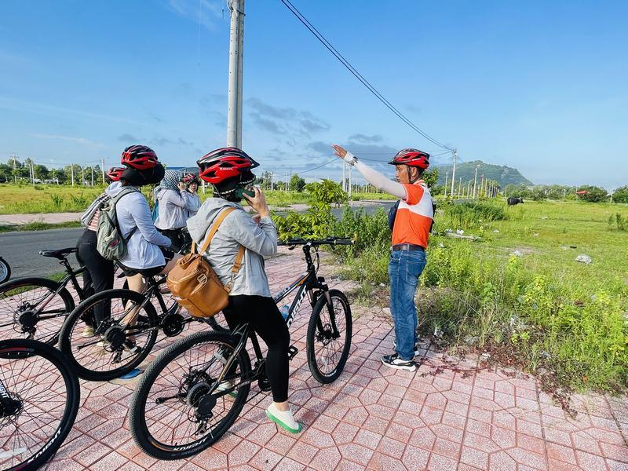
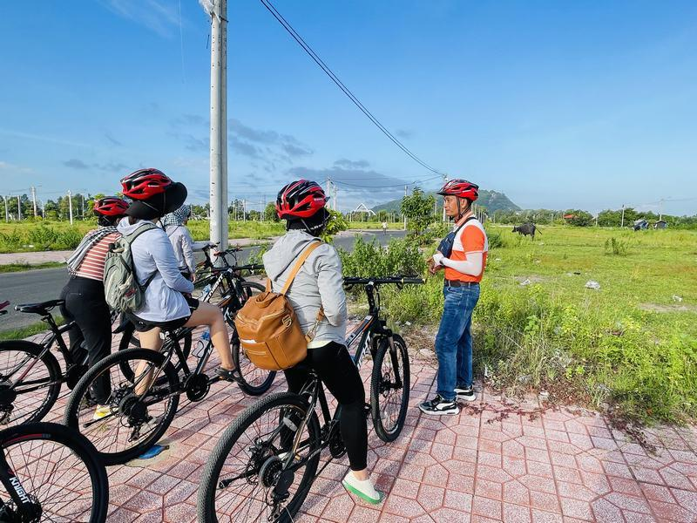
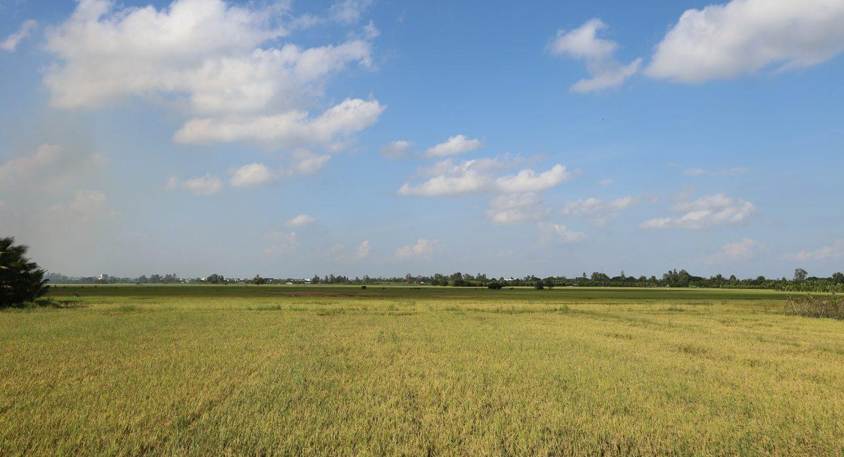

Easia Travel Head Office

Vietnam Head OfficeC/o: ATS Hotel, Suite 326 &327, 33B Pham Ngu Lao Street, Hanoi, VietnamTel: +84 24-39 33 13 62www.easia-travel.com

