MYANMAR – Yangon – Explore Yangon Alley Gardens
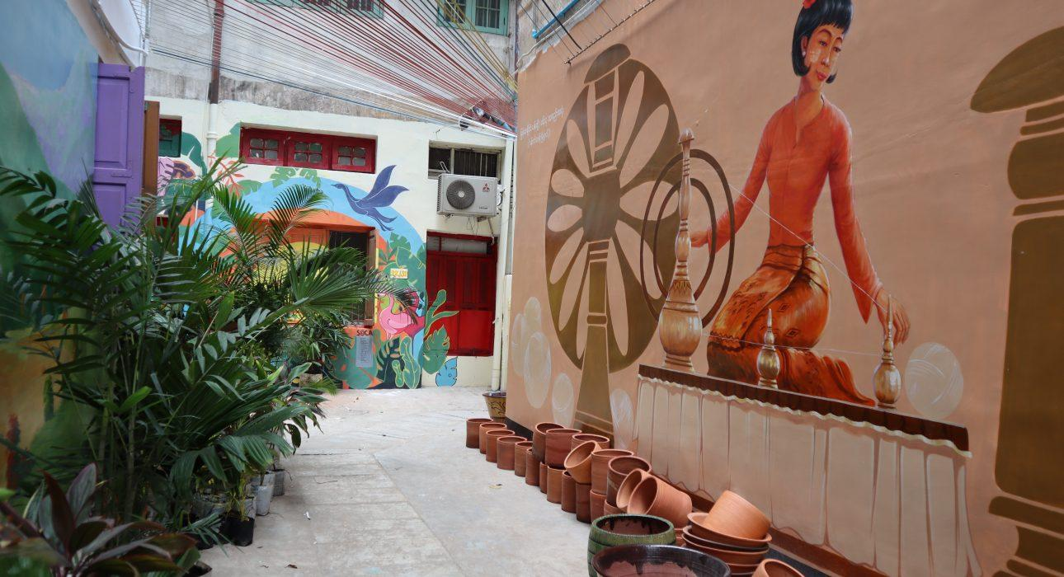

Over View

Theme
Art & Culture, Classic, Family, Sustainable

Country - City
Myanmar - Yangon

Market segment
Groups, Thematic Leisure

Price Level
$

Max pax
50 persons

Seasonality
All Year Round - Best season is from September to March

Arrival city
Yangon

Departure city
Yangon

Description

A short walk to explore Yangon downtown in an original way! Behind the picturesque apartment buildings of Yangon, we can find some urban gems. All around town, back alleys used in the past has open air waste fields have been rehabilitated as a safe public space for the local communities by Doh Eain, a social enterprise working on the improvement of urban spaces. Beautifully decorated with street art and street furniture, those back alleys are hidden gems that can be discovered on this walking tour around town.

Selling points

- A leisure walk around the downtown Yangon focusing on the urban projects of Doh Eain – a social enterprise that brings back alleys back to life for the community to use as a leisure space
- A short itinerary which can be extended if travelers wish to discover more
- A favorite of Yangon visitors with great opportunities to take beautiful pictures of the street art
- A discovery of some lesser-known streets of downtown Yangon while staying central – around Sule Pagoda
- An original way of discovering some hidden treasures of Yangon
- Easy to add to a downtown walking tour to combine the history of heritage buildings with modern urban projects

Time And Transportation

From | To | Distance | By | Duration | Road Condition
Sule Pagoda | Alley 2 @ 31 street | 220 meters | Walk | 3 minutes | Good
Alley 2 @ 31 street | Alley 5 @ 35 street | 220 meters | Walk | 9 minutes | Good
Sule Pagoda | Alley 5 @ 35 street | 900 meters | By Car | 4 minutes | Traffic

Photos

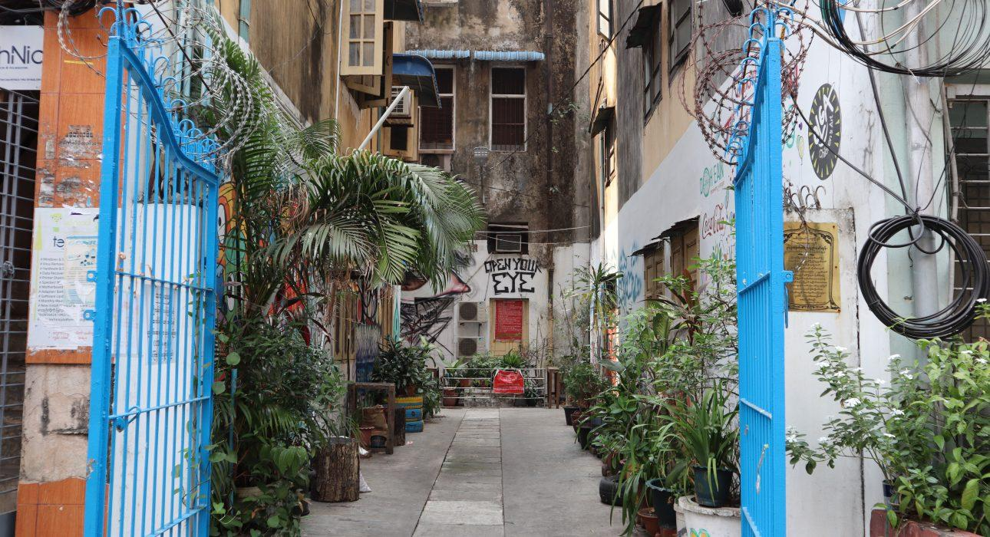
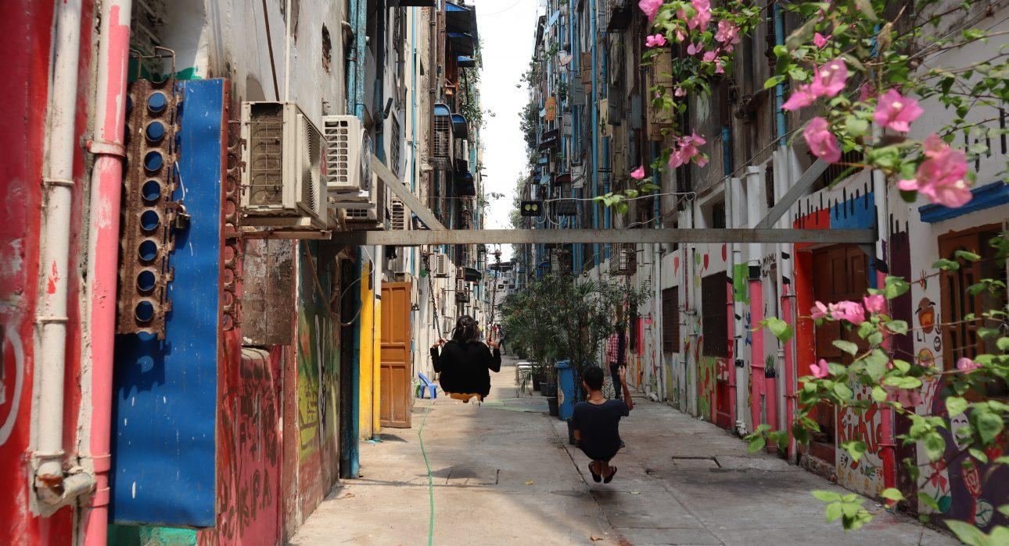
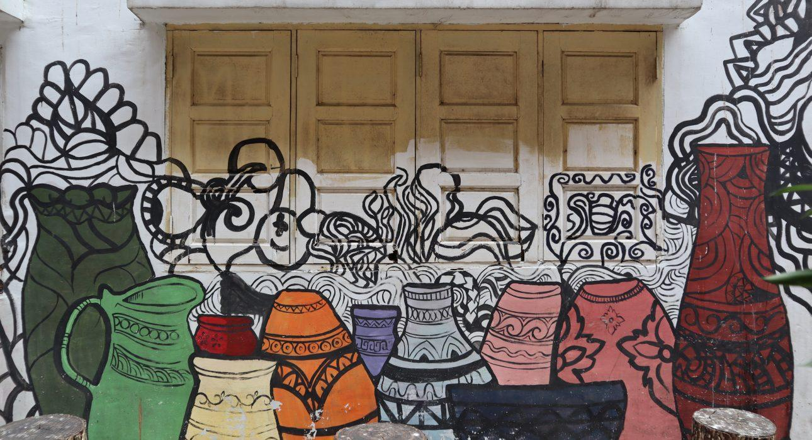
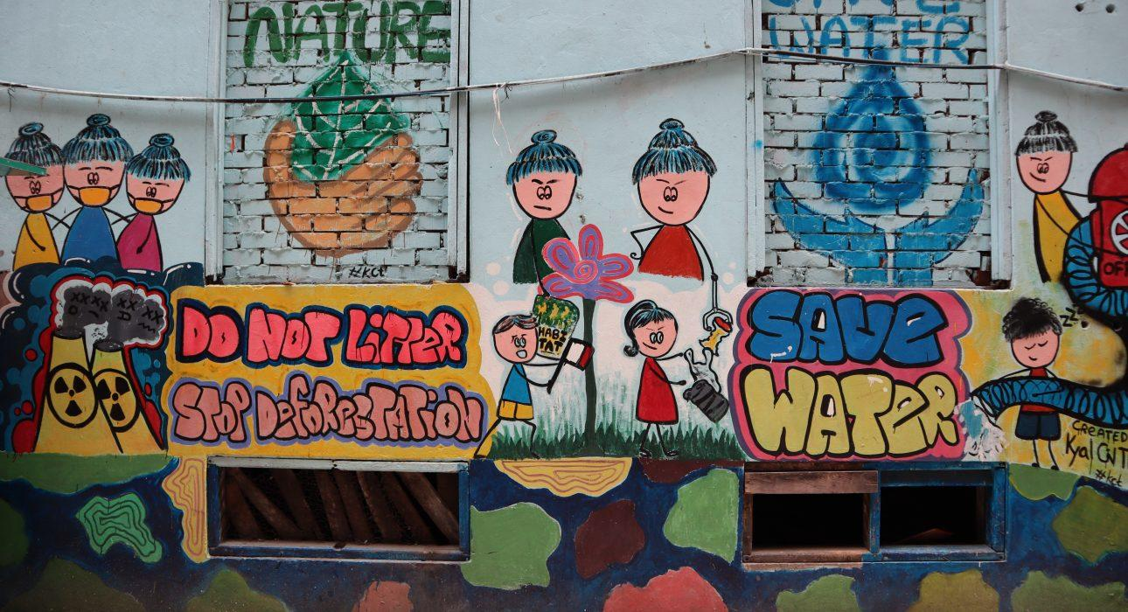
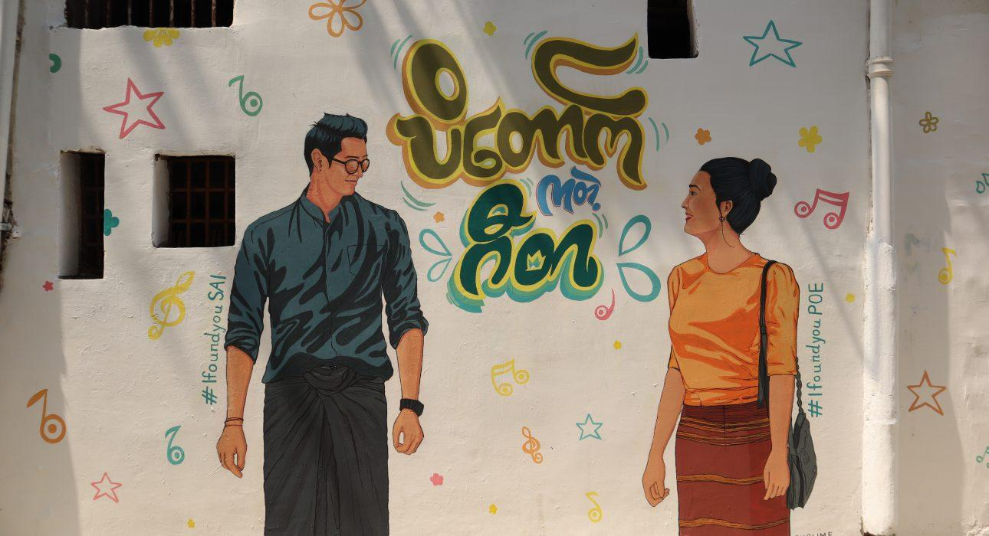
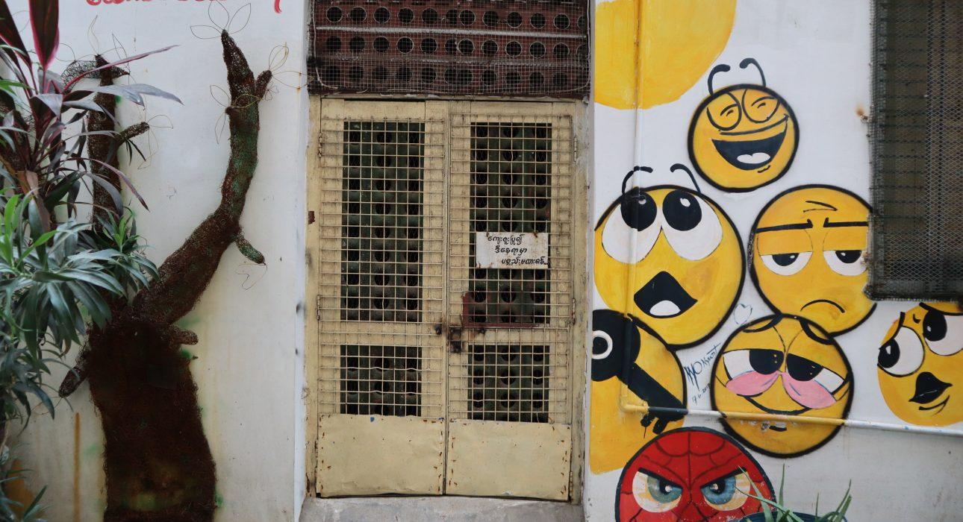
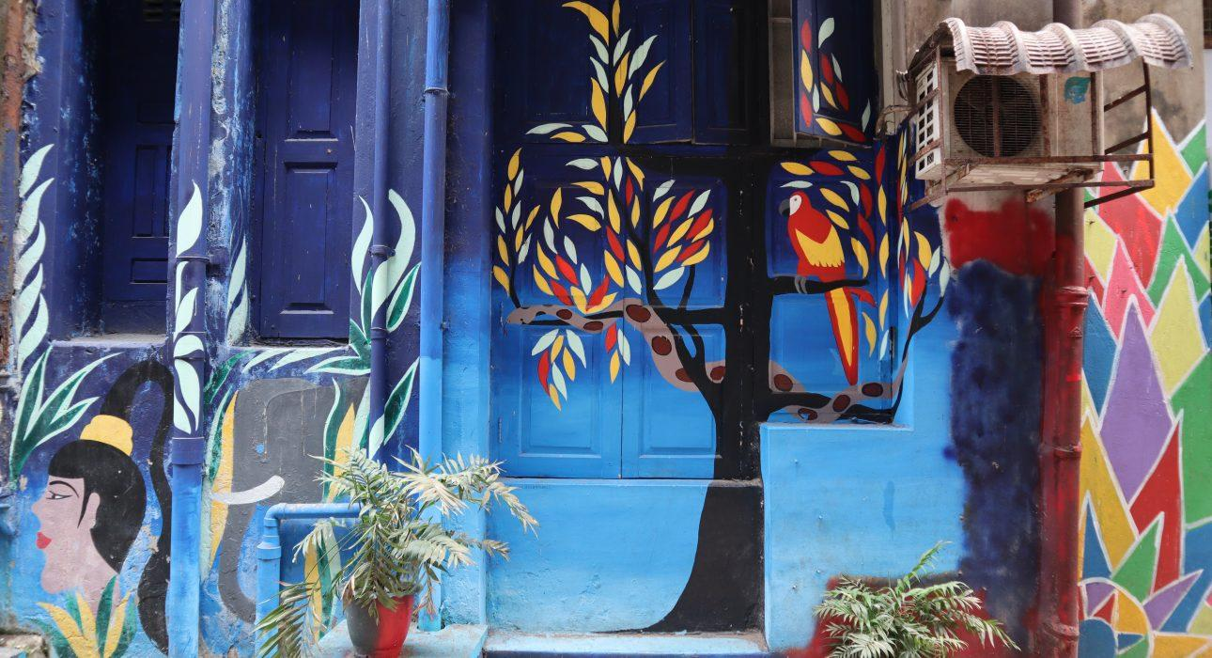
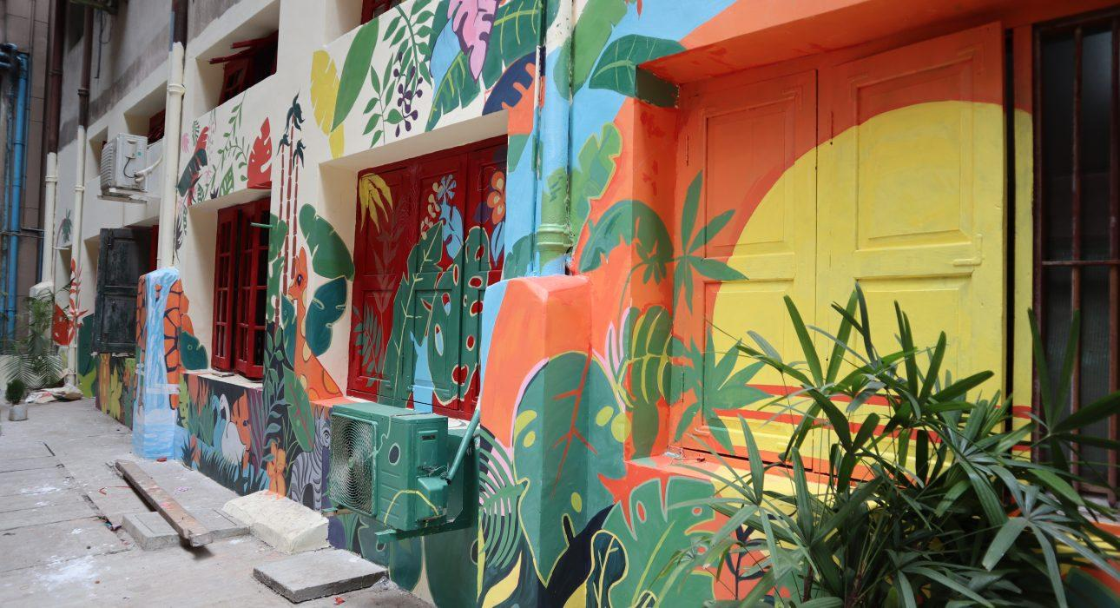
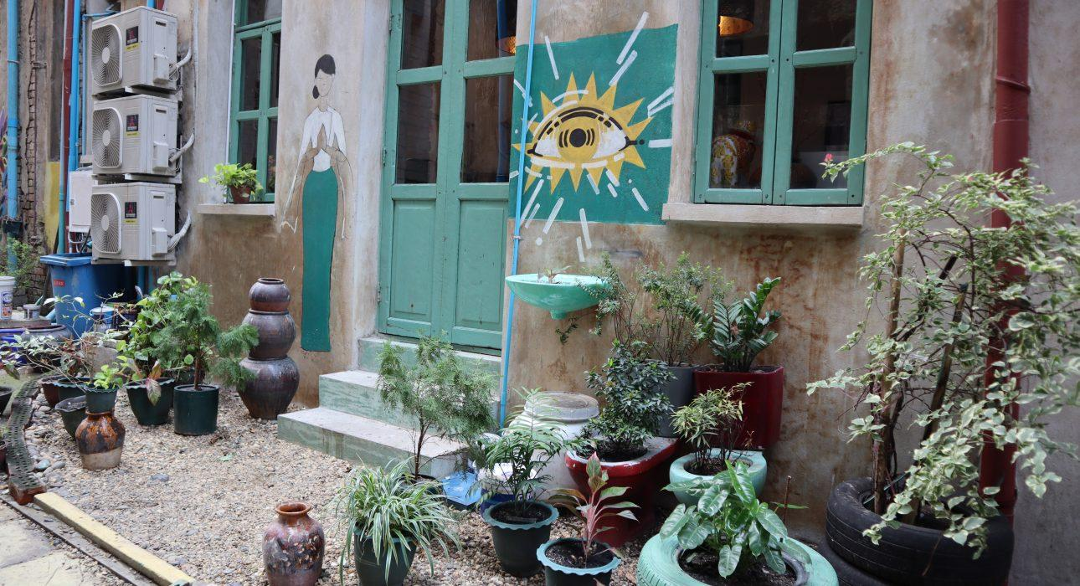
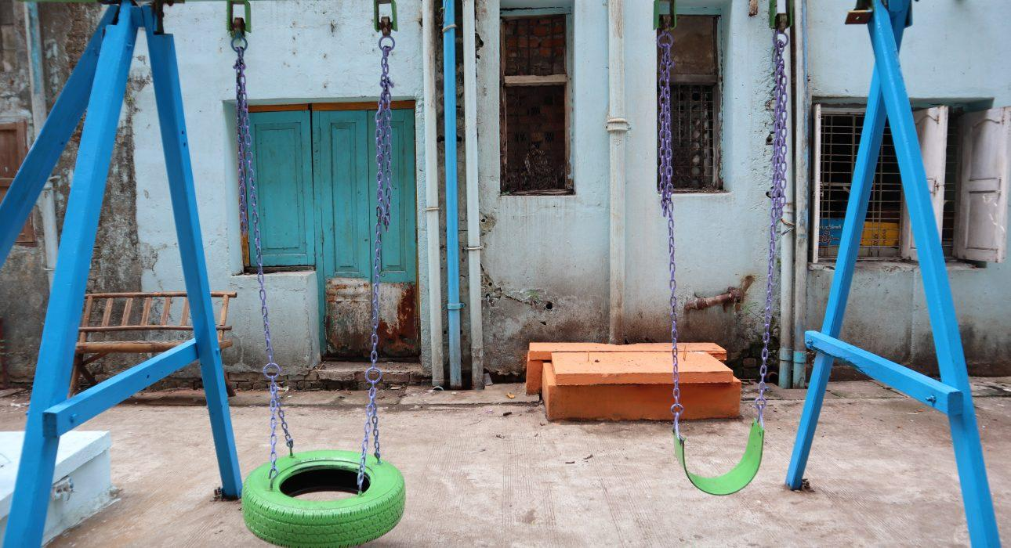
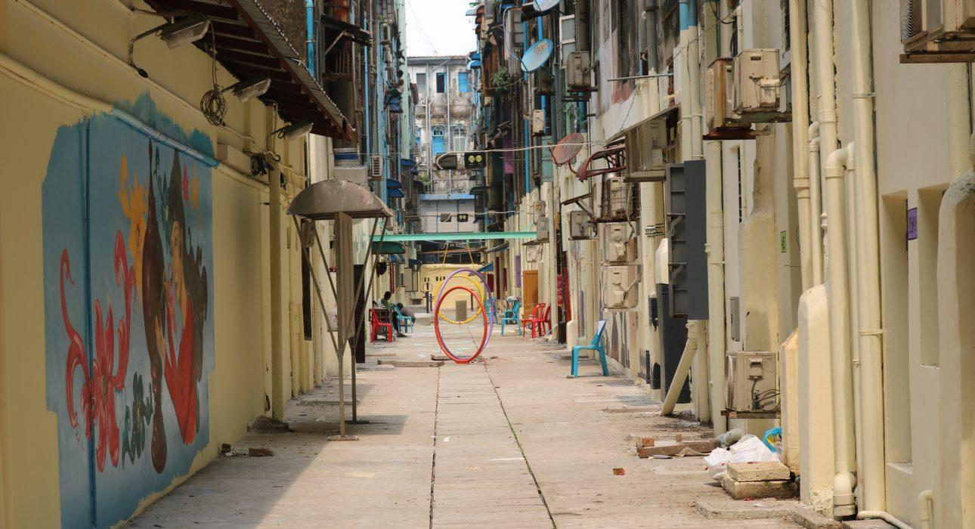

Easia Travel Head Office

Vietnam Head OfficeC/o: ATS Hotel, Suite 326 &327, 33B Pham Ngu Lao Street, Hanoi, VietnamTel: +84 24-39 33 13 62www.easia-travel.com

