MYANMAR – Bagan – Discover the art of Sand painting
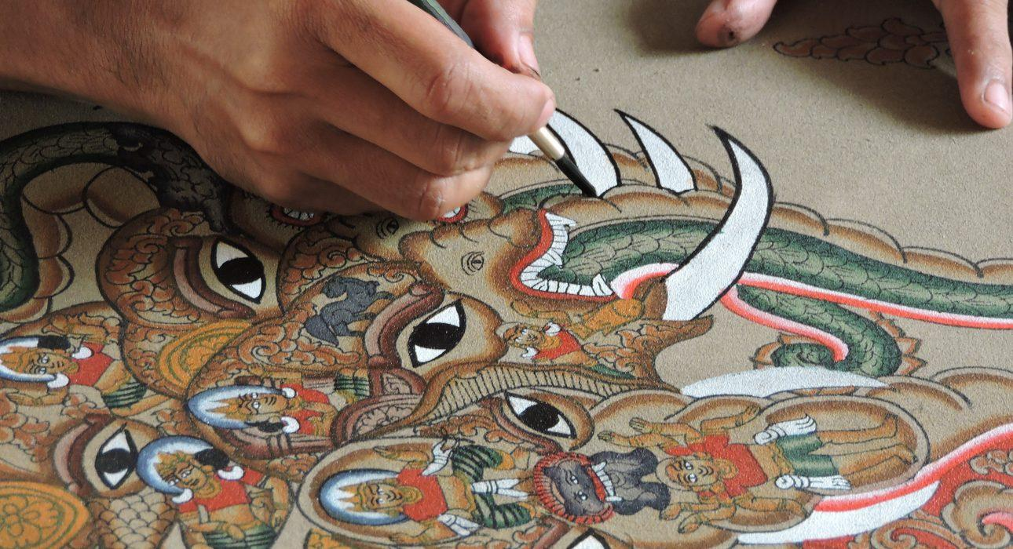

Over View

Theme
Art & Culture, Family

Country - City
Myanmar - Bagan

Market segment
Thematic Leisure

Price Level
$$

Max pax
10 persons

Seasonality
October to April

Arrival city
Bagan

Departure city
Bagan

Description

Less known than the craft of lacquerware, the art of sand painting is a fun activity for families looking for a hands-on experience with the children. The artist Tun Tun is opening the doors of its workshop, in his family home, to show the step by step process of this peculiar type of painting, from sifting to the sand to the application of colour pigments.

Can be combined with
Thematic Leisure
Bagan – Discover Bagan by BikeBagan – Visit to Taungbi LibraryBagan – On the Sandy Paths of Kyun Thiri

Selling points

- Hands-on activity suitable for families or small group to alternate from cultural sightseeing in Bagan
- Suitable in the hottest hour of the day to shelter from the sun and discover a lesser known craft
- A family workshop located in a small village – intimate experience for your group only
- Guided by the artists themselves, you will learn the different steps and get to paint your own canvas

Time And Transportation

From | To | Distance | By | Duration | Road condition
Old Bagan | Nyaung Oo | 10 km | Car | 25 minutes | Good
Nyaung Oo | New Bagan | 10 km | Car | 25 minutes | Good
New Bagan | Old Bagan | 5 km | Car | 15 minutes | Good

Photos

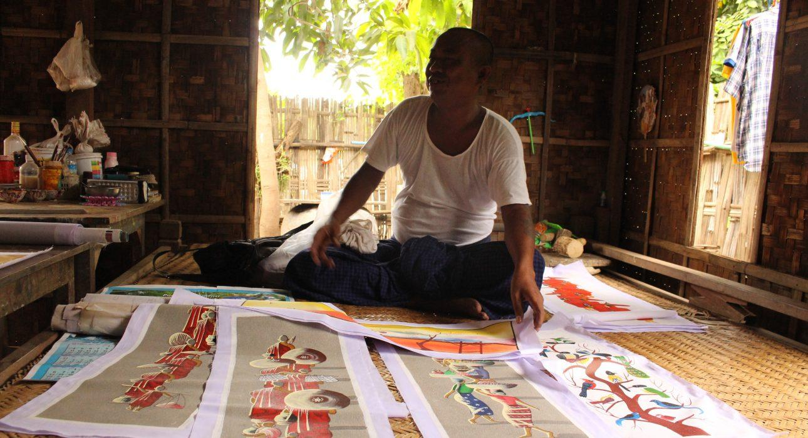
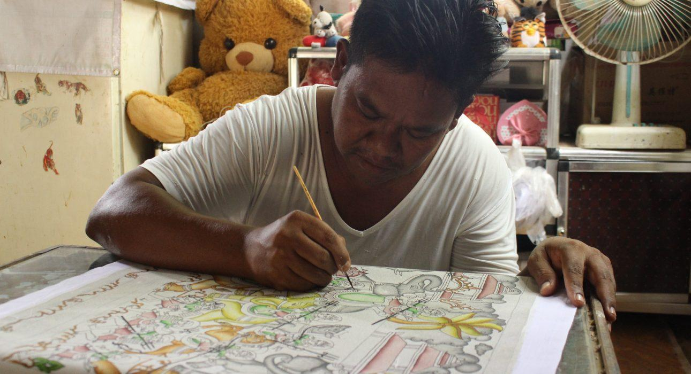
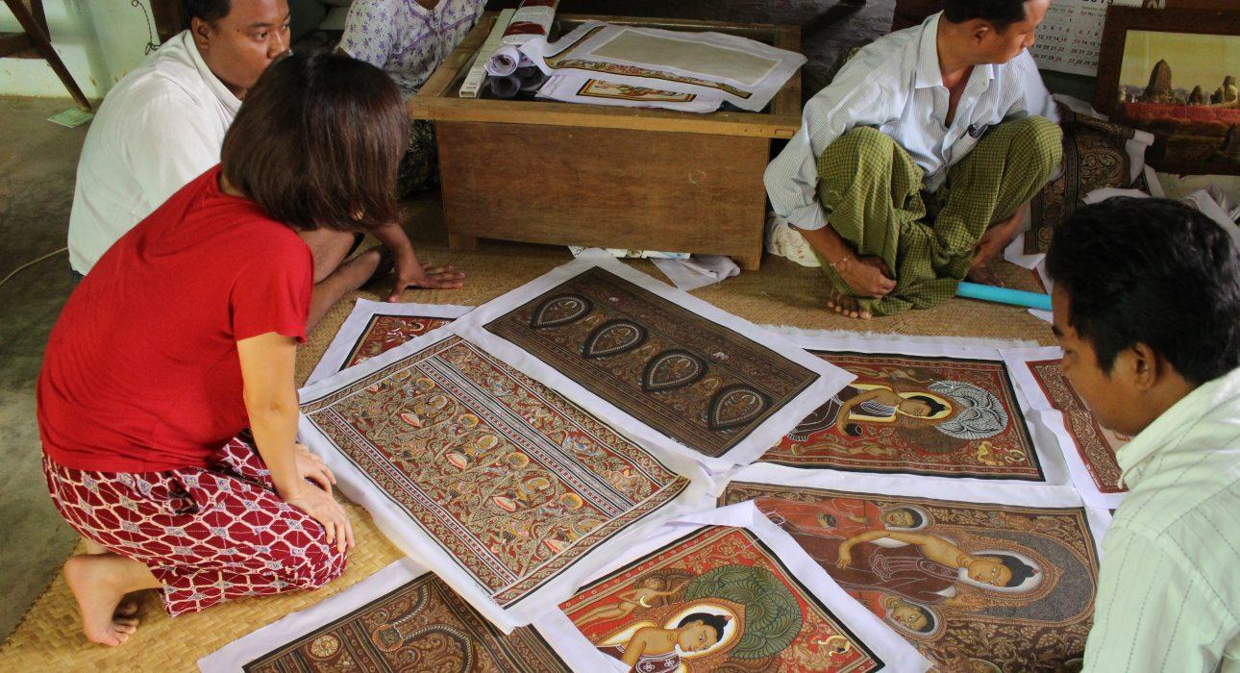
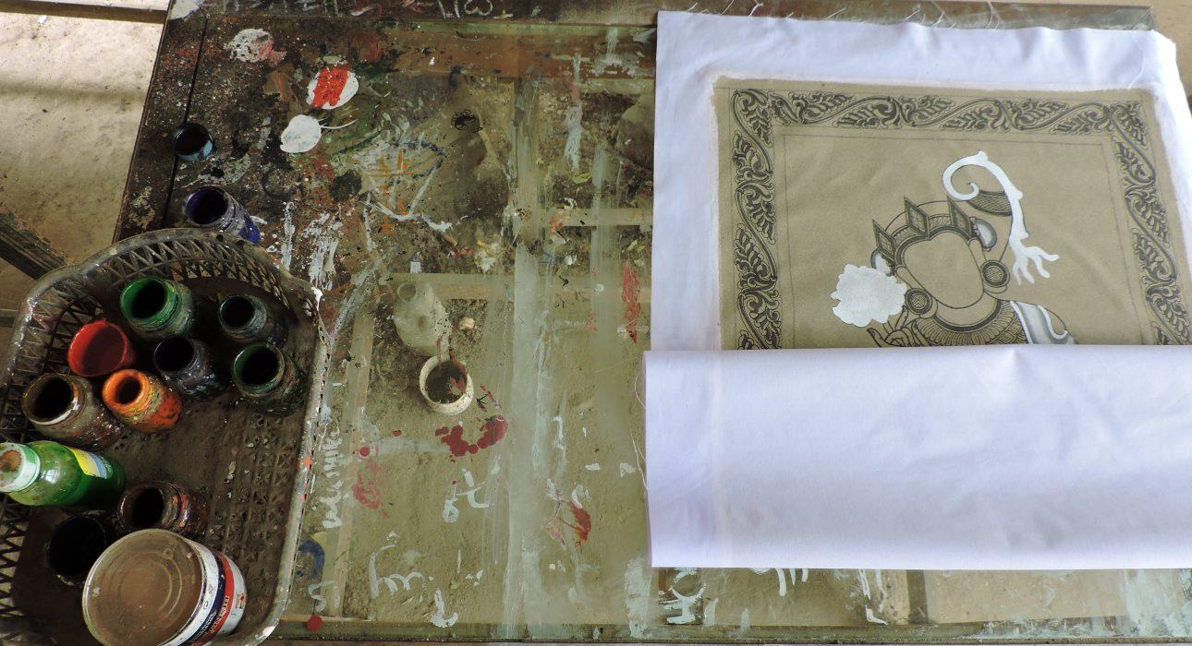
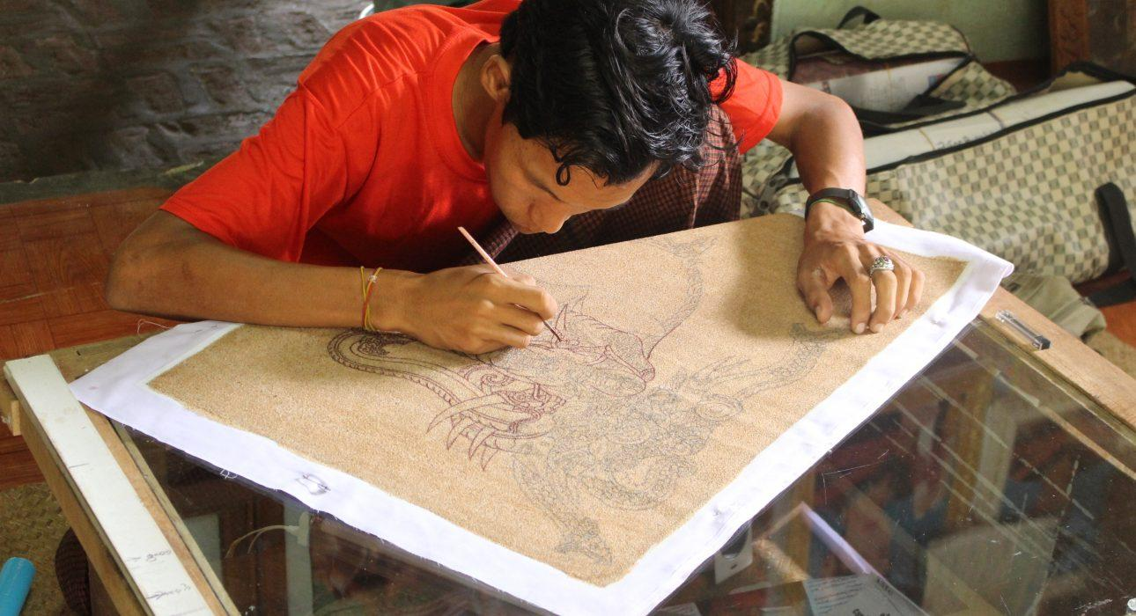
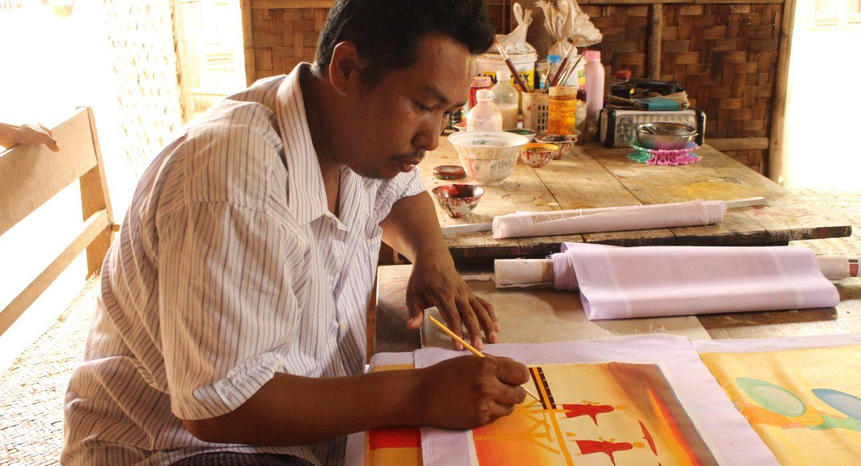
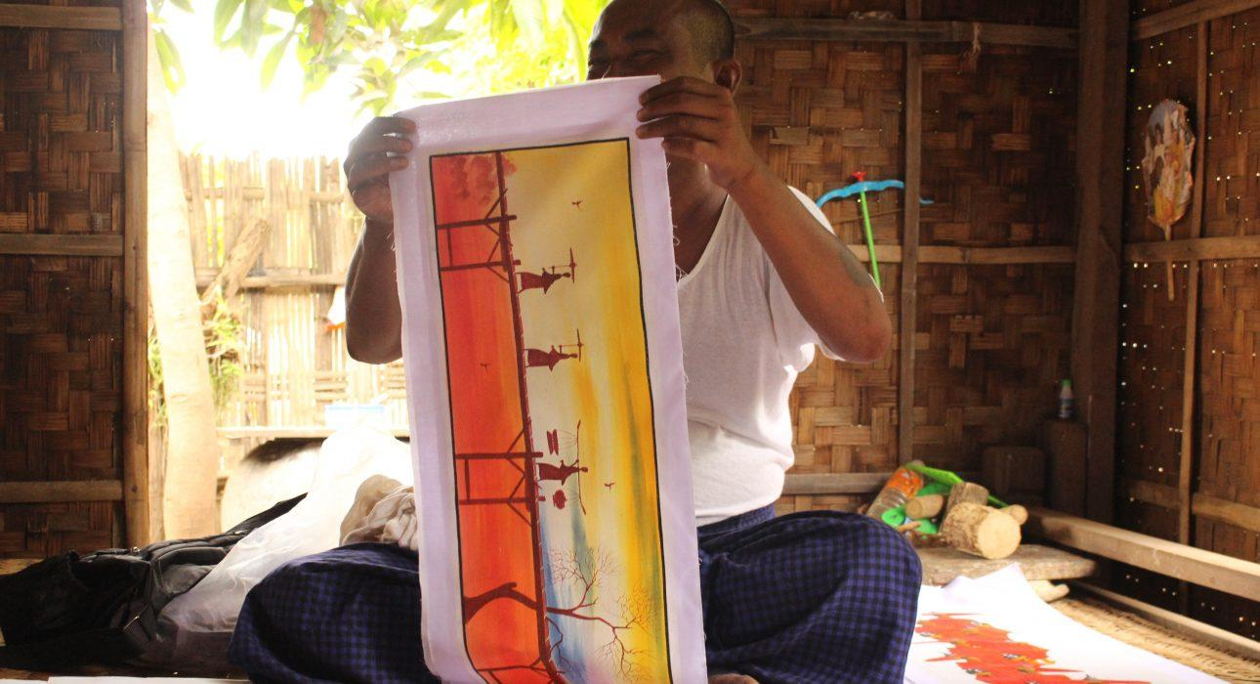

Easia Travel Head Office

Vietnam Head OfficeC/o: ATS Hotel, Suite 326 &327, 33B Pham Ngu Lao Street, Hanoi, VietnamTel: +84 24-39 33 13 62www.easia-travel.com

