VIETNAM – Hoi An – Hoi An Photo Tour, Morning Walk in the Old Town
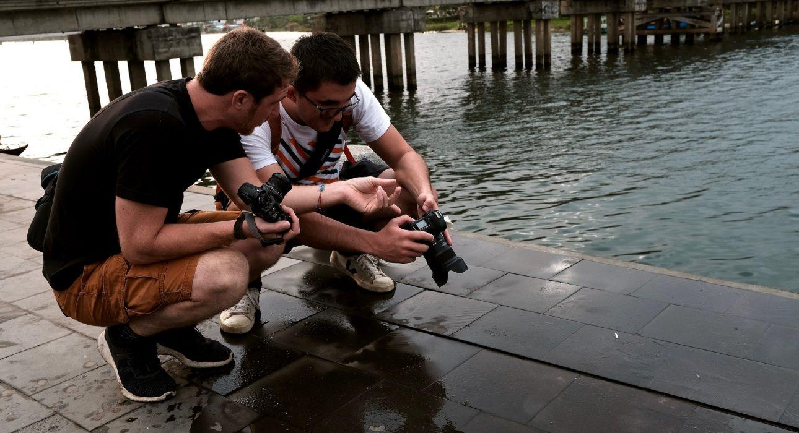

Over View

Theme
Classic

Country - City
Vietnam - Hoi An

Market segment
Thematic Leisure

Price Level
$$$

Max pax
12

Seasonality
All year long, not recommended during the rainy season

Arrival city
Hoi An

Departure city
Hoi An

Description

This photo tour takes travelers through the beautiful Ancient Town of Hoi An during sunrise. After a quick discussion to check your skills and knowledge, the journey will start around Hoi An. You will pass in front of many colorful houses, around the market, which is always bustling with locals trading in the morning, and in the riverfront where the sun slowly lights up the beautiful facade. For avid photographers this activity presents perfect opportunities to snap some incredible shots.

Selling points

- Hoi An at the most photogenic time of the day and without the crowds
- An experienced photographer who will adapt to the skills of the travelers
- Easy to organize for only 1 member of the group if the others are not interested in photography

Sustainability

Level Of The Excursion
Low - This activity impacts local community, culture and/or environment in a small but meaningful way

The Impact Of This Excursion

Environment Impact
Transportation

Additional Information
Positive Impact: This activity is conducted purely on foot through the Old Town.

Time And Transportation

Time of transportation may vary depending on the hotel’s location

Photos

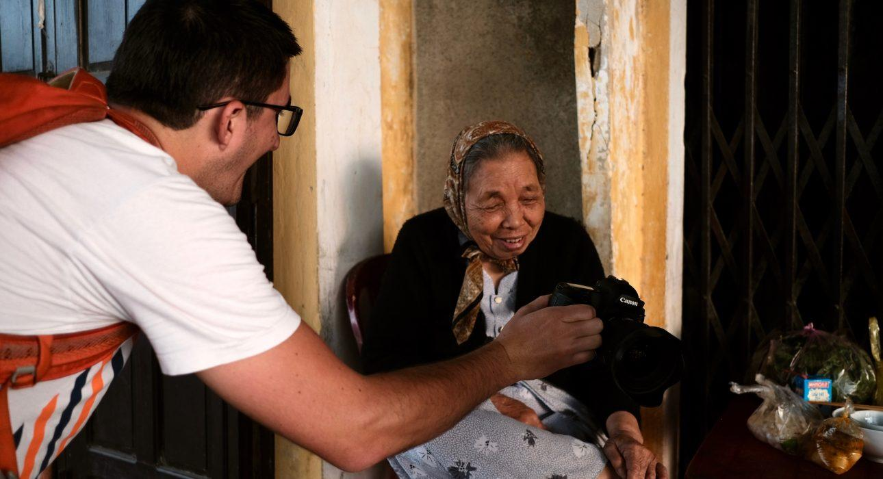
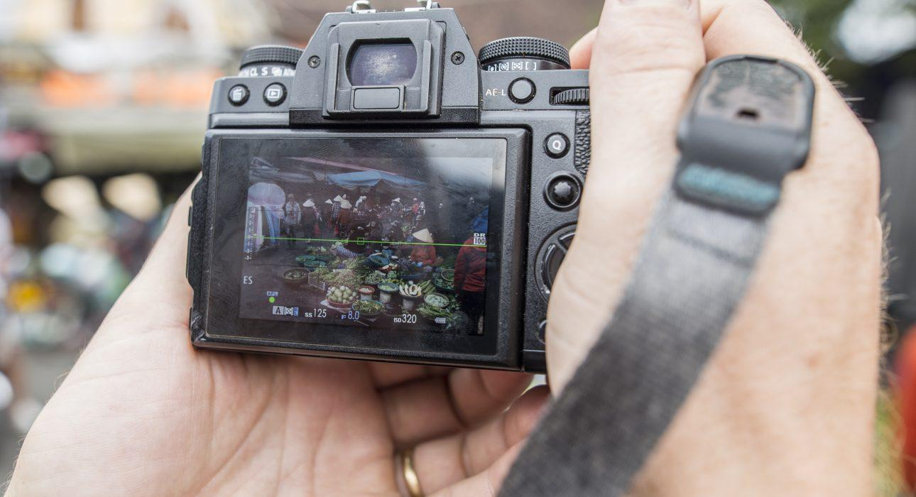
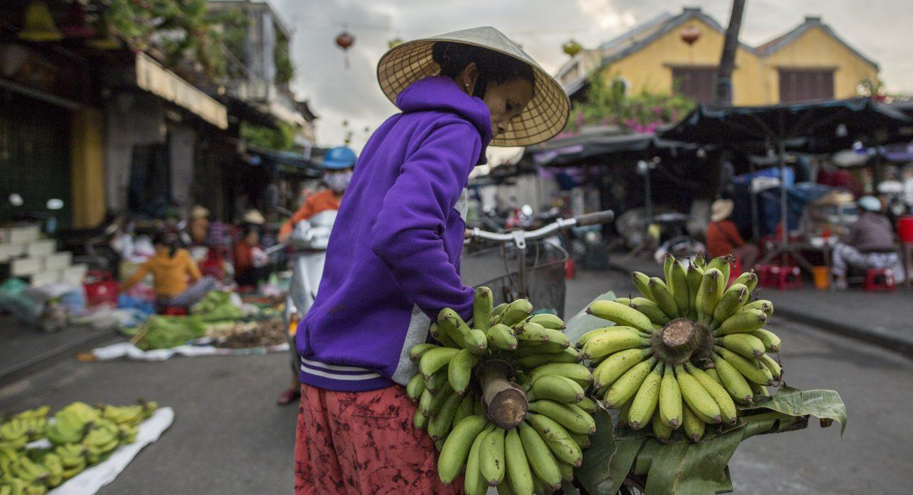
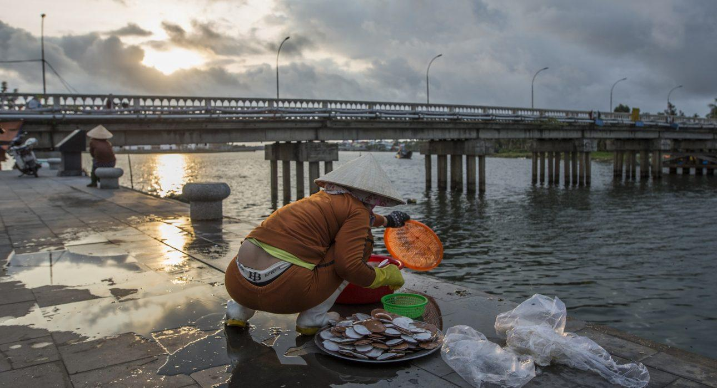

Easia Travel Head Office

Vietnam Head OfficeC/o: ATS Hotel, Suite 326 &327, 33B Pham Ngu Lao Street, Hanoi, VietnamTel: +84 24-39 33 13 62www.easia-travel.com

