VIETNAM – Hoi An – Learn About Rum in a Local Factory
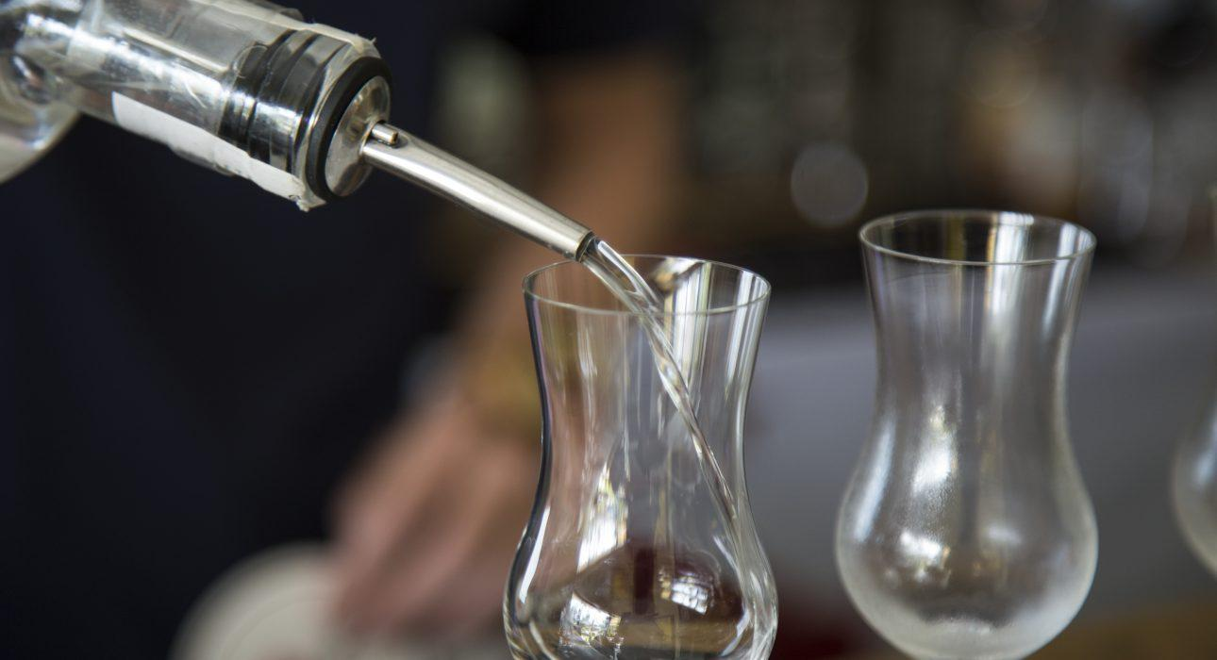

Over View

Theme
Art & Culture, Classic, Gastronomy

Country - City
Vietnam - Hoi An

Market segment
Thematic Leisure

Price Level
$$

Max pax
15 for the visit of the factory, 8 for the Rum Workshop, 6 for cocktail class

Seasonality
Year-round

Arrival city
Hoi An

Departure city
Hoi An

Description

During this fun activity, guests learn about the process of rum production, from the arrival of the pure sugar cane to the final product, a sealed bottle of rum. During the visit, explanations about the process as well as samples for tasting will be provided by a master distiller. The factory has been established in a beautiful set up in a colourful building near the sea.

Selling points

- Learn more about real Vietnamese agricultural rum with an experienced French team at a small local factory
- Taste different kinds of rum on spot, with the possibility to bring back high-quality rum (as gifts or for personal use)
- Possibility to add a private rum cocktail class or rum workshop for the travellers to make their rum and bring it back home
- The factory is beautiful and conveniently located for breaks with the refreshing sea air or to let the kids play while the parents enjoy a drink.
- Easy access to the factory, located a 15-minute drive south of Hoi An

Sustainability

Level Of The Excursion
Low - This activity impacts local community, culture and/or environment in a small but meaningful way

The Impact Of This Excursion

Social/cultural Impact
Empowerment and education

Economic Impact
Local individual benefits

Additional Information
Positive Impact:The activity helps some locals to increase their income, and also promotes local products of the region, such as sugar cane.

Time And Transportation

From | To | Distance | By | Duration | Road condition
Hoi An Center | Distillerie d’Indochine | 15 kilometers | Car | 15 minutes | Good
Danang City | Distillerie d’Indochine | 40 kilometers | Car | 1 hour | Good

Photos

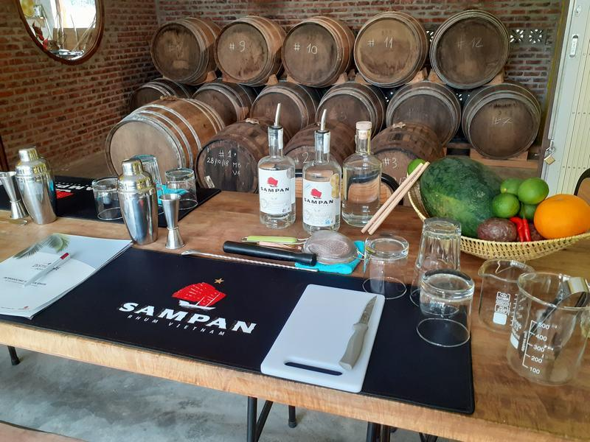
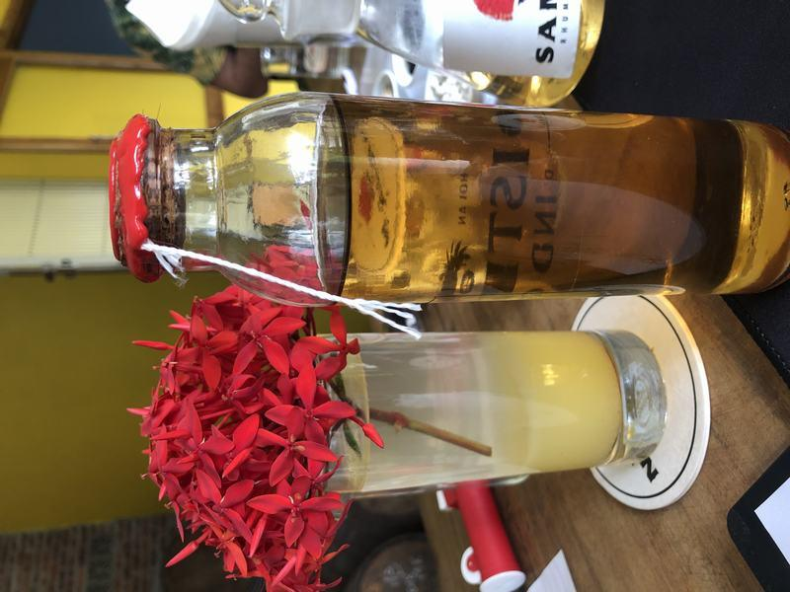
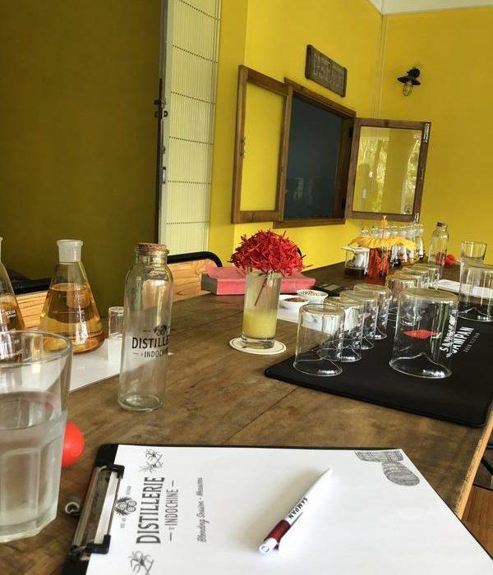
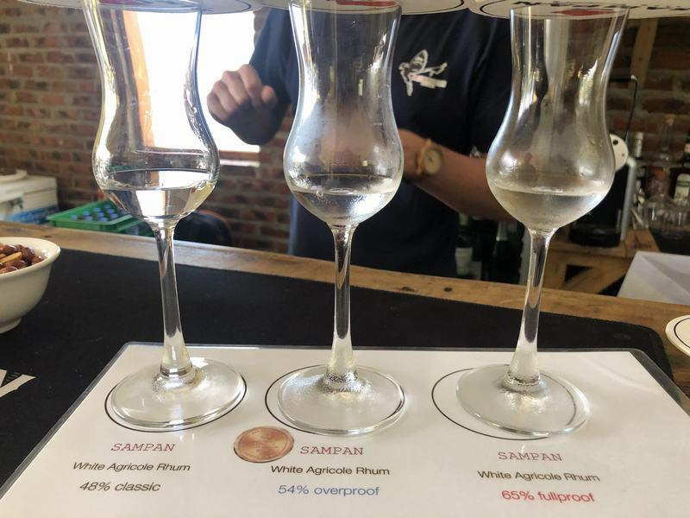
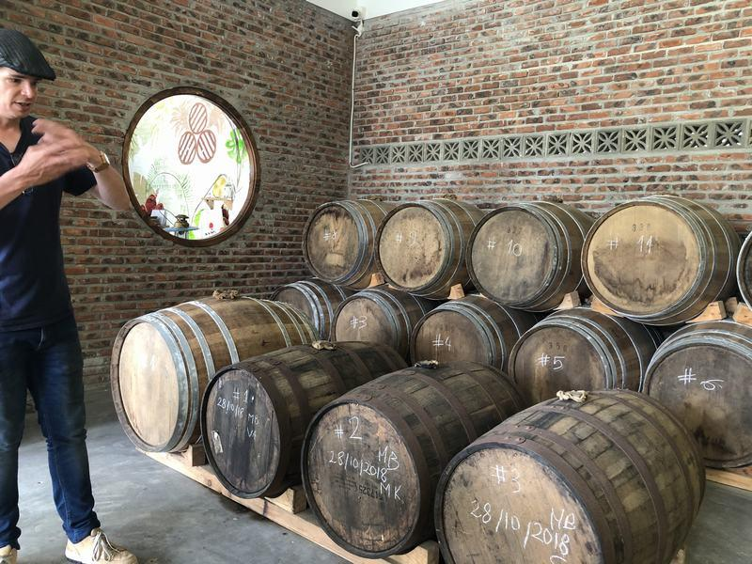
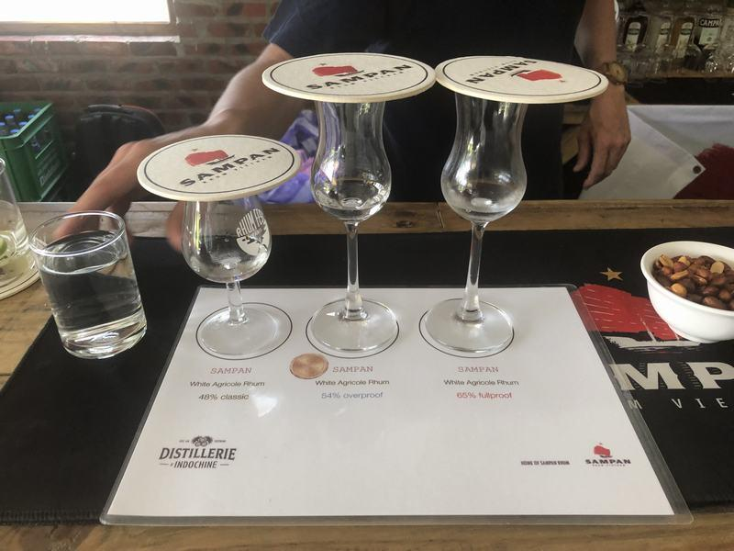
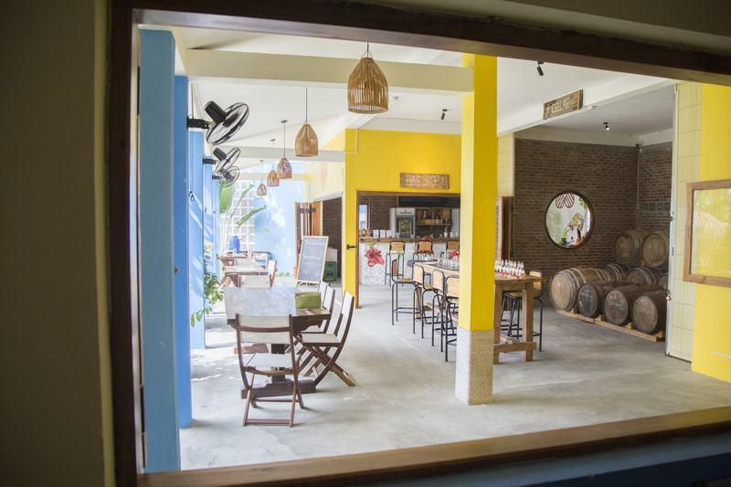
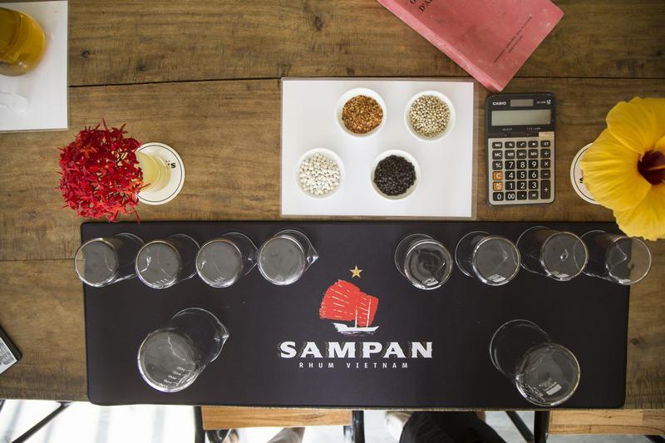
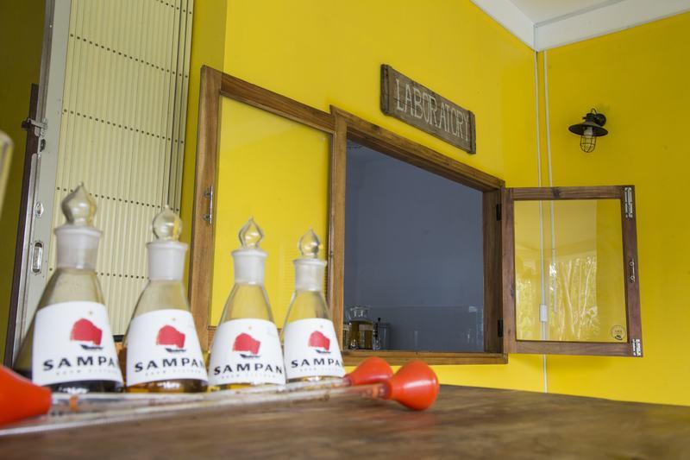
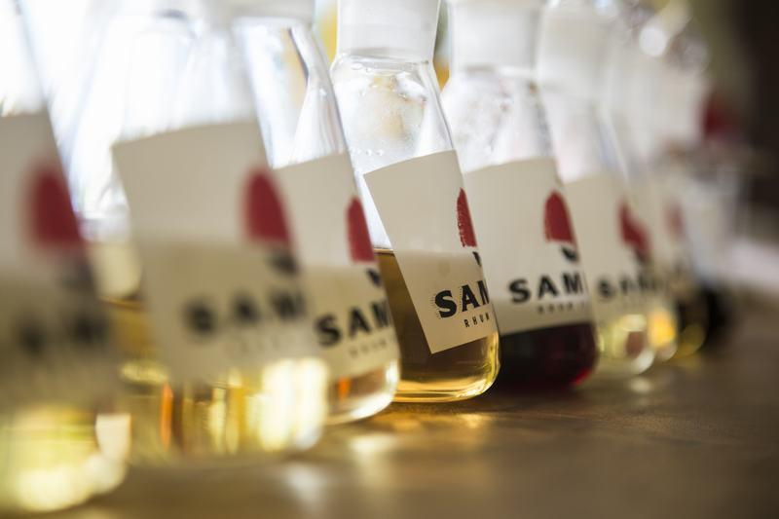
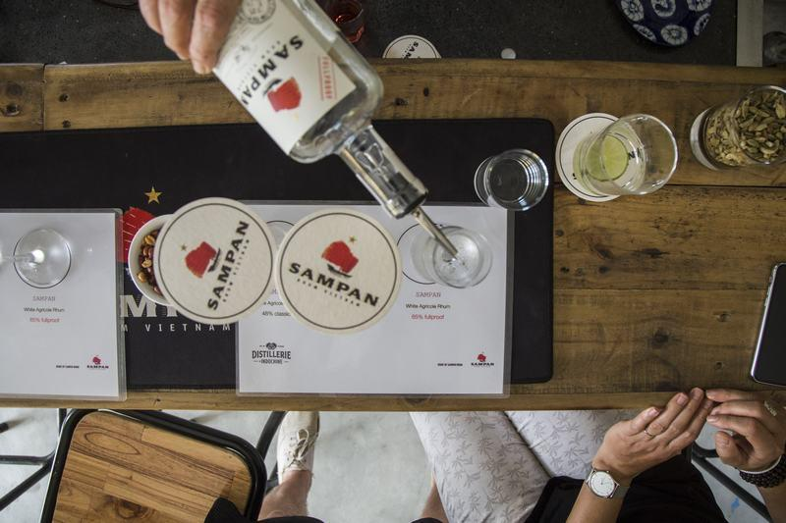
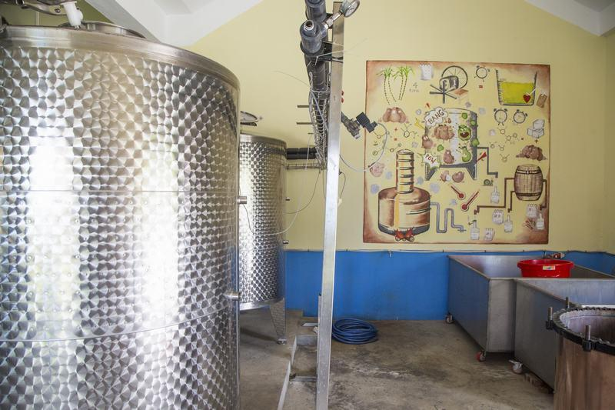

Easia Travel Head Office

Vietnam Head OfficeC/o: ATS Hotel, Suite 326 &327, 33B Pham Ngu Lao Street, Hanoi, VietnamTel: +84 24-39 33 13 62www.easia-travel.com

