VIETNAM – Ho Chi Minh City – Private Sunset Cruise on Saigon River
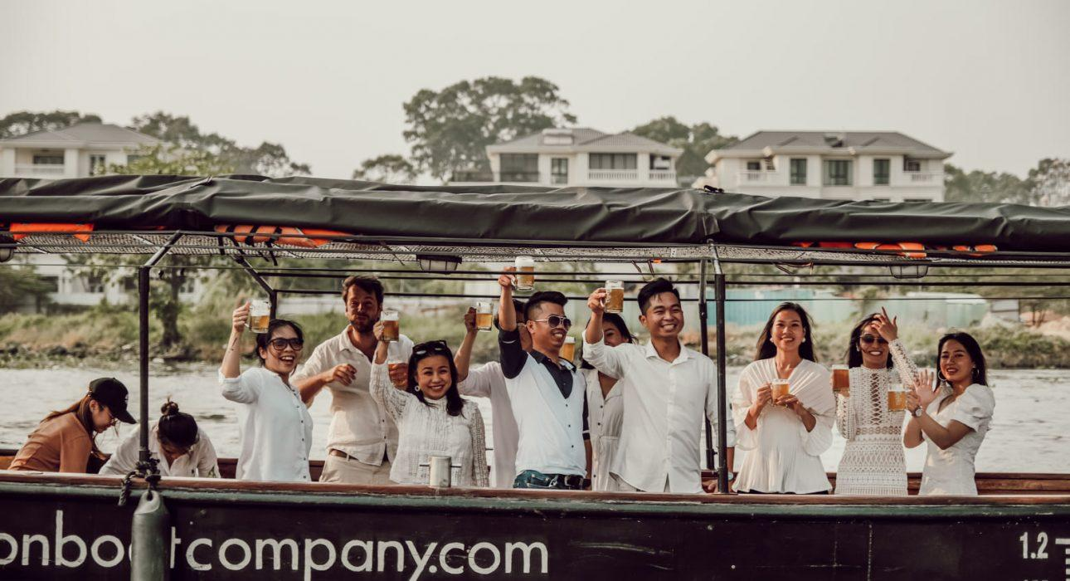

Over View

Theme
Cruise & River Cruise, Family, Honeymoon

Country - City
Vietnam - Ho Chi Minh City

Market segment
Groups, Thematic Leisure

Price Level
$$$$

Max pax
20

Seasonality
All Year Round (except rainy season in the south, May-Sep)

Arrival city
Ho Chi Minh City

Departure city
Ho Chi Minh City

Description

This activity offers the chance to enjoy a scenic sunset over Ho Chi Minh City from a beautiful boat on the river. The experience provides an alternative angle of the city in District 1, District 4 and the Thao Dien area while travellers relax in comfortable seats with refreshing drinks.

Can be combined with
Exclusive
Ho Chi Minh City – Meet the art: The vitality of Contemporary Art in Vietnam

Selling points

- A beautiful wooden boat, complete with a bar & toilets onboard
- The perfect time to observe the sunset with a cocktail
- Several optional extras available, including canapés or barbecue

Time And Transportation

Pick-up & drop-off pier may vary, depending on the hotel of the traveler

Photos

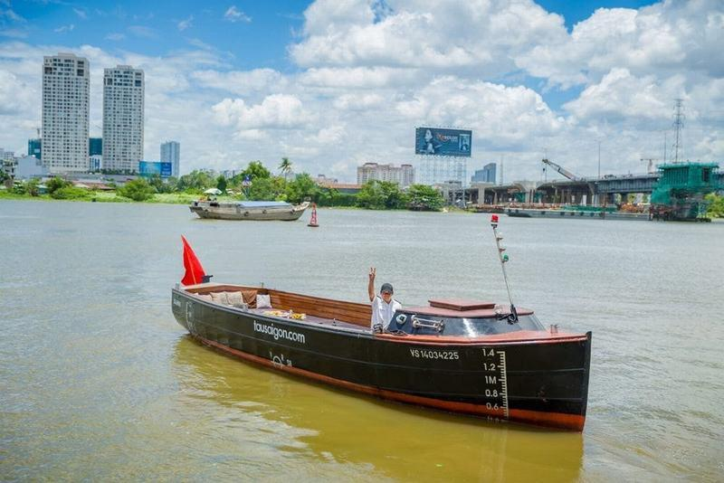
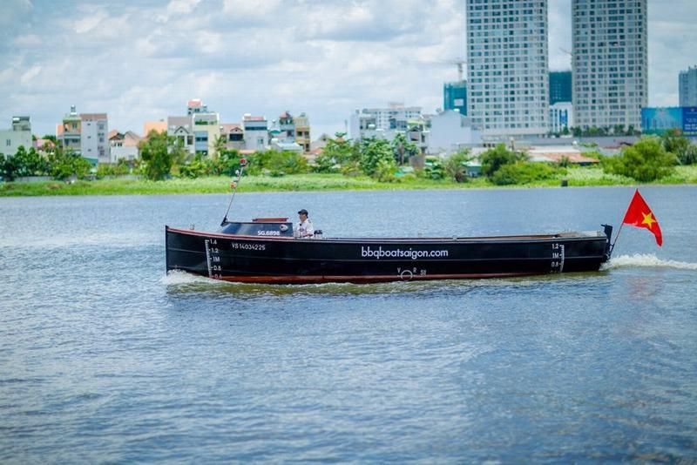
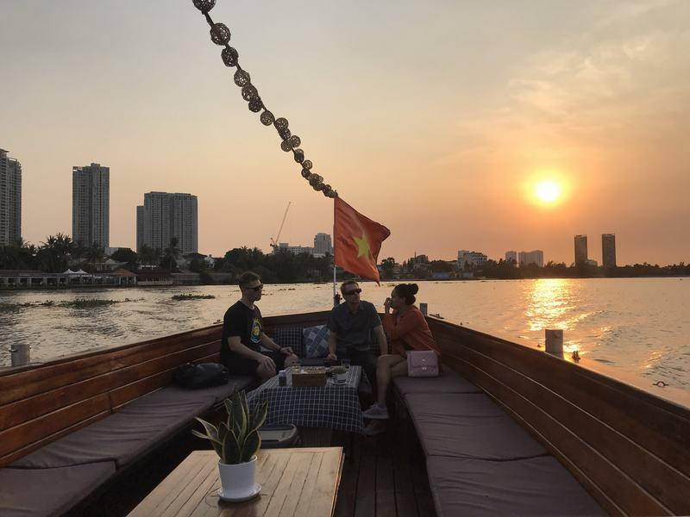
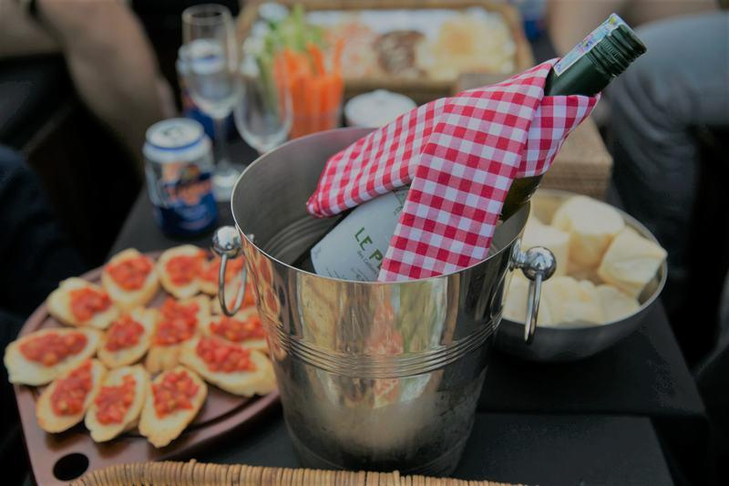
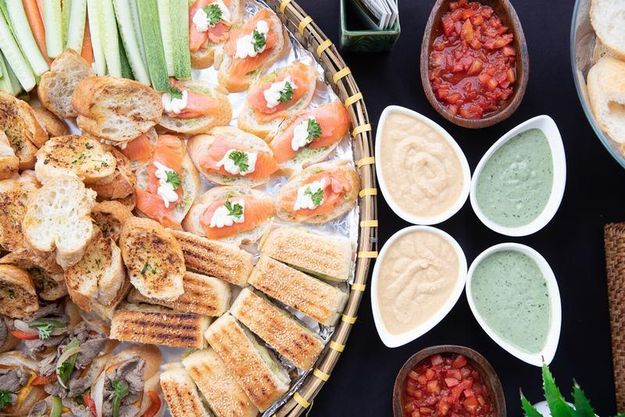
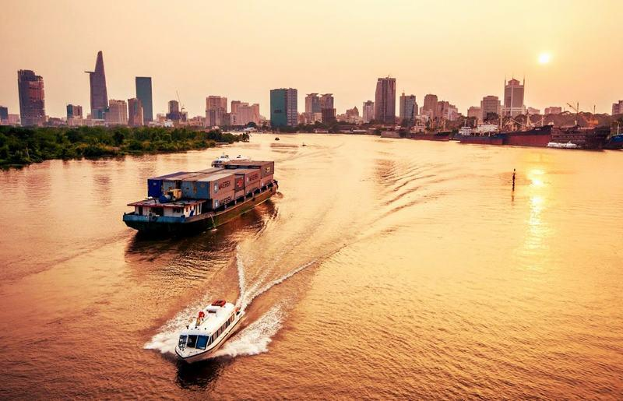
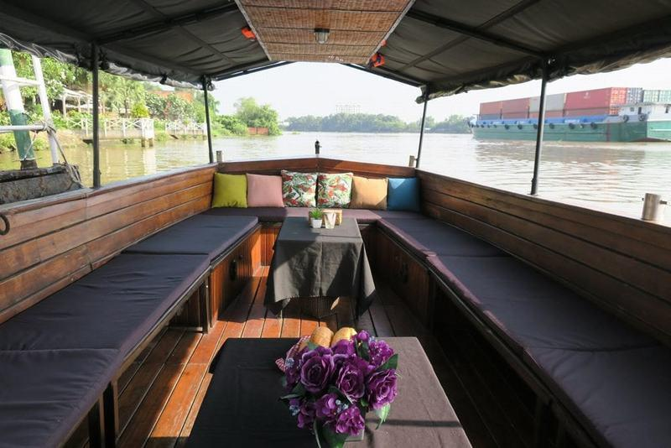
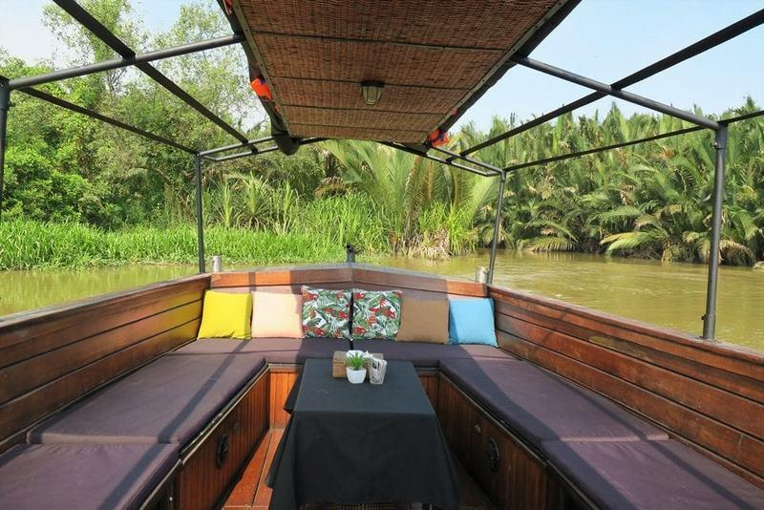
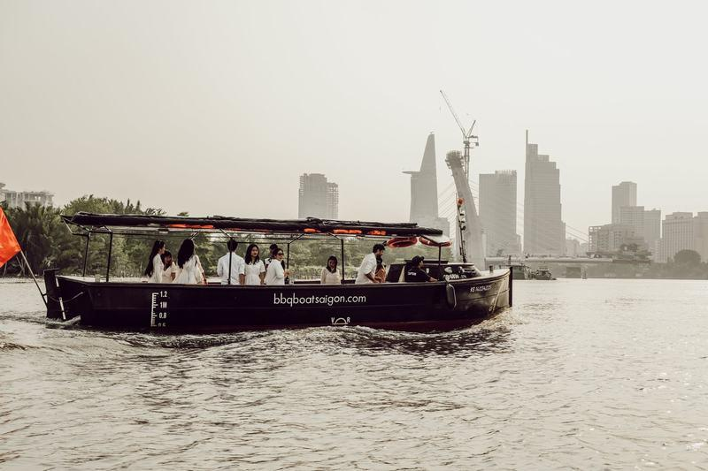
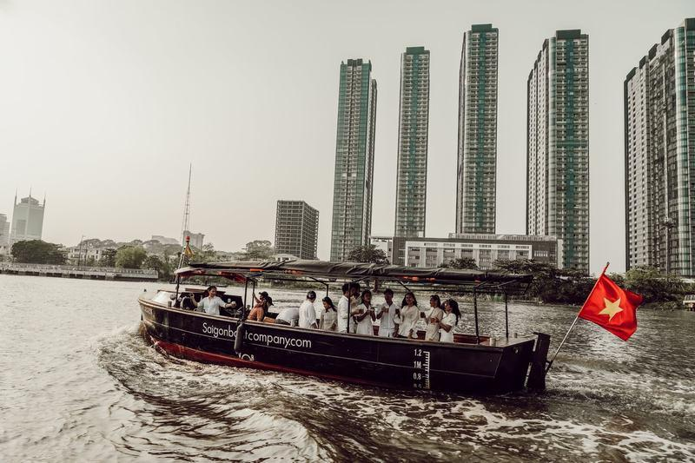

Easia Travel Head Office

Vietnam Head OfficeC/o: ATS Hotel, Suite 326 &327, 33B Pham Ngu Lao Street, Hanoi, VietnamTel: +84 24-39 33 13 62www.easia-travel.com

