VIETNAM – Hoi An – A Day to Learn About the Co Tu Minority
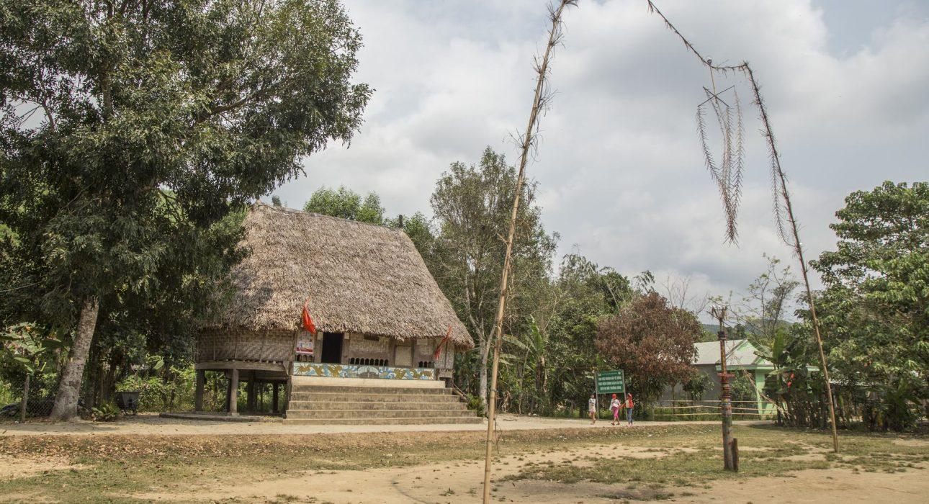

Over View

Theme
Art & Culture, Classic, Gastronomy, Sustainable

Country - City
Vietnam - Hoi An

Market segment
Thematic Leisure

Price Level
$$$

Max pax
50

Seasonality
All year round, rainy season from October to December

Arrival city
Hoi An

Departure city
Hoi An

Description

Spending a whole day learning about the Co Tu people will give travelers the privileged opportunity to discover a unique culture and interact with the local villagers. On the journey up the mountain, travelers will not only be immersed in incredible nature, but make stops along the way to experience daily life here, and meet the Co Tu people of the Bho Hoong village. The trip will be end with leisurely relaxation time with the triditional show of ‘Hat Ly’ at the communal house.

Selling points

- A multi-activity excursion with sightseeing, walking, local interaction, traditional cuisine and culture
- Easy to include from Hoi An, and a wonderful learning experience about a minority group in Central Vietnam (its customs, communal housing and specific food)
- Good for nature lovers and people interested in local culture and history

Sustainability

Level Of The Excursion
High – This activity strongly supports local communities and/or helps preserve the culture and environment

The Impact Of This Excursion

Social/cultural Impact
Cultural Conservation, Empowerment and education, Homestays, Involving minorities

Economic Impact
Community benefits

Additional Information
Positive Impact:
Th
is
activity provides a
n
in-depth discovery of a region inhabited by the Co Tu
ethnic group
, help
ing
to maintain
and preserve
the culture

(including
the specific food of the region)
.

I
t provides jobs & income to
an impoverished
area of Vietnam
operating
as a kind of Community Based Tourism.
Th
is
activity also helps to train local staff
in
hospitality, a
nd
provide
s

employment
to locals who
might otherwise

be unable to
find suitable jobs in this region. For example
,
the manager of the small hotel is a young woman who studied in Hue
;
without this project she
may have
had to work
stay
in Hue or Danang
for work,
even though she comes from the Co Tu region. The region has almost no
natural
resources, therefore developing tourism is a g
ood
way for the region to
generate income streams
.
Negative Impact:
The activity is made using a Jeep which is quite negative to the environment, but it’s also possible to do it using regular transportation.

Time And Transportation

From | To | Distance | By | Duration | Road condition
Hoi An | Bho Hoong village | 90 kilometers | Car | 2h 30min | Some ramps

Photos

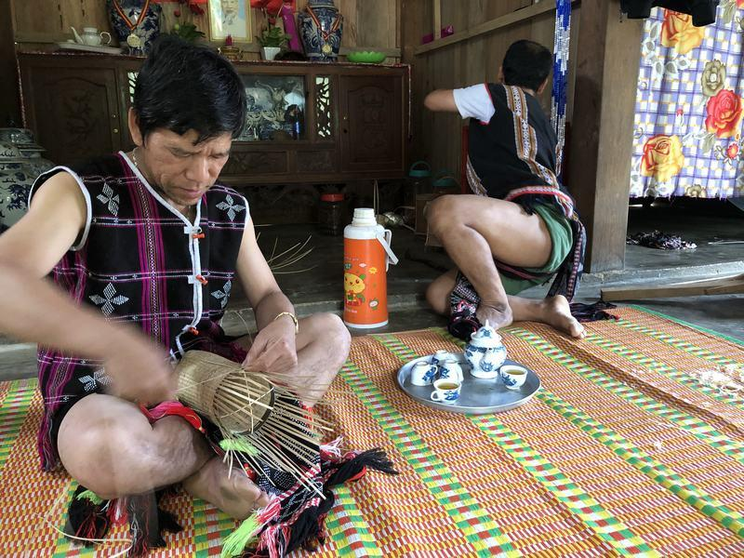
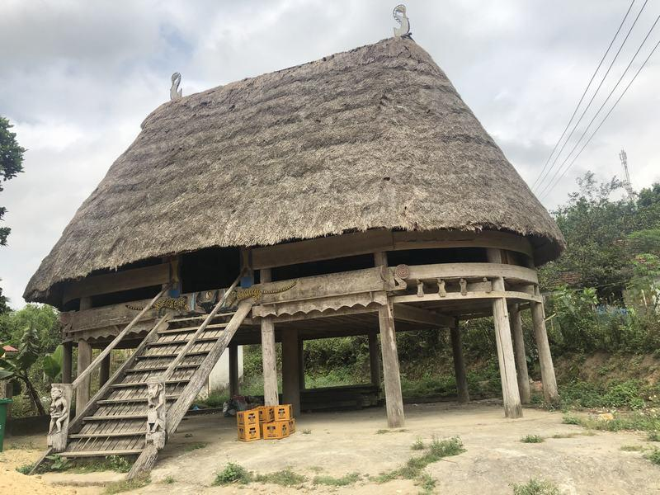
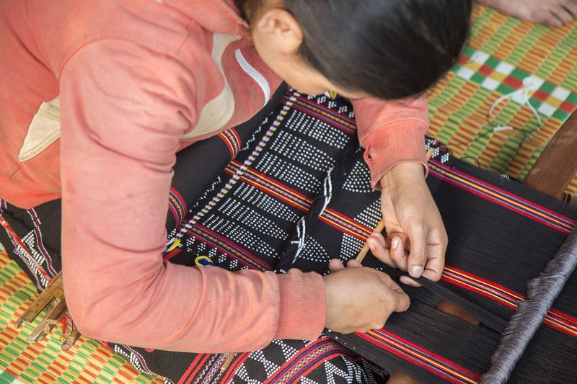
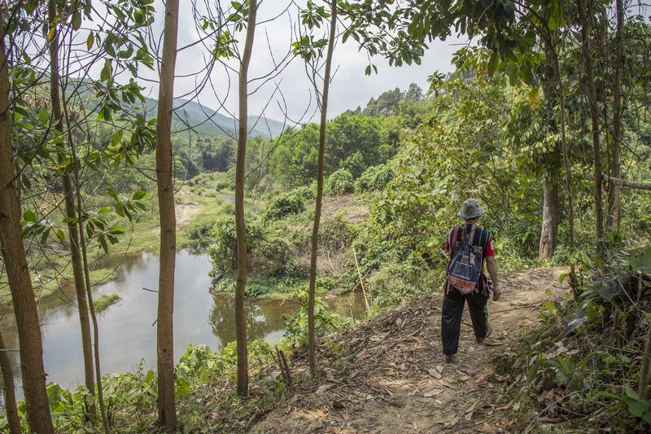
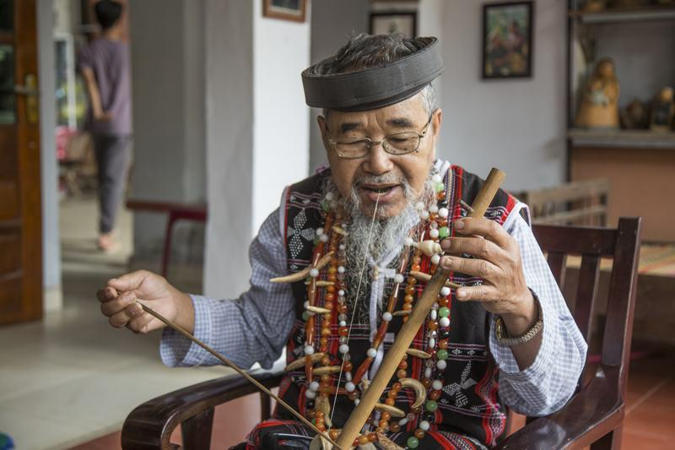
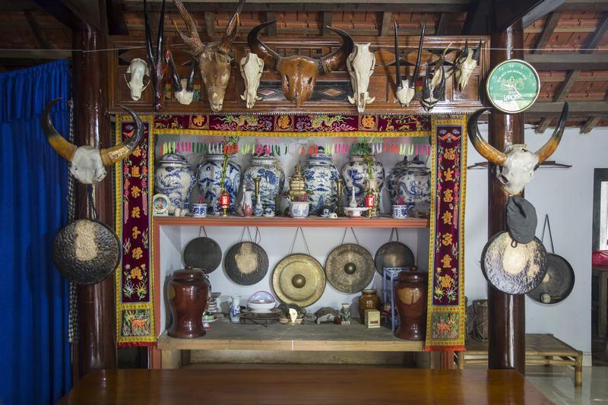

Easia Travel Head Office

Vietnam Head OfficeC/o: ATS Hotel, Suite 326 &327, 33B Pham Ngu Lao Street, Hanoi, VietnamTel: +84 24-39 33 13 62www.easia-travel.com

