MYANMAR – Bagan – Horse Cart Ride
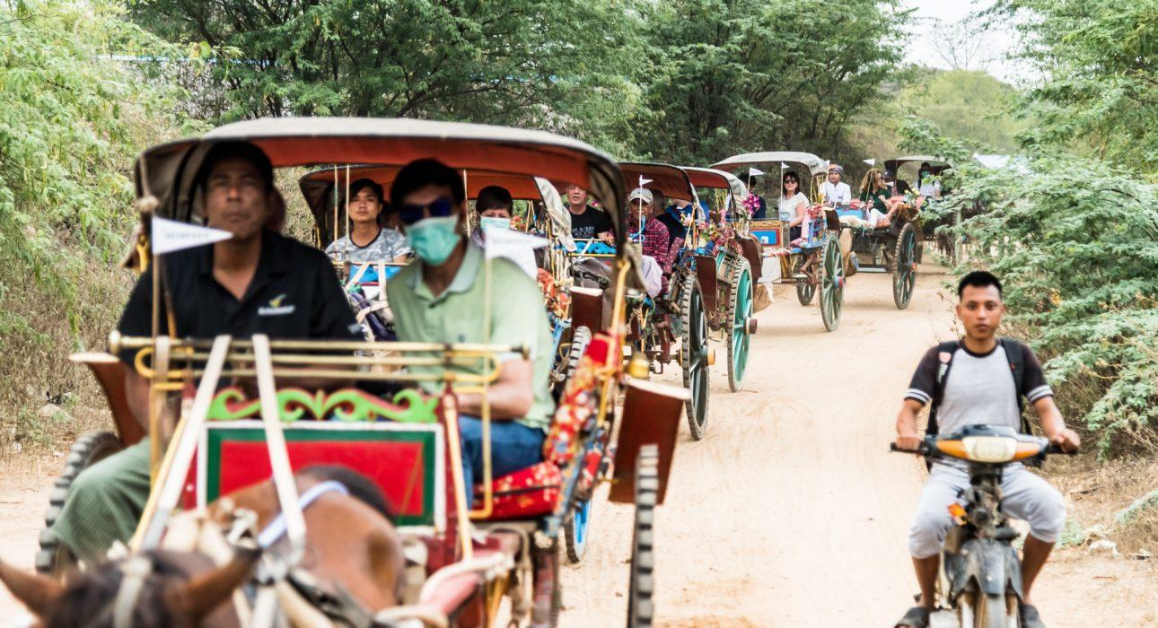

Over View

Theme
Classic, Family

Country - City
Myanmar - Bagan

Market segment
Groups, Thematic Leisure

Price Level
$

Max pax
100 persons

Seasonality
All Year Round

Arrival city
Bagan

Departure city
Bagan

Description

A leisure horse cart ride along the dusty lanes of Bagan, at sunrise or right before sunset. A favourite mode of transportation for many visitors in Bagan, the horse cart ride brings you on the sandy trails around the mystical temples of Bagan, at a slow pace which allows you to take beautiful pictures and enjoy the beauty of the ancient temples differently.

Can be combined with
Thematic Leisure
Bagan – Half-Day Discovery with Electric ScootersBagan – On the Sandy Paths of Kyun Thiri
Incentive
Bagan – Half-Day Discovery with Electric ScootersBagan – Sandbank Dinner
Groups
Bagan – Countryside Dinner by Candle LightBagan – Half-Day Discovery with Electric Scooters

Selling points

- A change of pace from the car or the electric scooter, slower to experience the atmosphere of Bagan differently
- Suitable for families
- Itinerary and time of the day is flexible to adapt to any type of sightseeing
- Available all day long, but best during sunrise or sunset
- Our favourite time is in the early morning when Bagan is still free of visitors and the spiritual atmosphere is even more palpable
- The colourful wooden carts with temples in the backdrop make for beautiful pictures
- One horse cart sits 2 or 3 adults

Time And Transportation

Photos

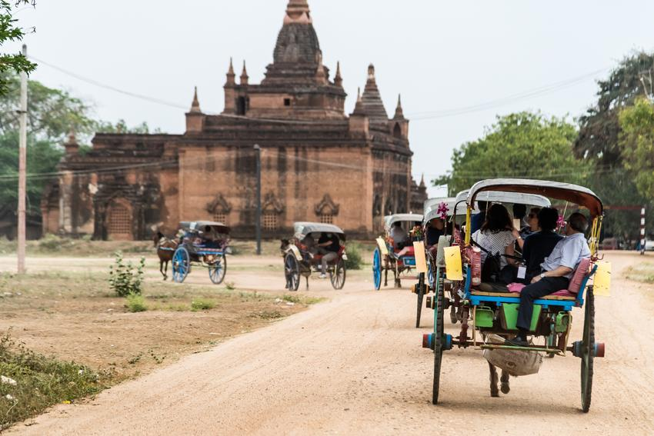
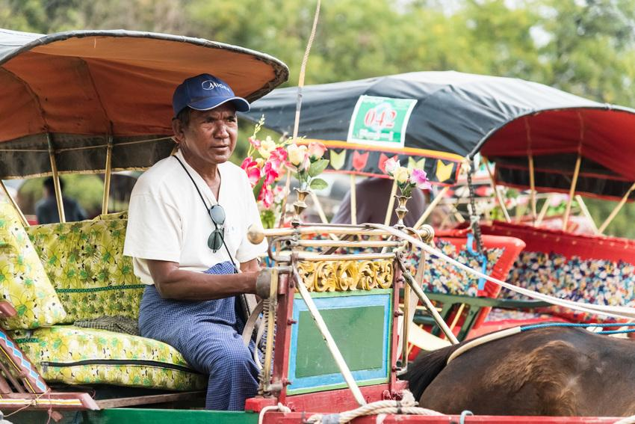
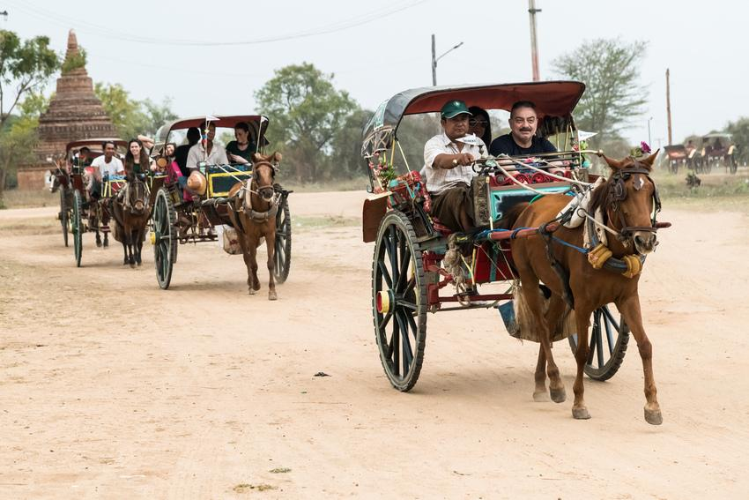
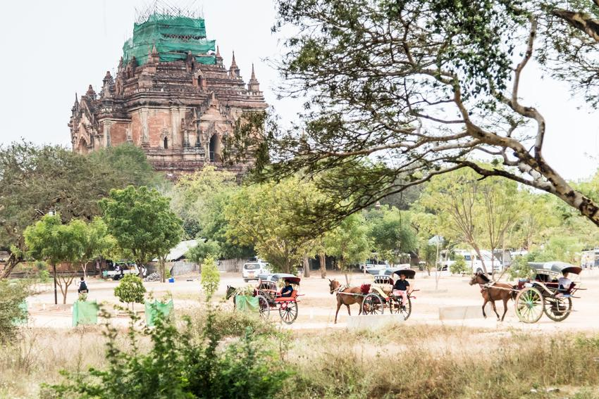
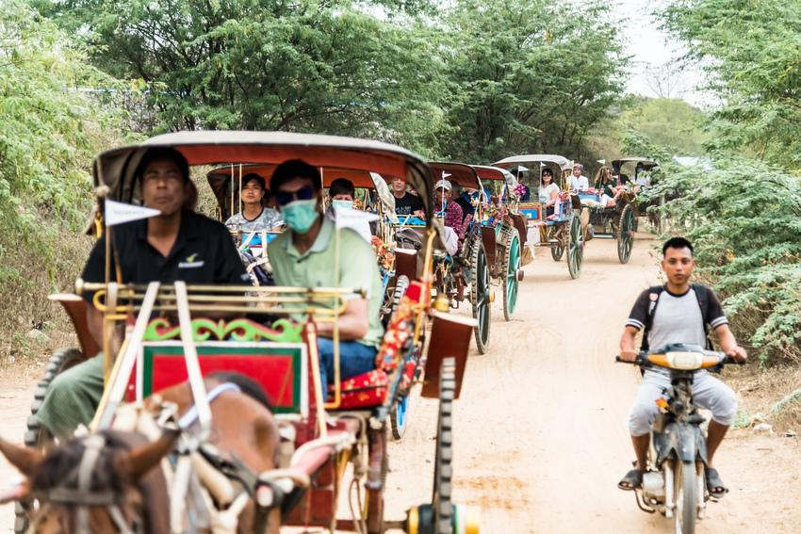
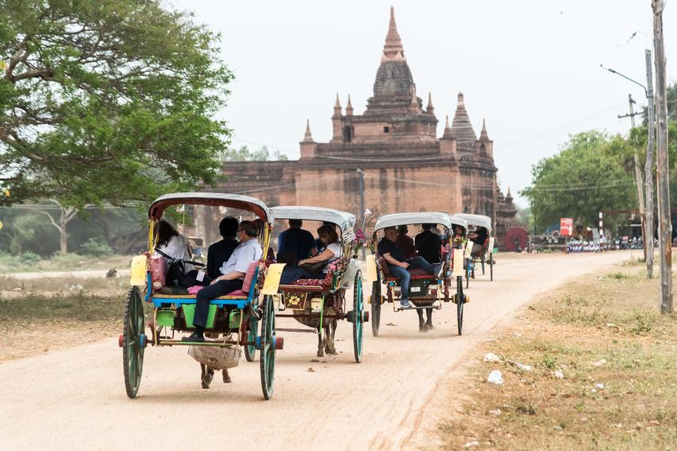
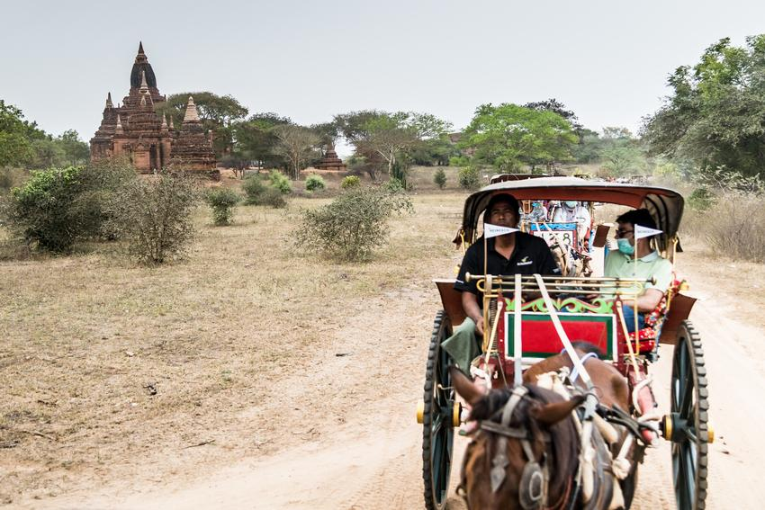
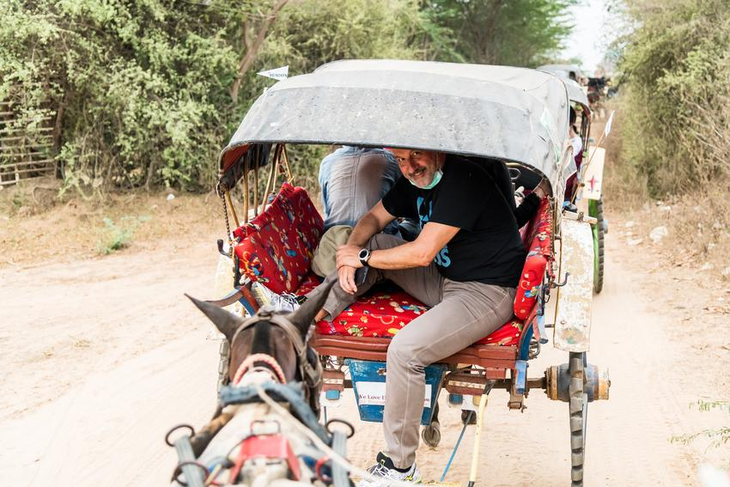
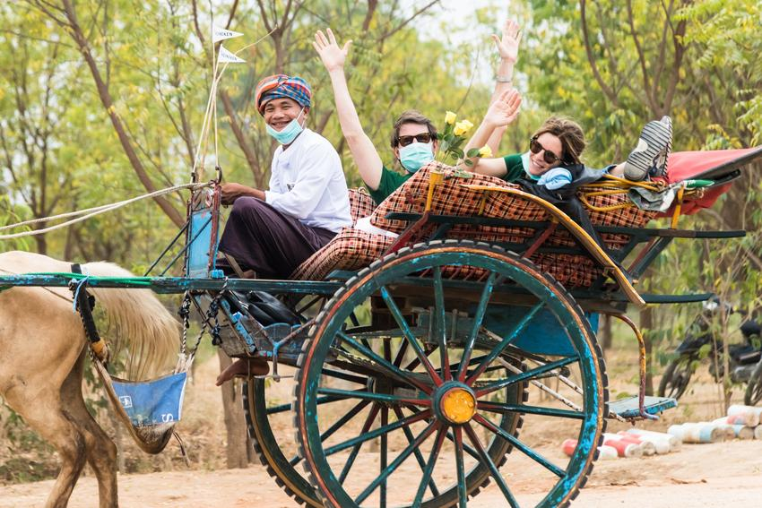
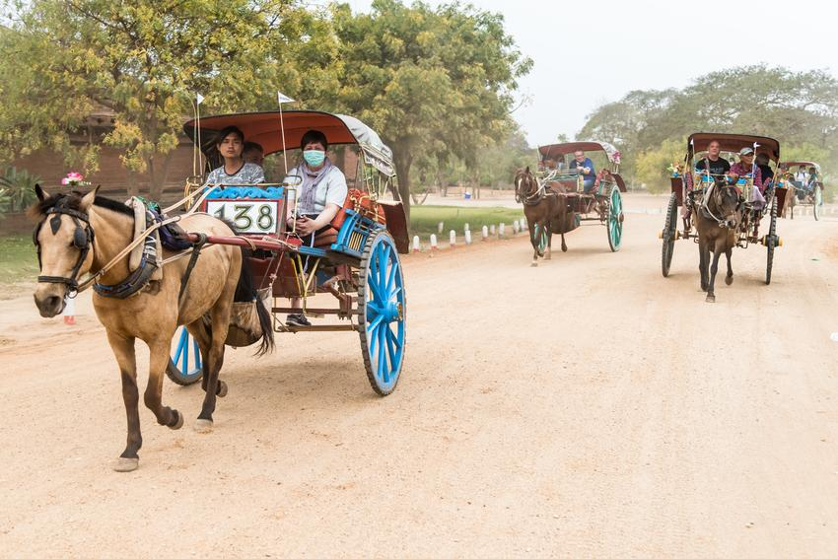

Easia Travel Head Office

Vietnam Head OfficeC/o: ATS Hotel, Suite 326 &327, 33B Pham Ngu Lao Street, Hanoi, VietnamTel: +84 24-39 33 13 62www.easia-travel.com

