LAOS – Luang Prabang – Meet a Prestigious UNESCO Expert at his Riverside Villa
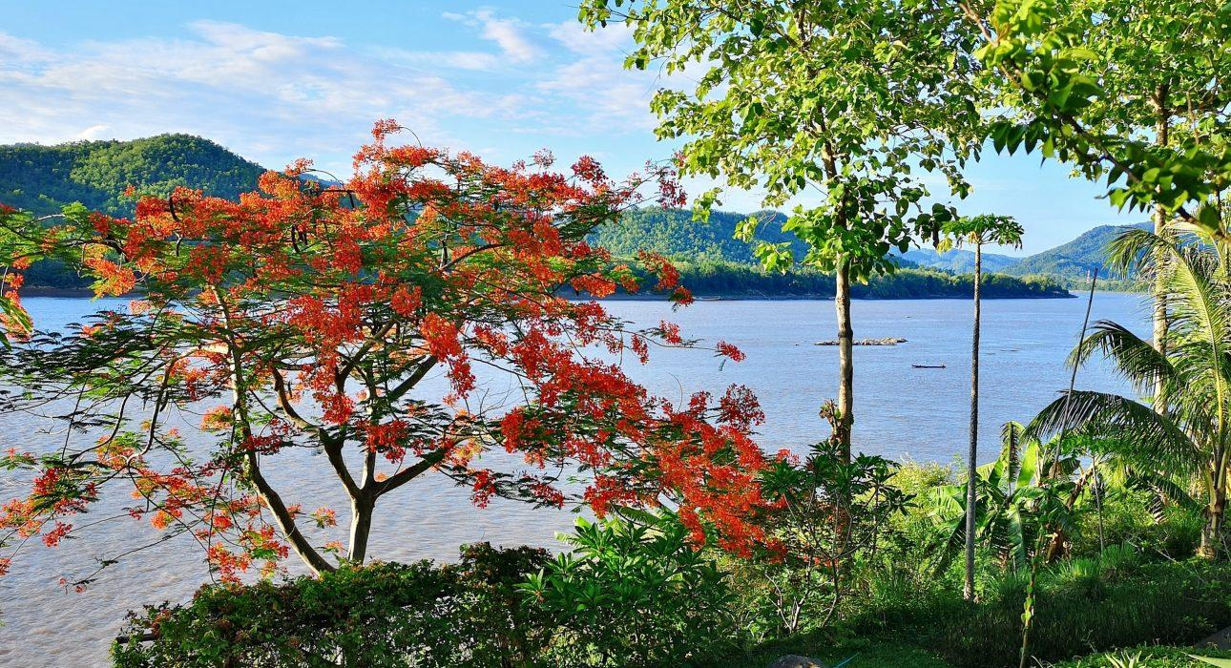

Over View

Theme
Art & Culture

Country - City
Laos - Luang Prabang

Price Level
$$$$

Max pax
15

Seasonality
All year round

Arrival city
Luang Prabang

Departure city
Luang Prabang

Description

This activity provides a chance to share a special lunch at a stunning private villa overlooking the Mekong with Mr. Francis Engelmann, a prestigious UNESCO expert who has been actively involved in the conservation of the city since 2001. He has a passion for history, urbanism and anthropology, knows Luang Prabang like no one else, and will be able to bring a new dimension to a visit of the sacred city of Laos. This unique activity consists of a private lunch (or tea break) with Francis at his beautiful riverside villa and is ideal for those looking for passionate intellectual discussions and a way to gain a deep understanding of everything that makes Laos such a magical and special place. It is an amazing option to combine with a visit of the nearby Kuang Sy Waterfalls.

Can be combined with
Exclusive
- Luang Prabang – Introduction to the local handicraft
- Luang Prabang – Meet a Unesco Expert (Architectural Tour)
- Luang Prabang – Private Event at a Riverside Villa

Selling points

- The encounter and event at Francis’ villa is a unique experience in a stunning location.
- An activity for those looking for intellectual and deep discussions with an expert on the local history and culture.
- The meeting with Francis does not follow any structure and conversation can be guided towards the travelers areas of interest.
- The location is an excellent choice for a luxurious catered riverside lunch or tea break.
- An excellent option which can be combined with a visit of Kuang Sy Waterfalls.
- A chance to enjoy a privately catered meal (or tea break) in a magnificent location.

Time And Transportation

The encounter and lunch or tea break at the riverside villa are best done after a morning visit to Kuang Sy waterfall. Timings for this are as follows:
From | To | Km | By | Duration | Road condition
Luang Prabang | Kuang Sy waterfall | 30 | Car / Bus | 45 minutes- 1 hour | Good
Kuang Sy waterfall | Francis’ Riverside Villa | 10 | Car / Bus | 10 minutes | Good

Photos

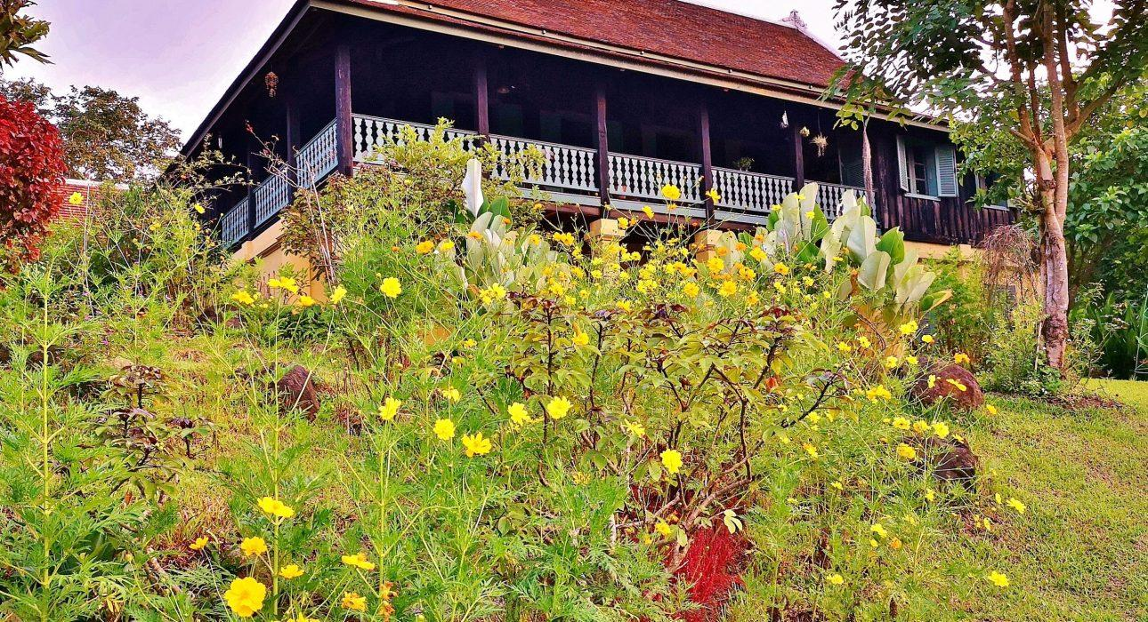
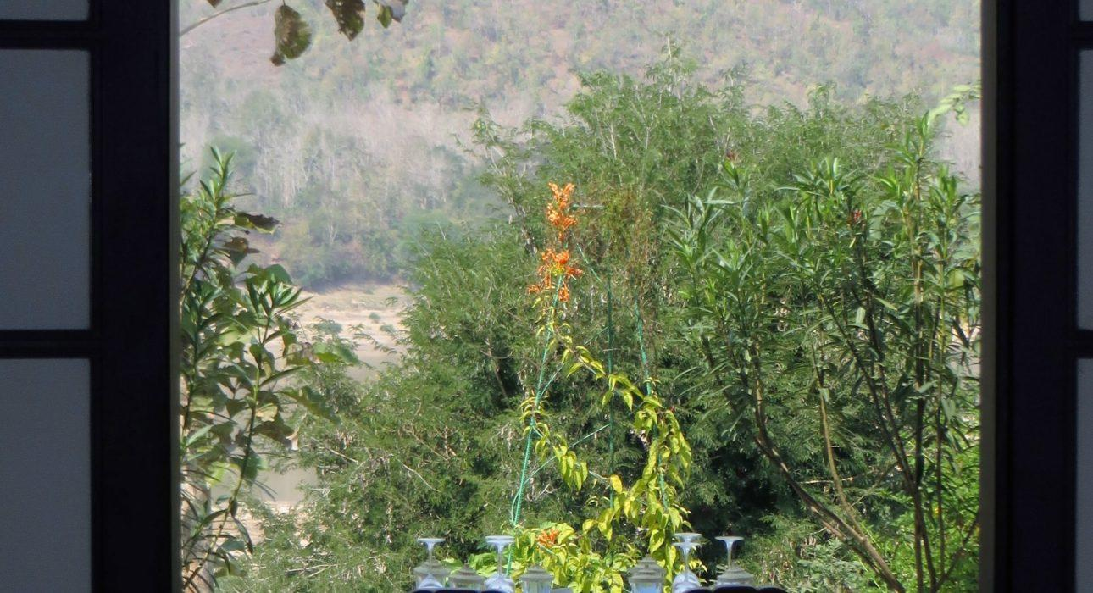
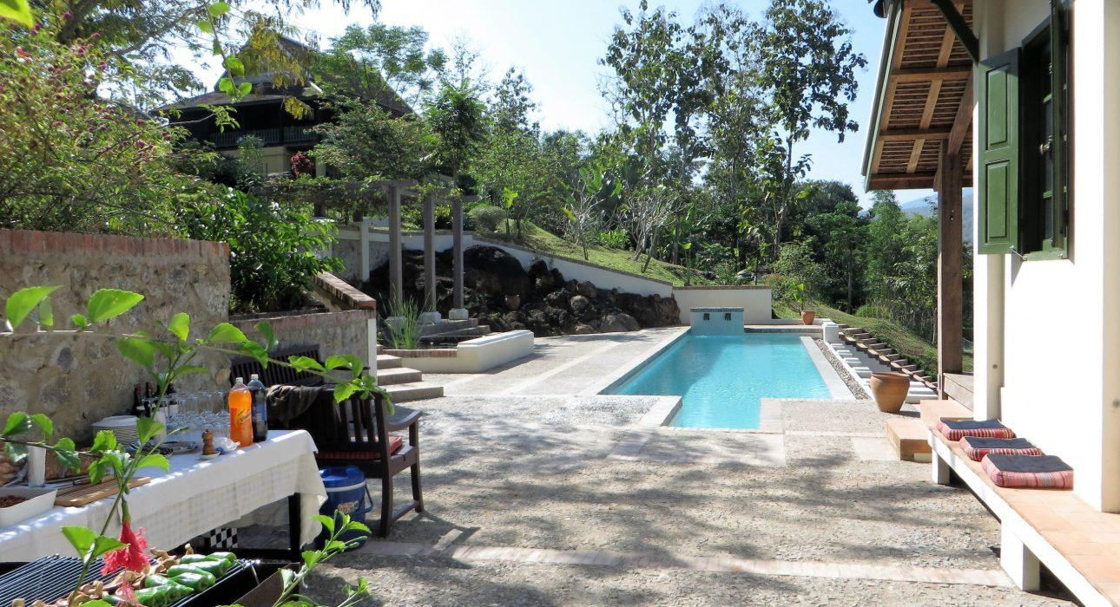

Easia Travel Head Office

Vietnam Head OfficeC/o: ATS Hotel, Suite 326 &327, 33B Pham Ngu Lao Street, Hanoi, VietnamTel: +84 24-39 33 13 62www.easia-travel.com

