THAILAND – Phuket – Chalong Bay Rum Stories and Cocktail Workshop
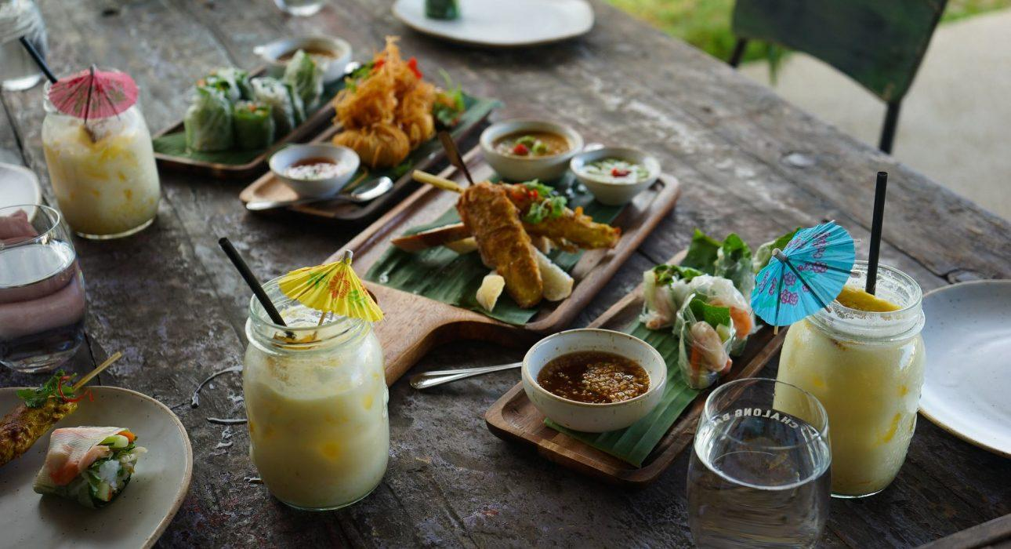

Over View

Theme
Art & Culture, Gastronomy

Country - City
Thailand - Phuket

Market segment
Groups, Thematic Leisure

Price Level
$$$$

Max pax
25

Seasonality
All year

Arrival city
PHUKET

Departure city
PHUKET

Description

After being welcomed by distillery staff, a ‘welcome mojito’ is served along with a friendly talk about what the experience comprises. During a half-hour guided visit, guests will learn how the rum culture began in Phuket, and the different steps of the rum distillery process.Rich with this new knowledge, they will enjoy a ‘do it yourself’ experience, mixing their own cocktails under the supervision and advice of an expert bartender.The tour will end sipping their own handmade drink in the relaxing atmosphere of the distillery garden.

Selling points

- An interesting hands-on experience ideal to learn another side of Phuket’s history
- Ideal to break the typical beach stay routine
- Learn by sipping a drink: an alternative to the regular outings in Phuket
- A peaceful tropical setting for a fun and educational experience

Sustainability

Level Of The Excursion
Low - This activity impacts local community, culture and/or environment in a small but meaningful way

The Impact Of This Excursion

Social/cultural Impact
Empowerment and education

Economic Impact
Local individual benefits

Additional Information

Positive impacts
The distillery is a 100% local, small-scale company. Their focus in on sourcing locally and employing local people.

Negative impacts
No negative.

Time And Transportation

Photos

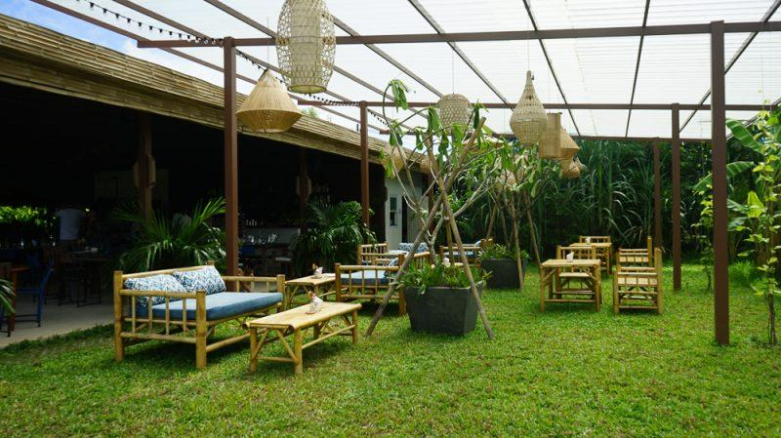
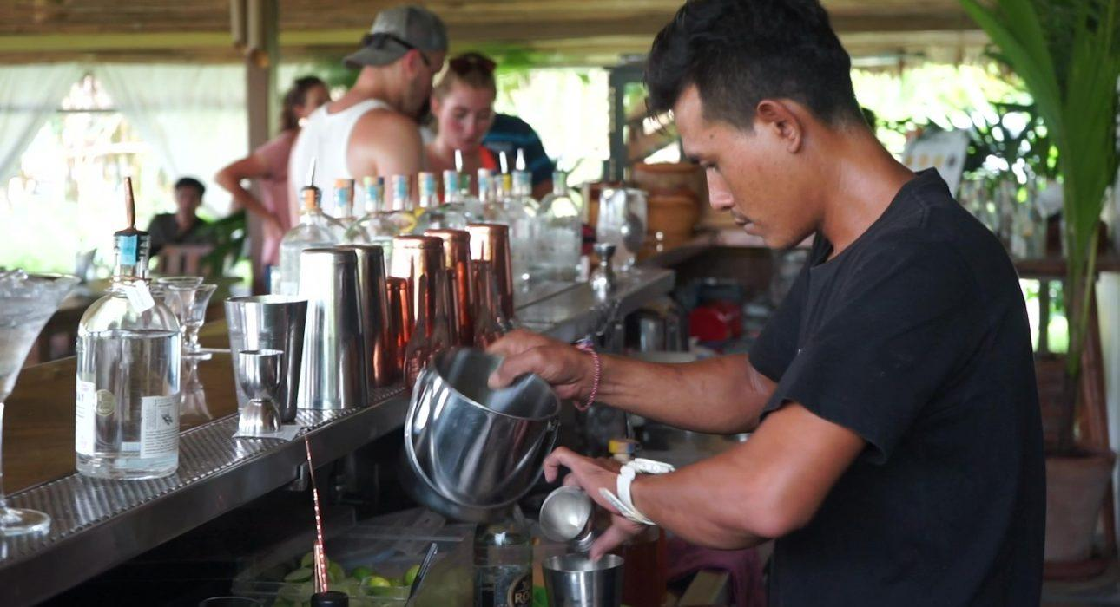
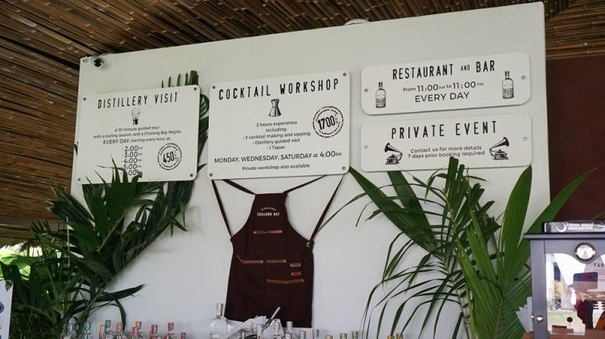
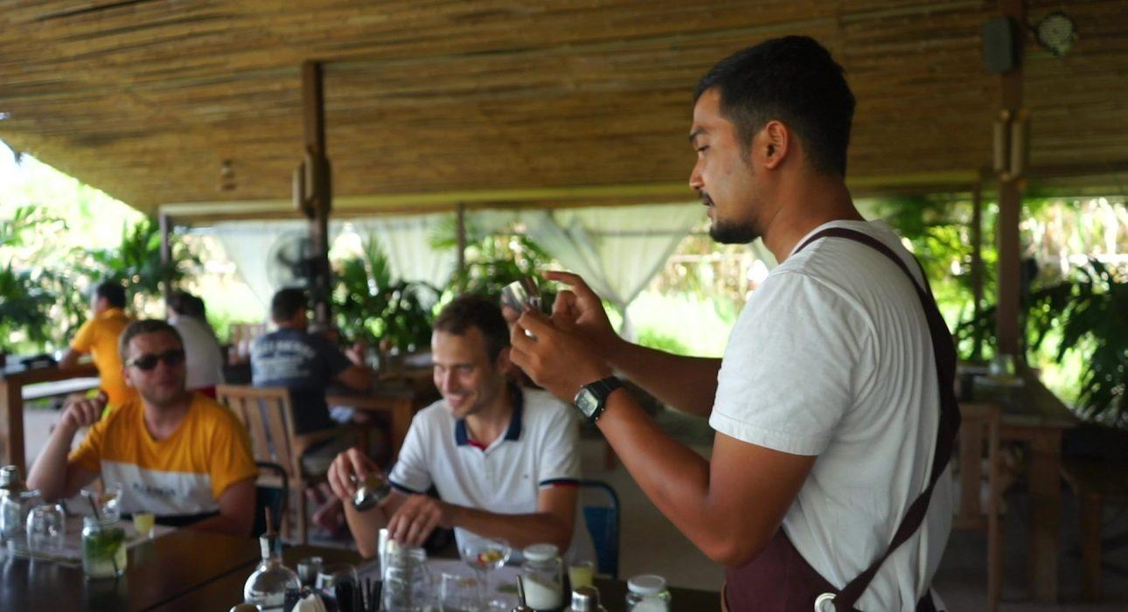
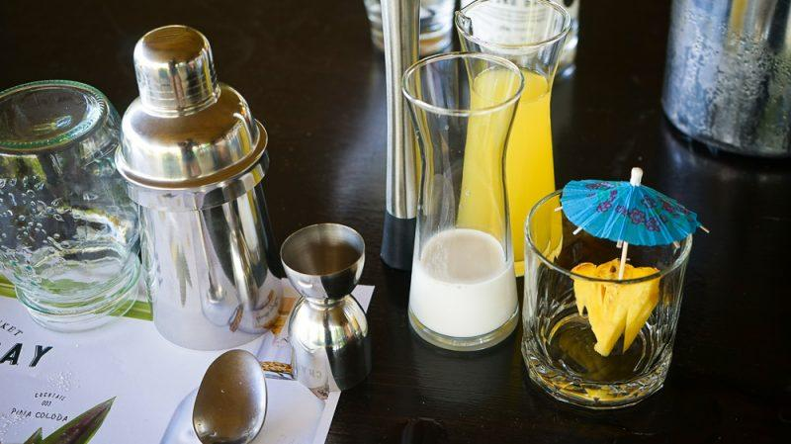
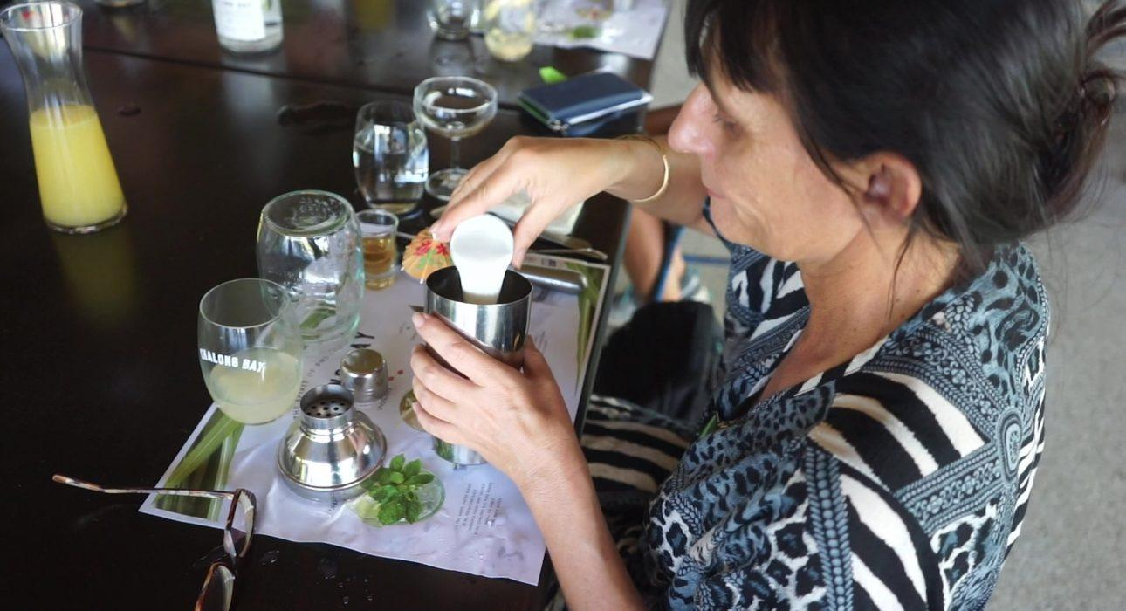
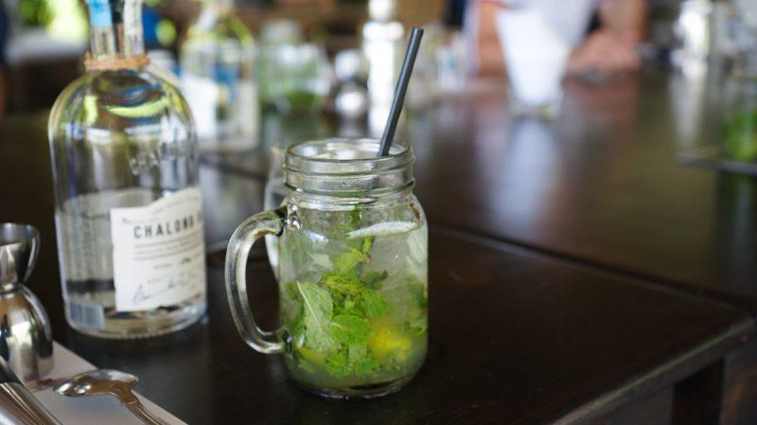
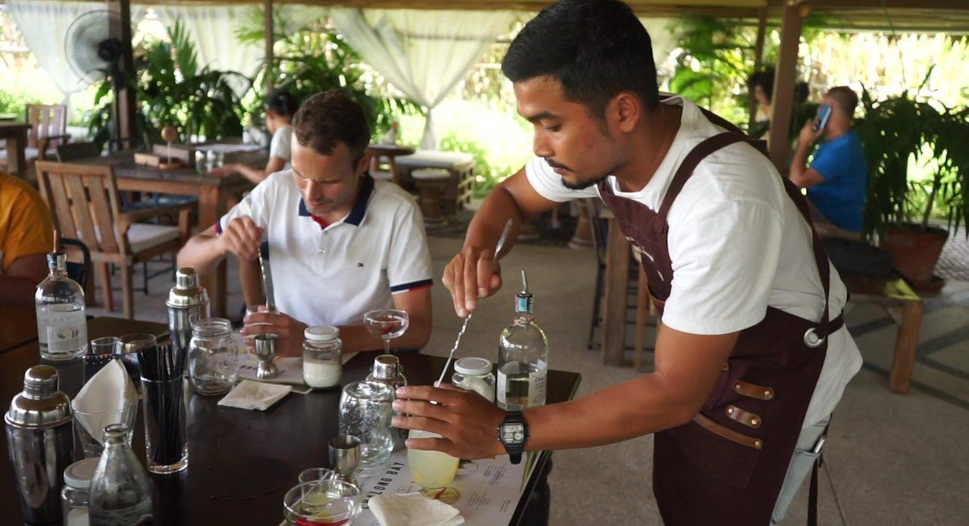
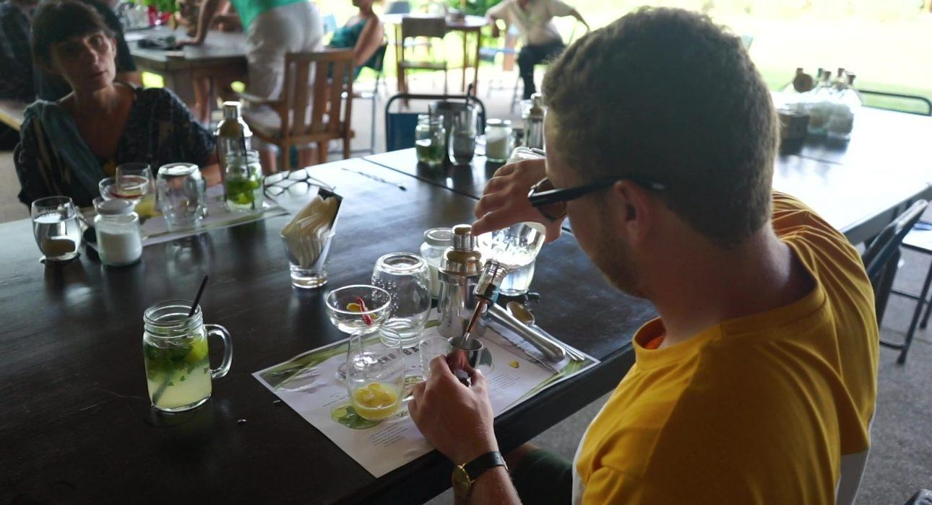
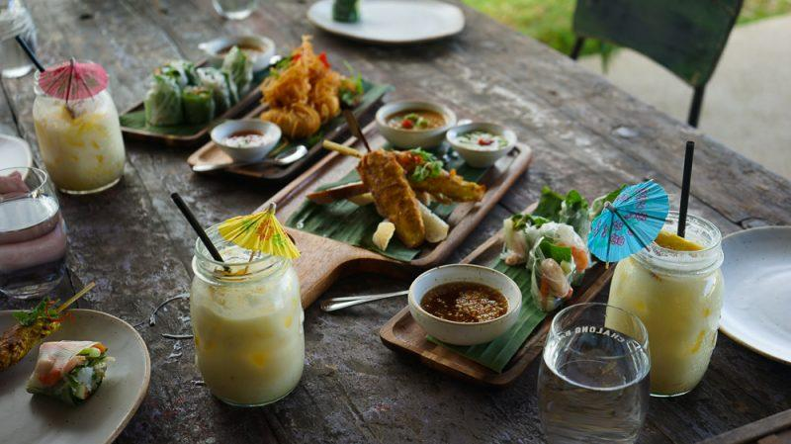

Easia Travel Head Office

