MYANMAR – Hpa An – Boat trip from Hpa An to Mawlamyine
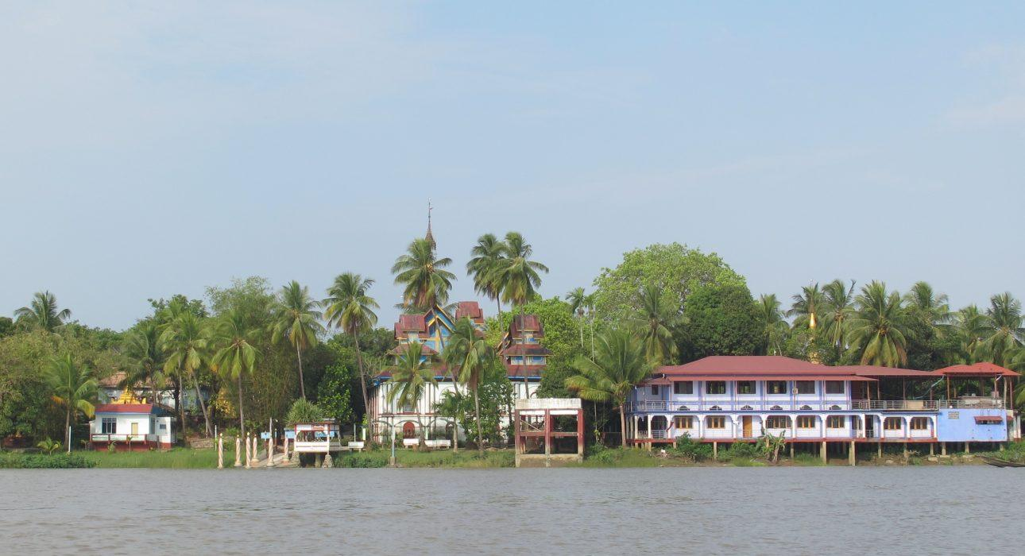

Over View

Theme
Art & Culture, Classic, Family

Country - City
Myanmar - Hpa An

Market segment
Groups, Thematic Leisure

Price Level
$

Max pax
30 persons

Seasonality
September to April

Arrival city
Hpa An

Departure city
Mawlamyine

Description

Though most travellers connect Hpa An and Mawlamyine by road, a boat journey is the best way to fully enjoy the exotic landscape of Southern Myanmar. A cruise on Thanlyin River between Hpa An and Mawlamyine makes it possible to access a lesser known landscape dotted with colourful pagodas, karstic mountains and riverside villages. Before arriving to Mawlamyine, we strongly advise to stop at Kawnhat village which houses U Nar Auk Monastery, a beautiful piece of architecture, very popular in the region. The monastery was erected by Nar Auk, a Burmese tycoon who created a boat ferry business to liberate the poor from the exploitation of British colony. An excursion off the beaten track in the beautiful countryside of Southern Myanmar.

Selling points

- Excursion off the beaten path in the beautiful countryside of Southern Myanmar
- A relaxing short cruise between Hpa An and Mawlamyine which offers a nature break along beautiful exotic landscapes
- A break at Kawnhat village is the highlight of the excursion: discovering a hidden colourful monastery complex with a rich history!

Time And Transportation

From | To | By | Duration | Distance
Mawlamyine | Hpa An | Boat | 3 hours | NA
Hpa An | Mawlamyine | Boat | 3 hours | NA
Hpa An | Mawlamyine | Car | 1h 30 | 55 kilometers

Photos

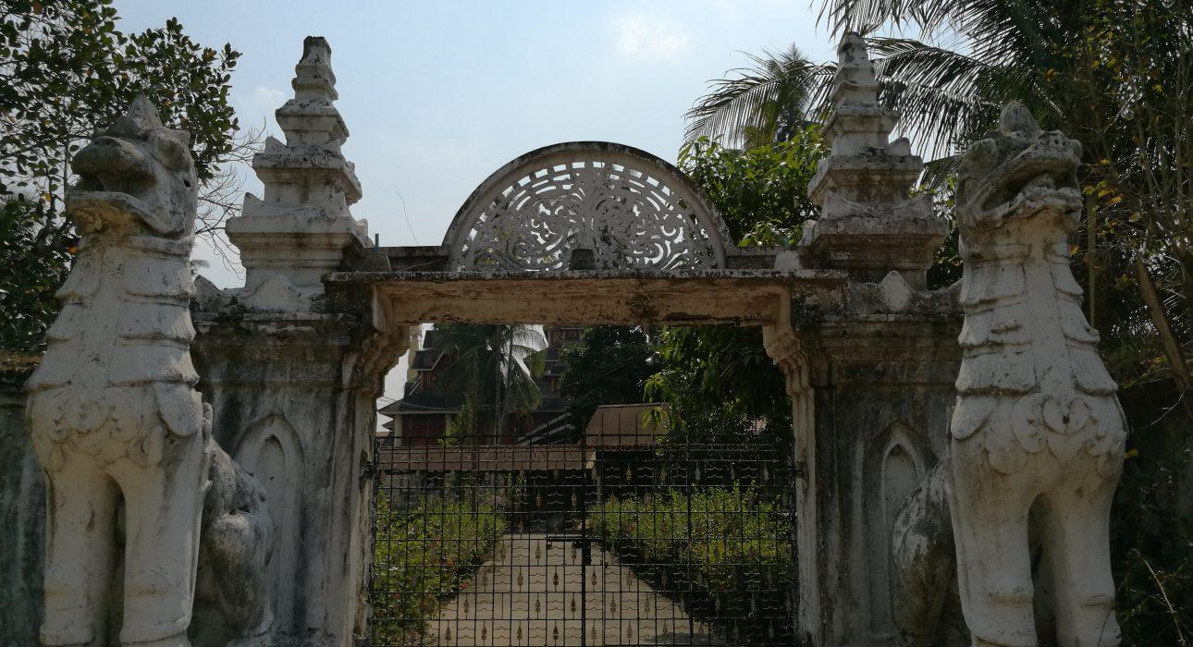
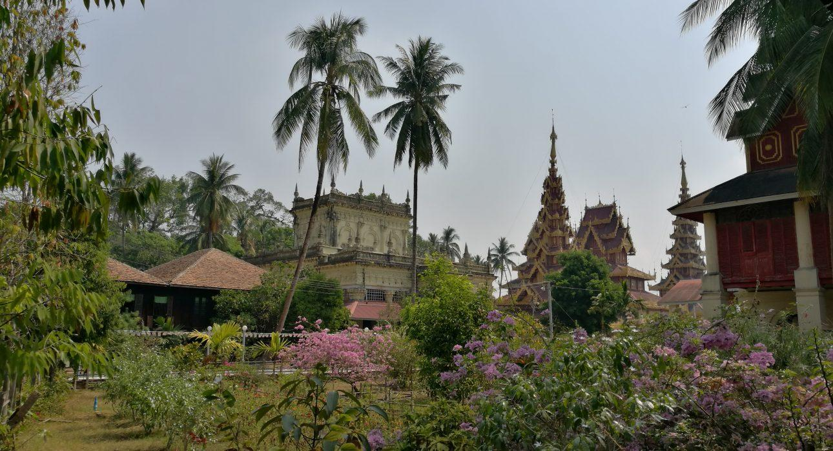
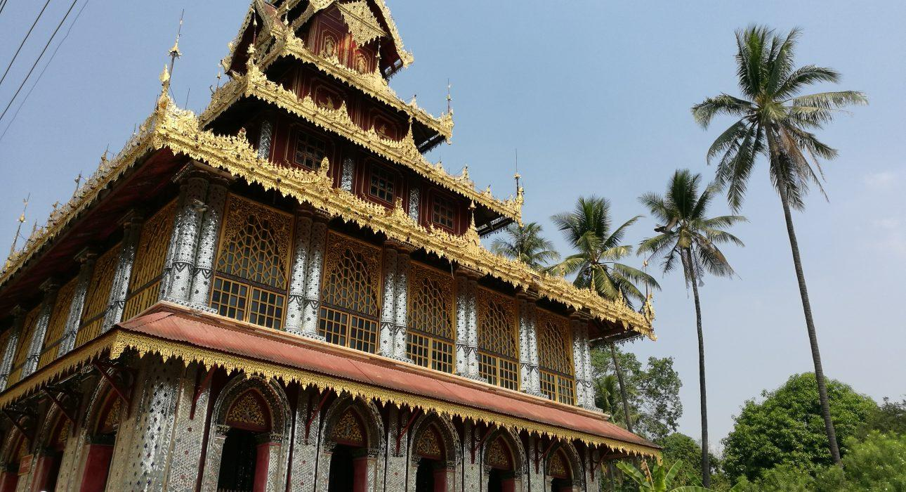
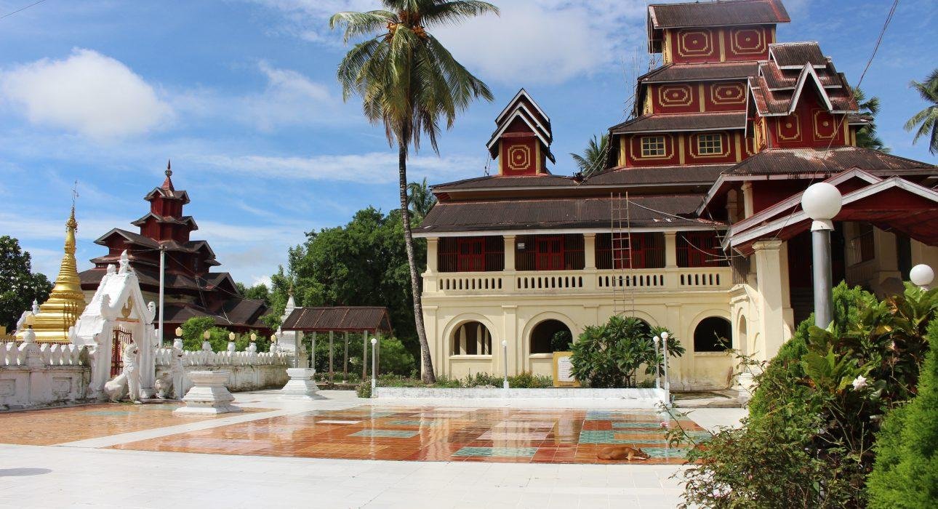
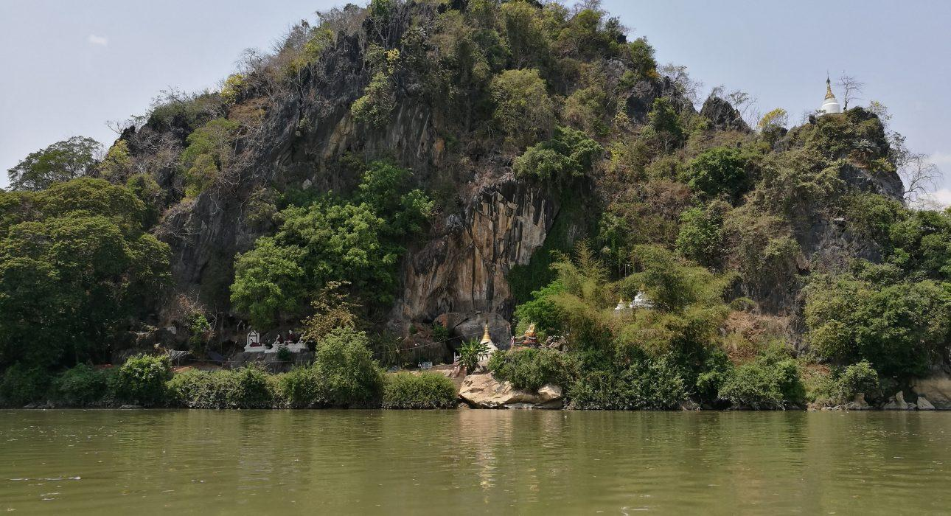
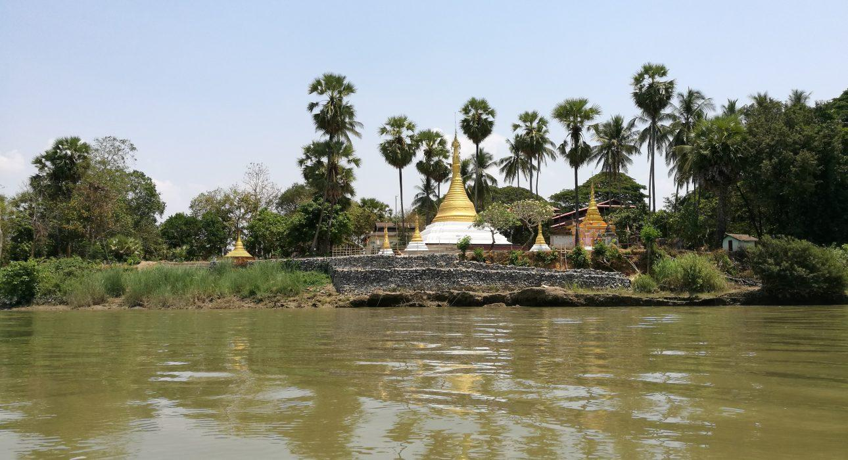
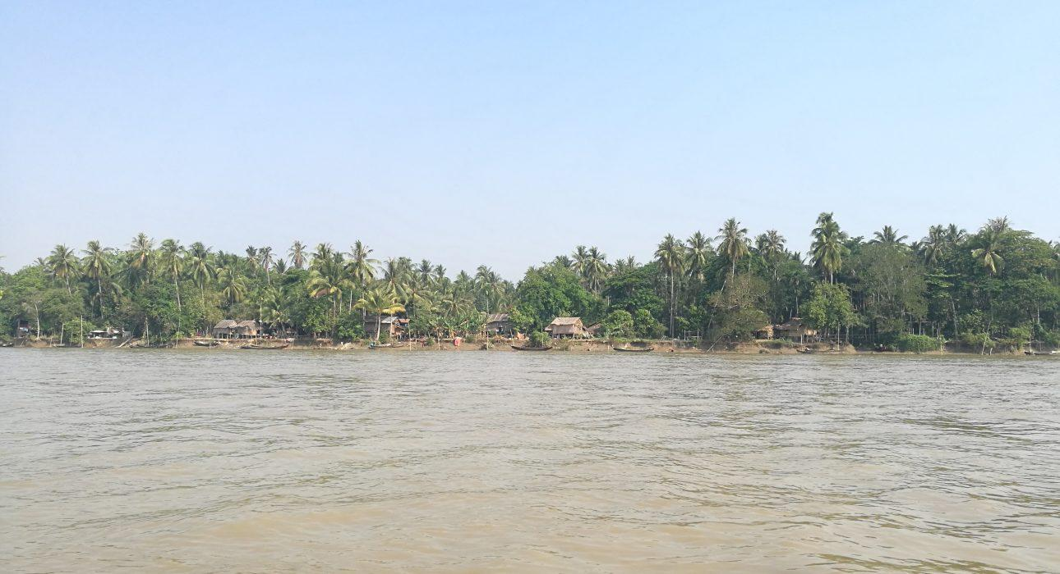

Easia Travel Head Office

Vietnam Head OfficeC/o: ATS Hotel, Suite 326 &327, 33B Pham Ngu Lao Street, Hanoi, VietnamTel: +84 24-39 33 13 62www.easia-travel.com

