THAILAND – Krabi – Koh Hong Escape and Sunset Cocktail on an Uninhabited Island
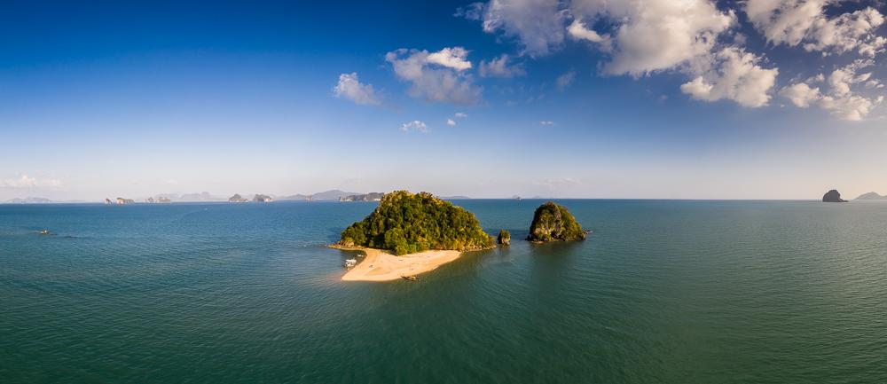

Over View

Theme
Beach Stay, Honeymoon

Country - City
Thailand - Krabi

Market segment
Thematic Leisure

Price Level
$$$$

Max pax
20

Seasonality
All year

Arrival city
Krabi

Departure city
Krabi

Description

Departing in the middle of the day (approximately 12:00 noon), the tour takes travelers for a long half-day tour on the Andaman Sea.After approximately one-hour cruising by speedboat, the first stop will be at the beautiful Hong Island where a delicious local lunch set up awaits the guests for an unexpected barefoot meal on a beach with stunning views of limestone islands on the horizon.After lunch, travelers begin a gentle island hopping experience around Hong Island to allow them the chance to discover the beauty of this now-famous but still well-preserved island, from the lagoon to a hidden cove where they can enjoy swimming or relaxing. In the mid-afternoon when most tourists leave the island, guests can enjoy an empty experience on the idyllic island.As the light is gently changes, the tour continues to another remote island where guests can enjoy a private cocktail and snacks with dedicated staff to enjoy memorable and unique moments watching the sunset.The speedboat will then bring the guests back to the mainland at the end of the day, arrive at their hotel in the early evening.

Selling points

- An original island hopping experience for high-end couples, families or small groups of friends
- Hong Island from a different perspective
- A must-see of the Andaman Sea, combined with 2 unique private experiences to enjoy without a crowd

Sustainability

Level Of The Excursion
Low - This activity impacts local community, culture and/or environment in a small but meaningful way

The Impact Of This Excursion

Environment Impact
Waste/plastic packaging, National parks

Economic Impact
Local individual benefits

Additional Information

Positive impacts
During the trip there is a focus on environmental conservation wherever possible, for example by avoiding to use of single-use plastics.

Negative impacts
The boat used during the activity uses fossil fuel which causes Co² emissions,

Time And Transportation

Photos

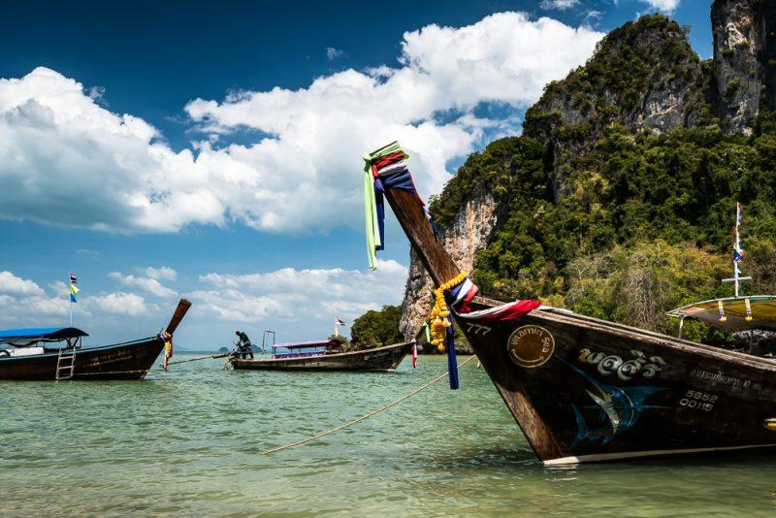
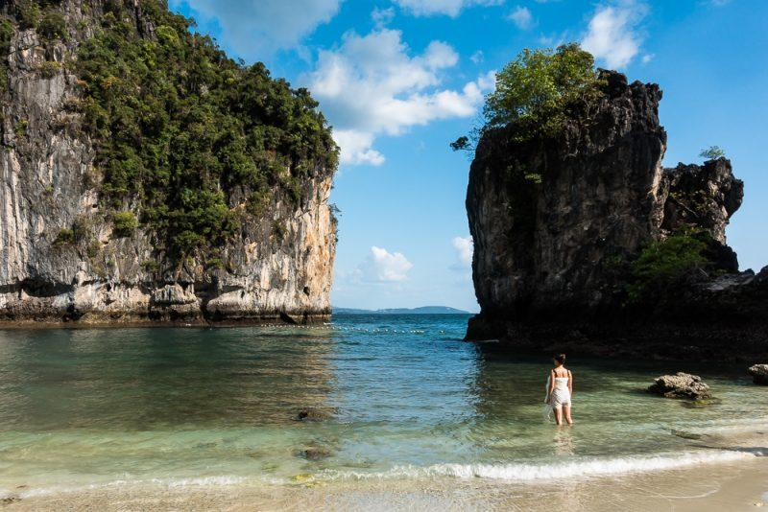
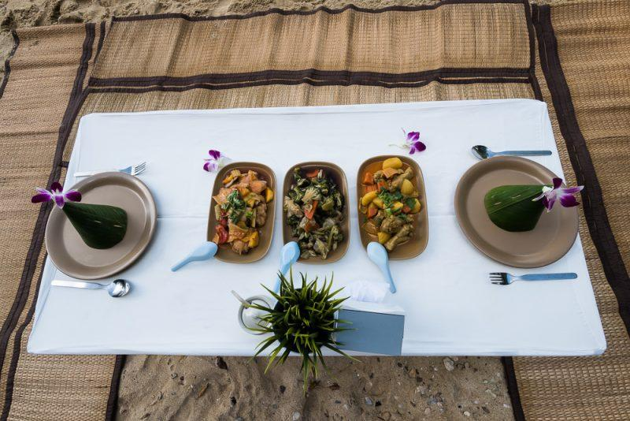
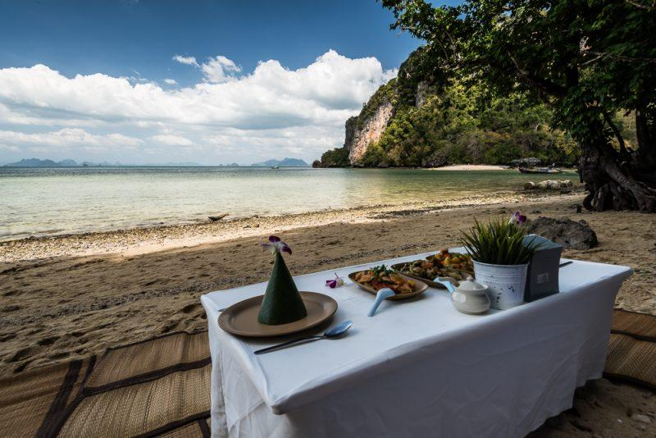
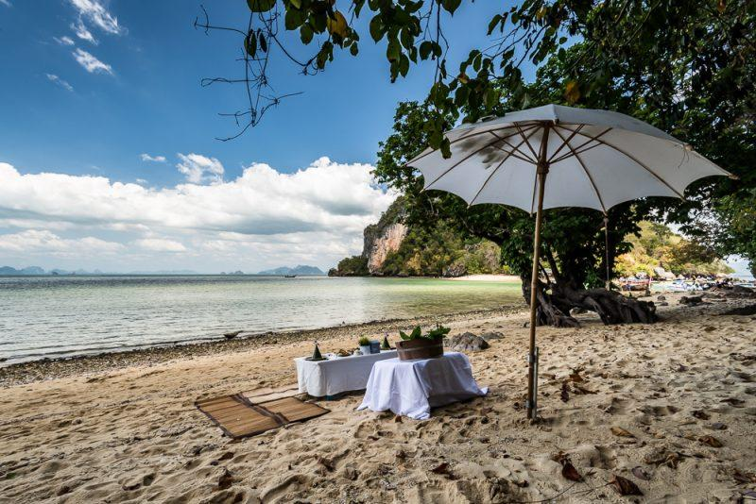
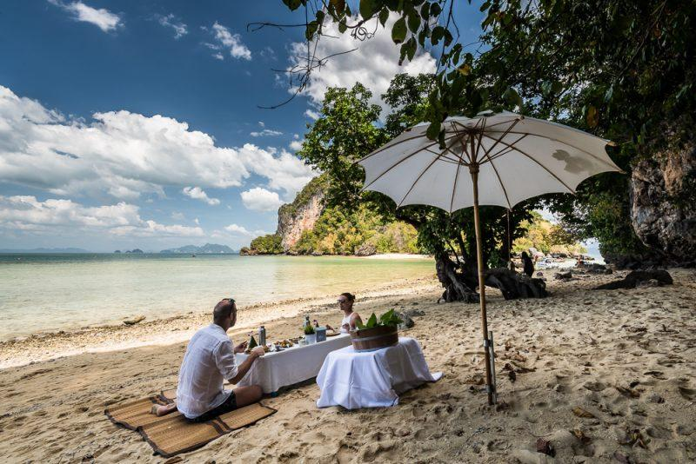
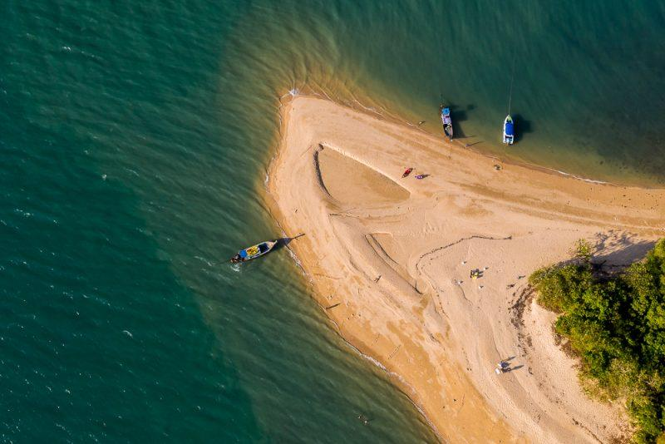
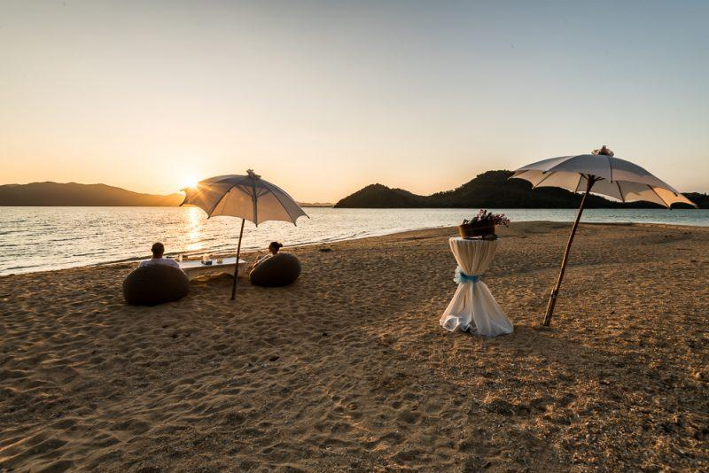
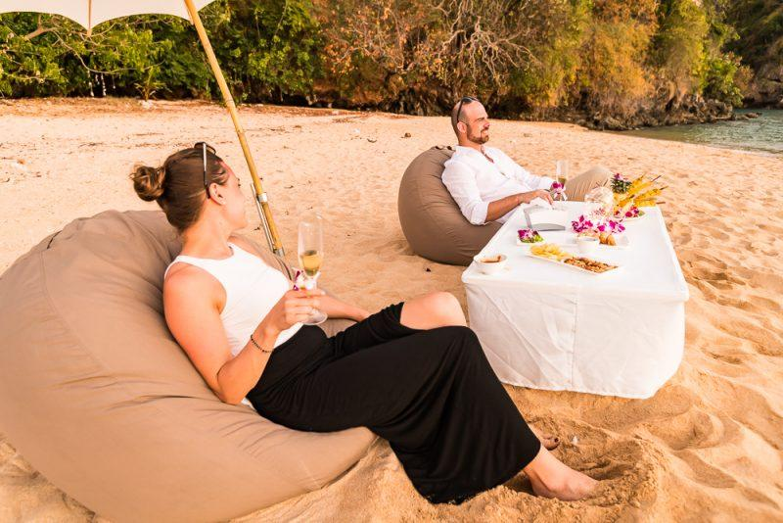
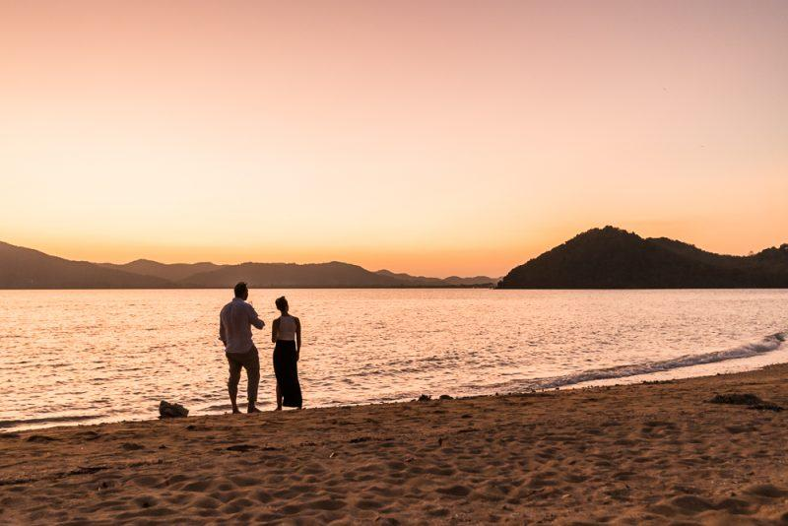

Easia Travel Head Office

