LAOS – Luang Prabang – Private Event at a Mekong Riverside Villa
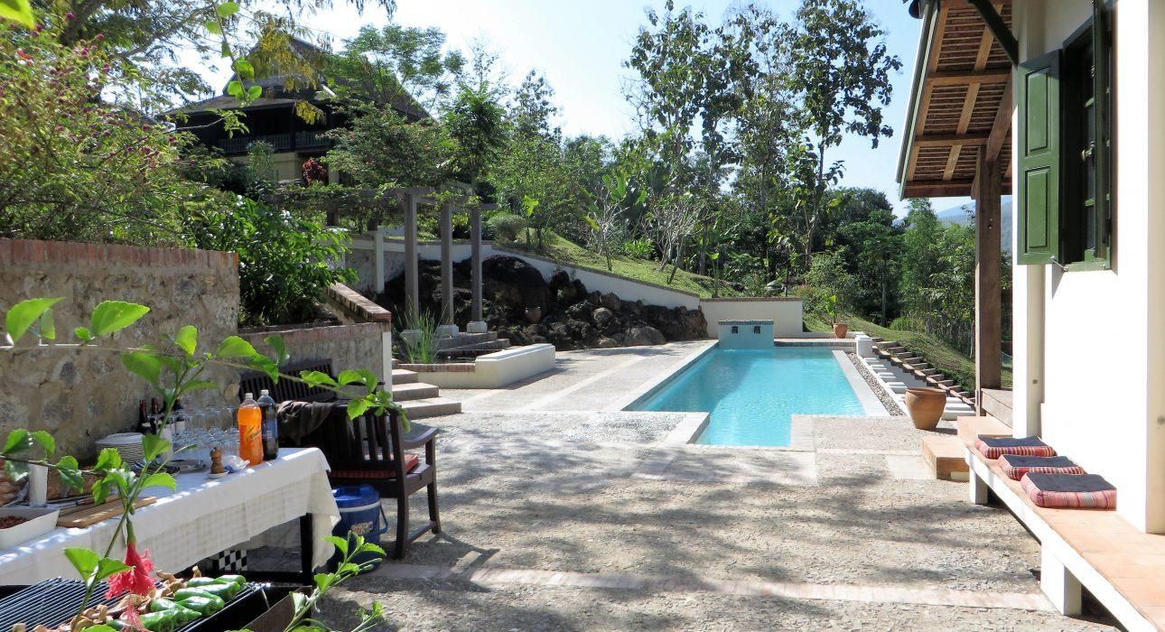

Over View

Theme
Classic, Family, Honeymoon

Country - City
Laos - Luang Prabang

Market segment
Thematic Leisure

Price Level
$$$$

Max pax
20

Seasonality
All Year Round

Arrival city
Luang Prabang

Departure city
Luang Prabang

Description

An exclusive catered event at a stunning private villa on the banks of the Mekong River, not far from the breathtaking Kuang Sy Waterfalls. The villa was built by Mr. Francis Engelmann, a prestigious UNESCO expert who has been actively involved in conserving the world heritage city of Luang Prabang since 2001. The traditional architecture of the property, along with the carefully maintained gardens and the natural beauty of the nearby river, provides a unique location for an exclusive moment away from the crowds. The private catered event can either be a luxurious lunch or dinner inside the house, on the terrace, or by the pool. There is also the option for something more akin to a cocktail event with a selection of delicious aperitifs and refreshing beverages.

Can be combined with
Thematic Leisure
- LAOS – Luang Prabang – Visit Kuang Sy Waterfalls
- LAOS – Luang Prabang – Breakfast at Kuang Sy
- LAOS – Luang Prabang – Buffalo Dairy Farm

Selling points

- An activity for those looking to get away from the crowds and enjoy some peace and serenity.
- An exclusive lunch or evening option which can be combined with a visit of Kuang Sy Waterfalls.
- A chance to enjoy a privately catered meal (lunch or dinner) or cocktail party in a magnificent location.
- Ideal for couples, families, or small groups of up to 20 people.

Sustainability

Level Of The Excursion
Low - This activity impacts local community, culture and/or environment in a small but meaningful way

The Impact Of This Excursion

Economic Impact
Local individual benefits

Time And Transportation

From | To | Km | By | Duration | Road condition
Night Market | Kuang Sy waterfall | 30 | Car / Bus | 45 minutes- 1 hour | Good
Kuang Sy waterfall | Mekong Riverside Villa | 10 | Car / Bus | 10 minutes | Good

Photos

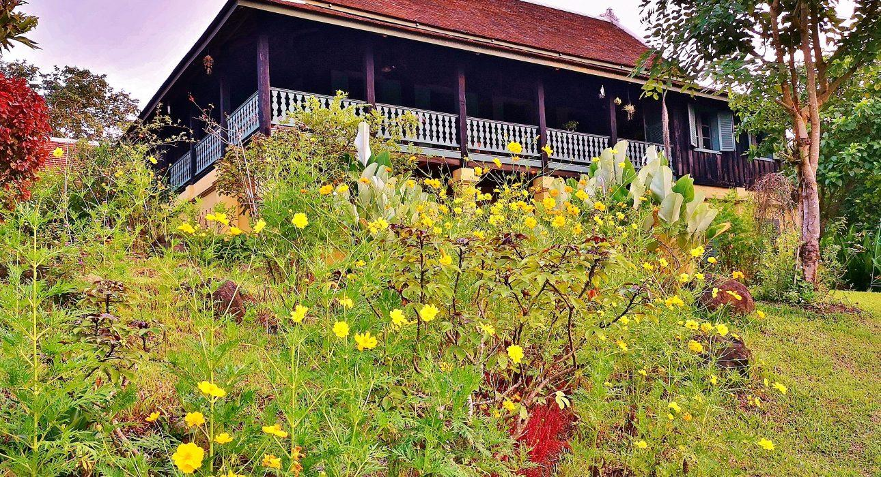
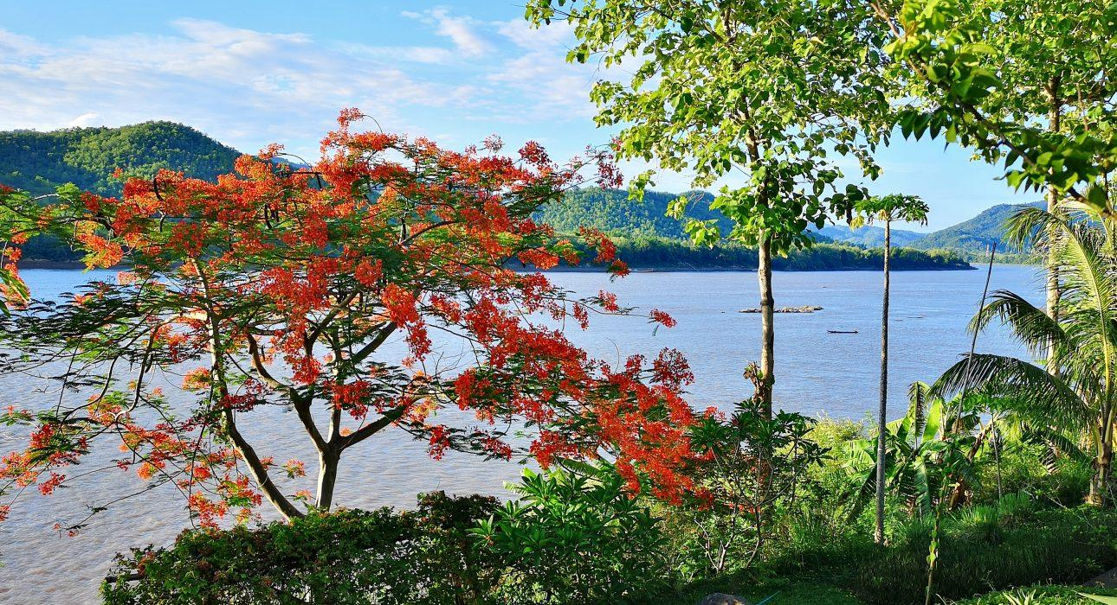
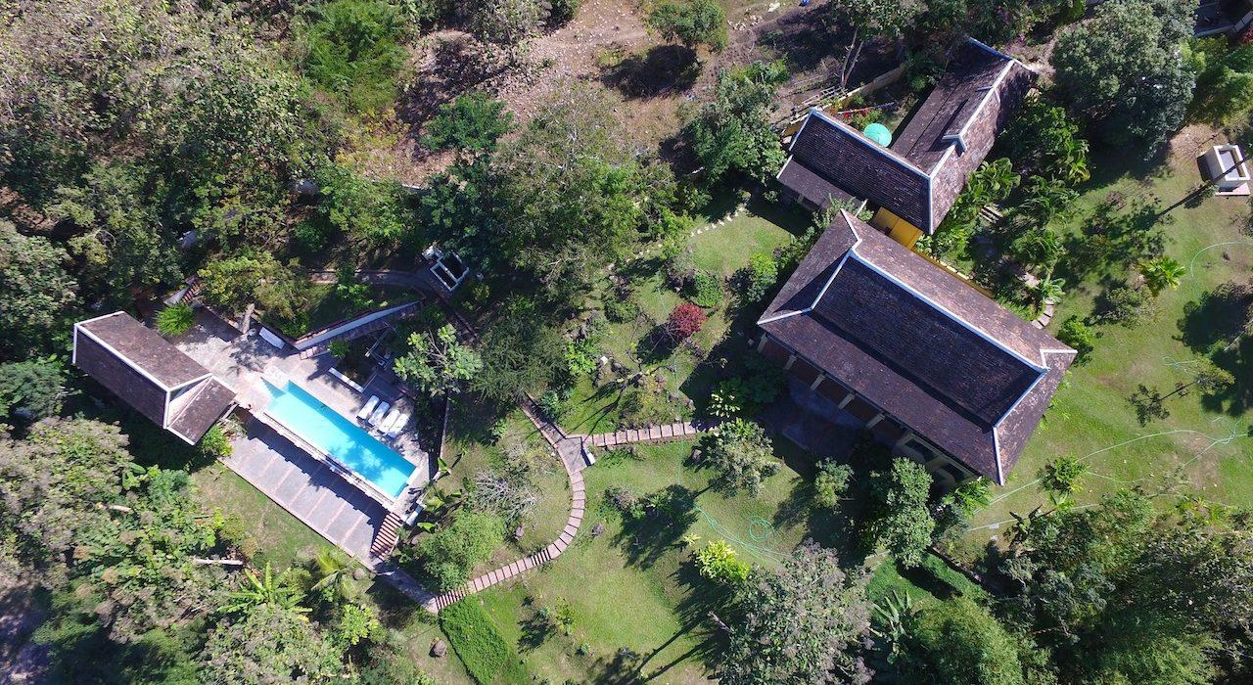
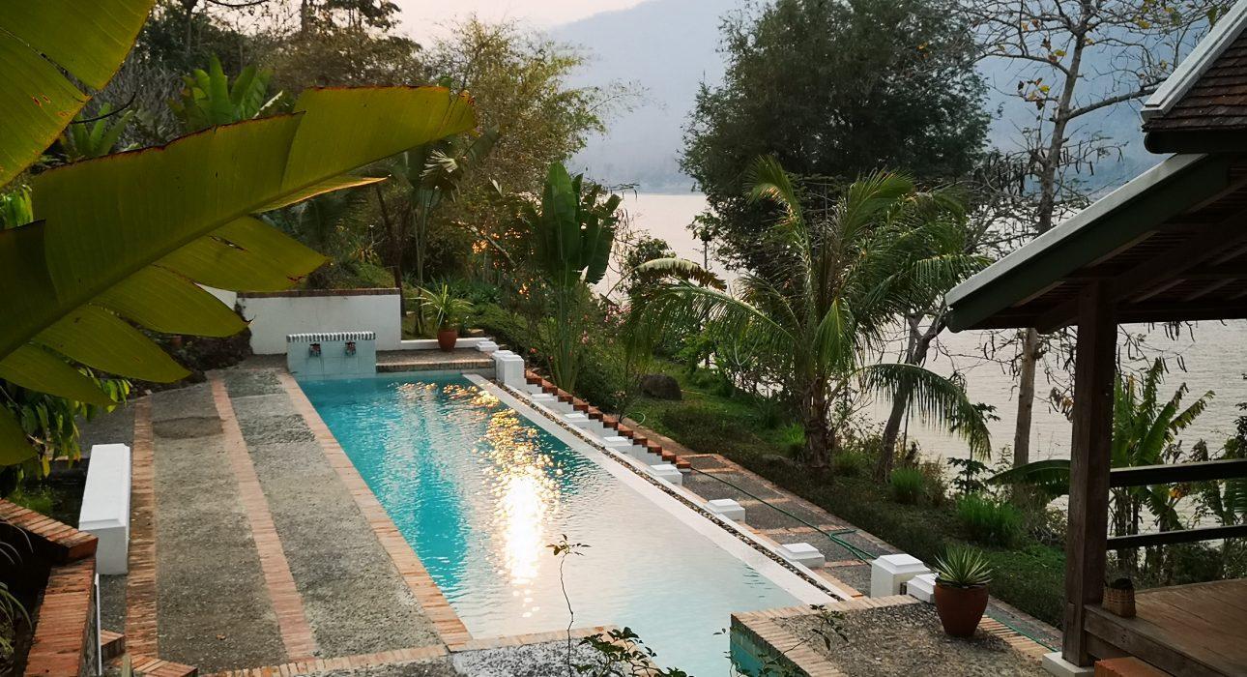
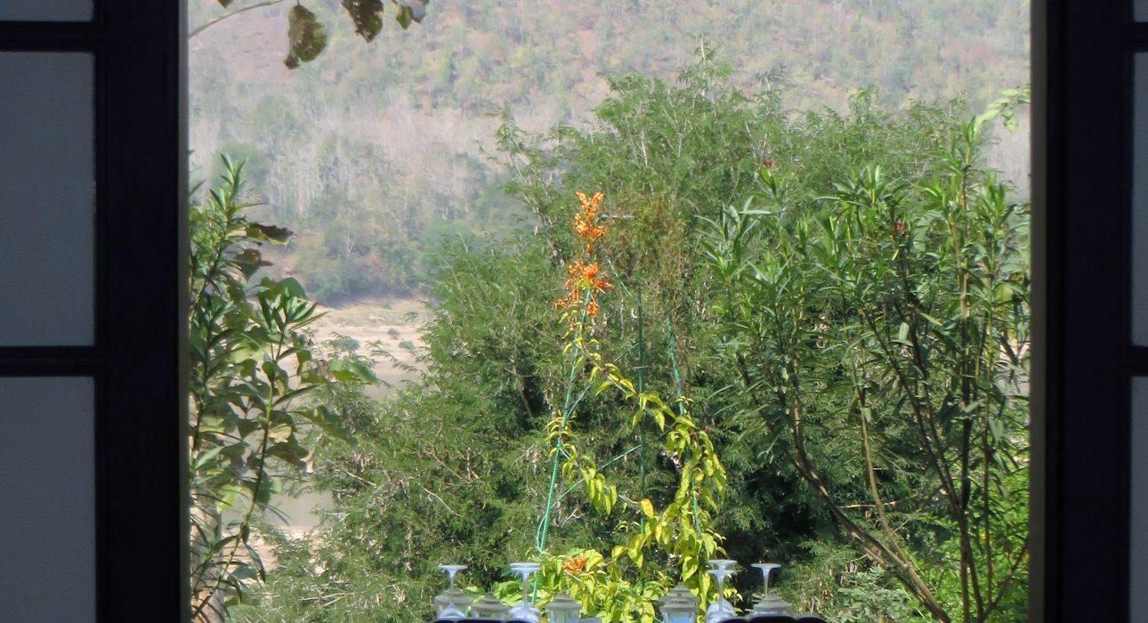

Easia Travel Head Office

Vietnam Head OfficeC/o: ATS Hotel, Suite 326 &327, 33B Pham Ngu Lao Street, Hanoi, VietnamTel: +84 24-39 33 13 62www.easia-travel.com

