LAOS – Luang Prabang – Bear Care Tour
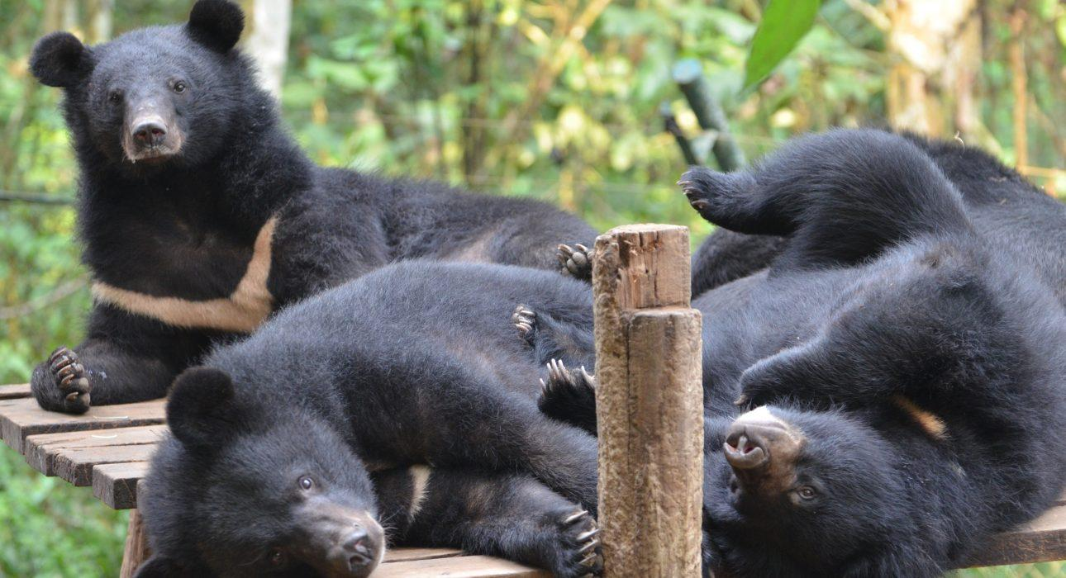

Over View

Theme
Classic, Family, Sustainable

Country - City
Laos - Luang Prabang

Market segment
Groups, Thematic Leisure

Price Level
$$

Max pax
20

Seasonality
All Year Round

Arrival city
Luang Prabang

Departure city
Luang Prabang

Description

Free the Bears is located 30 kilometers outside of Luang Prabang at the start of the trail leading up to the Kuang Sy waterfall. Travelers will be in awe at how sweet the sun and moon bears (Asian black bears) look as they lounge in hammocks and in tree houses while occasionally interacting with each other. Many of the bears at the Luang Prabang rescue centers were destined for bile farms or kept illegally as pets or work animals. Since its founding in Laos in 2003, Free the Bears has been working with the provincial Ministry of Agriculture to create a safe haven for these innocent victims of illegal wildlife trafficking. The organization has nearly 80 moon and sun bears, split between two rescue centers in Luang Prabang. It is worth noting that the rescue centers rely exclusively on tours and donations to fund their work in helping to provide their rescued bears with life-long continuing care and comfortable living conditions. As well as receiving in-depth knowledge about what makes this project unique, visitors to the rescue center will get the chance to hide food for the bears in their enclosure (without the bears there, of course!). Visitors will also have the opportunity to assist the team, after lunch, with the creation of “enrichment” to help the bears mimic natural wildlife behaviors which they may not regularly perform in captivity.

Can be combined with
Thematic Leisure
- LAOS – Luang Prabang – Rice Cultivation at a Lao Farm
- LAOS – Luang Prabang – Visit Kuang Sy Waterfalls
- LAOS – Luang Prabang – Breakfast at Kuang Sy
Exclusive
- LAOS – Luang Prabang – Private Event at a Mekong Riverside Villa
- LAOS – Luang Prabang – Breakfast at Kuang Sy

Selling points

- FIT, GIT, MICE suitable.
- Great family friendly supplement on the way to Kuang Sy waterfall, the bears always amaze children.
- An opportunity for travelers to stop at the bear rescue center on the way to the waterfall and learn about and support this initiative.
- A sustainable activity which works to combat the prolific illegal wildlife trade in the region.
- A great activity for any animal lover.

Sustainability

Level Of The Excursion
Medium – This activity offers tangible positive contributions to the local community, culture and/or environment

The Impact Of This Excursion

Social/cultural Impact
Empowerment and education

Environment Impact
Involving Wildlife, National parks

Economic Impact
Local individual benefits, Community benefits

Time And Transportation

From | To | Km | By | Duration | Road condition
Night Market | Kuang Sy Waterfalls | 30 | Car / Bus | 45 minutes | Good

Photos

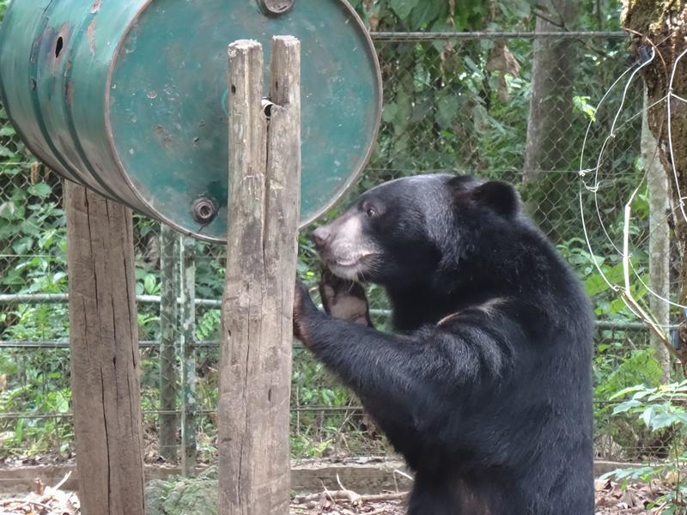
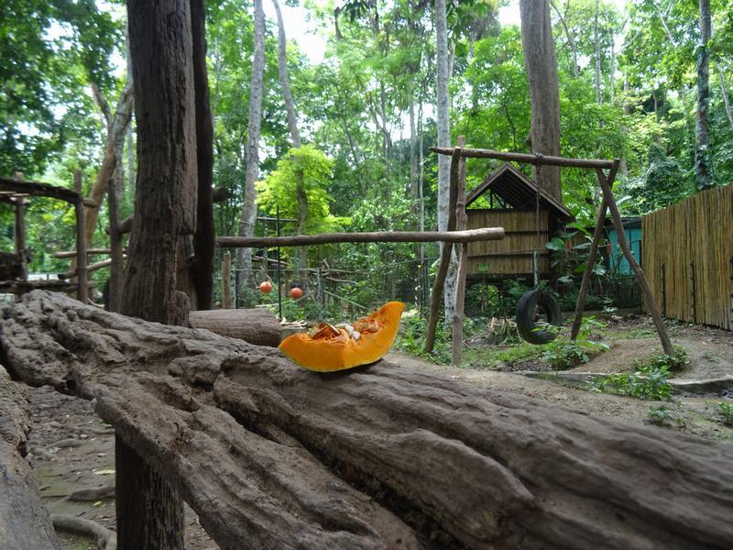
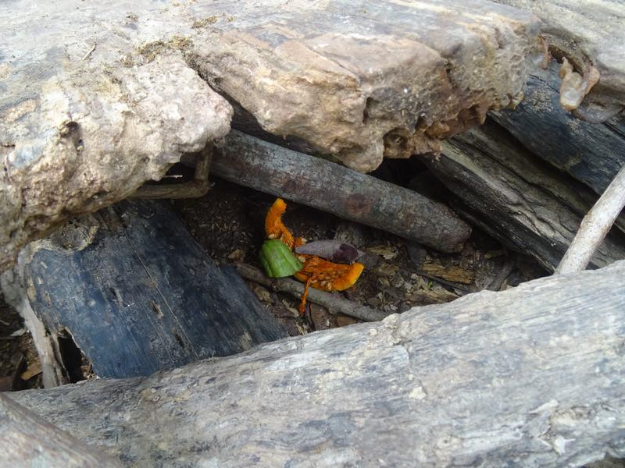
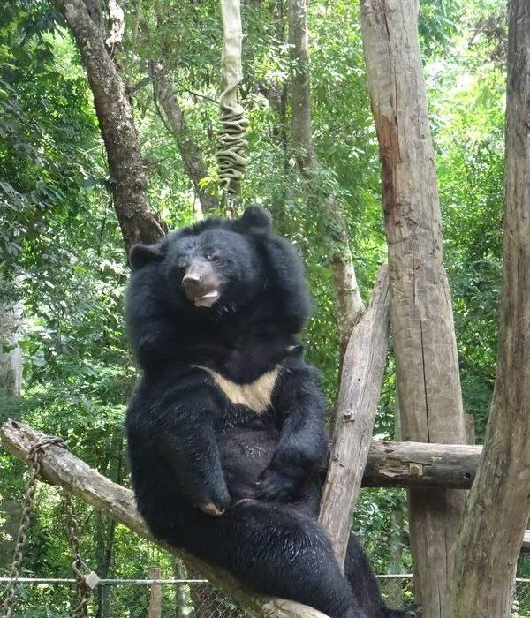
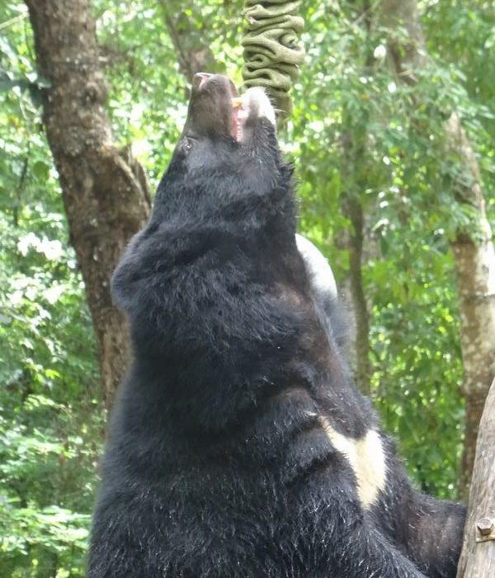
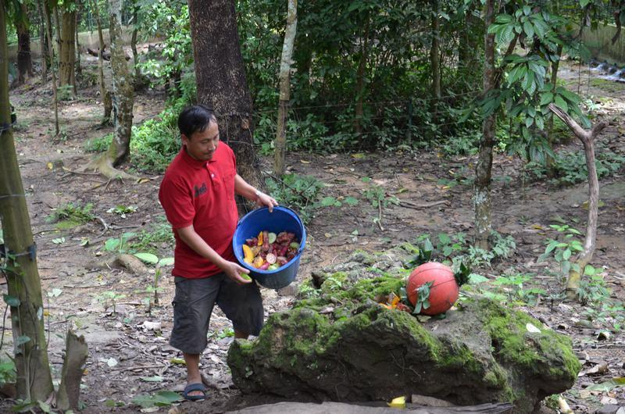
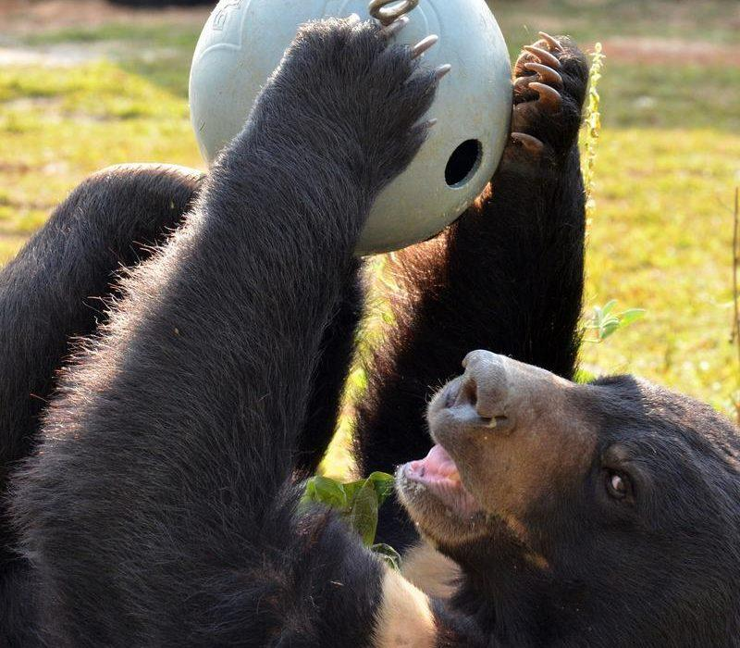
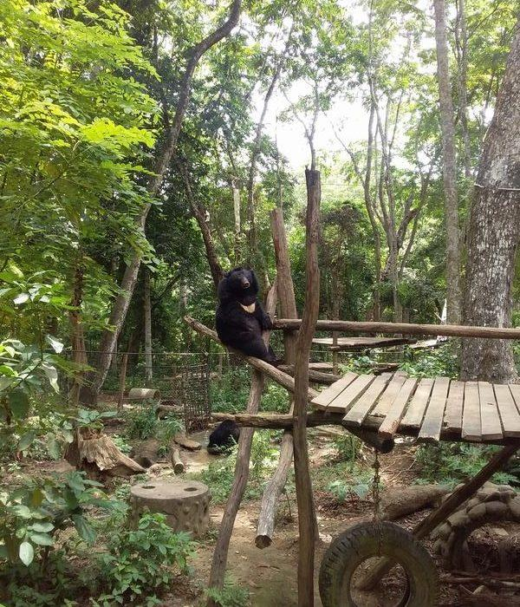
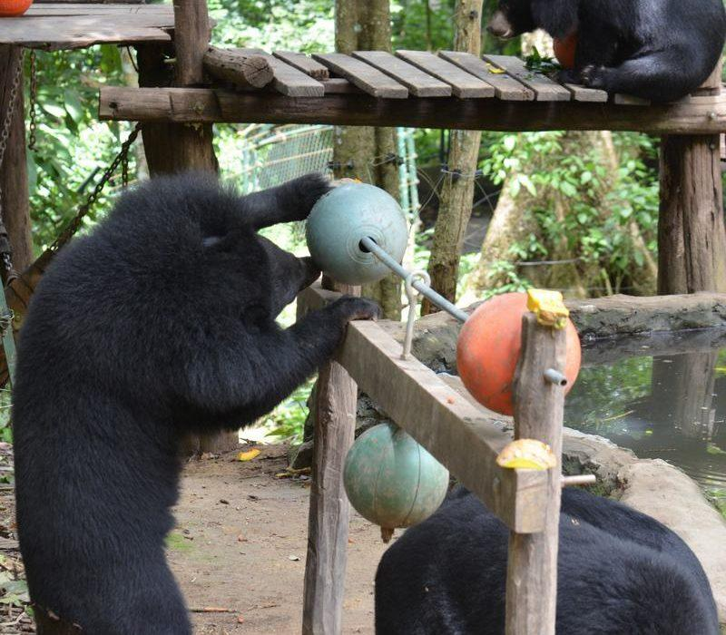
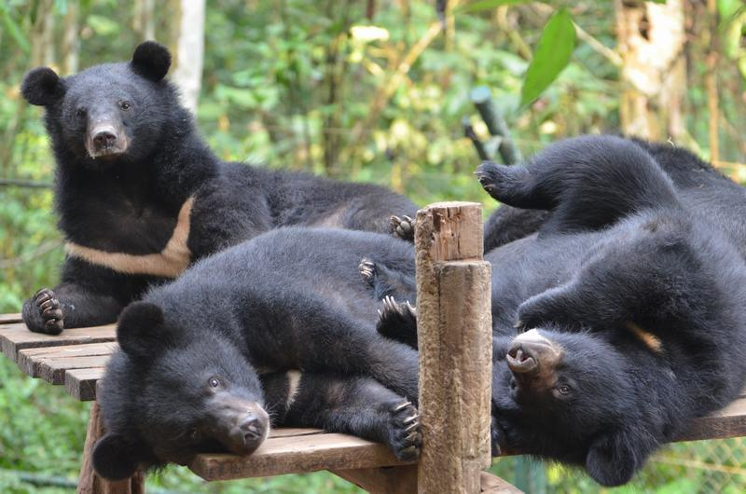

Easia Travel Head Office

Vietnam Head OfficeC/o: ATS Hotel, Suite 326 &327, 33B Pham Ngu Lao Street, Hanoi, VietnamTel: +84 24-39 33 13 62www.easia-travel.com

