LAOS – Luang Prabang – Visit the Deaf and Mute Center

Over View

Theme
Sustainable

Country - City
Laos - Luang Prabang

Market segment
Thematic Leisure

Price Level
$

Max pax
20

Seasonality
All Year Round

Arrival city
Luang Prabang

Departure city
Luang Prabang

Description

The Luang Prabang Special Education School provides deaf and mute children with professional and vocational training, giving them the opportunity to integrate into the local job market. They can receive training in weaving, dressmaking, carpentry, mechanics, and hospitality. To help support their work, the center has several small social enterprises to help with the financial costs of the project as well as to expand training opportunities for the students. A short visit to the school is an opportunity to learn about the center and the work that they do, before enjoying a coffee at their on-site cafe and browsing the locally made handicrafts that are on sale in the gift shop. Another popular souvenir to take away, is a few phrases in sign language. For each visit to the center a donation is provided.

Can be combined with
Thematic Leisure
- LAOS – Luang Prabang – City Tour Luang Prabang
- LAOS – Luang Prabang – Visit Kuang Sy Waterfalls
- LAOS – Luang Prabang – UXO Museum Project
- LAOS – Luang Prabang – Bear Care Tour

Selling points

- A way to support a less fortunate local community.
- An ideal way to support the local community while travelling.
- A short visit which is easily added as a time-filler in the morning or afternoon.
- A unique perspective on the vocational training options available to people who are differently abled.
- May be interesting for travelers that work in educational or vocational training.

Sustainability

Level Of The Excursion
High – This activity strongly supports local communities and/or helps preserve the culture and environment

The Impact Of This Excursion

Social/cultural Impact
Empowerment and education, Community welfare and health

Economic Impact
Community benefits

Time And Transportation

From | To | Km | By | Duration | Road condition
Night Market | Deaf and Mute Center | 4 | Minivan | 10 minutes | Good

Photos

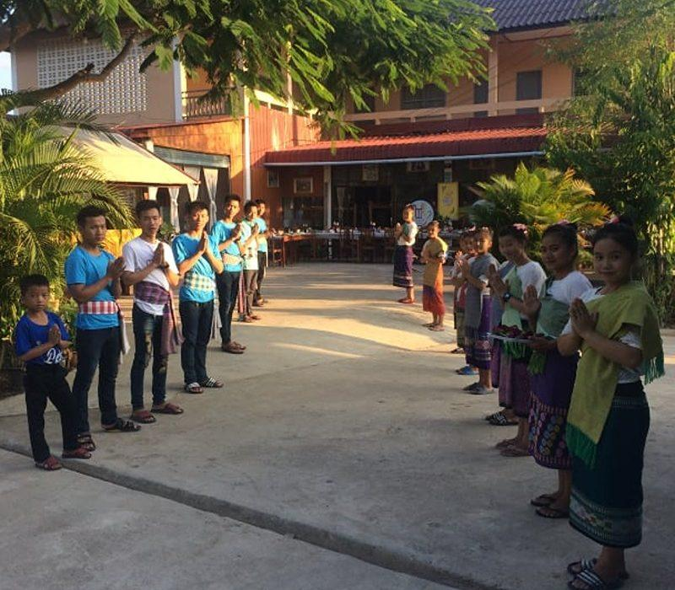
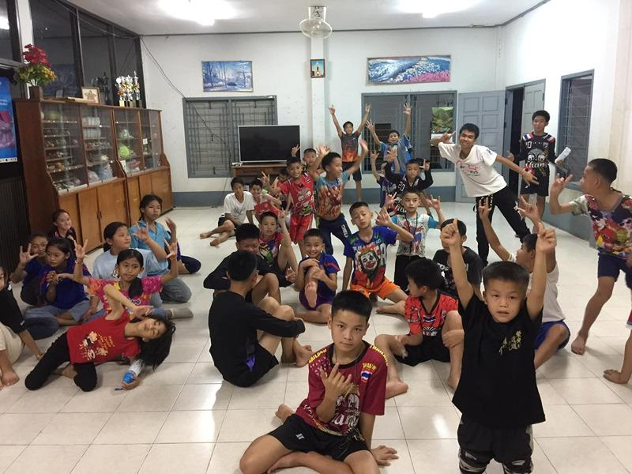
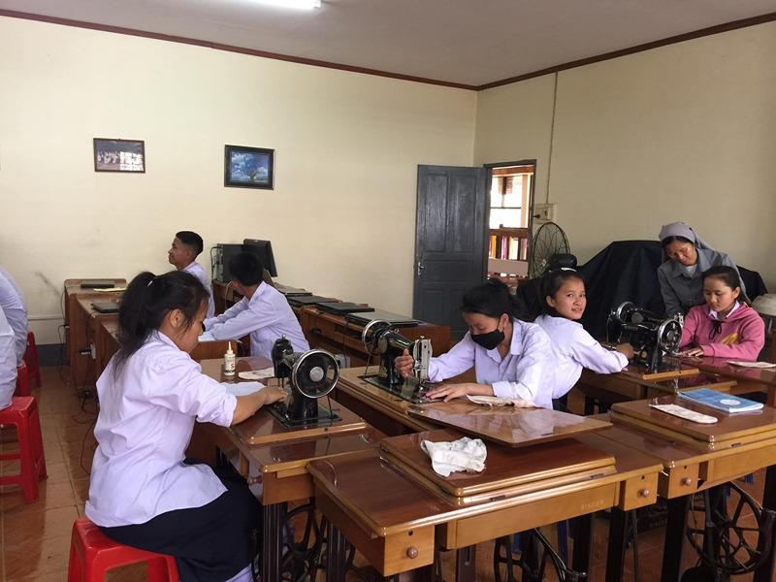
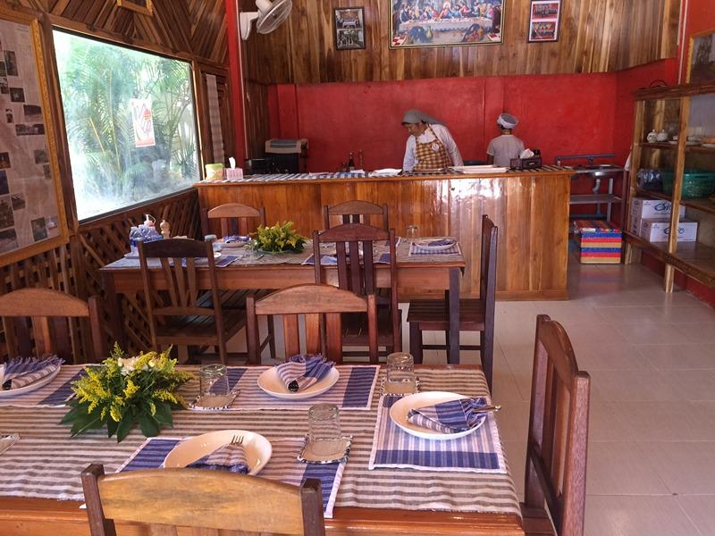
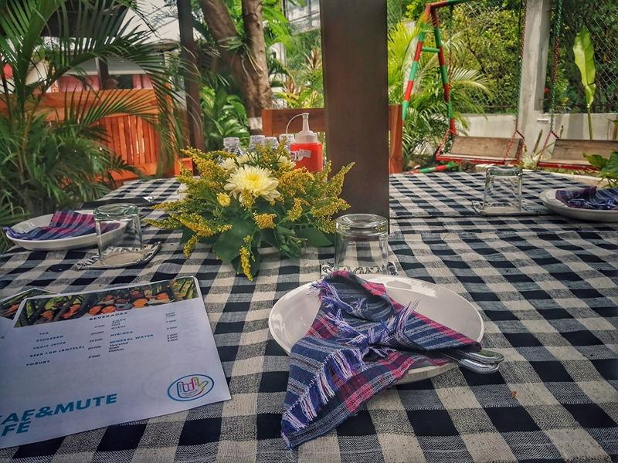
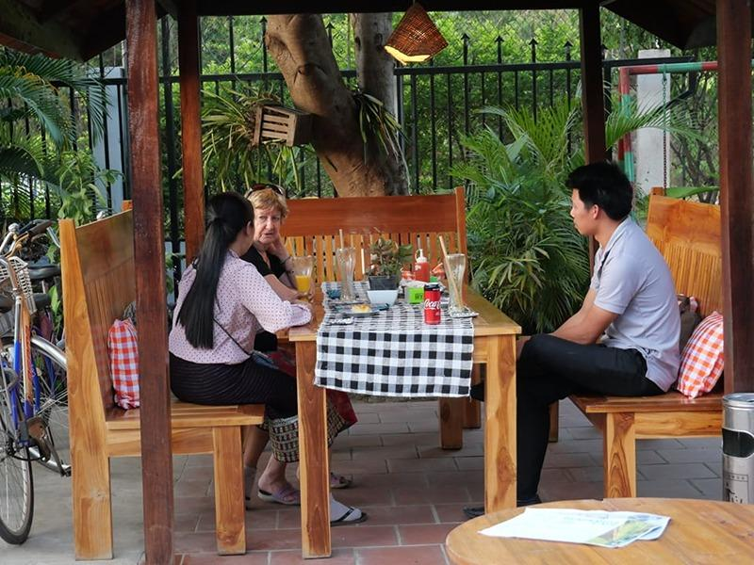
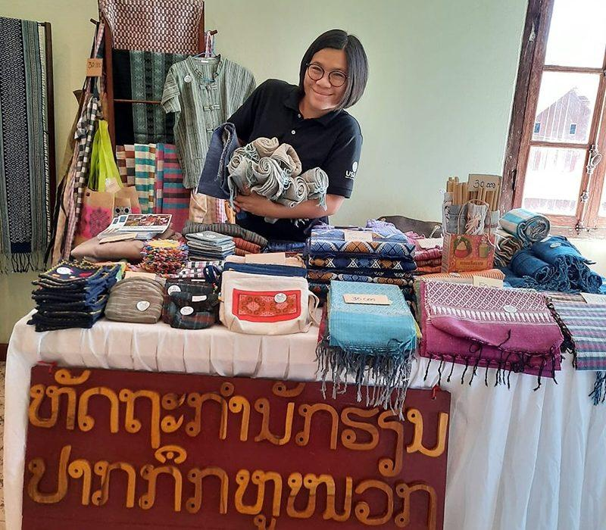
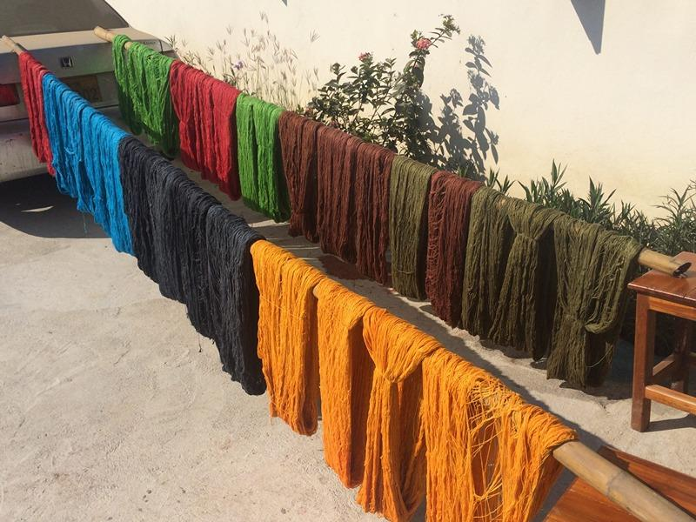
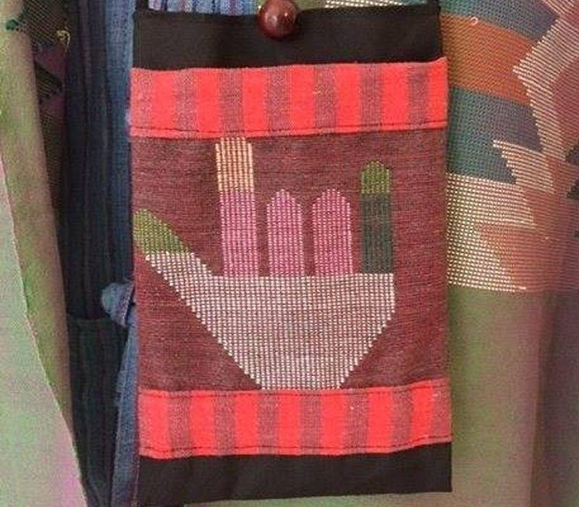
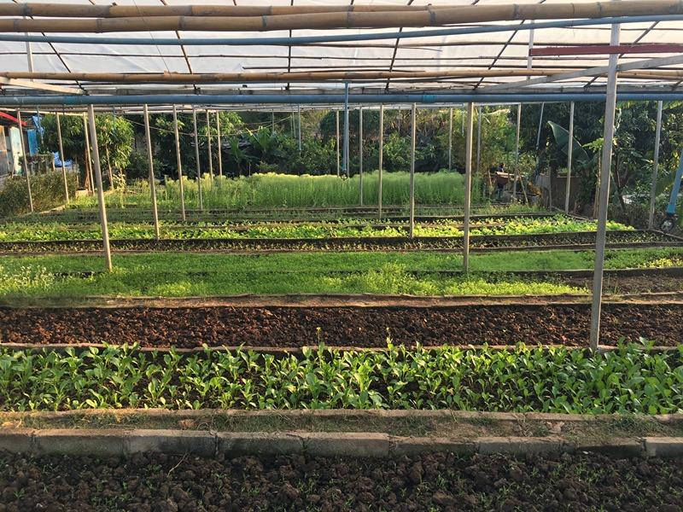

Easia Travel Head Office

Vietnam Head OfficeC/o: ATS Hotel, Suite 326 &327, 33B Pham Ngu Lao Street, Hanoi, VietnamTel: +84 24-39 33 13 62www.easia-travel.com

