LAOS – Xieng Khuang – Visit the MAG and UXO Centers
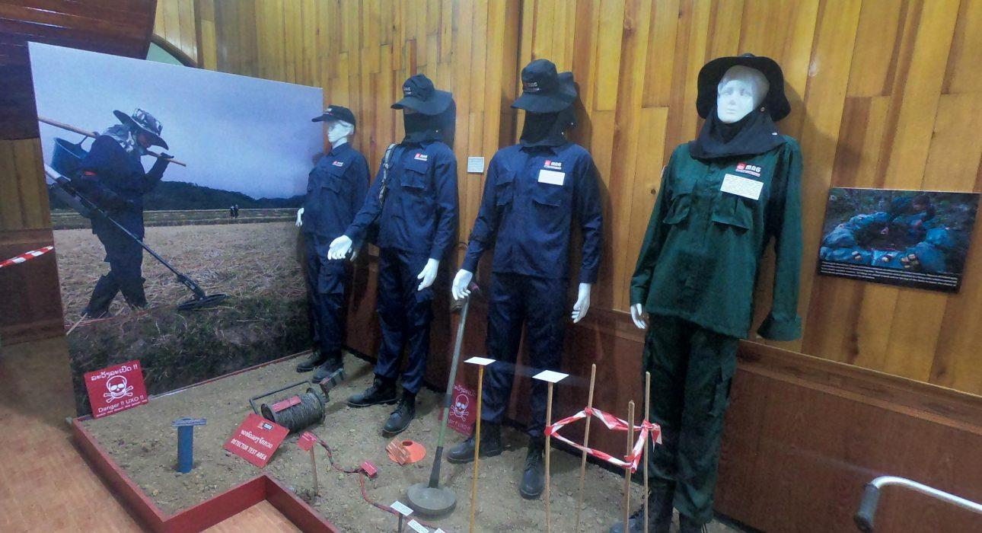

Over View

Theme
Art & Culture, Classic, Sustainable

Country - City
Laos - Xieng Khuang

Market segment
Groups, Thematic Leisure

Price Level
$

Max pax
20

Seasonality
All year round

Arrival city
Phonsavan

Departure city
Phonsavan

Description

Between 1964 and 1973 more than two million tons of bombs were dropped on Laos. An estimated 30 per cent of them did not detonate, and continue to kill and injure. MAG has been clearing the deadly legacy of the bombing in Laos since 1994, saving lives and building safer futures for local communities. At the MAG visitor center it is possible to learn how the bombs got there, how they affect people and how MAG clears them; watch films, including the acclaimed documentaries Bomb Harvest and Surviving the Peace; and view incredible images, including features on scrap metal collection and all-female clearance teams. The visit to the MAG Center will be complemented by an additional visit to the nearby UXO Museum

Can be combined with
Thematic Leisure
- Xieng Khuang – Visit Plain of Jars and Muang Khoung
- Xieng Khuang – Mulberries Silk Farm
- Xieng Khuang – Visit the Xieng Khuang Provincial Museum

Selling points

- A good opportunity for people interested in the history of Laos.
- An opportunity to make a positive impact in the local community.
- A sustainable activity which supports the communities affected by the war.
- An interesting activity in the town center which complements a visit of the Jar Sites, also affected by UXO and cleared by MAG.
- A short activity ideal as a time filler.

Time And Transportation

From | To | Km | By | Duration | Road condition
Vansana Plain of Jars Hotel | MAG and UXO Center | 2 | Minivan | 5 minutes | Good

Photos

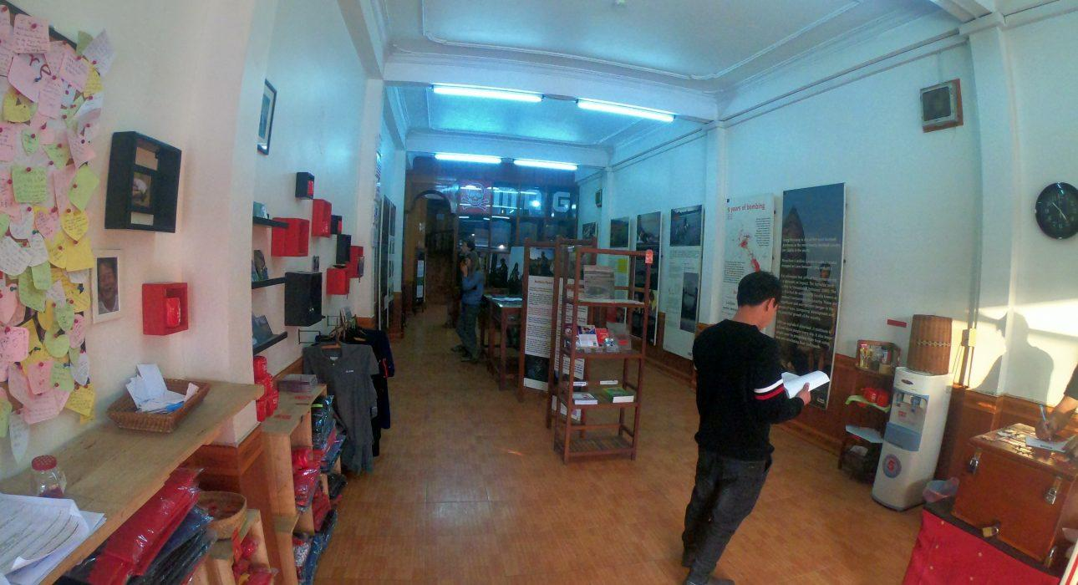
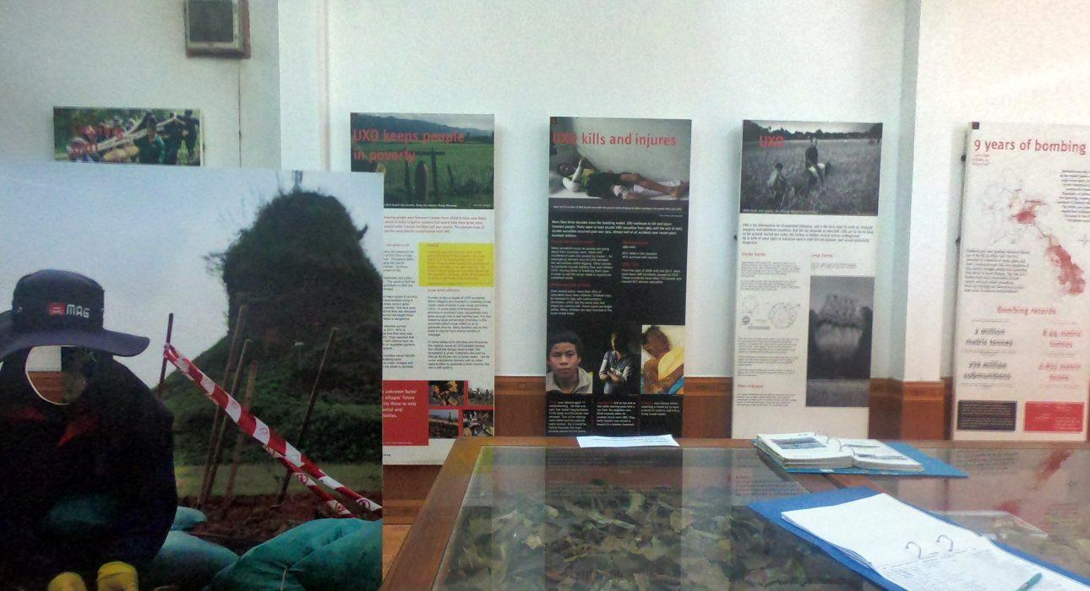

Easia Travel Head Office

Vietnam Head OfficeC/o: ATS Hotel, Suite 326 &327, 33B Pham Ngu Lao Street, Hanoi, VietnamTel: +84 24-39 33 13 62www.easia-travel.com

