LAOS – Xieng Khuang – Xieng Khuang Provincial Museum
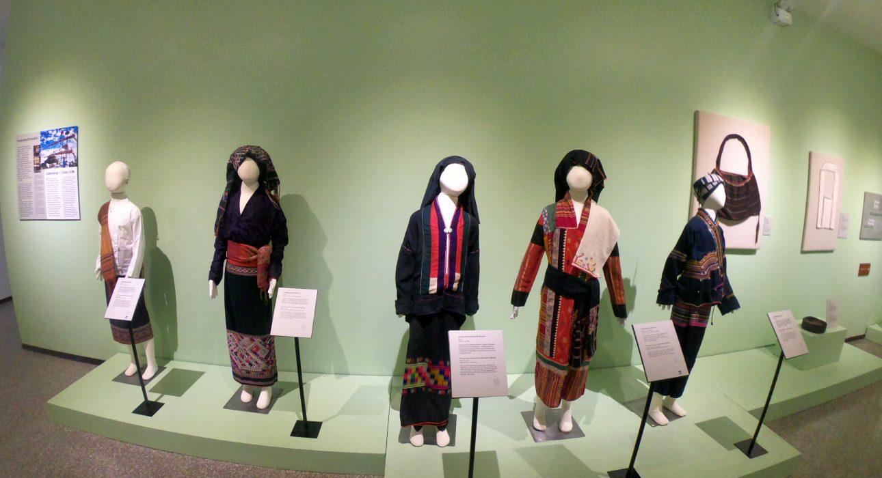

Over View

Theme
Art & Culture, Classic, Sustainable

Country - City
Laos - Xieng Khuang

Market segment
Groups, Thematic Leisure

Price Level
$

Max pax
50

Seasonality
All Year Round except Mondays

Arrival city
Phonsavan

Departure city
Phonsavan

Description

Opened in late 2018, the Xieng Khouang Provincial Museum is said to be ‘one of the best in Southeast Asia’On the first floor, there are displays on Xieng Khuang‘s prehistory, including the mysterious Plain of Jars and the magnificent Phuan Kingdom that once ruled the plateau.On the second floor, there is an insightful and concise exhibit on the Indochina Wars. There are also beautifully displayed fabrics, clothing, musical instruments and artifacts belonging to the six main ethnic groups in Xieng Khouang. The struggle for an independent Laos is carefully and accurately portrayed. Four short movies play continuously in a purpose-built film room covering topics from cultural diversity and local attractions to moving accounts of the Indochina Wars.

Can be combined with
Thematic Leisure
- Xieng Khuang – Visit Plain of Jars and Muang Khoung
- Xieng Khuang – Mulberries Silk Farm
- Xieng Khuang – Visit the MAG and UXO Centers

Selling points

- An excellent opportunity for people interested in the history of Laos.
- An exciting activity in the town center which complements a visit to the Jar Sites.
- A short activity is ideal as a time filler.

Time And Transportation

From | To | Km | By | Duration | Road condition
Vansana Plain of Jars Hotel | MAG and UXO Center | 2 | Minivan | 5 minutes | Good

Photos

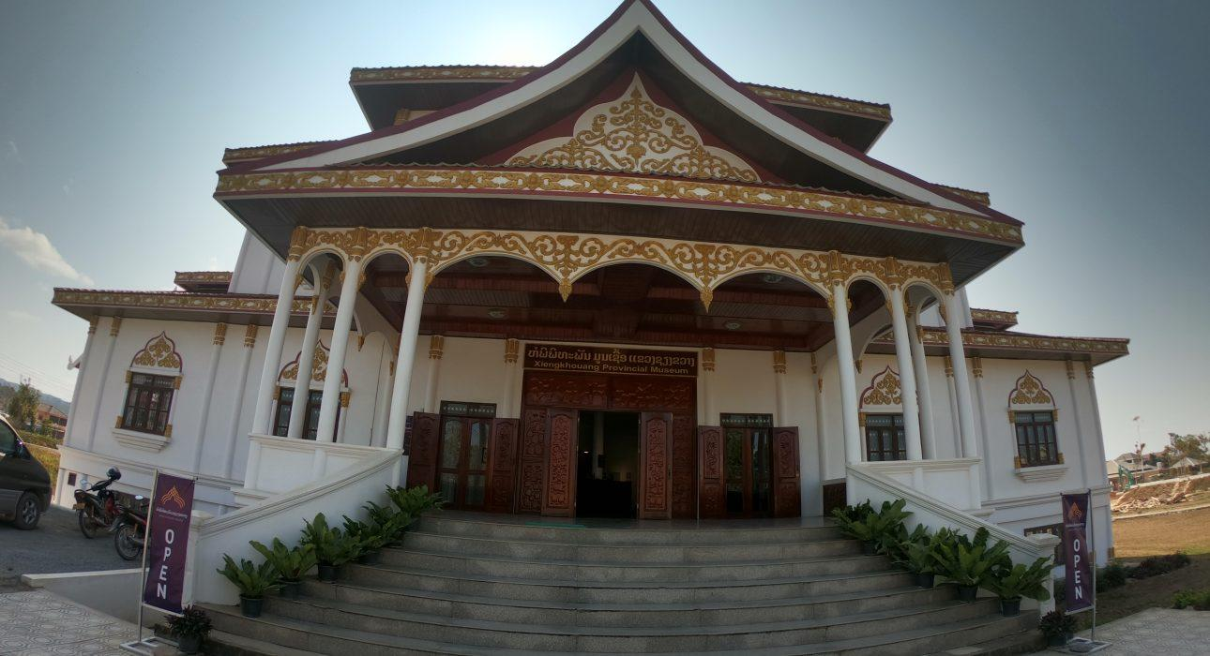
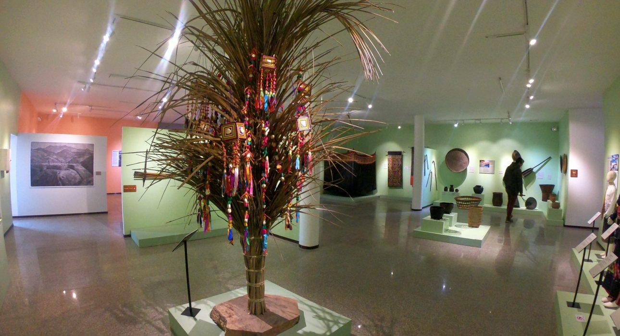
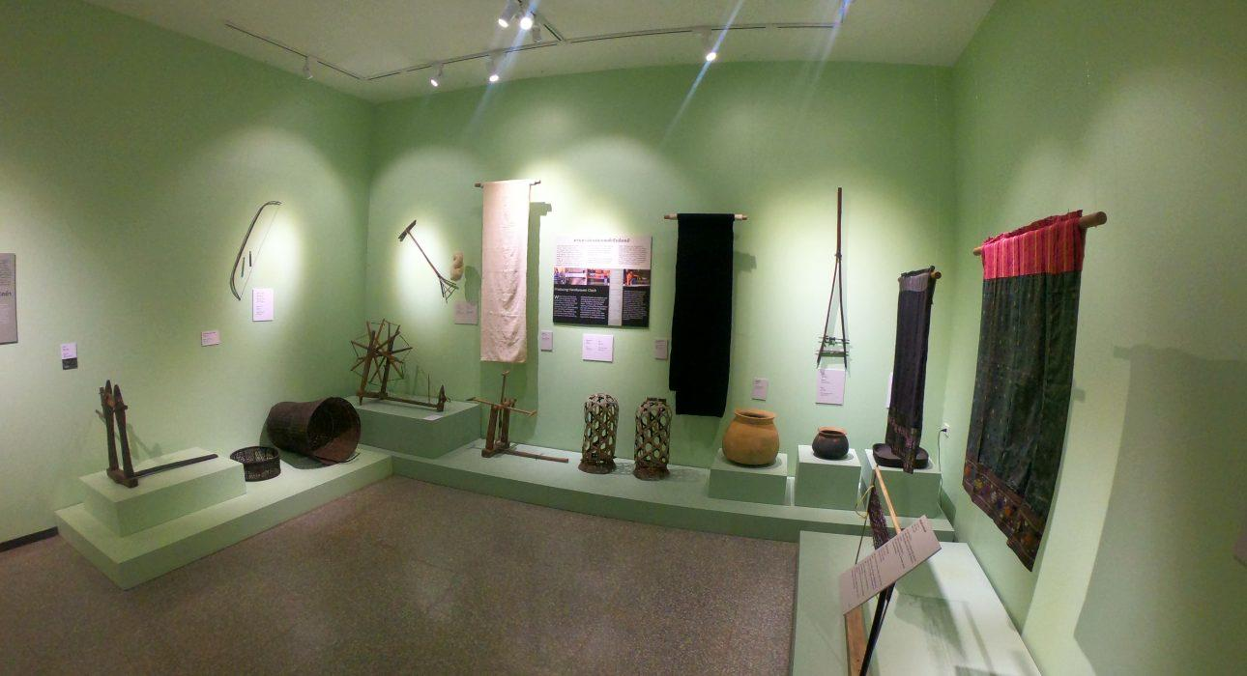
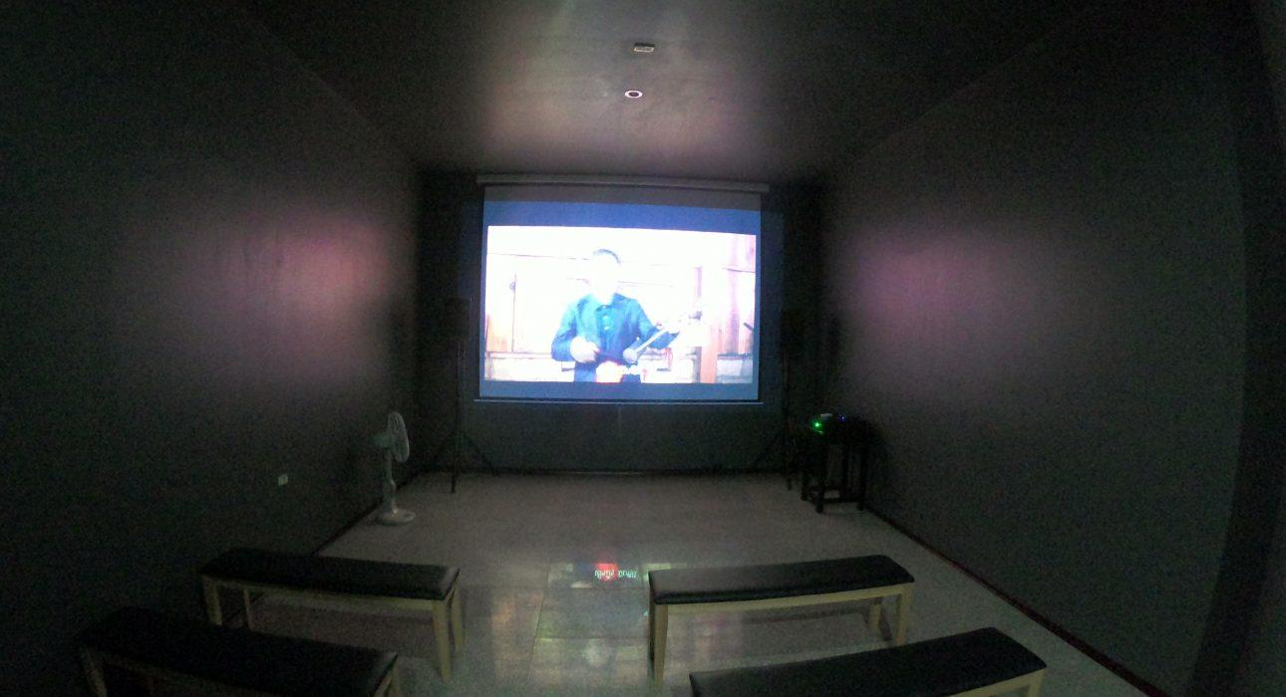
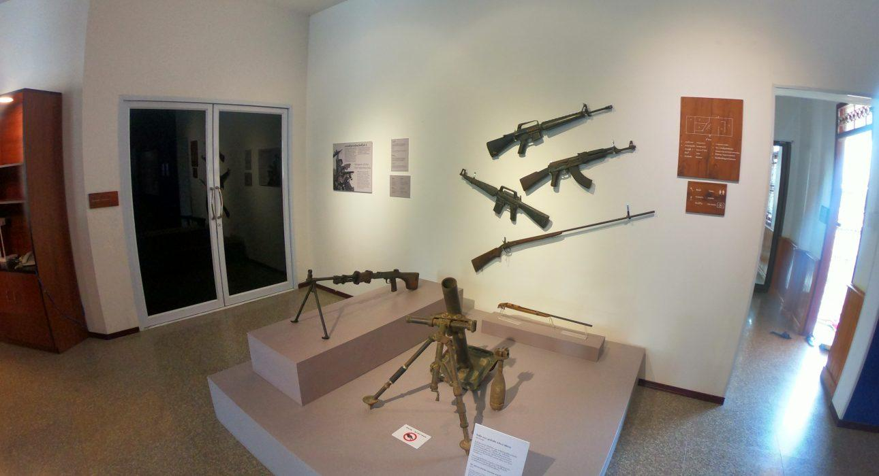

Easia Travel Head Office

Vietnam Head OfficeC/o: ATS Hotel, Suite 326 &327, 33B Pham Ngu Lao Street, Hanoi, VietnamTel: +84 24-39 33 13 62www.easia-travel.com

