VIETNAM – Ho Chi Minh City – Thanh Da Peninsula by Saigon Water Bus
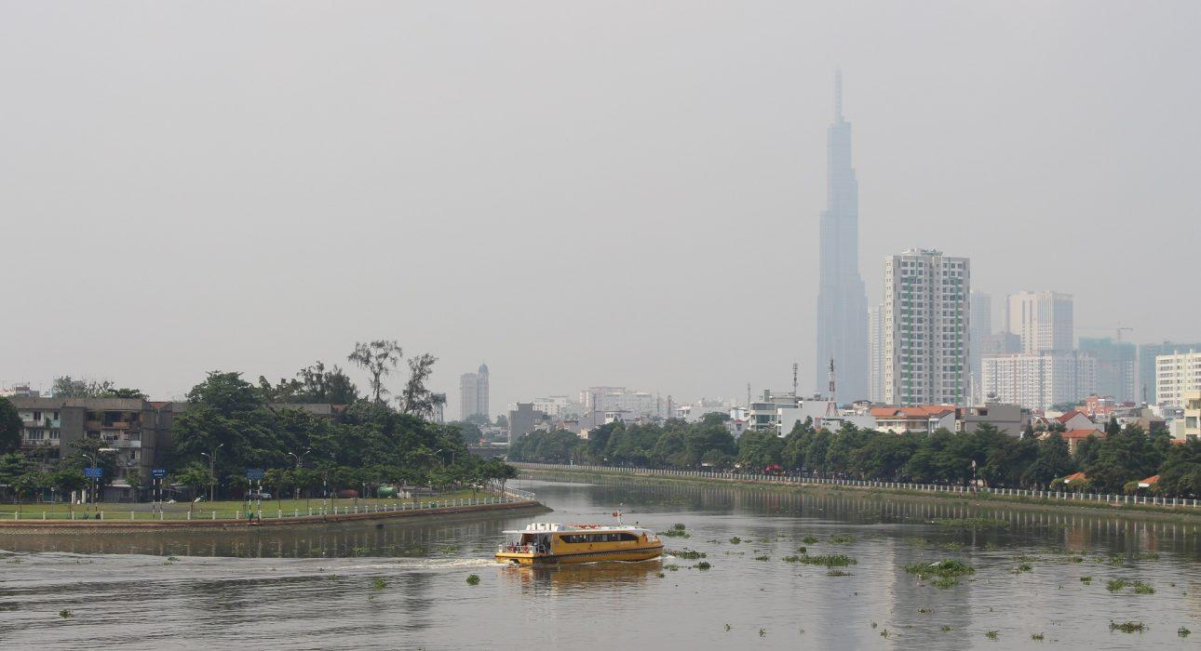

Over View

Theme
Classic, Cruise & River Cruise, Family, Sustainable

Country - City
Vietnam - Ho Chi Minh City

Market segment
Groups, Thematic Leisure

Price Level
$

Max pax
30

Seasonality
All year

Arrival city
Ho Chi Minh City

Departure city
Ho Chi Minh City

Description

This activity gives travelers a chance to experience the “water bus” of Ho Chi Minh City and to explore Thanh Da Peninsula. The water bus is a public transportation system cruising on the Saigon River, moving from the skyscrapers of District 1 to more rural, suburban areas. Thanh Da is a quiet space in the middle of Ho Chi Minh City, comprising apartments and a slower way of life than the rest of the city. Thanh Da Island has long been famous as a place to escape the city without actually leaving it. Their mixing of both makes this activity an excellent way for travelers to discover several aspects of the town.

Can be combined with
Thematic Leisure
- Ho Chi Minh City – Explore District 5 In Depth
- Ho Chi Minh City – Meet the art: The vitality of contemporary art in Vietnam
- Ho Chi Minh City – Visit the Tumultuous Capital of the South
- Ho Chi Minh City – Experience Vietnamese Cuisine Cooking Class

Selling points

- A chance to experience different and unique atmospheres in the city
- An opportunity to interact with and travel like locals while using the waterbus or walking through Thanh Da market
- Suitable for almost every traveler
- To include in the itinerary in the morning to avoid the heat.

Sustainability

Level Of The Excursion
Medium – This activity offers tangible positive contributions to the local community, culture and/or environment

The Impact Of This Excursion

Environment Impact
Transportation

Economic Impact
Community benefits

Additional Information
Positive Impact:The activity uses public transportation (public boat) and has a positive economic impact on the rarely visited district of Thanh Da.

Time And Transportation

Photos

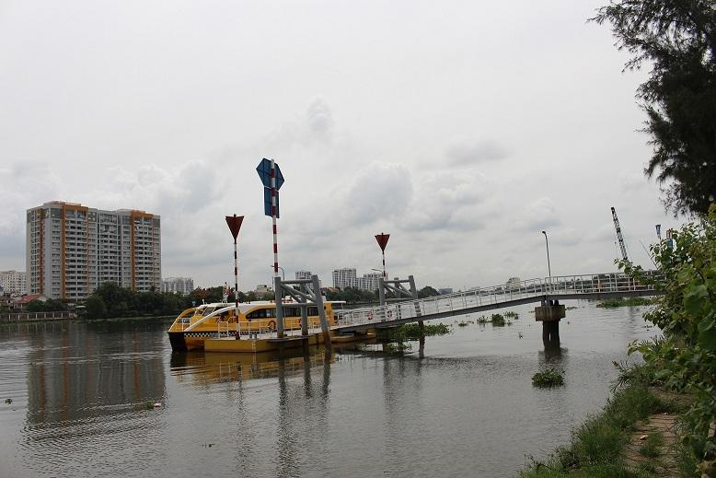
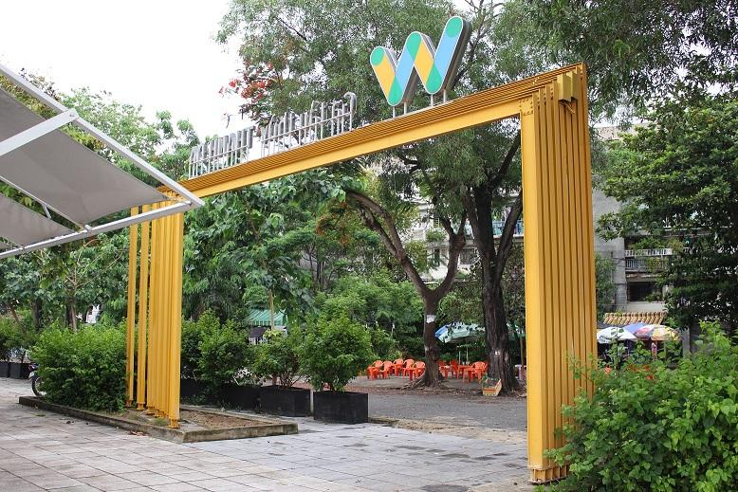
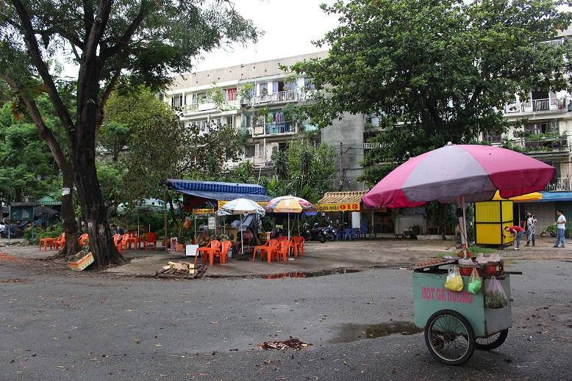
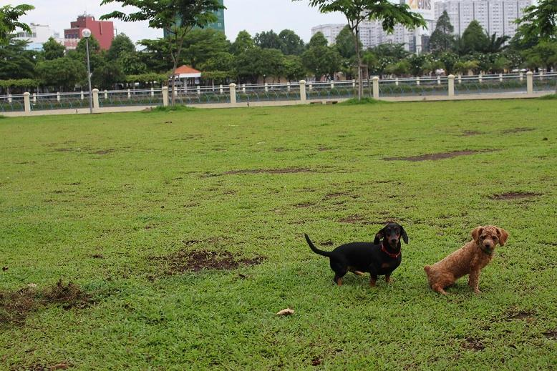
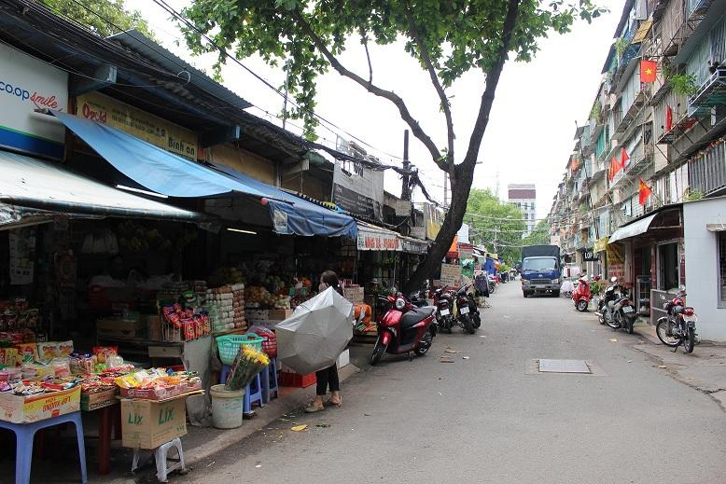
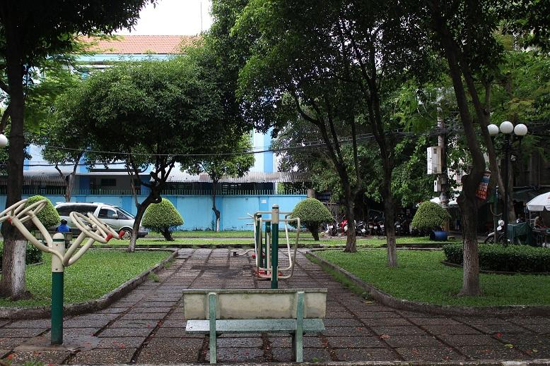
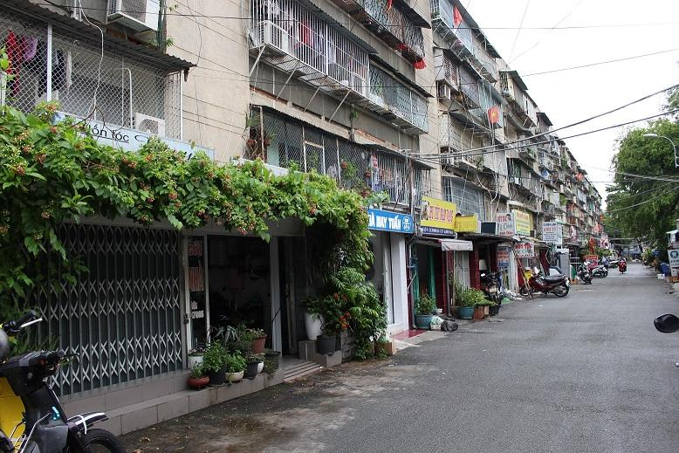
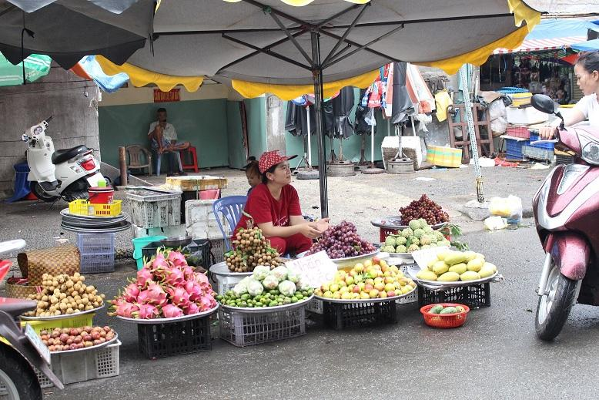
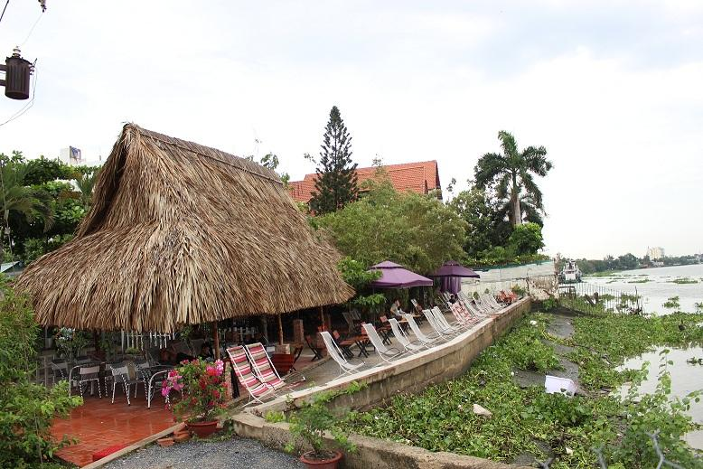

Easia Travel Head Office

Vietnam Head OfficeC/o: ATS Hotel, Suite 326 &327, 33B Pham Ngu Lao Street, Hanoi, VietnamTel: +84 24-39 33 13 62www.easia-travel.com

