MYANMAR – Mandalay – Sunset Cocktail Boat at U Bein Bridge
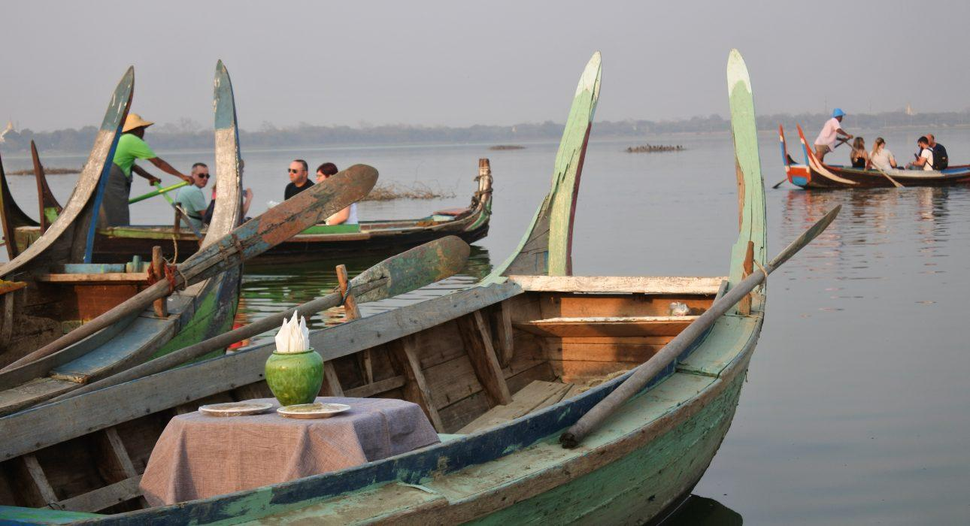

Over View

Theme
Classic, Family, Honeymoon

Country - City
Myanmar - Mandalay

Market segment
Groups, Thematic Leisure

Price Level
$$

Max pax
100 persons

Seasonality
Best season from October to April

Arrival city
Mandalay

Departure city
Mandalay

Description

U Bein bridge is a must-see from Mandalay region, especially at the end of the day when the sun is setting on the horizon, casting shadows of the locals crossing the bridge to go home. The scene is best captured from the distance, in a private boat where one can enjoy the peaceful atmosphere despite the surrounding buzz. The experience will be topped off with a refreshing cocktail and some snacks.

Can be combined with
Thematic Leisure
Mandalay – Amarapura Walking Tour

Selling points

- U Bein Bridge is a must-see, particularly at sunset. Experiencing the sunset from the Sampan boat allows for a more private and special experience
- From the boat, the travellers can better capture the whole length of the bridge and take the famous picture of the bridge with the sunset setting on the other side
- Though Sampan boats can be rented on spot to cross the lake, they do not offer the special set up we will prepare for the travellers with cocktail and snack
- We are working with a fleet of boat operators we trust to make the experience the most enjoyable – take time for the travellers to take picture and enjoy the moment
- Despite the surrounding buzz at the bridge, hopping on a boat always remain a special moment of quiet
- Travellers will have time to both walk along the bridge and hop on the boat for the best photo opportunities from both point of view
- Must-do for photographers to capture the best shots

Time And Transportation

From | To | Distance | By | Duration
Mandalay | U Bein Bridge | 11 kilometers | Car | 25 mintues
Ava jetty | U Bein Bridge | 12 kilometers | Car | 25 minutes

Photos

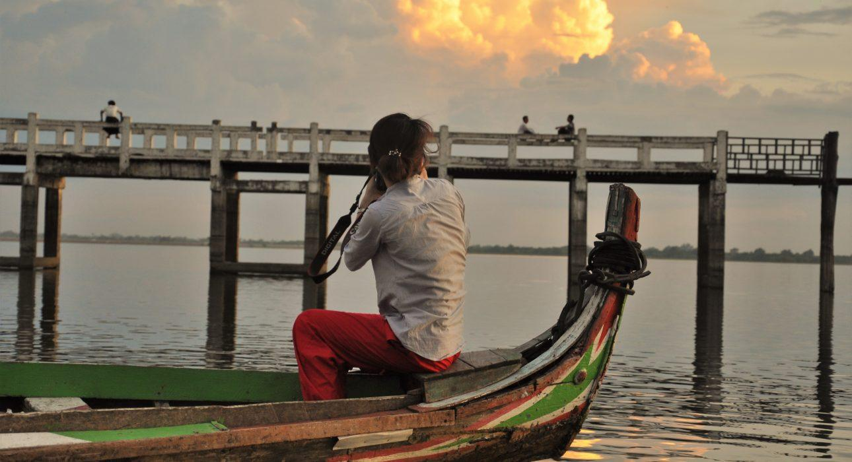
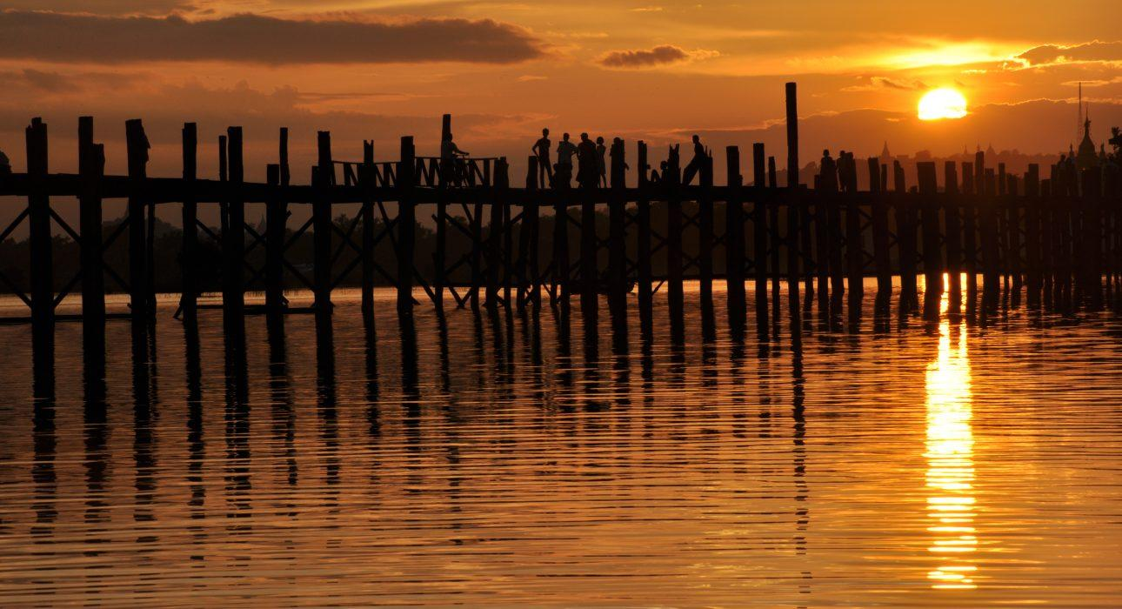
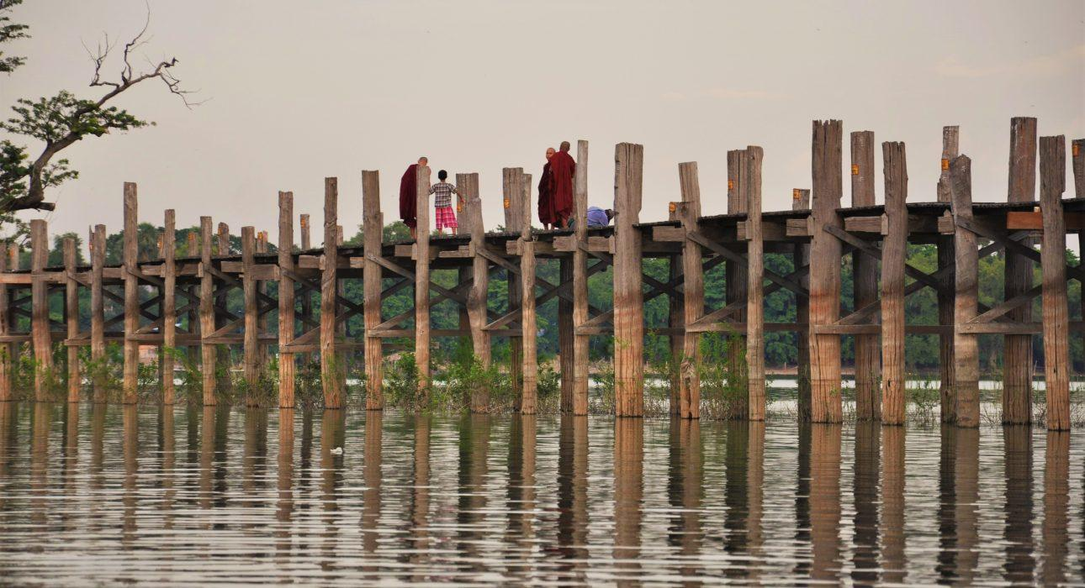
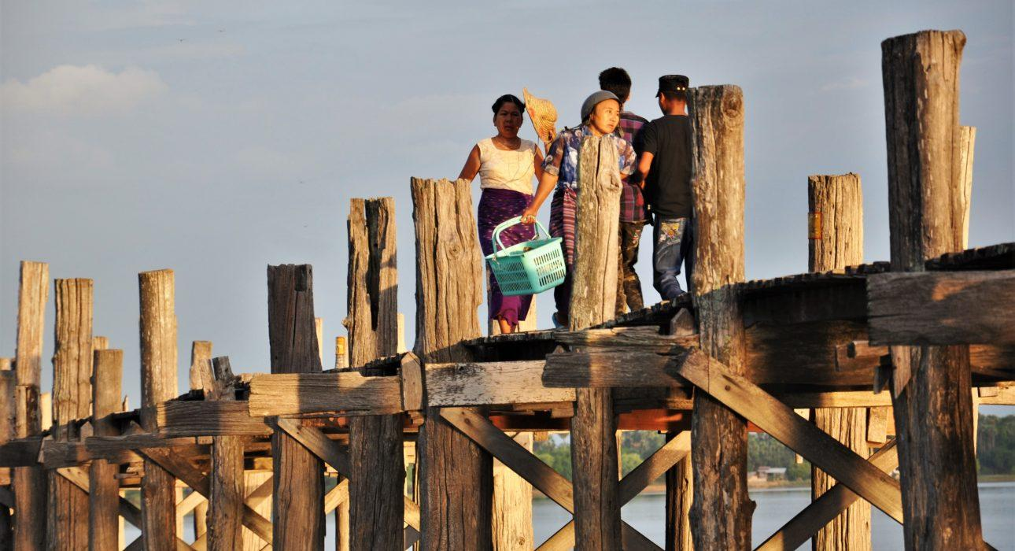
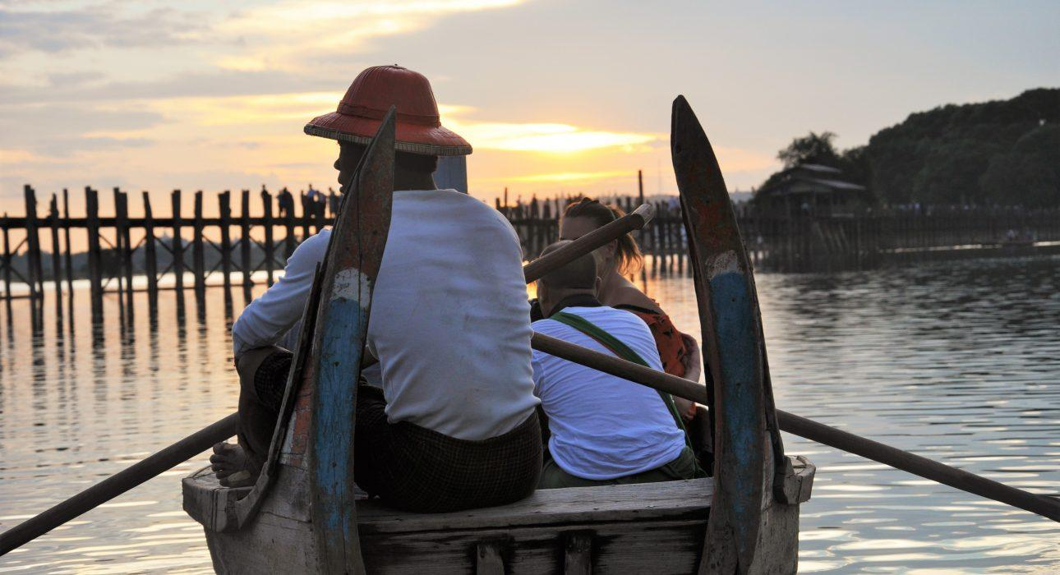
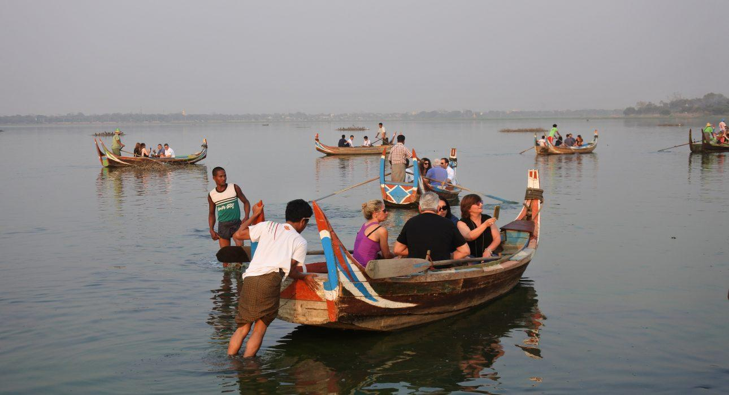
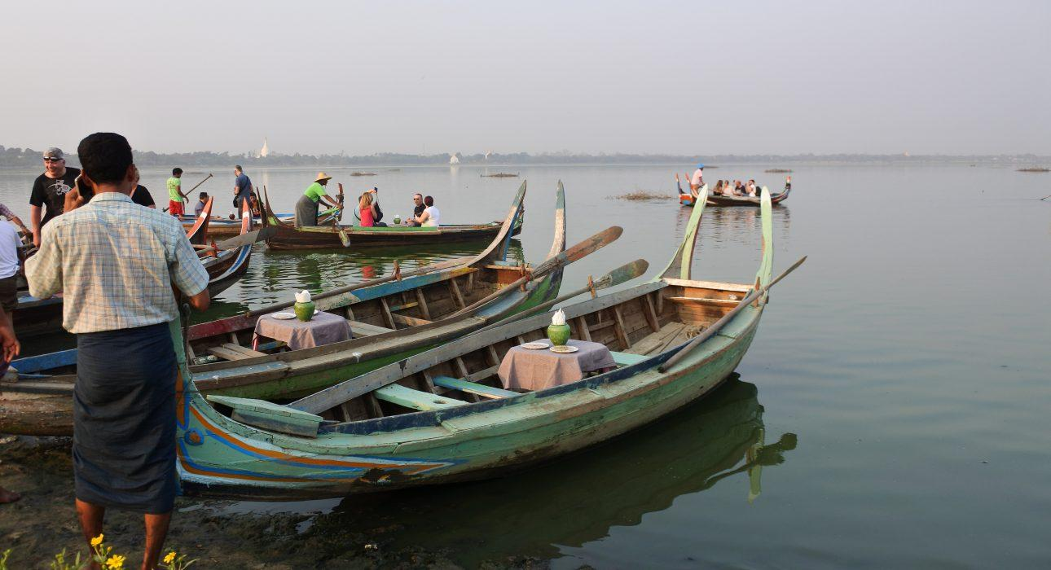
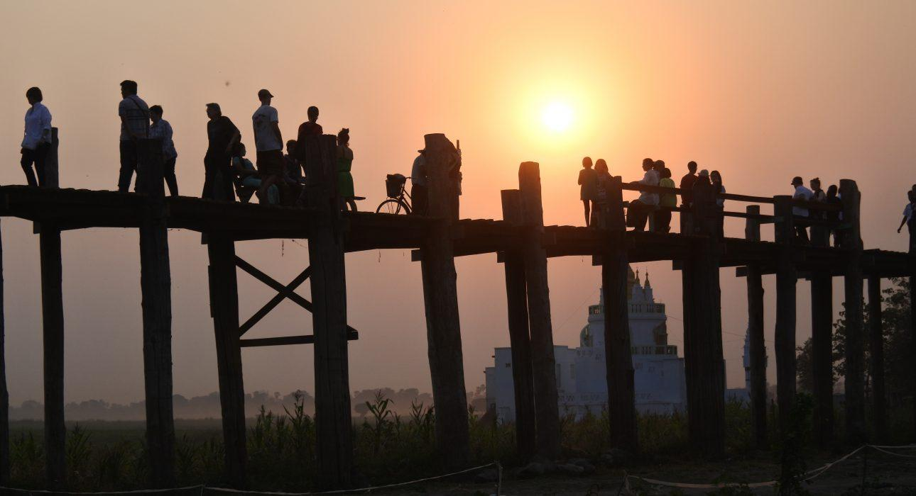

Easia Travel Head Office

Vietnam Head OfficeC/o: ATS Hotel, Suite 326 &327, 33B Pham Ngu Lao Street, Hanoi, VietnamTel: +84 24-39 33 13 62www.easia-travel.com

