MYANMAR – Yangon – Circular Train Adventure
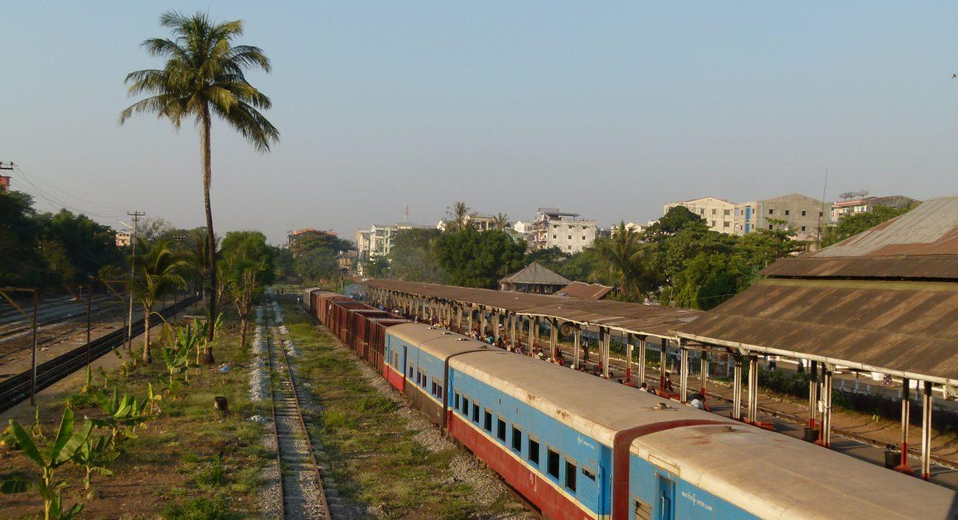

Over View

Theme
Classic, Family

Country - City
Myanmar - Yangon

Market segment
Groups, Thematic Leisure

Price Level
$

Max pax
100 persons

Seasonality
All Year Round

Arrival city
Yangon

Departure city
Yangon

Description

The outskirts of Yangon are as colourful and bustling as the city’s downtown streets. The circular train, though looking derelict, is still the main way to travel in and out of the downtown area for most of the inhabitants. A ride on the window-less train is an adventure within everyone’s reach, mingling with commuters and hawkers, selling everything from fresh fruits to peanuts and tissues on the platforms and in the train. This short train ride is combined with a trishaw tour around local markets and residential areas, where the pulse of the city is even more intense and finishes at a tea shop for an afternoon snack.

Can be combined with
Thematic Leisure
Yangon – Visit Shwedagon like a local pilgrimYangon – Flavours of Yangon
Incentive
Yangon – Urban Sunset DrinksYangon – BBQ Night Dinner

Selling points

- A best seller activity which gives an introduction about the country: its colourful markets, the busy neighbourhoods, street sellers and welcoming population
- Original mode of transportation: the local train followed by a leisure trishaw ride
- The circular train is an attraction of itself: many street sellers walking from one carriage to the other, many activities in and outside the train which have no windows
- A perfect addition to a more cultural discovery of Yangon to discover both faces of the ancient capital city: its cultural heritage and its bustling life

Time And Transportation

From | To | Distance | By | Duration | Road condition
Kanbe station | Bauktaw station | N/A | Train | 4 minutes | N/A
Bauktaw station | Tamwe station | N/A | Train | 3 minutes | N/A
Tamwe station | Myittanyunt station | N/A | Train | 4 minutes | N/A
Myittanyunt station | Mahlwagon station | N/A | Train | 4 minutes | N/A
Mahlwagon station | Pazundaung station | N/A | Train | 4 minutes | N/A
Pazundaung station | Central station | N/A | Train | 6 minutes | N/A
Shwedagon pagoda | Kanbe station | 9 kilometers | Car | 30 minutes | Good but crowded
Yangon Central Railway | Kanbe station | 9 kilometers | Car | 30 minutes | Good but crowded
Shwedagon pagoda | Kyee Min Daing station | 5 kilometers | Car | 20 minutes | Good but crowded
Yangon Central Railway | Kyee Min Daing station | 9 kilometers | Car | 30 minutes | Good but crowded

Photos

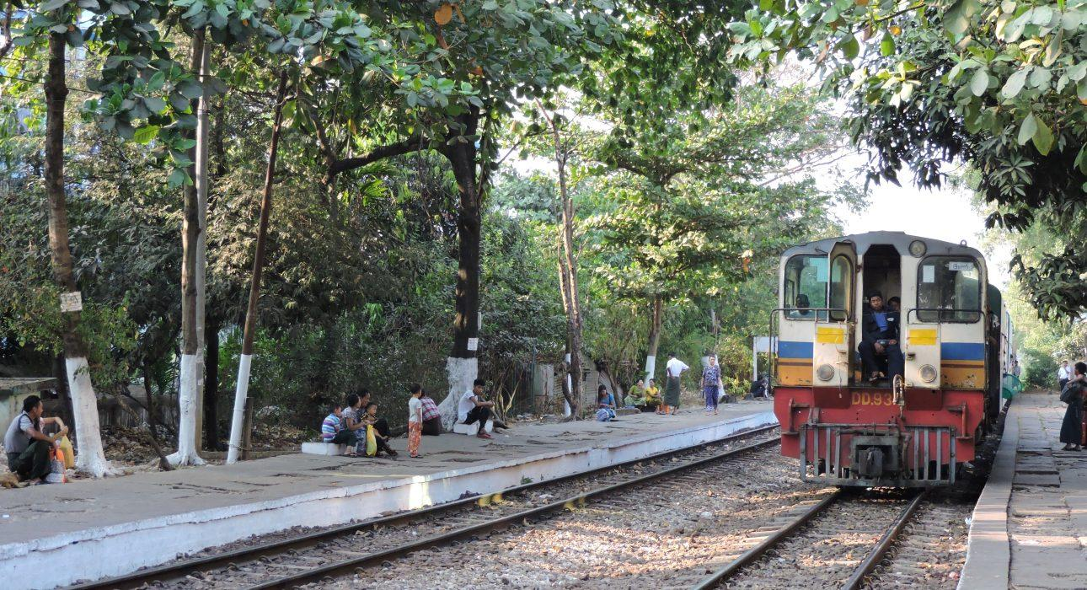
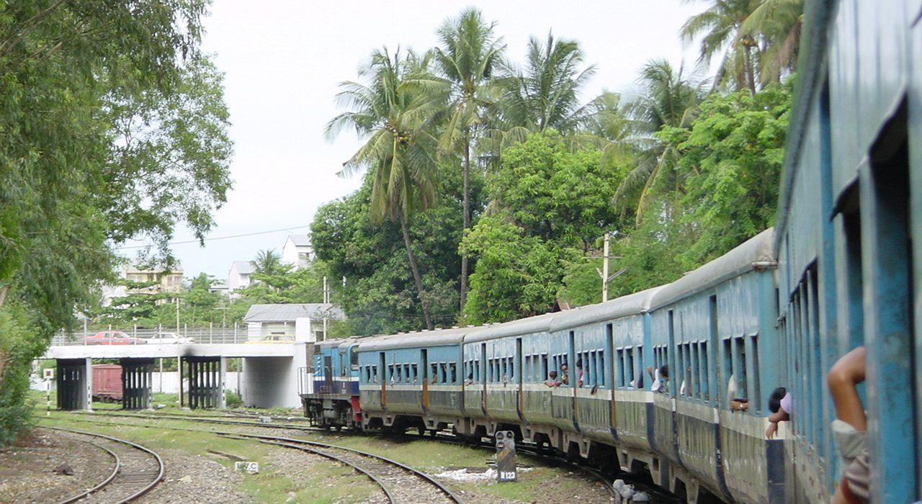
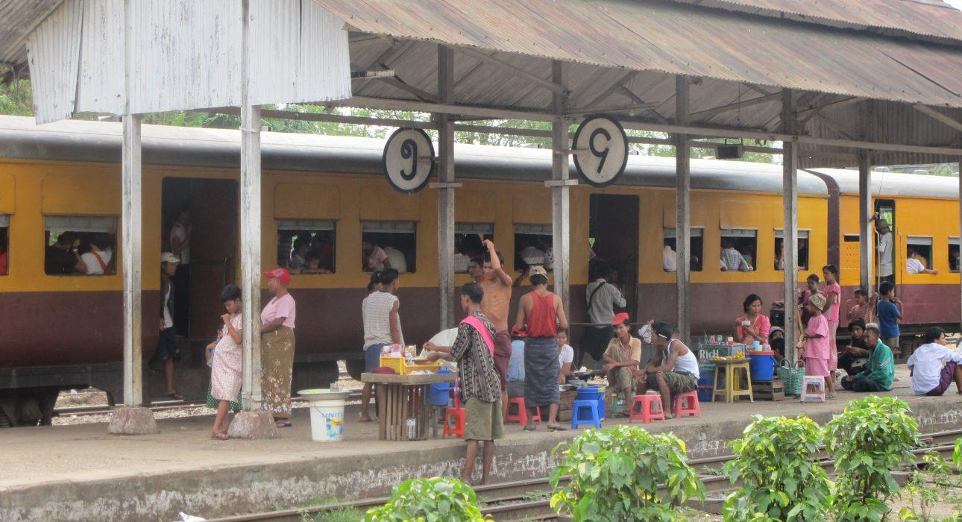
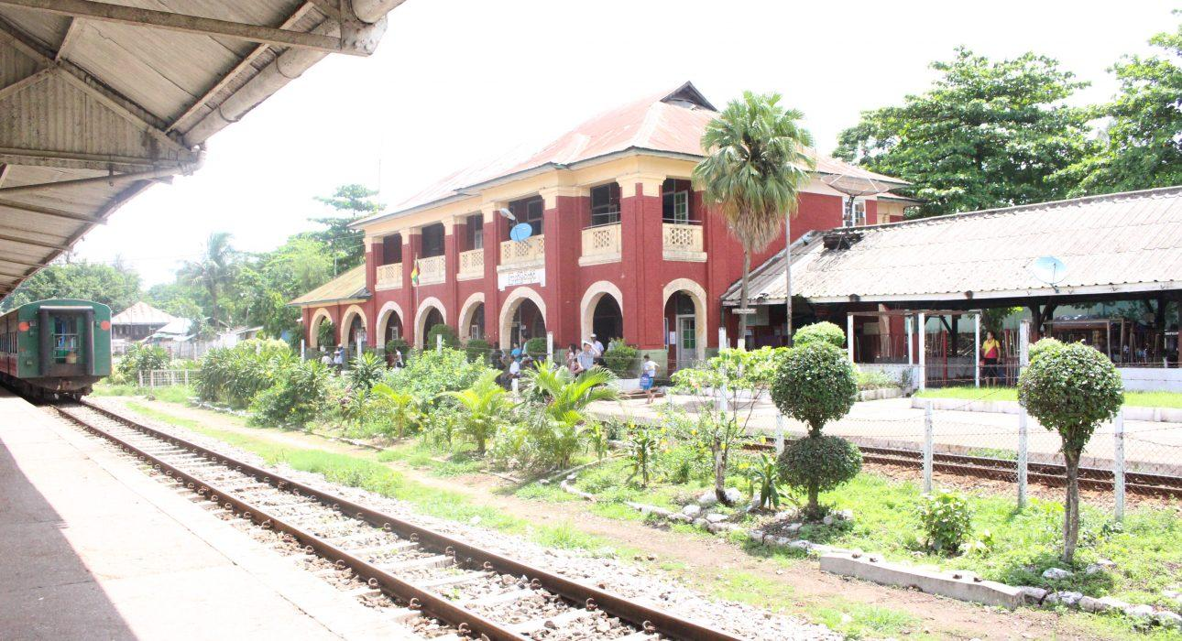
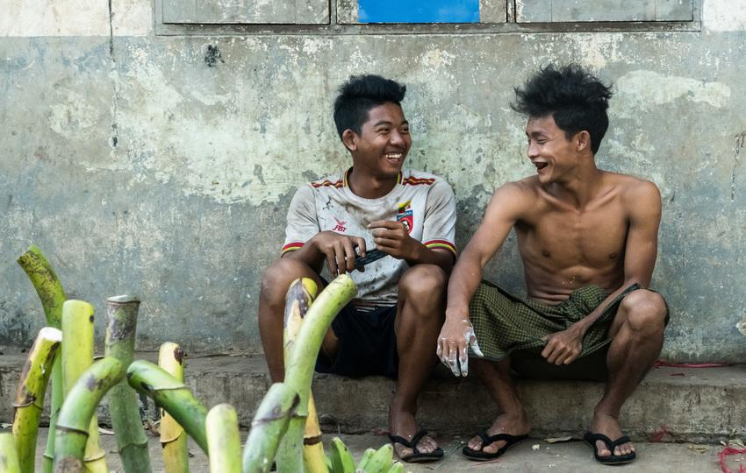
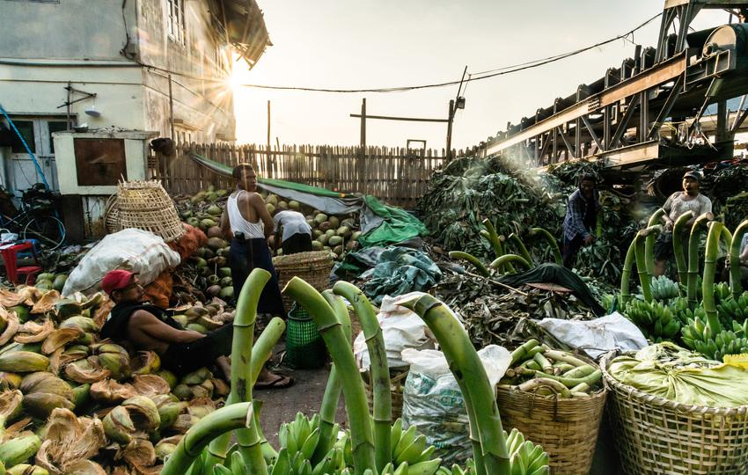
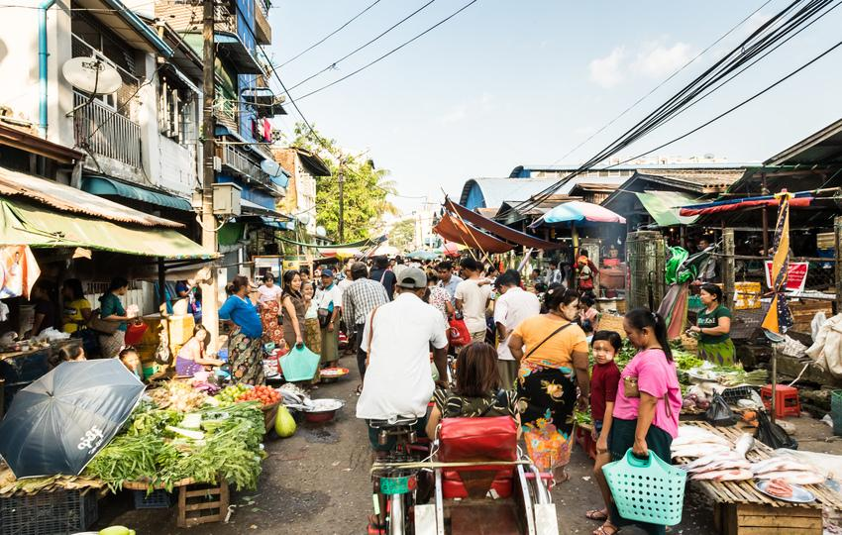
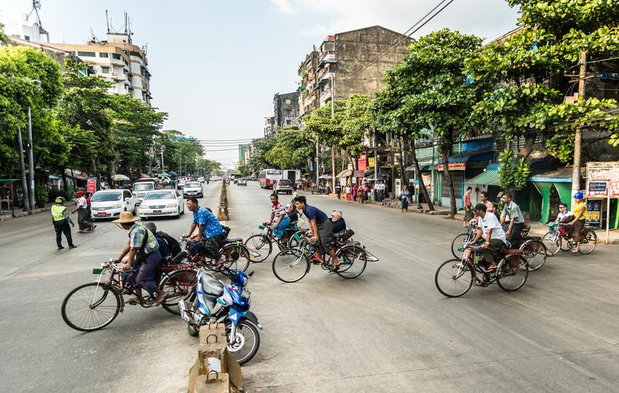
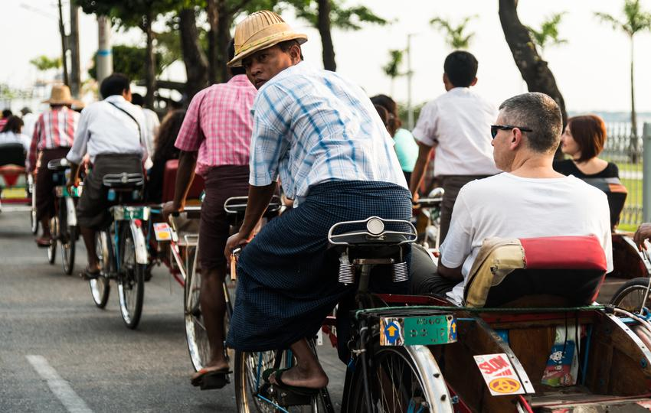
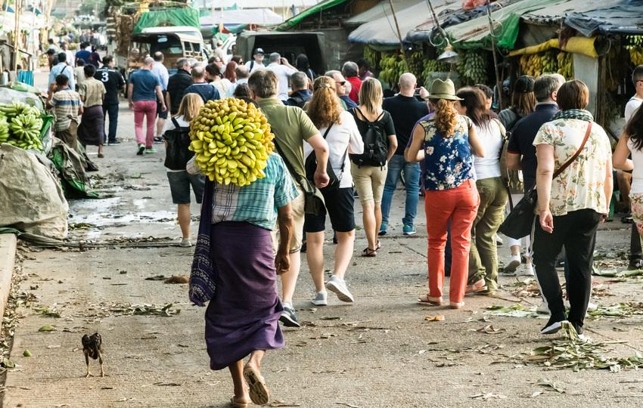

Easia Travel Head Office

Vietnam Head OfficeC/o: ATS Hotel, Suite 326 &327, 33B Pham Ngu Lao Street, Hanoi, VietnamTel: +84 24-39 33 13 62www.easia-travel.com

