MYANMAR – Bagan – Journey to Mount Popa
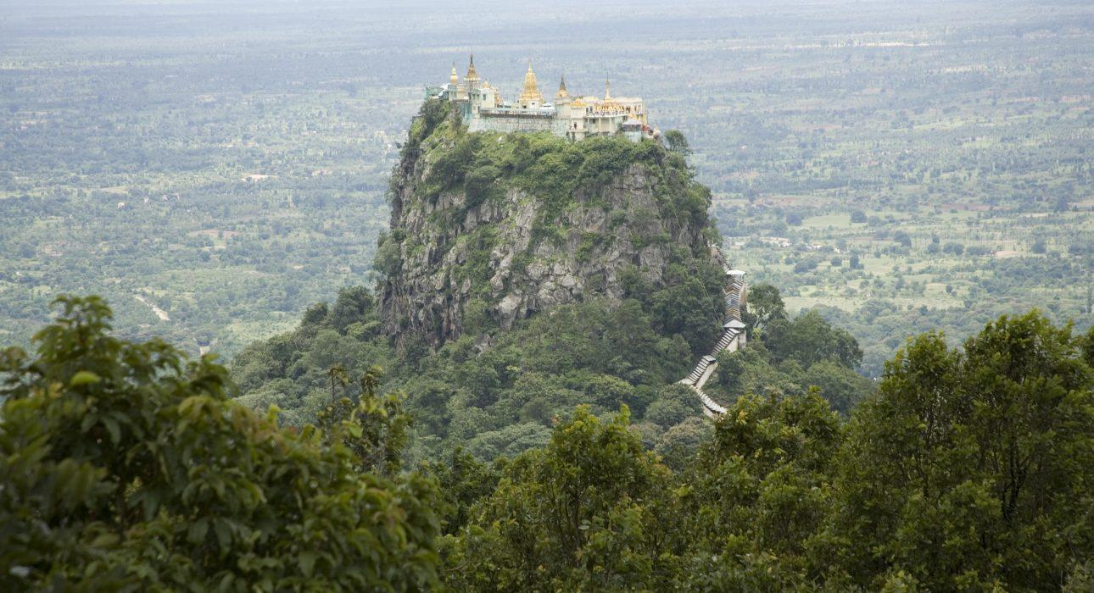

Over View

Theme
Classic

Country - City
Myanmar - Bagan

Market segment
Groups, Thematic Leisure

Price Level
$

Max pax
60 persons

Seasonality
All Year Round

Arrival city
Bagan

Departure city
Bagan

Description

Located southeast of Bagan, Mount Popa is an ancient extinct volcano mainly known for the nearby monastery of Taung Kalat perched on an isolated rock! A journey to Mount Popa allows for the visit to a few other off the beaten tracks villages such as Chauk and Salay, both on the shores of the Irrawaddy River. Whether on a day trip, to spend the night or as a stopover on the way to Shan State, Mount Popa is a good alternative for travellers who want to explore some more quaint countryside landscapes outside of Bagan.

Selling points

- Ideal as a day trip outside of Bagan when combined with Salay as it combines local markets, off the beaten tracks villages and cultural sightseeing.
- Best option is to spend the night at Popa Mountain Resort and enjoy the view from the restaurant and swimming pool
- Mount Popa offers beautiful views on Taung Kalat, the famous monastery nestled on top of the spire of rock. A visit to Taung Kalat monastery should be completed with surrounding villages, a night at the Popa Mountain resort or a short hike on top of Mount Popa, as a visit to the monastery only doesn’t fill a day trip.
- Add a boat transfer to Salay to make the trip more memorable. Travellers will then journey to Mount Popa by car and travel back to Bagan.

Time And Transportation

From | To | Distance | Time | By | Road condition
Bagan | Taung Kalat | 60 km | 1h 30 | car | Good
Bagan | Salay | 56 kmNA | 1h 302h30 | carboat | Good
Bagan | Chauk | 35 km | 45 minutes | car | Good
Salay | Popa | 60 km | 1h 30 | car | Good
Chauk | Salay | 25 km | 30 minutes | car | Good

Photos

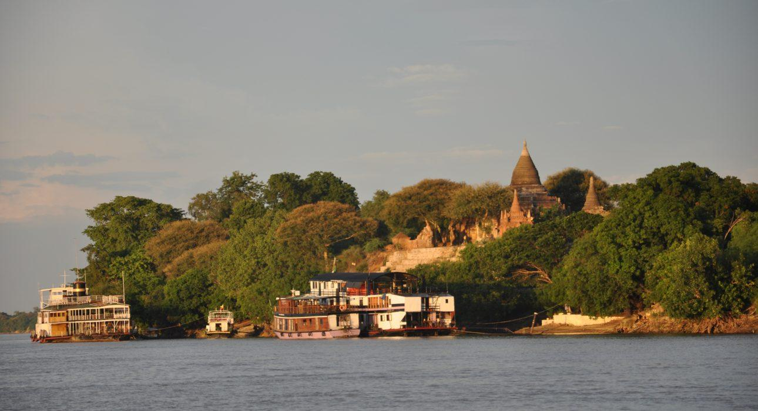
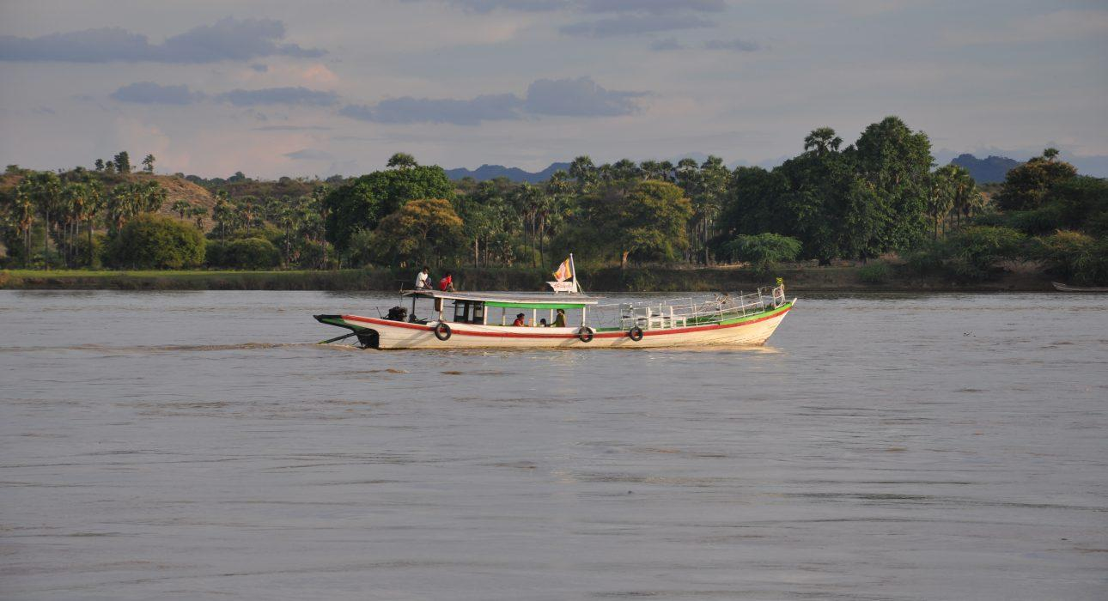
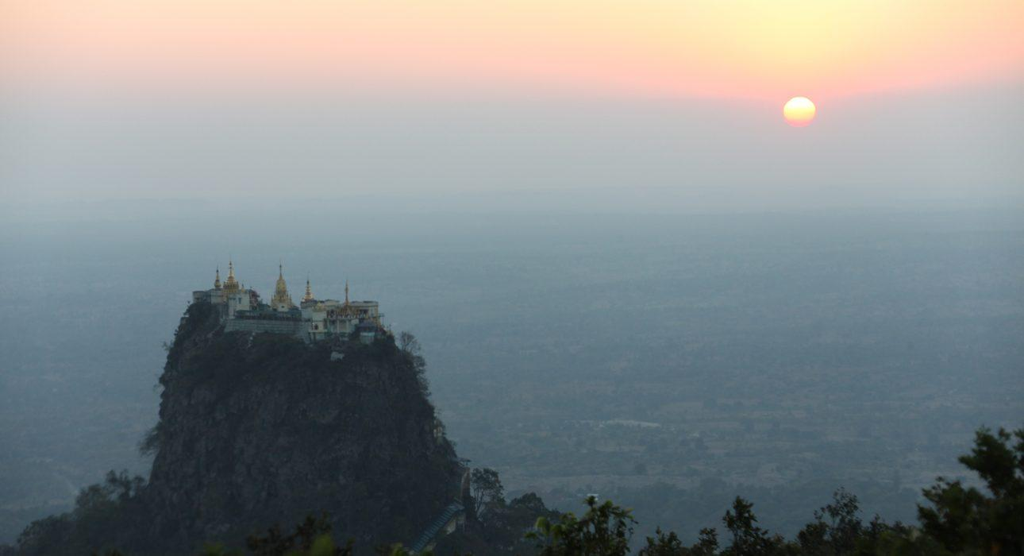
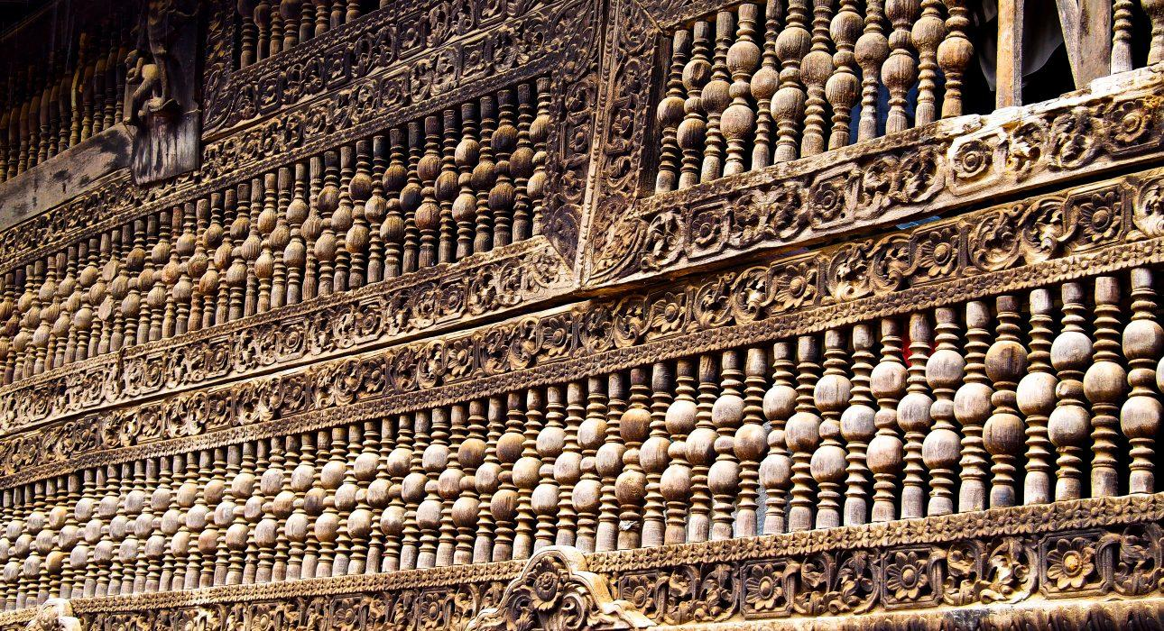
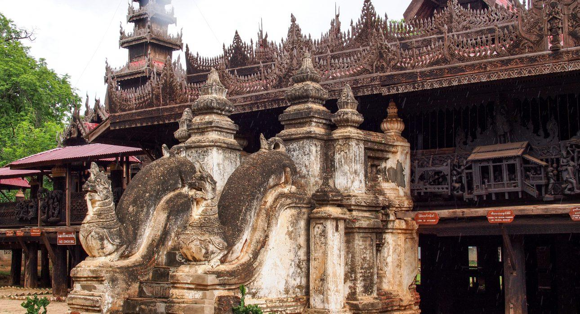
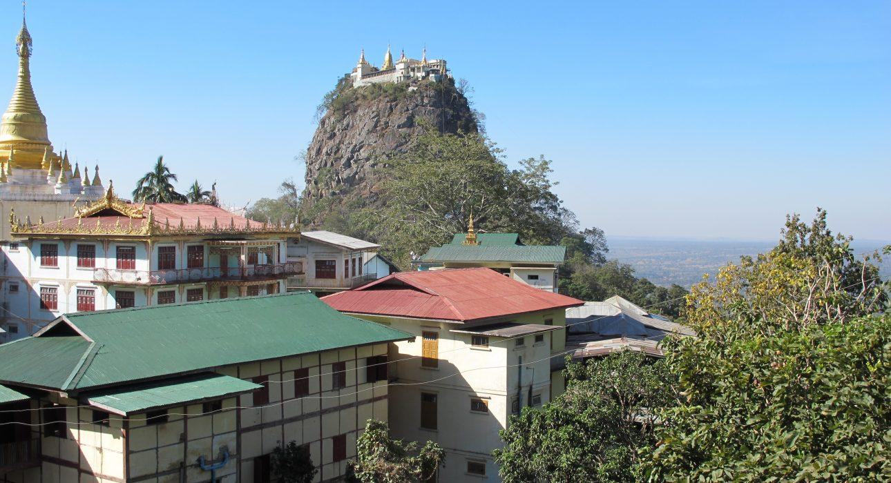
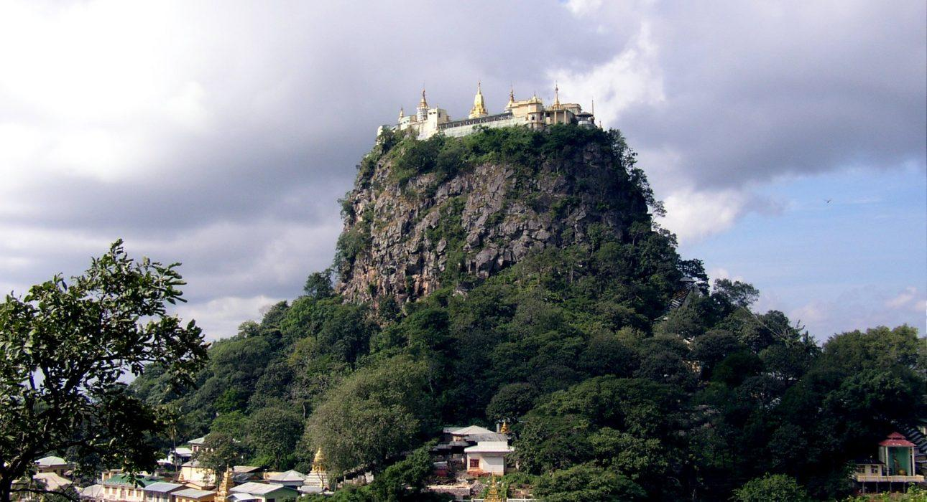
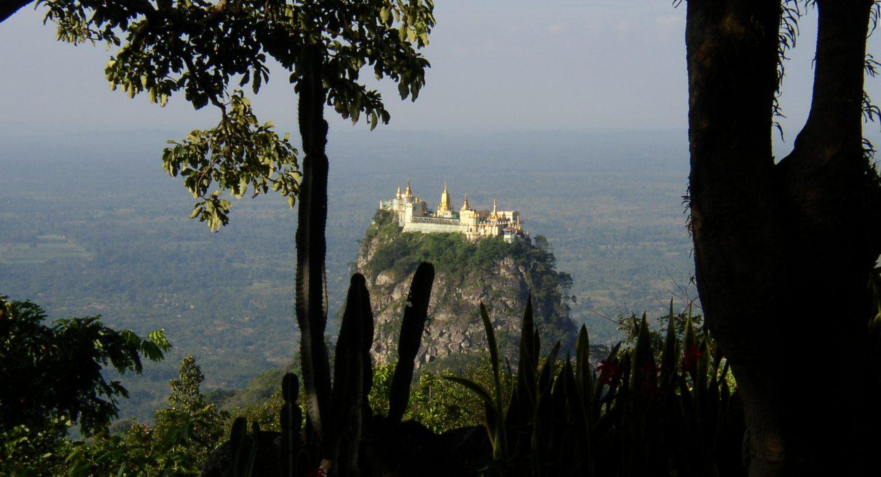

Easia Travel Head Office

Vietnam Head OfficeC/o: ATS Hotel, Suite 326 &327, 33B Pham Ngu Lao Street, Hanoi, VietnamTel: +84 24-39 33 13 62www.easia-travel.com

