MYANMAR – Bagan – Leisure Day Cruise from Pakokku to Bagan
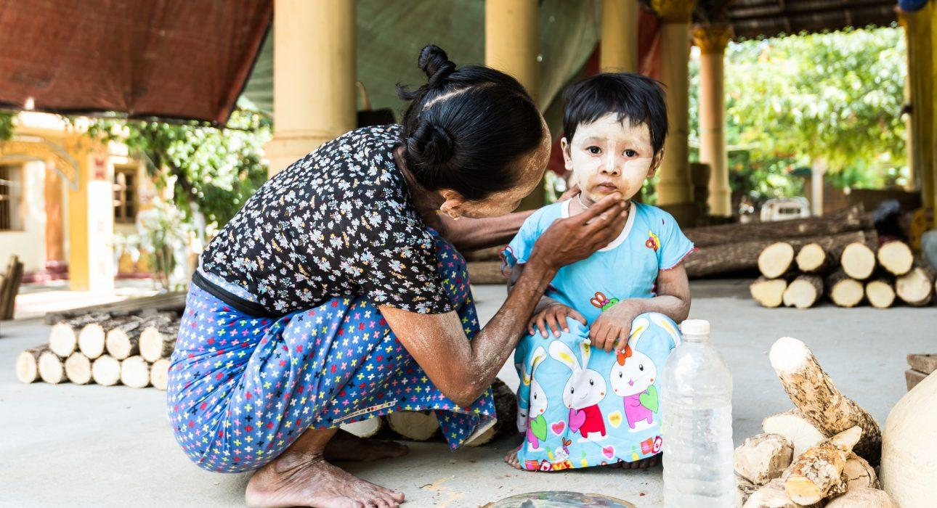

Over View

Theme
Classic

Country - City
Myanmar - Bagan

Market segment
Groups, Thematic Leisure

Price Level
$

Max pax
80 persons

Seasonality
All Year Round

Arrival city
Mandalay

Departure city
Bagan

Description

Located between Mandalay and Bagan, on the shores of the Irrawaddy River, Pakokku is a quaint town, famous for its production of thanaka, the traditional cosmetic one can see on everyone’s cheeks. After a tuk tuk ride around town, the journey continues by boat all the way to Bagan. On board, enjoy refreshments and drinks will be served. This short cruise from Pakokku to Bagan is the ideal alternative to a journey by car, arriving in Bagan as the sun is slowly setting on the horizon, shedding its soft light on the temples dotting the riverside.

Can be combined with
Thematic Leisure
Bagan – Horse Cart RideBagan – Discover Bagan by BikeBagan – Countryside Dinner by Candle Light

Selling points

- A travellers’ favourite: a taste of the countryside life off the beaten track easy to integrate in an itinerary combining all the highlights
- The 2-hour cruise from Pakokku to Bagan offers the perfect introduction to Bagan as the travellers spot the first temples, dotting the riverside, as the sun is setting
- A tuk tuk ride around Pakokku to visit a mix of temples and crafts
- Ideal for families who want to explore a bit the countryside and avoid too many driving hours

Time And Transportation

From | To | Distance | Time | By | Road condition
Bagan | Pakokku | N/A | 2 hours | Boat | N/A
Mandalay | Pakokku | 160 kilometers | 3h 30 | Car | Good
Bagan | Pakokku | 37 kilometers | 1h 30 | Car | Good

Photos

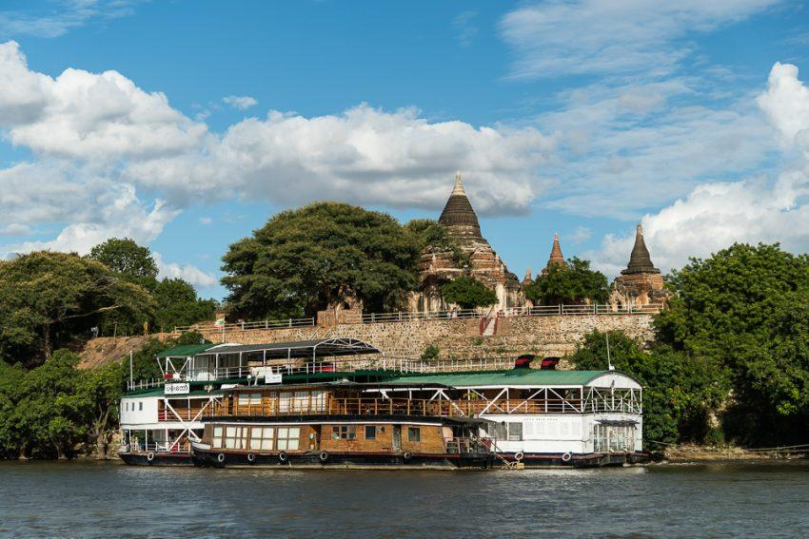
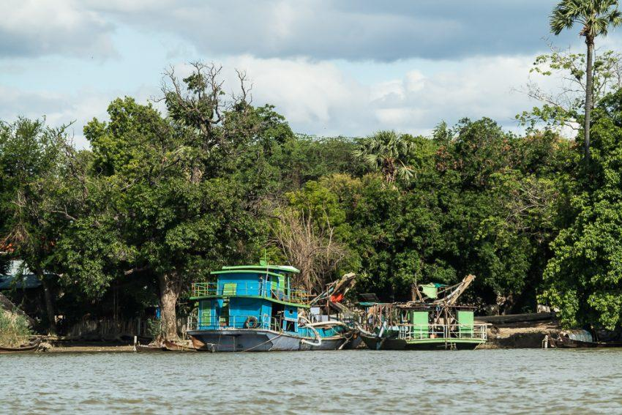
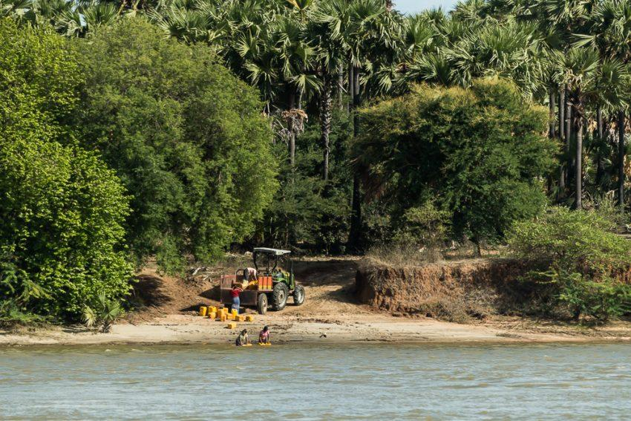
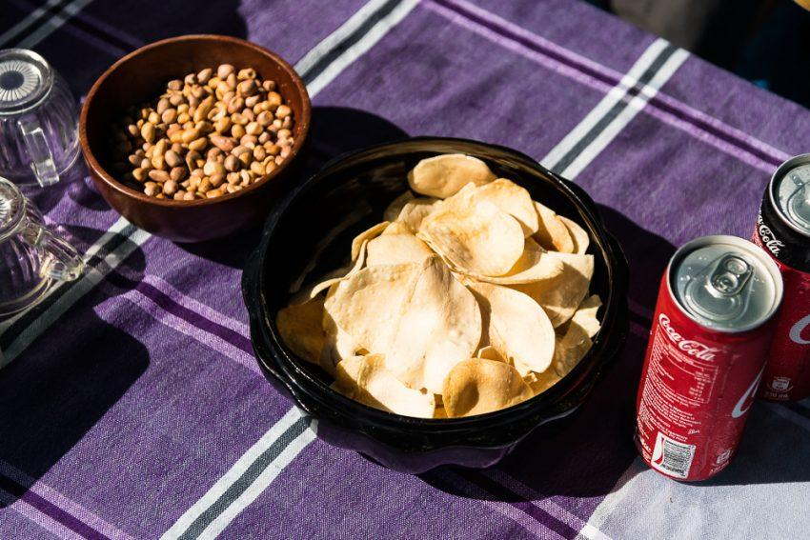
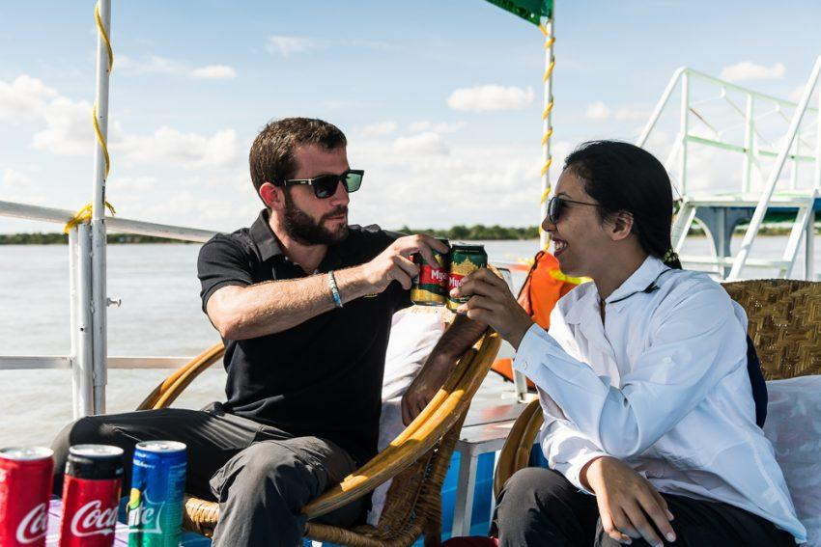
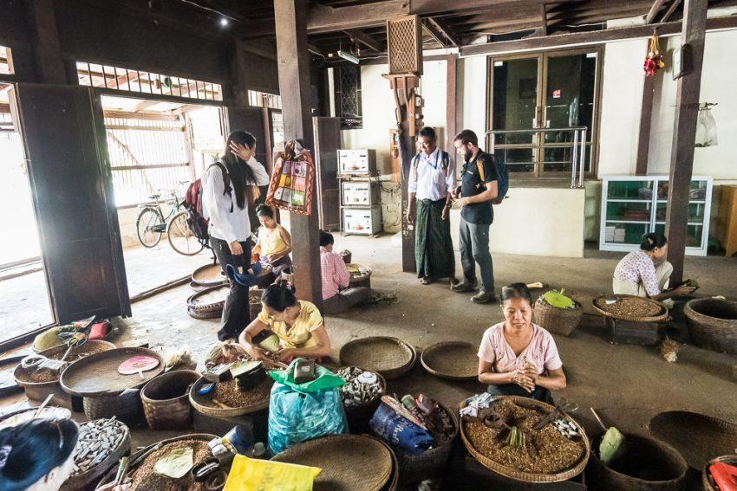
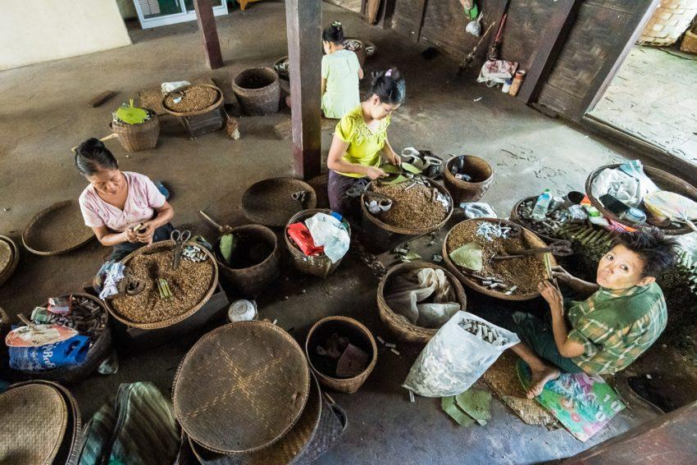
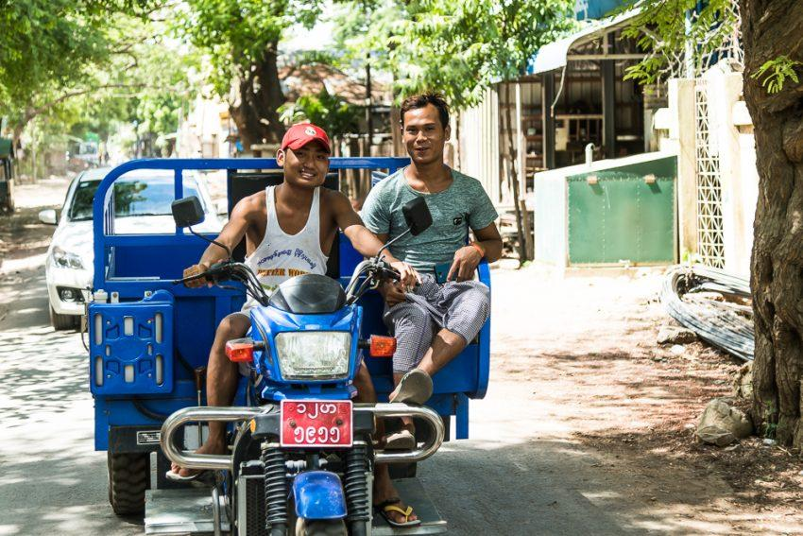
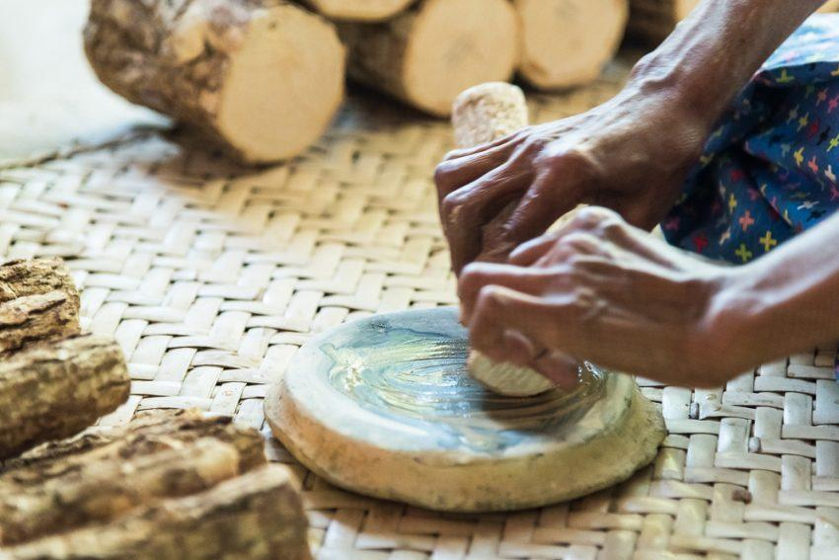
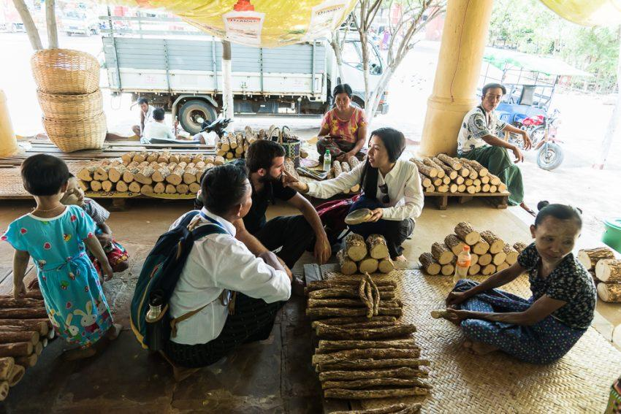
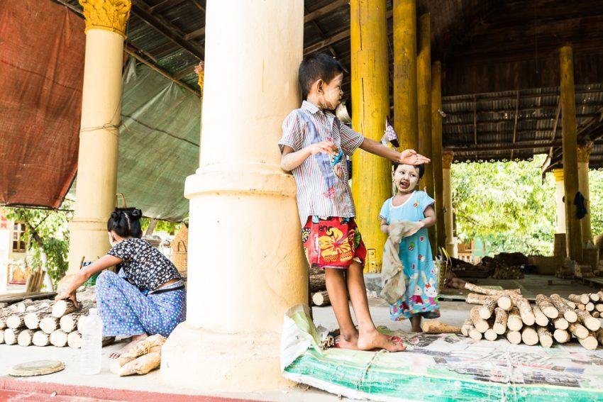
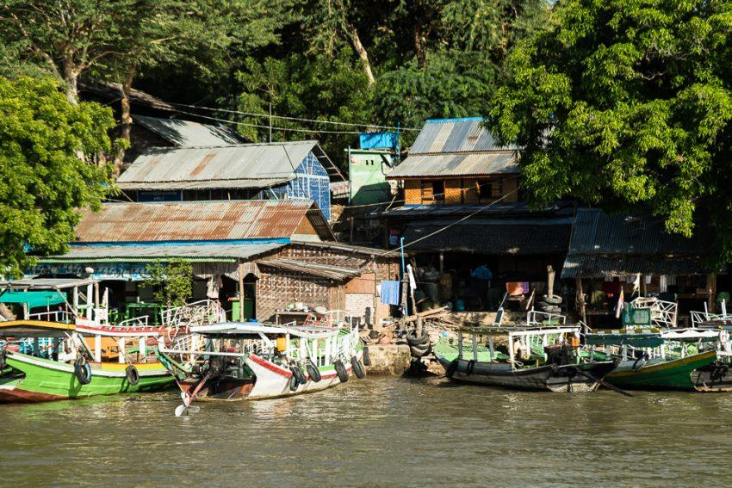

Easia Travel Head Office

Vietnam Head OfficeC/o: ATS Hotel, Suite 326 &327, 33B Pham Ngu Lao Street, Hanoi, VietnamTel: +84 24-39 33 13 62www.easia-travel.com

