MYANMAR – Nyaung Shwe – Quarry Dinner
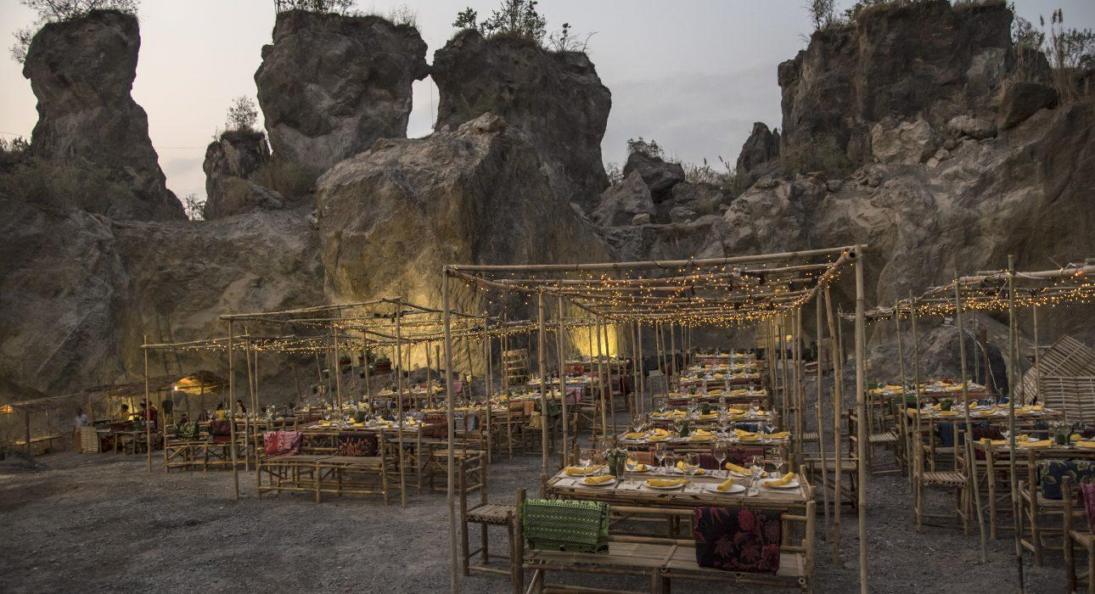

Over View

Theme
Gastronomy

Country - City
Myanmar - Nyaung Shwe

Market segment
Groups

Price Level
$$$

Max pax
100 persons

Seasonality
October to April

Arrival city
Nyaung Shwe

Departure city
Nyaung Shwe

Description

A short drive from Nyaung Shwe lies an ancient stone pit with delightful and elegant setting, serving Shan barbecue dinner, unlimited open bar, entertainment with Shan folk show, music, dance floor and private artisan night market to stroll around and discover traditional craftsmanship. A stunning location and atmosphere to enjoy an extraordinary gala dinner.

Selling points

- A surprising setting for an outdoor gala dinner which stands out from the more traditional options offered around Inle Lake
- An unusual location creating a guaranteed “wow effect” as the set-up and lighting highlights the dramatic rock formation
- Fun and casual night where a craft market, traditional BBQ and traditional dance are offered as entertainment before transitioning into a night disco with DJ
- Exclusively for Incentive groups looking for an extraordinary last night in Inle Lake…without being on the lake

Time And Transportation

From | To | Distance | By | Duration | Road condition
Nyaung Shwe | Quarry Dinner | / | Bus | 15 Minutes | Good
Hotels from Eastern shore | Quarry Dinner | / | Bus | 45 Minutes | Good

Photos

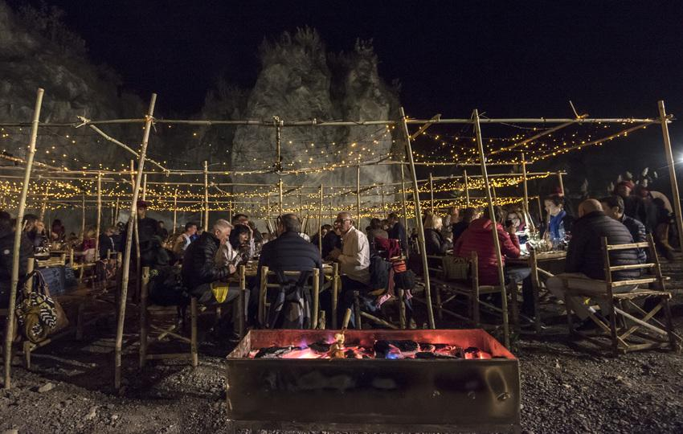
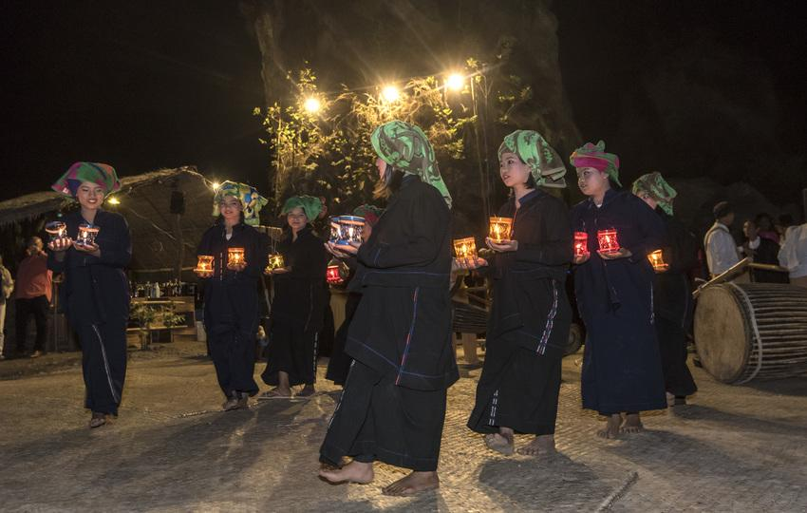
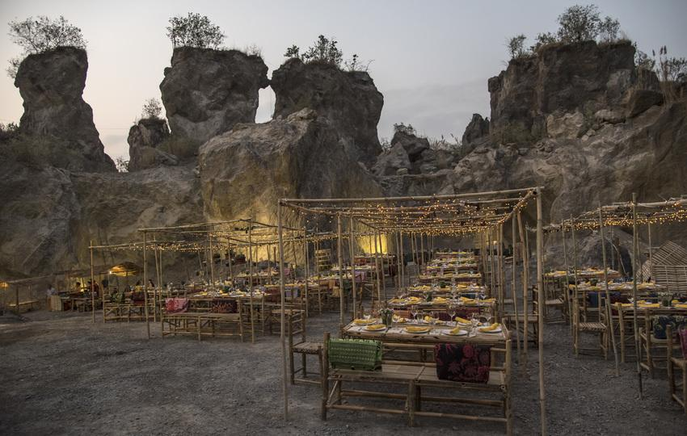
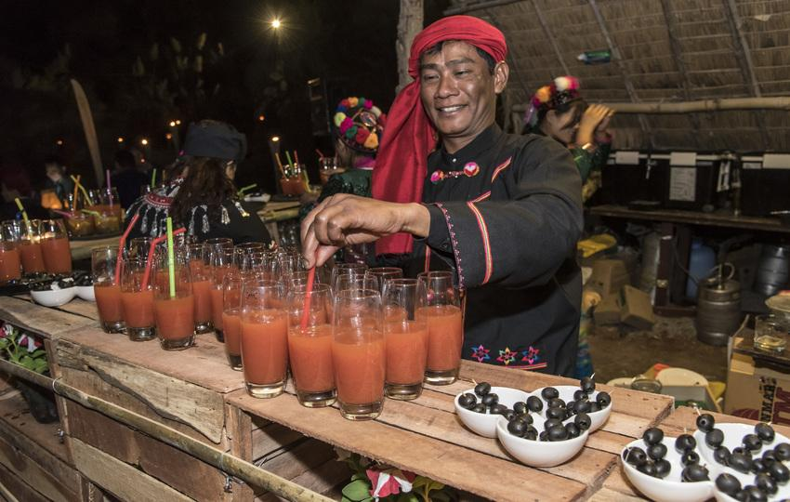
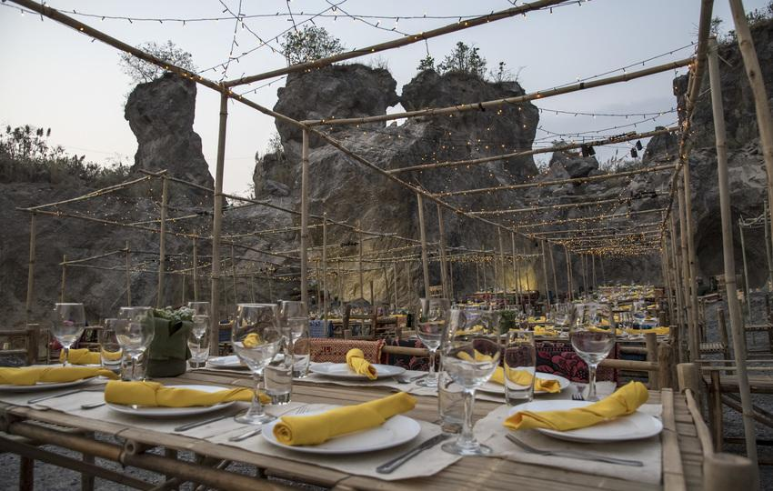
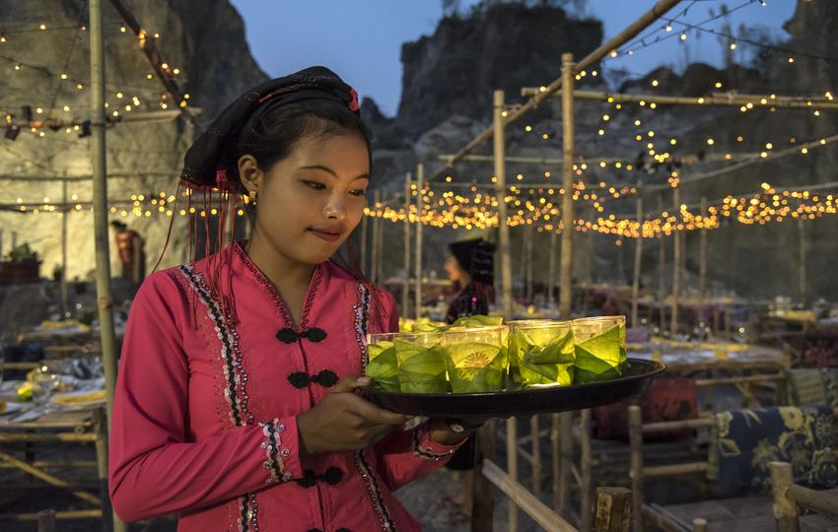
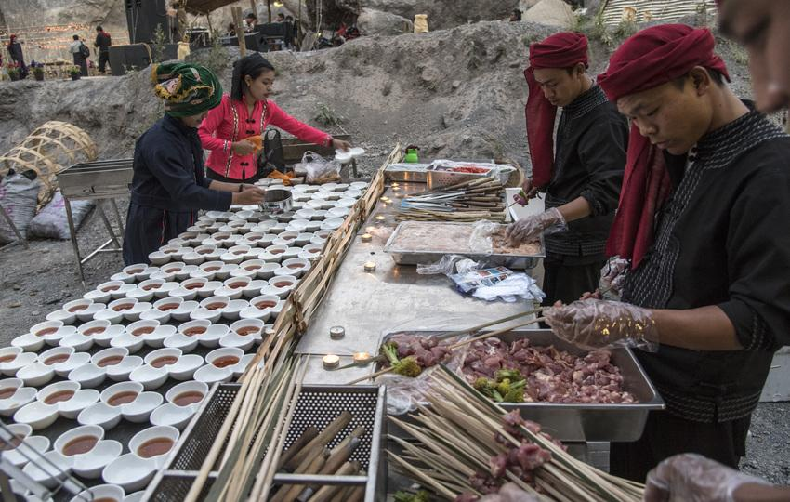
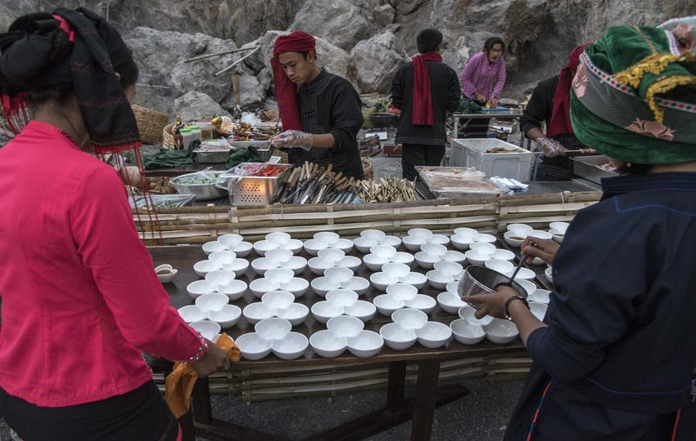
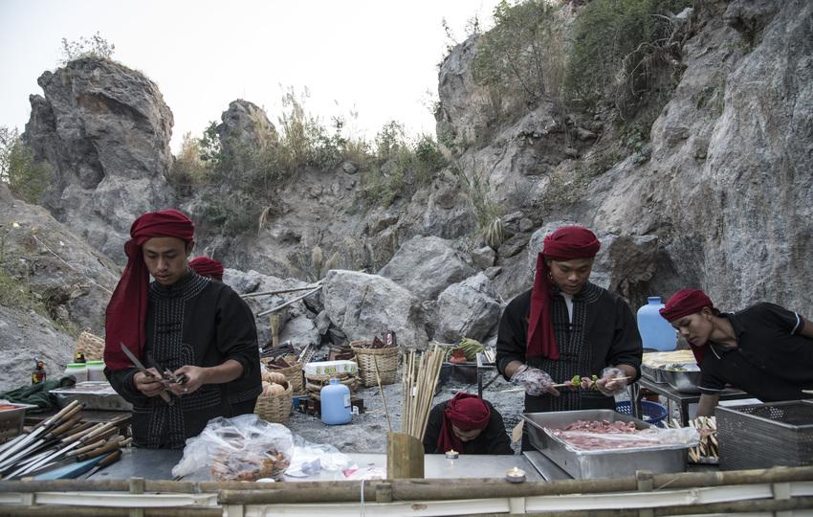
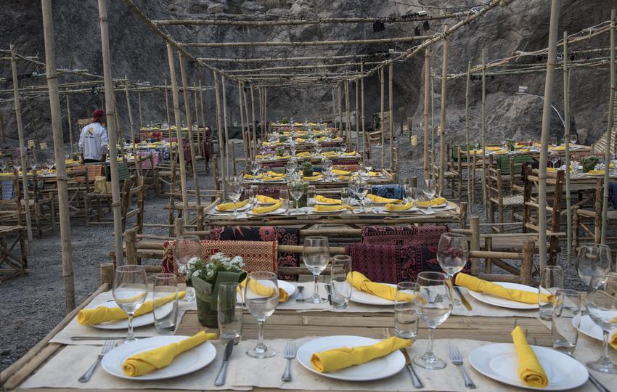
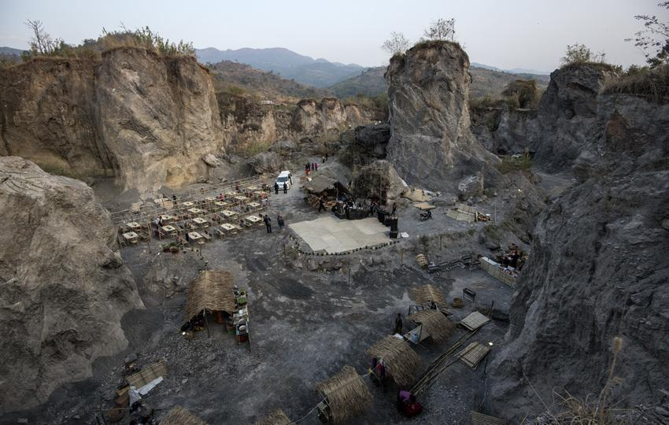
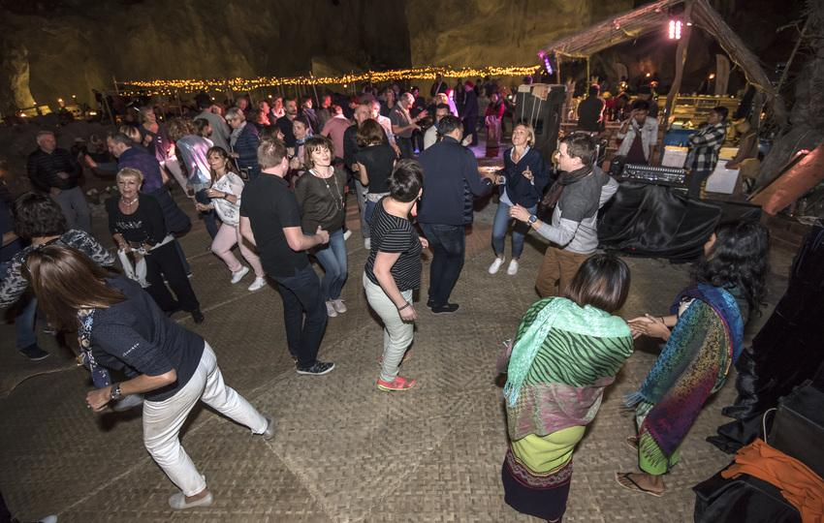

Easia Travel Head Office

Vietnam Head OfficeC/o: ATS Hotel, Suite 326 &327, 33B Pham Ngu Lao Street, Hanoi, VietnamTel: +84 24-39 33 13 62www.easia-travel.com

