THAILAND – Khura Buri – Surin Islands Snorkeling and Moken Village
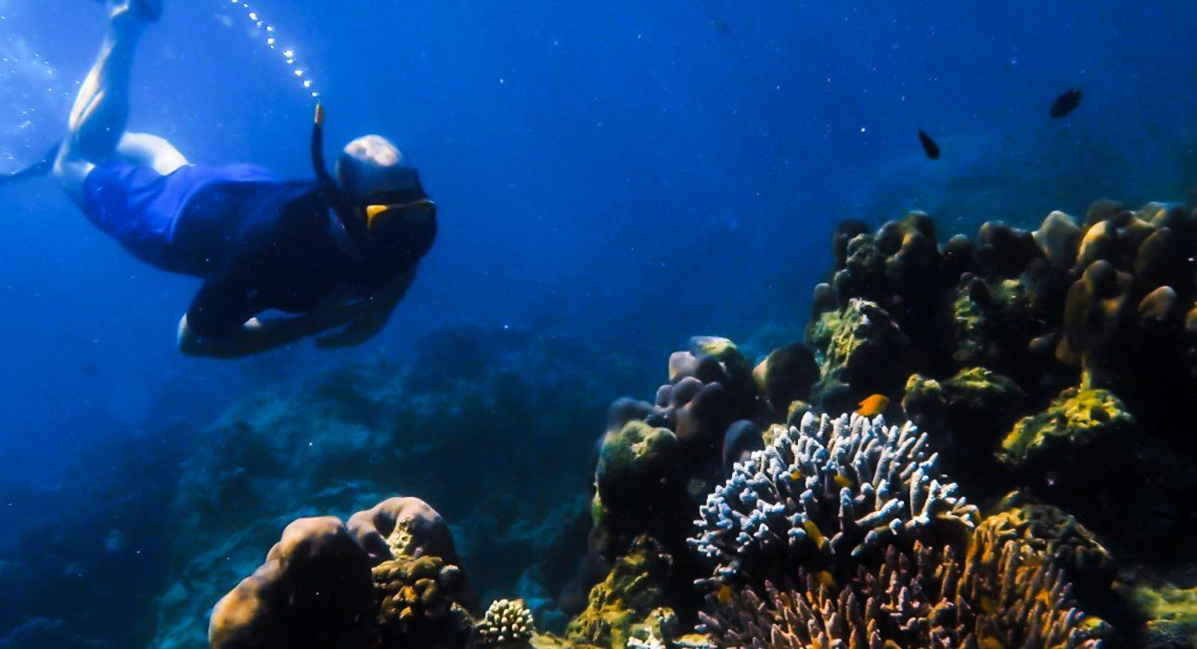

Over View

Theme
Beach Stay

Country - City
Thailand - Phang Nga

Market segment
Groups, Thematic Leisure

Price Level
$$$$

Level of difficulties
LEVEL 0

Max pax
30

Seasonality
From November to April only - Mu Koh Surin National Park is closed during rainy season

Arrival city
Khura Buri - Khao Lak

Departure city
Khura Buri - Khao Lak

Description

This full-day tour starts at Khura Buri Greenview pier, where a two engine speedboat will take the travelers to the Surin Archipelago.After a safety briefing by staff about how to snorkel, and ensuring that the mask, snorkel, and fins are correctly sized for each participant, the boat will depart on the 1 hour 15-minute ride to the beautiful Surin Islands Archipelago.3 snorkeling sessions are scheduled. The crew can adjust spots depending on the weather, and the guides’ expertise provides the best snorkeling experience and an excellent encounter with underwater fauna.After the first stop in May Yai Bay, the boat will anchor at the main island for a buffet lunch. Some time will be left to discover the surroundings and the pristine beaches of the island, sunbathe, and relax until the next snorkeling session among the colorful corals of Sapparod Bay and Bon Bay. A visit to the nearby Moken village is possible and provides an opportunity to learn about the unique way of life of the sea nomads, sadly threatened and forced to become sedentary.On the way back, the boat will pass by the green Koh Ra, before arriving in Khura Buri around 16:30.

Selling points

- The fantastic beauty of the Surin Island archipelago is less crowded than the other Andaman sea islands.
- 3 friendly and colorful snorkeling experiences of approximately 1 hour and 30 minutes each, guided by an experienced, friendly, and helpful crew.
- An opportunity to learn about the challenges faced by the Moken community, threatened by modernization and deforestation
- Safety standards are well respected, and tour organizers are well-trained.

Sustainability

Level Of The Excursion
Medium – This activity offers tangible positive contributions to the local community, culture and/or environment

The Impact Of This Excursion

Social/cultural Impact
Cultural Conservation, Empowerment and education, Involving minorities

Environment Impact
National parks

Economic Impact
Local individual benefits, Community benefits

Additional Information

Positive impacts
The activity takes places in an area inhabited by minorities. The activity creates opportunity for them to show their traditional way of life earn income from tourism. Moreover, the activity takes place in a National Park and the entrance fee contributes to the conservation and management of the natural resources.

Negative impacts
The boat used during the activity uses fossil fuel which causes Co² emissions.

Sensitive Character
The activity involves ethnic minorities who are vulnerable to exploitation and whose culture is at risk of disappearing. The accompanying guide makes sure all ethic standards are adhered to to minimize negative impacts on the community.

Time And Transportation

From | To | km | Duration | by | Road condition
Khao Lak | Greenview pier Khura Buri | 87 | 1.15 hour | car | Good
Phuket | Greenview pier Khura Buri | 160 – 210 | 2.30 to 3 hours | car | Good
Greenview pier Khura Buri | Surin Islands | 60 | 1 hour | Speedboat | Sea
Greenview pier Khura Buri | Khao Sok | 100 | 1.30 hour | car | Good

Photos

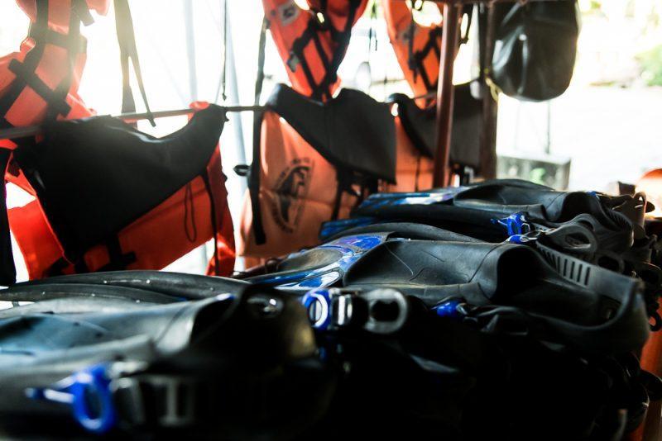
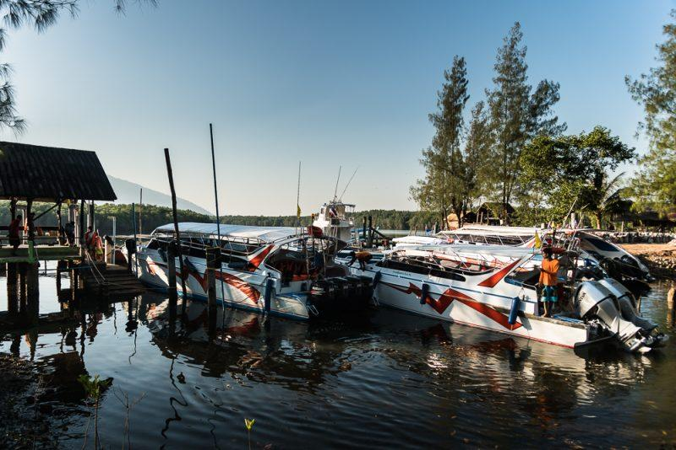
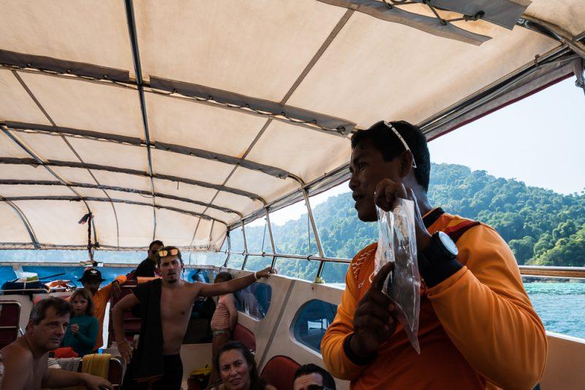
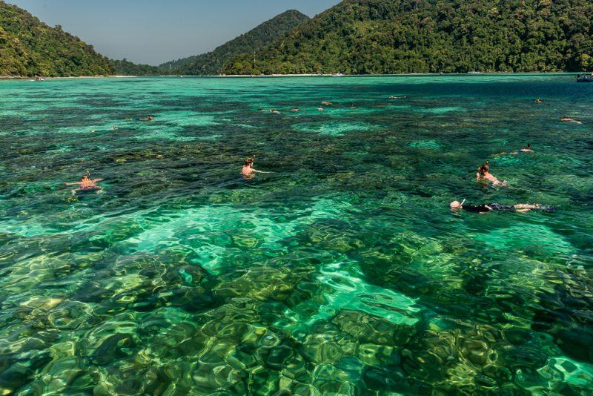
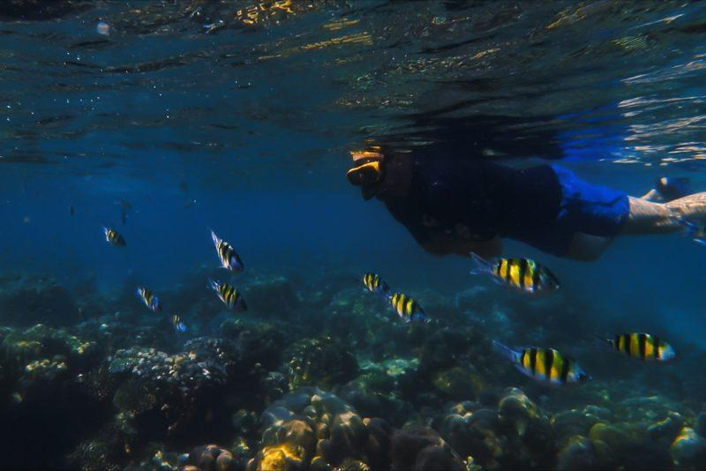
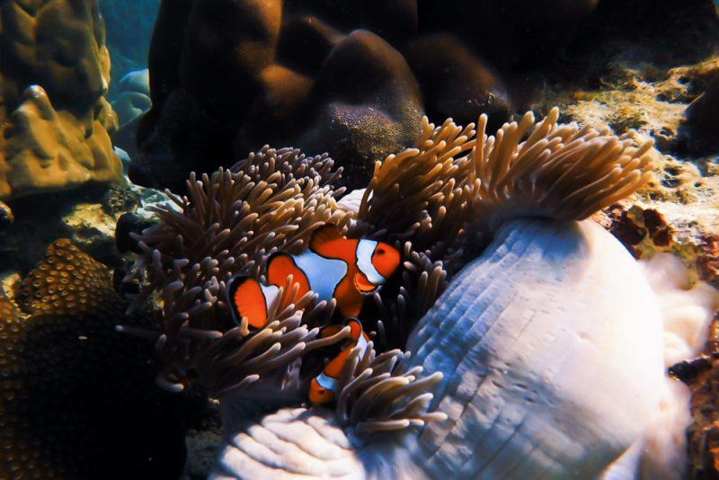
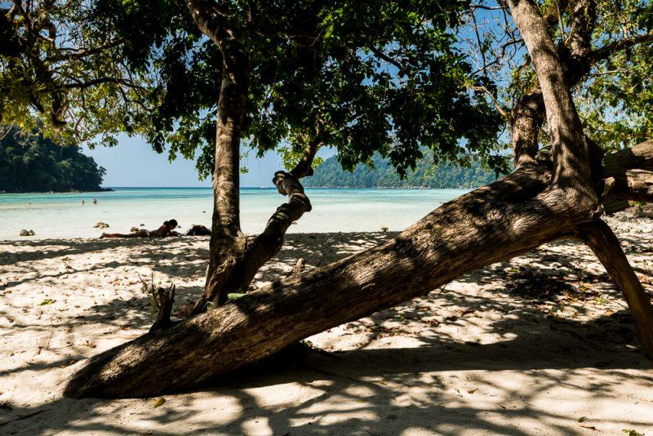

Easia Travel Head Office

